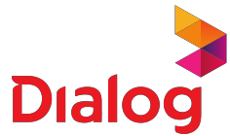

**Payment confirmation**

Transaction ID : {{TRANSACTION_ID}}

Here is a summary of your recent payment.

Payment information Payment details

Details of your payment from MyDialog App

# Date

{{DATE}}

# Status

**Connection**

**Connection Reference**

**Amount (Rs.) Status**

Success

# Payment Method

eZcash

Mobile prepaid {{PHONE}} 1,500.00 Payment Success

**Total** 1,500.00