**Part 2: Creating Your First XML Document (20 Minutes)**

**1. Create an XML Document:**

Open your IDE (NetBeans, Eclipse, etc.) and create a new Java Project.

Create a new file named books.xml in your project folder.

Use the following example to create an XML document representing a simple list of books:

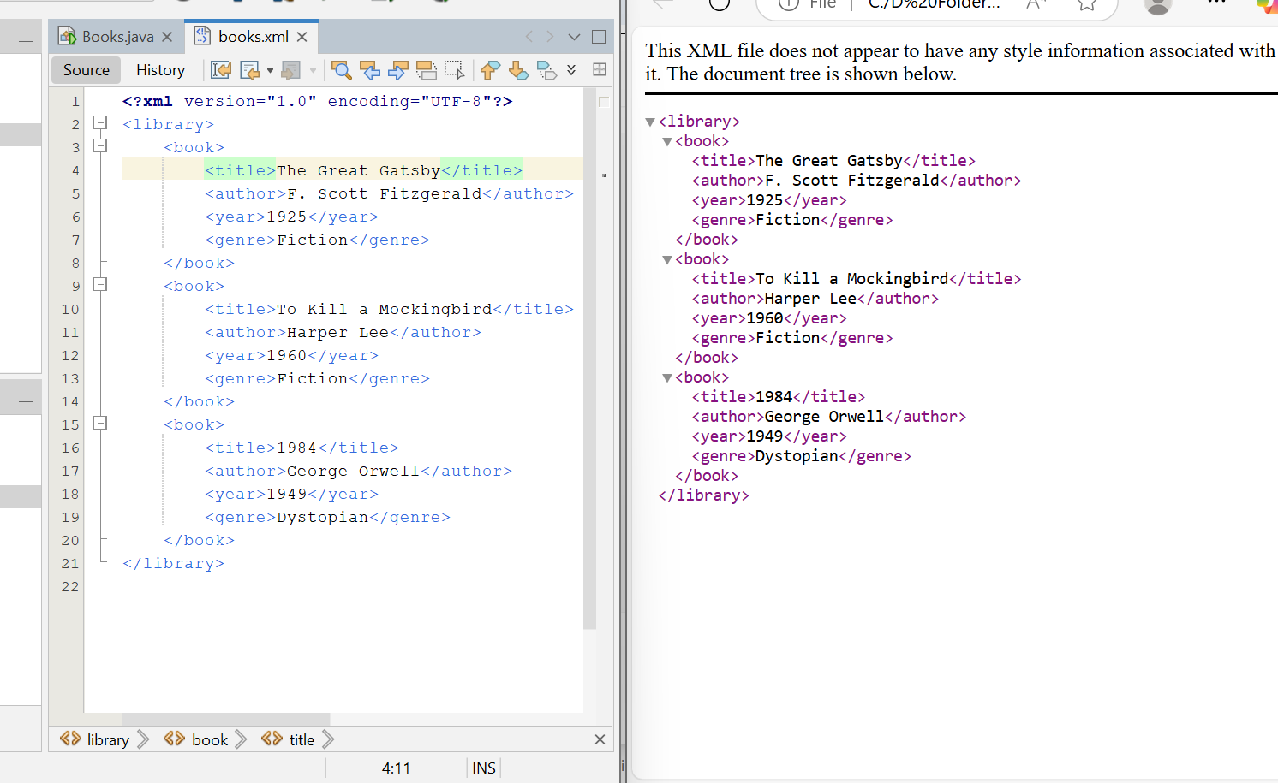

**Part 3: Parsing XML in Java (30 Minutes)**

Now that we have created an XML document, let’s read and parse it using Java. We'll use Java DOM (Document Object Model) parsing for this task. 1. Create a Java Class for XML Parsing:

Create a new Java class named XmlParser.java in your project. o Add the following code to read and parse the books.xml file: