TITLE : TCP Backlog (Listen Queue Size) Analysis using Wireshark

Short Description of your DA :
Study and demonstration of TCP backlog, the listen queue size that stores incoming connection requests during the TCP three-way handshake. Using Wireshark traces, SYN, SYN-ACK, and ACK packets are observed and related to how servers queue pending connections and what happens when the backlog is full.

REFERENCE LINKS :

BLOG LINK :
https://www.malware-traffic-analysis.net/

YOU TUBE :
https://www.youtube.com/watch?v=eQItiKZpuSc

Challenges faced in DA1 :
- Understanding backlog vs accept queue
- Identifying SYN/SYN-ACK packets
- Relating theory to Wireshark traces

Scenario(EXAMPLE) :

When semester results are released on the college portal, thousands of students try to open the website at the same time.
Every student’s browser sends a TCP SYN request to the server to start a connection.
Since many SYN requests arrive simultaneously:
- some connections are placed in the listen queue (TCP backlog)
- when the backlog becomes full
- remaining connection requests are dropped or delayed
- students may see:
  - page not loading
  - “connection timed out”
  - repeated loading attempts
This happens because the TCP backlog size is limited, and the server cannot handle unlimited pending connections at once.

A SMALL DIAGRAM REPRESENTATION OF HOW THIS WHOLE THING WORKS :

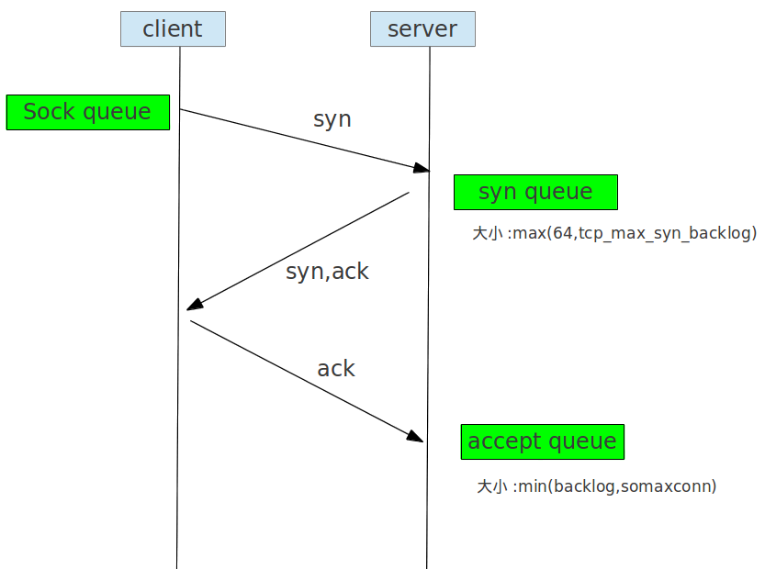

🔹 TCP Flag Combinations in the 3-Way Handshake

1️) SYN = 1, ACK = 0
- Meaning: First packet from client to server — connection request
- Queue: Goes into backlog queue (listen queue)
- Connection state: Half-open (just started handshake)
- Example: Client sends request to access the server

2️) SYN = 1, ACK = 1
- Meaning: Server’s response to client — SYN-ACK packet
- Queue: Still in backlog queue, waiting for final ACK
- Connection state: Half-open (server knows client wants connection, waiting for ACK)
- Example: Server saying “I’m ready, complete handshake”

3️) SYN = 0, ACK = 1
- Meaning: Final ACK from client to server — completes handshake
- Queue: Moves connection from backlog → accept queue
- Connection state: Fully established
- Example: Client says “OK, connection established, now I can send data”

SCREEN SHOTS :
