Title :
TCP Backlog (Listen Queue Size) Analysis using Wireshark under Normal, Medium and High Traffic Conditions..

Introduction :
Computer networks handle large numbers of connection requests from clients to servers. When many users try to connect at the same time, the server temporarily stores half-open TCP connections in a queue called the TCP backlog (listen queue).
This Digital Assignment analyzes how TCP backlog behaves under different traffic conditions using Wireshark packet capture and hping3 traffic generation tool. By observing SYN, SYN-ACK and retransmissions, we can understand how network performance changes when traffic increases.
The experiment helps visualize how real servers behave when traffic load increases and when connection requests exceed server capacity.

Objectives :
- To analyze TCP backlog queue behavior using Wireshark.
- To compare network performance under normal, medium and high traffic conditions.
- To observe SYN packets, SYN-ACK responses and retransmissions.
- To measure delay and failed connections when traffic increases.
- To understand how server performance changes with increasing connection requests.

Reference from which the DA was started :
SharkFest Wireshark tutorials and Malware Traffic Analysis website helped understand packet-level behavior and TCP handshake concepts.
Reference link:
Wireshark Foundation Official Documentation :
https://www.wireshark.org/docs/
The reference provided packet-level examples of TCP communication and helped understand how SYN packets behave when server load increases.

Description :
The Digital Assignment was started using Wireshark documentation and SharkFest tutorials which explain TCP packet behavior and network performance analysis. These resources provide practical understanding of TCP handshake packets, SYN requests, retransmissions, and delay analysis. The hping3 tool documentation helped in generating controlled TCP traffic for different load conditions.

Architecture of the Work :
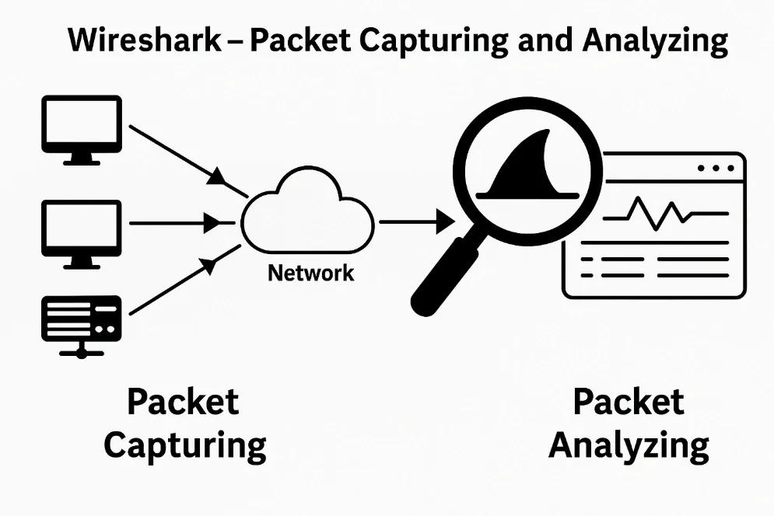

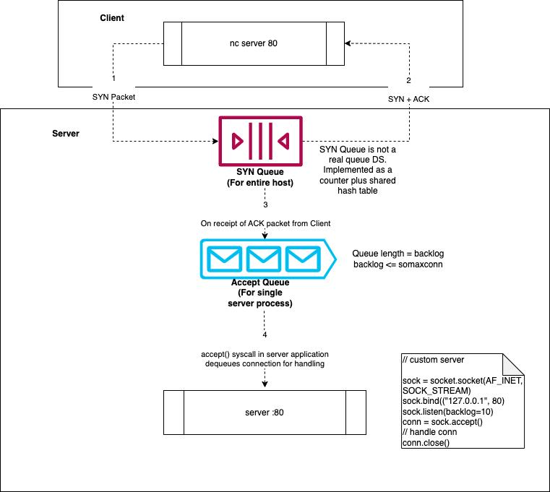

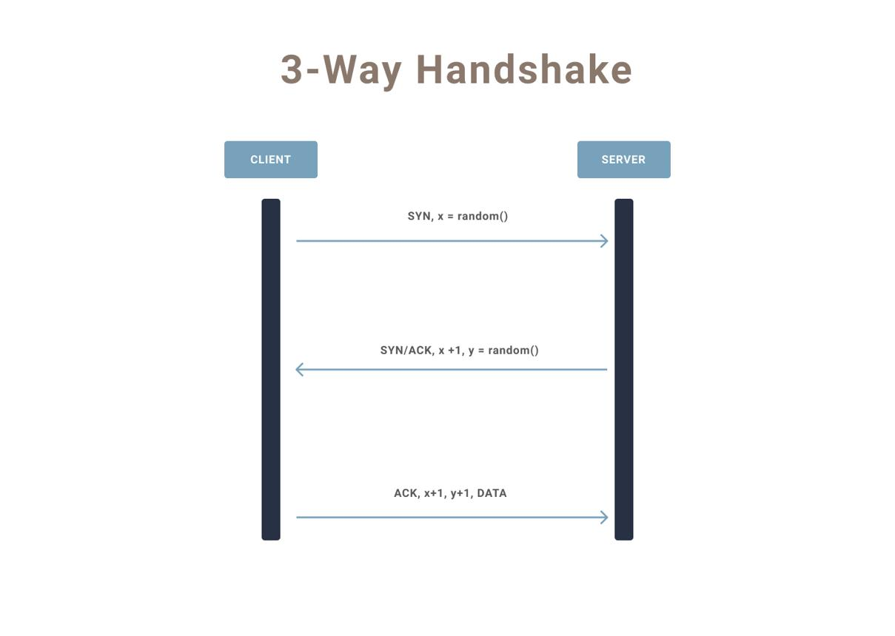

PROCEDURE :

Low Traffic (Light Load) :
- Low SYN rate, small number of packets
- command: sudo hping3 -S -p 8080 -i u100000 -c 20 <server-ip>
Behavior
- Every SYN gets SYN-ACK
- Connections smooth
- Backlog mostly empty
Wireshark
- Proper SYN → SYN-ACK pairs
- No delay or retransmissions
Demo line
- TCP backlog easily handles all connection requests.
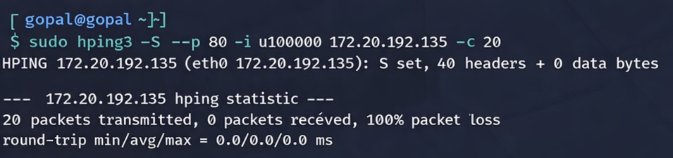

Meduim Traffic (Moderate Load) :
- Moderate SYN rate, more packets
- command: sudo hping3 -S -p 8080 -i u20000 -c 100 <server-ip>
Behavior
- Most SYN get SYN-ACK
- Small delay appears
- Backlog starts filling
Wireshark
- More SYN packets
- Slight delay and few retransmissions
Demo line
- Backlog starts filling, causing small delay but connections still accepted.
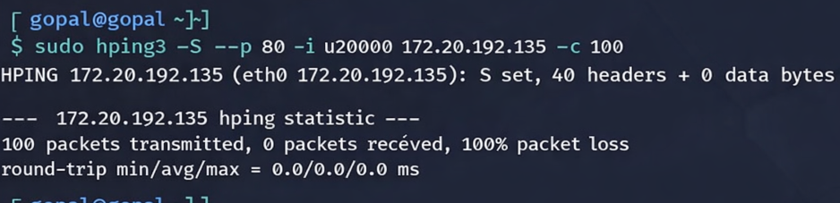

High Traffic (Heavy Load) :
- High SYN rate, many packets
- command: sudo hping3 -S -p 8080 -i u10000 -c 200 <server-ip>
Behavior
- Backlog becomes full
- Some connections delayed or dropped
Wireshark
- Many SYN packets
- Missing SYN-ACK responses
- More retransmissions
Demo line
- Backlog becomes full, so server cannot handle all requests.
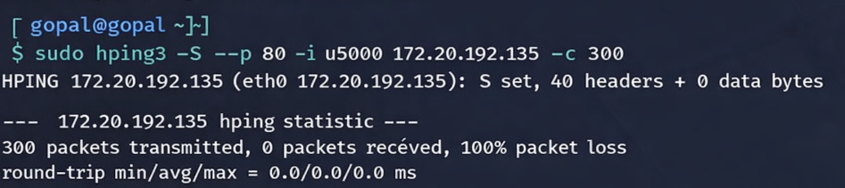

Inferences on network parameter :

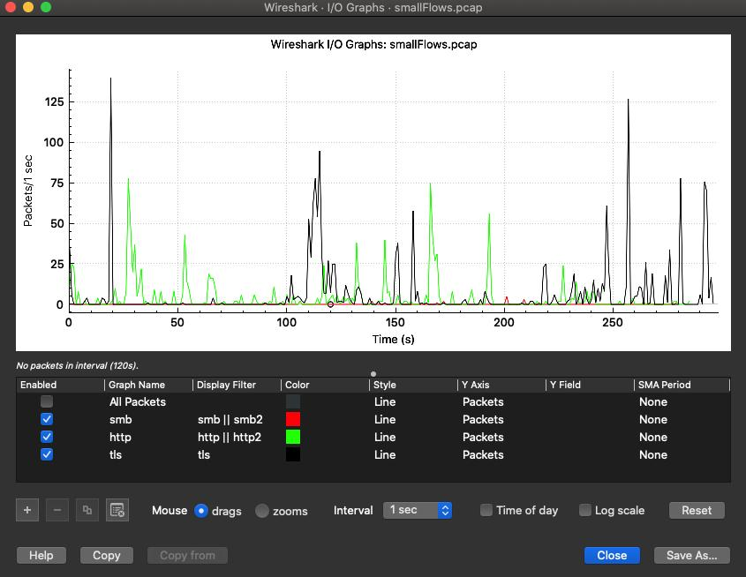

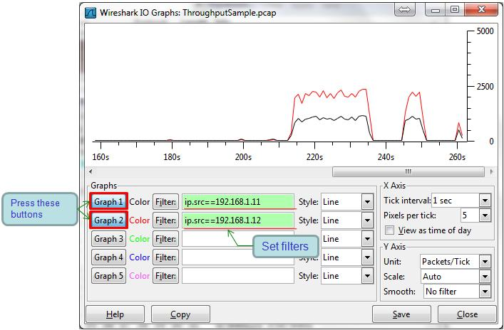

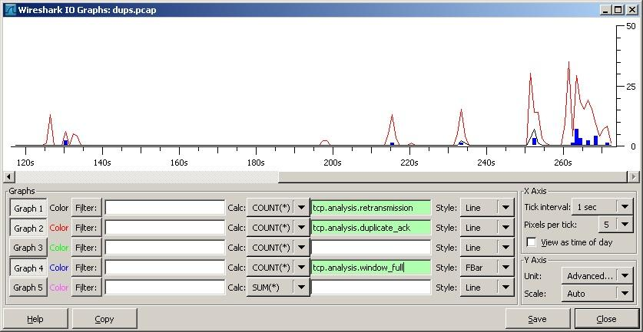

1) Under low and normal traffic conditions, the TCP backlog queue handles all incoming SYN requests without delay, and almost all connections are successfully established.
2) As traffic increases to medium level, the backlog queue begins filling, which causes a slight increase in time between SYN and SYN-ACK packets.
3) Under high traffic conditions, the backlog queue becomes saturated, resulting in SYN packet retransmissions and delayed connection establishment.
4) The difference between number of SYN packets and SYN-ACK responses increases as traffic load increases, indicating reduced connection success rate.
5) Increase in Round Trip Time (RTT) under heavy traffic shows that connection requests spend more time waiting in the backlog queue.

New Findings from my Work :
- TCP backlog queue fills faster when SYN requests increase.
- SYN retransmissions increase when traffic becomes high.
- Delay between SYN and SYN-ACK increases as load increases.

Possible Recommendations :

- Increase backlog queue size in server settings.
- Use load balancing to reduce traffic on single server.
- Monitor SYN retransmissions to detect congestion early.

