**[Skip navigation links](http://shuspace.shu.ac.uk/webapps/blackboard/content/listContent.jsp?course_id=_218043_1&content_id=_2561797_1&mode=reset#endNav)Advanced Web Applications**

**National Admission Agency (NAA) Case-study**

## Team Assignment

In this assignment you are asked to develop a prototype Web application using ASP.NET MVC (C#) and XML Web Services. You should undertake this assignment as a team.

Introduction

During this week you will learn numerous techniques which allow you to build Web applications using ASP.NET MVC and XML Web Services. This assignment gives you an opportunity to consolidate your skills, in order to design, and implement the concepts of a working Web application.

Business case study

National Admission Agency (NAA) is an agency that manages applications for affiliated Universities. Applicants apply for courses at Universities through NAA. NAA is responsible for application process for University applicants. There are two sides to the system:

|  |
| --- |
| 1. One side of the system is how users use the system. The user side of the system is twofold; |
| 1. Applicant user; the way applicant uses the system is one side. Applicant should be able to create their profile and subsequently be able to maintain the profile. Maintaining the profile means to make changes to some of the information in order to ensure that the profile remains valid and up to date. Having created a profile, applicant should be able to look up courses at different universities and, with ease, create applications for a number of courses that may be at different Universities. Having applied for the courses they should be able to manage their applications. Managing an application means to make changes to some of the details but no changes are allowed to the University or the course. An application can be deleted only if University has not yet made an offer (if University has not yet processed the application). NAA allows the applicant to make up to 5 applications not including the deleted applications. Applicant can go firm on one offer if the offer is made and it is not ‘R’ (Reject). |
| 1. University; the way Universities use the system is the other side. Universities use their own systems which in turn uses the Web services that NAA provides. Universities should be able to manage (download and track progress of) own applications (applicants’ profile and application), make offer, and be (if need be) able to add information regarding the offer (for example specify conditions for a conditional offer or provide reasons for rejecting an application). Offers can be one of the following; R: Reject, P: Pending, C: Conditional, U: Unconditional. You need to make good assumptions. For example University should not be able to change an unconditional offer to conditional. |
| 1. The second side of the system is how NAA manages University and course information. This is about the way NAA system acquires and manages information about Universities and courses at Universities and how it displays the information to the applicant to help him make his choices. Information about the courses tends to be dynamic and frequently changing. NAA is therefore required to consume University Web services for the information. For the purpose of this exercise we have two affiliated Universities;  |  |  | | --- | --- | | University | Web Service URL | | Sheffield | <http://webteach_net.hallam.shu.ac.uk/cmsmr2/SheffieldWebService.asmx> | | Sheffield Hallam | <http://webteach_net.hallam.shu.ac.uk/cmsmr2/SHUWebService.asmx> | |

Boundary of NAA System

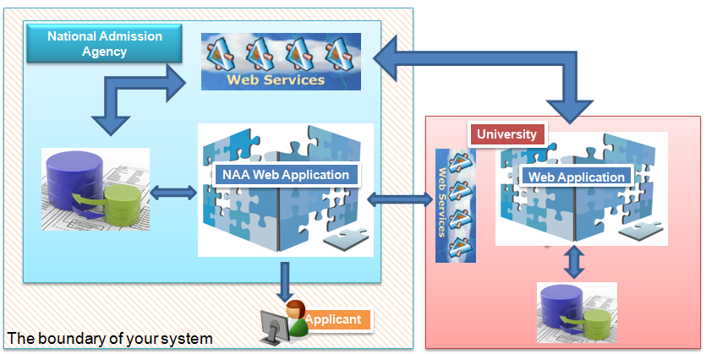

|  |  |
| --- | --- |
| Database schema |  |
|  |  |

Mark Scheme

Assignment Submission

You will demonstrate your application using a presentation.

In your presentation you must include

1. How you have fulfilled the functionality listed above
2. How you have addressed the criteria for assessment above
3. You must submit in electronic format; Solution folder containing the source code for your Web application