TASK 1:

1) Count the occurrences of each letter in the text.

Algorithm:

1. Create an empty dictionary.
2. Update values when it finds the same character

Code:

freq = {}  
# A  
for i in teststr:  
 if i in freq:  
 freq[i] += 1  
 else:  
 freq[i] = 1

Output:

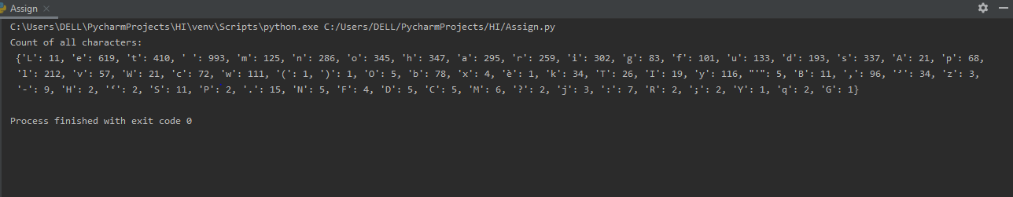

2) Print the number of one-letter, two-letter, three-letter words and so on.

Algorithm:

1. Let counts of each letter word.
2. Initialize them with zero
3. Check lengths of words and update according to it

Code:

count1 = 0;  
count2 = 0;  
count3 = 0;  
count4 = 0;  
count5 = 0;  
count6 = 0;  
count7 = 0;  
count8 = 0;  
count9 = 0;  
count10 = 0;  
for j in data:  
 if len(j) == 1:  
 count1 = count1 + 1;  
 elif len(j) == 2:  
 count2 = count2 + 1;  
 elif len(j) == 3:  
 count3 = count3 + 1;  
 elif len(j) == 4:  
 count4 = count4 + 1;  
 elif len(j) == 5:  
 count5 = count5 + 1;  
 elif len(j) == 6:  
 count6 = count6 + 1;  
 elif len(j) == 7:  
 count7 = count7 + 1;  
 elif len(j) == 8:  
 count8 = count8 + 1;  
 elif len(j) == 9:  
 count9 = count9 + 1;  
 elif len(j) == 10:  
 count10 = count10 + 1;  
  
print("One letter word " + str(count1))  
print("Two letter word " + str(count2))  
print("Three letter word " + str(count3))  
print("Four letter word " + str(count4))  
print("Five letter word " + str(count5))  
print("Six letter word " + str(count6))  
print("Seven letter word " + str(count7))  
print("Eight letter word " + str(count8))  
print("Nine letter word " + str(count9))  
print("Ten letter word " + str(count10))

Output :

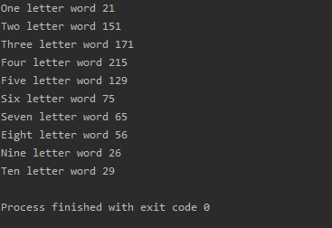

3) Print the number of occurrences of each different word in the text.

Algorithm:

1. Create an empty tuple
2. Count words and if word is found increase the count

Code:

counts = dict()  
for word in data:  
 if word in counts:  
 counts[word] += 1  
 else:  
 counts[word] = 1  
  
print(counts)

Output:

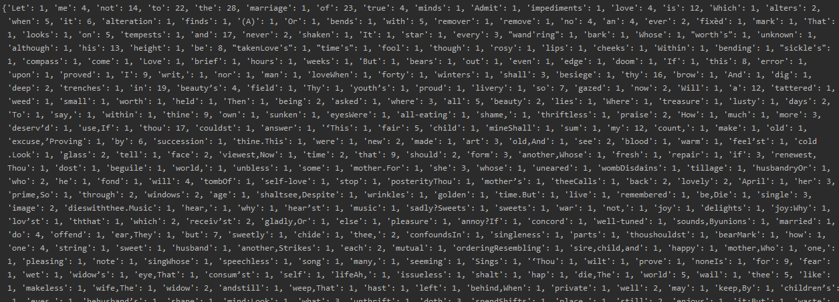

{'Let': 1, 'me': 4, 'not': 14, 'to': 22, 'the': 28, 'marriage': 1, 'of': 23, 'true': 4, 'minds': 1, 'Admit': 1, 'impediments': 1, 'love': 4, 'is': 12, 'Which': 1, 'alters': 2, 'when': 5, 'it': 6, 'alteration': 1, 'finds': 1, '(A)': 1, 'Or': 1, 'bends': 1, 'with': 5, 'remover': 1, 'remove': 1, 'no': 4, 'an': 4, 'ever': 2, 'fixèd': 1, 'mark': 1, 'That': 1, 'looks': 1, 'on': 5, 'tempests': 1, 'and': 17, 'never': 2, 'shaken': 1, 'It': 1, 'star': 1, 'every': 3, "wand'ring": 1, 'bark': 1, 'Whose': 1, "worth's": 1, 'unknown': 1, 'although': 1, 'his': 13, 'height': 1, 'be': 8, "takenLove's": 1, "time's": 1, 'fool': 1, 'though': 1, 'rosy': 1, 'lips': 1, 'cheeks': 1, 'Within': 1, 'bending': 1, "sickle's": 1, 'compass': 1, 'come': 1, 'Love': 1, 'brief': 1, 'hours': 1, 'weeks': 1, 'But': 1, 'bears': 1, 'out': 1, 'even': 1, 'edge': 1, 'doom': 1, 'If': 1, 'this': 8, 'error': 1, 'upon': 1, 'proved': 1, 'I': 9, 'writ,': 1, 'nor': 1, 'man': 1, 'loveWhen': 1, 'forty': 1, 'winters': 1, 'shall': 3, 'besiege': 1, 'thy': 16, 'brow': 1, 'And': 1, 'dig': 1, 'deep': 2, 'trenches': 1, 'in': 19, 'beauty’s': 4, 'field': 1, 'Thy': 1, 'youth’s': 1, 'proud': 1, 'livery': 1, 'so': 7, 'gazed': 1, 'now': 2, 'Will': 1, 'a': 12, 'tattered': 1, 'weed': 1, 'small': 1, 'worth': 1, 'held': 1, 'Then': 1, 'being': 2, 'asked': 1, 'where': 3, 'all': 5, 'beauty': 2, 'lies': 1, 'Where': 1, 'treasure': 1, 'lusty': 1, 'days': 2, 'To': 1, 'say,': 1, 'within': 1, 'thine': 9, 'own': 1, 'sunken': 1, 'eyesWere': 1, 'all-eating': 1, 'shame,': 1, 'thriftless': 1, 'praise': 2, 'How': 1, 'much': 1, 'more': 3, 'deserv’d': 1, 'use,If': 1, 'thou': 17, 'couldst': 1, 'answer': 1, '‘This': 1, 'fair': 5, 'child': 1, 'mineShall': 1, 'sum': 1, 'my': 12, 'count,': 1, 'make': 1, 'old': 1, 'excuse,’Proving': 1, 'by': 6, 'succession': 1, 'thine.This': 1, 'were': 1, 'new': 2, 'made': 1, 'art': 3, 'old,And': 1, 'see': 2, 'blood': 1, 'warm': 1, 'feel’st': 1, 'cold.Look': 1, 'glass': 2, 'tell': 1, 'face': 2, 'viewest,Now': 1, 'time': 2, 'that': 9, 'should': 2, 'form': 3, 'another,Whose': 1, 'fresh': 1, 'repair': 1, 'if': 3, 'renewest,Thou': 1, 'dost': 1, 'beguile': 1, 'world,': 1, 'unbless': 1, 'some': 1, 'mother.For': 1, 'she': 3, 'whose': 1, 'uneared': 1, 'wombDisdains': 1, 'tillage': 1, 'husbandryOr': 1, 'who': 2, 'he': 1, 'fond': 1, 'will': 4, 'tombOf': 1, 'self-love': 1, 'stop': 1, 'posterityThou': 1, 'mother’s': 1, 'theeCalls': 1, 'back': 2, 'lovely': 2, 'April': 1, 'her': 3, 'prime,So': 1, 'through': 2, 'windows': 2, 'age': 1, 'shaltsee,Despite': 1, 'wrinkles': 1, 'golden': 1, 'time.But': 1, 'live': 1, 'remembered': 1, 'be,Die': 1, 'single': 3, 'image': 2, 'dieswiththee.Music': 1, 'hear,': 1, 'why': 1, 'hear’st': 1, 'music': 1, 'sadly?Sweets': 1, 'sweets': 1, 'war': 1, 'not,': 1, 'joy': 1, 'delights': 1, 'joy:Why': 1, 'lov’st': 1, 'ththat': 1, 'which': 2, 'receiv’st': 2, 'gladly,Or': 1, 'else': 1, 'pleasure': 1, 'annoy?If': 1, 'concord': 1, 'well-tuned': 1, 'sounds,Byunions': 1, 'married': 1, 'do': 4, 'offend': 1, 'ear,They': 1, 'but': 7, 'sweetly': 1, 'chide': 1, 'thee,': 2, 'confoundsIn': 1, 'singleness': 1, 'parts': 1, 'thoushouldst': 1, 'bearMark': 1, 'how': 1, 'one': 4, 'string': 1, 'sweet': 1, 'husband': 1, 'another,Strikes': 1, 'each': 2, 'mutual': 1, 'orderingResembling': 1, 'sire,child,and': 1, 'happy': 1, 'mother,Who': 1, 'one,': 1, 'pleasing': 1, 'note': 1, 'singWhose': 1, 'speechless': 1, 'song': 1, 'many,': 1, 'seeming': 1, 'Sings': 1, '‘Thou': 1, 'wilt': 1, 'prove': 1, 'noneIs': 1, 'for': 9, 'fear': 1, 'wet': 1, 'widow’s': 1, 'eye,That': 1, 'consum’st': 1, 'self': 1, 'lifeAh,': 1, 'issueless': 1, 'shalt': 1, 'hap': 1, 'die,The': 1, 'world': 5, 'wail': 1, 'thee': 5, 'like': 1, 'makeless': 1, 'wife,The': 1, 'widow': 2, 'andstill': 1, 'weep,That': 1, 'hast': 1, 'left': 1, 'behind,When': 1, 'private': 1, 'well': 2, 'may': 1, 'keep,By': 1, 'children’s': 1, 'eyes,': 1, 'hehusband’s': 1, 'shape': 1, 'mind:Look': 1, 'what': 3, 'unthrift': 1, 'doth': 3, 'spendShifts': 1, 'place,': 1, 'still': 2, 'enjoys': 1, 'it;But': 1, 'waste': 1, 'hath': 5, 'end,And': 1, 'kept': 1, 'unused'

Task 2:

Find the fewest words that will link them.

Algorithm:

1. Convert list into set for duplicate values
2. If end word is not in set return 0;
3. Create a dictionary ‘curr’. Initialize with start word.
4. Initialize res (answer)
5. Create an empty tuple next
6. For each word check if there exists a word which have just one letter difference
7. Update the res
8. Add word to next

Code:

def minladder(beg, end, list):  
 *"""* ***:type*** *beginWord: object  
 """* list = set(list)  
 if end not in list:  
 return 0  
  
 curr = {beg}  
 res = 1  
 while curr:  
 list -= curr  
 next = set()  
 for word in curr:  
 for i in range(len(word)):  
 for c in 'abcdefghijklmnopqrstuvwxyz':  
 new = word[:i] + c + word[i + 1:]  
 if new == end:  
 return 1 + res  
 if new in list:  
 next.add(new)  
 curr = next  
 res += 1  
 return 0  
  
  
Lists = open('Words.txt').read().splitlines()  
  
start1 = "flour"  
target1 = "bread"  
start2 = "chaos"  
target2 = "peace"  
start3 = "river"  
target3 = "shore"  
start4 = "sleep"  
target4 = "dream"  
start5 = "black"  
target5 = "white"  
start6 = "witch"  
target6 = "fairy"  
start7 = "tears"  
target7 = "smile"  
start8 = "which"  
target8 = "think"  
start9 = "paper"  
target9= "story"  
start10 = "early"  
target10 = "trees"  
  
  
print(minladder(start1, target1, Lists))  
print(minladder(start2, target2, Lists))  
print(minladder(start3, target3, Lists))  
print(minladder(start4, target4, Lists))  
print(minladder(start5, target5, Lists))  
print(minladder(start6, target6, Lists))  
print(minladder(start7, target7, Lists))  
print(minladder(start8, target8, Lists))  
print(minladder(start9, target9, Lists))  
print(minladder(start10, target10, Lists))

Output:

