**Documentation**

**Project Overview:** The project implements Clothing Closet which is a small business that sells donated “gently used” and new clothing articles for men and women. The clothing closet keeps track of:

1. the **person** that donates the item (id, name, email, social security number, address, phone, etc.)
2. **persons** that buy items or follow the clothing closet
3. the **item** (id, size, condition, value (this goes on the receipt below), description, date acquired, picture, category, date sold, selling price, person that bought item if known)

**Relationships and Business Rules:**

1. Individuals donate from one to many items but items donated are associated with one and only one person.
2. A donation receipt is associated with one and only one person (donator) and one and only one person (member that receives/checks in the donation).
3. An item can be in one or more categories (belts, shoes, men’s jacket, etc.)
4. An item is bought by one and only one person. A person buys from zero to many items.

**USERS AND ACCESS:**

1. Guests: Register themselves as customers
2. Registered Guests: Can browse and buy items, login
3. Admin: Checking an item with a donor, Login, No need to register

**Target Market**: Any inventory based on products that requires maintenance of inventory by admin. Also inventory that requires customers access with respect to selling the products online can use this web application for the similar purpose. Thus e commerce websites would be the best suggested target market.

**Home Page:**

**Name of the page:** Home.jsp

**Purpose of the page:** Starting page

**Audience of the page:** user and admin

**Data fields:** NA

**Validations:** NA

**Buttons/Hyperlinks:** Home Page, Login, Create Account, Item, Empty Cart

**Special notes:** This is the landing page of the application.

**Login Page:**

**Name of the page:** login.jsp

**Purpose of the page:** login for admin and user

**Audience of the page:** user and admin

**Data fields:** Username, Password

**Validations:** admin and user will have different landing pages upon login, user name and password should match the database details.

**Buttons/Hyperlinks:** Signup, Forgot Password, Login button

**Special notes:** The user can login or signup or click on the forgot password

**Men/Women/Kids:**

**Name of the page:** products.jsp

**Purpose of the page:** Show the images to buy

**Audience of the page:** user and admin

**Data fields:** NA

**Validations:** NA

**Buttons/Hyperlinks:** Quick View, Add to cart,

**Special notes:** This page will show up only on requesting the servlet action.

**Contact Us Page:**

**Name of the page:** contact.html

**Purpose of the page:** Users can send a mail to the support team if he have any doubts regarding the site, or if he have any problems with logging in.

**Audience of the page:** user and admin

**Data fields:** Name, email, subject, message

**Validations:** email should have the email format (with @ and .com)

**Buttons/Hyperlinks:** submit button to send an email

**Special notes:** Using this page users can send an email for support or any questions

**Admin Page:**

**Name of the page:** productAdd.jsp

**Purpose of the page:** Admin can add images for shopping

**Audience of the page:** Admin

**Validations:** email should have the email format

**Buttons/Hyperlinks:** Upload photo and enter details about image.

**Special notes:** Admin can add and delete images .

**User Page**

**Name of the page:** Products.jsp

**Purpose of the page:** Page for user to select product for shopping.

**Audience of the page:** user.

**Buttons/Hyperlinks:** Quick view, add to cart

**Special notes:**. This page will show up only on requesting the servlet action.

**Site Map for the project**

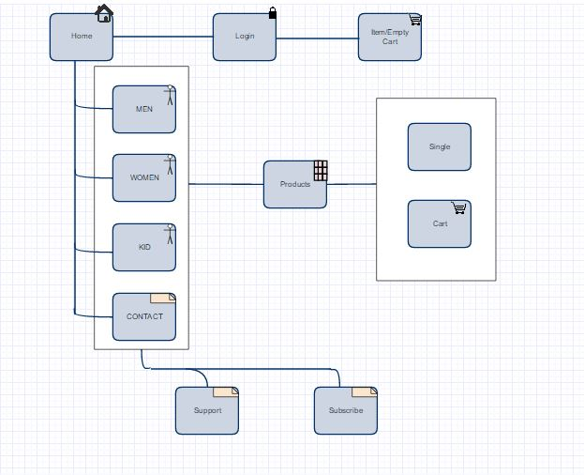

**ER Diagram**

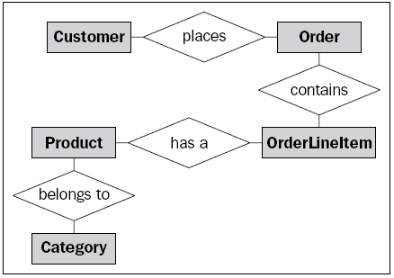

**Screenshots of Project**

