# What are the components of UCS?

## **Fabric Interconnects:**

The Cisco UCS Fabric Interconnect exists to connect your Cisco UCS Servers to your network. Beyond this, the Fabric Interconnects are where Cisco UCS Manager is run from, which is the software secret sauce for Cisco UCS. When you are logging into your Cisco UCS system, you are actually logging into Cisco UCS Manager via the Fabric Interconnects.

* Network connectivity to both LAN and SAN.
* UCS infrastructure management through the embedded management software, UCSM, for both hardware and software management.

Types of Ports on Fabric Interconnect:

* Universal Ports – Operate as Ethernet or Fibre Channel ports
* Ethernet Ports – For Ethernet or FCoE connectivity
* Uplink Ports – for uplink to the Cisco Nexus Infrastructure

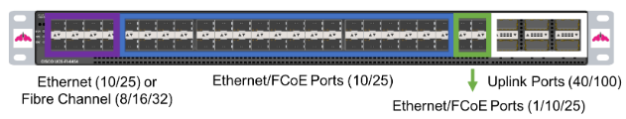

### **VIC (Virtual Interface Card) :**

In the world of Cisco UCS, VIC stands for Virtual Interface Card.  The Cisco UCS VIC is a key component of the Cisco UCS Platform, as it connects the Cisco UCS Servers to either the Fabric Interconnect.

In a rack server configuration, the VIC card would connect either to the Fabric Interconnect or a Fabric Extender (FEX), which we will soon learn more about.

In a blade server configuration, the VIC card connects to the FEX which resides in the back of the blade chassis, it cannot connect directly to the Fabric Interconnect.

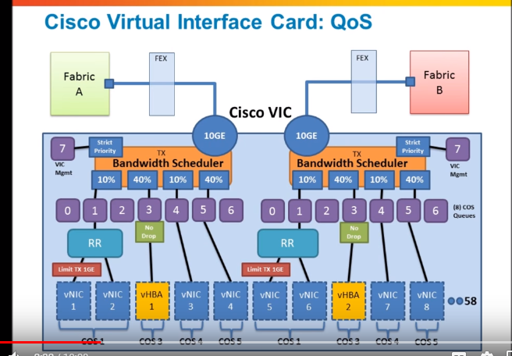

### **Blade Chassis Cisco FEX:**

The FEXes are connected to the Fabric Interconnects. There are two FEX slots in the Blade Chassis, one for A side connectivity and one for B side connectivity. FEX A connects to Fabric Interconnect A, and FEX B connects to Fabric Interconnect B.

The Fabric Interconnects are not cross connected, like your instinct may tell you to do. Failure of a FEX or Fabric Interconnect is handled at the software layer, by either the software running on your blades, or by UCS Manager, it is your choice!

### **Rack Mount Cisco FEX:**

This operates with a similar principle as the Blade Chassis FEX, except it is mounted in a rack. The purpose of this is to add more ports to your Fabric Interconnect so you can take advantage of the Cisco UCS’s full potential.

# What are the types of UCS Servers?

**Rack Servers:**

Rack Servers are the rack mounted servers that could specifically be fitted in a server rack. Rack Servers are the servers which are made with efficient configurations to support a wide range of requirements.

Rackmount servers are self-sufficient meaning the cooling, power supplies, hard disks, processors, memory, raid controller are all enclosed within that single server.

Rack servers are economical and great choice if your server requirement is small. You can simply plug the rack mounted server into a standard electrical outlet and connect the network cables and the device is operational.

Rack servers can be highly efficient when you require more than one server as they don’t require a huge chassis.

**Blade Servers:**

Blade servers are those servers which can accommodate multiple servers in a smaller area. These servers usually have a thin like structure having just the CPUs, memory, integrated network controllers, and sometimes storage drives built in.

These servers also manage their chassis according to their components required. Because of their thin like structure, blade servers can be conveniently fitted into one single rack along with providing high processing power.

* Blade servers promote hot swappable feature which could provide you redundancy when one blade faces a problem making it to be pulled and replaced much more easily.
* Blade servers requires only one cable (often fibre) for running to the chassis which reduces the use of individual cables running for each blade server.
* Blade servers require minimal space and at the same time provides high processing power.

# What are the Hypervisor and its types?

Hypervisor is a form of virtualization software used in Cloud hosting to divide and allocate the resources on various pieces of hardware. The program which provide partitioning, isolation or abstraction is called virtualization hypervisor. Hypervisor is a hardware virtualization technique that allows multiple guest operating systems (OS) to run on a single host system at the same time. A hypervisor is sometimes also called a virtual machine manager (VMM).

**TYPE-1 Hypervisor:**

Hypervisor runs directly on underlying host system. It is also known as “Native Hypervisor” or “Bare metal hypervisor”. It does not require any base server operating system. It has direct access to hardware resources. Examples of Type 1 hypervisors include VMware ESXi, Citrix XenServer and Microsoft Hyper-V hypervisor.

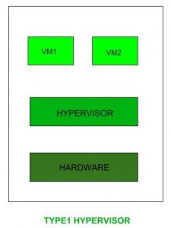

**TYPE-2 Hypervisor:**

A Host operating system runs on underlying host system. It is also known as ‘Hosted Hypervisor”. Basically a software installed on an operating system. Hypervisor asks operating system to make hardware calls. Example of Type 2 hypervisor include VMware Player or Parallels Desktop. Hosted hypervisors are often found on endpoints like PCs.

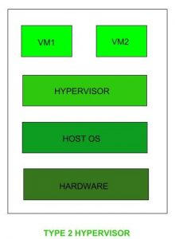

**Note :** Type 1 hypervisor offer much better performance than type 2 ones because theres no middle layer, making them the logical choice for mission-critical application and workloads.

**HYPERVISOR REFERENCE MODEL:**

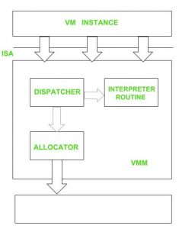

**DISPATCHER:**

The dispatcher behaves like the entry point of the monitor and reroutes the instructions of the virtual machine instance to one of the other two modules

**ALLOCATOR:**

The allocator is responsible for deciding the system resources to be provided to the virtual machine instance. It means whenever virtual machine tries to execute an instruction that results in changing the machine resources associated with the virtual machine, the allocator is invoked by the dispatcher.

**INTERPRETER:**

The interpreter module consists of interpreter routines. These are executed, whenever virtual machine executes a privileged instruction.

# What is virtual switch?

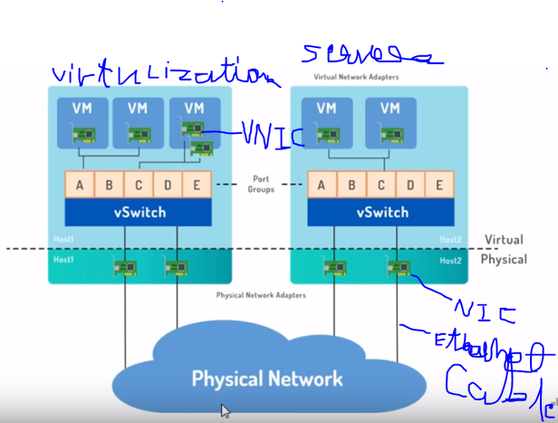

Virtual networking to connect VMs to the physical network

* How do you get virtual machines out to the network?

A virtual switch (vSwitch) is a software application that allows communication between virtual machines. A vSwitch does more than just forward data packets, it intelligently directs the communication on a network by checking data packets before moving them to a destination.

Virtual switches are usually embedded into installed software, but they may also be included in a server’s hardware as part of its firmware. A virtual switch is completely virtual and can connect to a network interface card (NIC). The vSwitch merges physical switches into a single logical switch. This helps to increase bandwidth and create an active mesh between servers and switches.

# What is SAN?

A storage area network (SAN) or storage network is a computer network which provides access to consolidated, block-level data storage. SANs are primarily used to enhance accessibility of storage devices, such as disk arrays, to servers so that the devices appear to the operating systems as locally attached devices.

A SAN is block-based storage, leveraging a high-speed architecture that connects servers to their logical disk units (LUNs). A LUN is a range of blocks provisioned from a pool of shared storage and presented to the server as a logical disk. The server partitions and formats those blocks—typically with a file system—so that it can store data on the LUN just as it would on local disk storage.

They are designed to remove single points of failure, making SANs highly available and resilient.

1. Flexible for many to many connectivity among servers and storage device with the help of fibre channel hubs and switches.
2. Up to 10 Km separation between a server and a storage system using appropriate fibre optic cables.
3. Better isolation capabilities allowing the non-disruptive addition of new servers and peripherals.

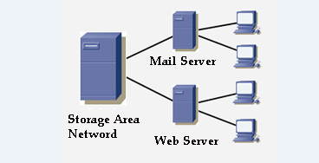

# VSAN:

A virtual storage area network (**VSAN**) is a logical partition in a physical storage area network (SAN). VSANs allow traffic to be isolated within specific portions of a storage area network so that if a problem occurs in one logical partition, it can be handled with a minimum of disruption to the rest of the network.

A virtual network interface card (vNIC) or virtual host bus adapter (vHBA) logically connects a virtual machine to a virtual interface on the UCS fabric interconnect and allows the virtual machine to send and receive traffic through that interface

World Wide Numbers (WWN): uniquely identifies FC devices

World Wide Port Number (WWPN): end device (HBA Port)

World Wide Node Number (WWNN): connectivity device (Fabric Switch)

A converged network adapter (**CNA**) is a single network interface card (NIC) that contains both a Fibre Channel (FC) host bus adapter (HBA) and a TCP/IP Ethernet NIC.

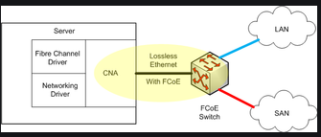

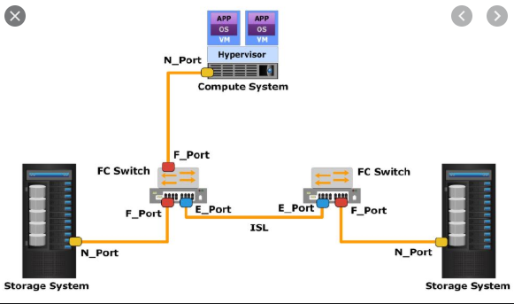

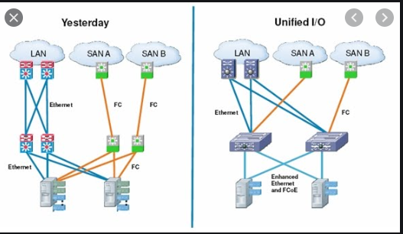

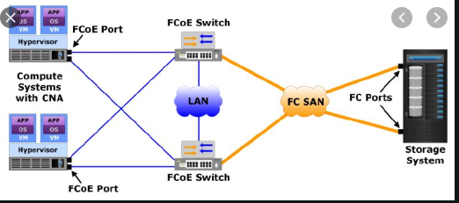

**RAM :**

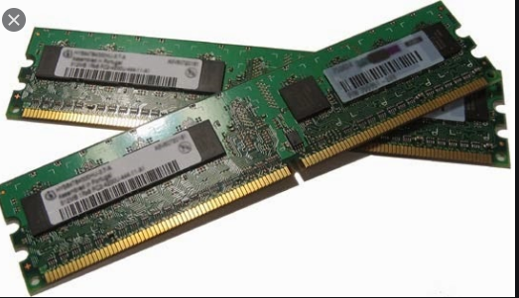

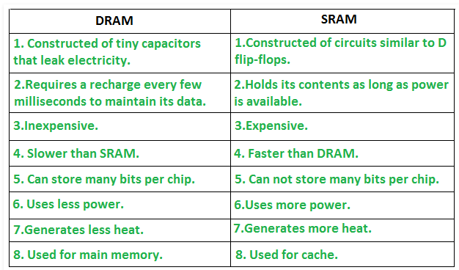

* The programs and data that the CPU requires during execution of a program are stored in this memory.
* It is a volatile memory as the data loses when the power is turned off.

**Read Only Memory (ROM) –**

* Stores crucial information essential to operate the system, like the program essential to boot the computer.
* It is not volatile.
* Always retains its data.
* Used in embedded systems or where the programming needs no change.
* Used in calculators and peripheral devices.
* ROM is further classified into 4 types- *ROM*, *PROM*, *EPROM*, and *EEPROM*.

1. **PROM (Programmable read-only memory)** – It can be programmed by user. Once programmed, the data and instructions in it cannot be changed.
2. **EPROM (Erasable Programmable read only memory)** – It can be reprogrammed. To erase data from it, expose it to ultra violet light. To reprogram it, erase all the previous data.
3. **EEPROM (Electrically erasable programmable read only memory)** – The data can be erased by applying electric field, no need of ultra violet light. We can erase only portions of the chip.

For most of today’s computer bootstrap is stored in Read Only Memory (ROM)

1. This location is good for storage because this place doesn’t require initialization and moreover location here it is fixed so that processor can start executing when powered up or reset.
2. ROM is basically read-only memory and hence it cannot be affected by the computer virus.

# **Hard Disk Drive (HDD) Secondary memory**

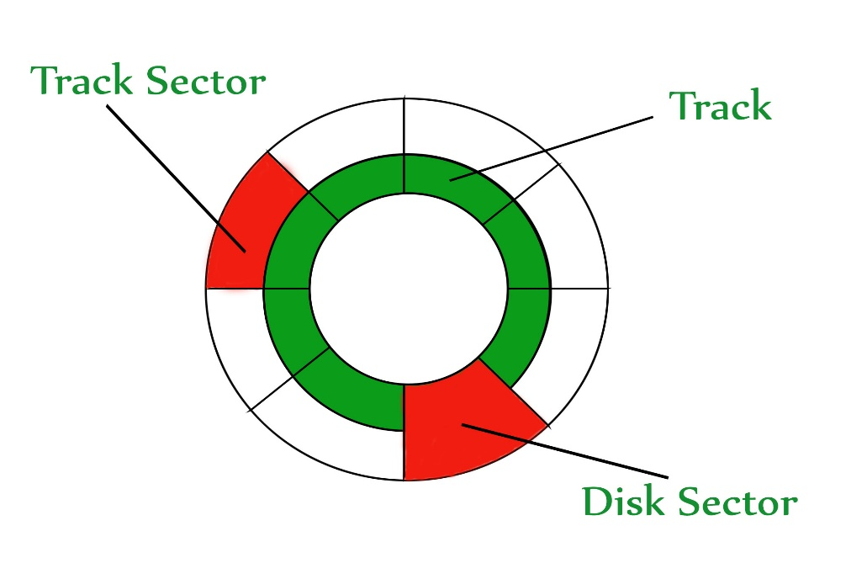

The disk is divided into **tracks**. Each track is further divided into **sectors**. The point to be noted here is that outer tracks are bigger in size than the inner tracks but they contain the same number of sectors and have equal storage capacity. This is because the storage density is high in sectors of the inner tracks where as the bits are sparsely arranged in sectors of the outer tracks. Some space of every sector is used for formatting. So, the actual capacity of a sector is less than the given capacity.

Read-Write(R-W) head moves over the rotating hard disk. It is this Read-Write head that performs all the read and write operations on the disk and hence, position of the R-W head is a major concern. To perform a read or write operation on a memory location, we need to place the R-W head over that position.

# **solid-state drive (SSD)**

**solid-state drive (SSD)** is a solid-state storage device that uses integrated circuit assemblies as memory to store data.

There are **no moving mechanical components** in SSD. This makes them different from conventional **electromechanical** drives such as hard disk drives (HDDs) or floppy disks, which contain movable read/write heads and spinning disks. SSDs are typically more resistant to physical shock, run silently, have quicker access time and lower latency compared to electromechanical devices.

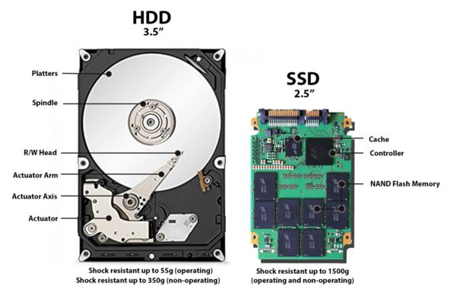

**Flash memory** is an electronic (solid-state) non-volatile computer memory storage medium that can be electrically erased and reprogrammed.

An **SSD controller**, also referred to as a processor, includes the electronics that bridge the Flash memory components to the **SSD** input/output interfaces. The **controller** is an embedded processor that executes firmware-level software.

SSD caching, also known as flash caching, is the temporary storage of data on NAND flash memory chips in a solid-state.

**Cache Memory** is a special very high-speed memory. It is used to speed up and synchronizing with high-speed CPU. Cache memory is costlier than main memory or disk memory but economical than CPU registers. Cache memory is an extremely fast memory type that acts as a buffer between RAM and the CPU. It holds frequently requested data and instructions so that they are immediately available to the CPU when needed.

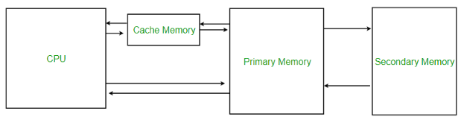

* **Level 1 or Register –**  
  It is a type of memory in which data is stored and accepted that are immediately stored in CPU. Most commonly used register is accumulator, Program counter, address register etc.
* **Level 2 or Cache memory –**  
  It is the fastest memory which has faster access time where data is temporarily stored for faster access.
* **Level 3 or Main Memory –**  
  It is memory on which computer works currently. It is small in size and once power is off data no longer stays in this memory.
* **Level 4 or Secondary Memory –**  
  It is external memory which is not as fast as main memory but data stays permanently in this memory.

**SATA and SAS:**

**SATA** stands for serial advanced technology attachment and SAS stands for serial attached SCSI (Small Computer System interface).

Basically they are connectors that connect the server motherboard with the hard drive.

# What is Network Febric?

Network fabric is an industry term that describes a network topology in which components pass data to each other through interconnecting switches.

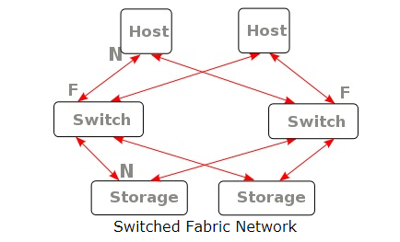

# What is Host Bus Adapter (HBA)?

**Adapter:** An **adapter** is a device that converts attributes of one device or system to those of an otherwise incompatible device or system.

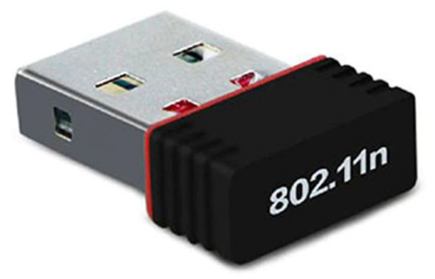

**Fig. Wireless Adaptor**

Ex. Mobile charger (AC to DC), wireless Bluetooth (for wireless keyboard, mouse).

A *host controller* connects a computer to a peripheral device, such as a storage device, network, or human interface device. As a host controller can also be viewed as bridging the protocols used on the buses between peripheral and computer, and internally to the computer, it is also called a *host bus adapter*. Likewise, specific types may be called adapters: a network interface controller may be called a *network adapter*, and a graphics card a *display adapter.*

**Microprocessor:**

A **microprocessor** is an electronic component that is used by a computer to do its work. It is a central processing unit on a single integrated circuit chip containing millions of very small components including transistors, resistors, and diodes that work together.

**BUS :**

.

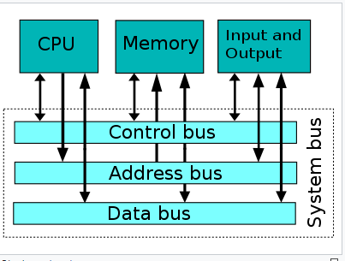

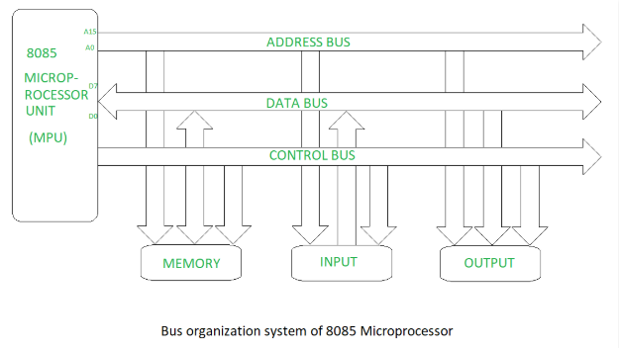

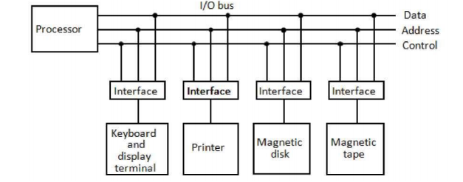

In computer architecture, a **bus** is a communication system that transfers data between components inside a computer, or between computers. This expression covers all related hardware components (wire, optical fiber , etc.) and software, including communication protocols.

Bus is a group of conducting wires which carries information, all the peripherals are connected to microprocessor through Bus.

**Address bus –**

The computer must be able to access every character of memory rapidly, so every character has its own address number.

It is a group of conducting wires which carries address only. Address bus is unidirectional because data flow in one direction, from microprocessor to memory or from microprocessor to Input/output devices. The Length of the address bus determines the amount of memory a system can address.

**Data bus –**

It is a group of conducting wires which carries Data only. Data bus is bidirectional because data flow in both directions, from microprocessor to memory or Input/Output devices and from memory or Input/Output devices to microprocessor.

When it is write operation, the processor will put the data (to be written) on the data bus, when it is read operation, the memory controller will get the data from specific memory block and put it into the data bus.

**Control bus –**

It is a group of conducting wires, which is used to generate timing and control signals to control all the associated peripherals, microprocessor uses control bus to process data that is what to do with selected memory location.

If one line of control bus may be the read/write line. If the wire is low (no electricity flowing) then the memory is read, if the wire is high (electricity is flowing) then the memory is written.

* Timing Signals used to synchronize the memory and IO operations with a CPU clock.

**Small Computer System Interface** (**SCSI**, is a set of standards for physically connecting and transferring data between computers and peripheral devices.

**Fiber Channel (FC) :**

A fiber channel (FC) is a computer networking technology that is used to transfer data between one or more computers at very high speeds. It was initially designed for supercomputers but is now commonly implemented in storage networking server environments as a replacement to small computer system interface (SCSI) and other serial storage technologies.

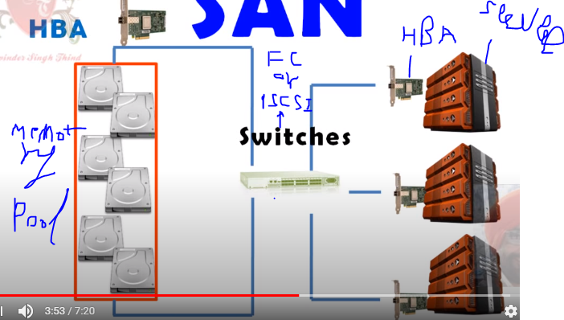

Types of solutions:

Fiber Channel (FC)

iSCSI Protocol

iSCSI stands for Internet Small Computer Systems Interface. iSCSI is a transport layer protocol that works on top of the Transport Control Protocol (TCP). It enables block-level SCSI data transport between the iSCSI initiator and the storage target over TCP/IP networks. ISCSI supports encrypting the network packets, and decrypts upon arrival at the target.

**Small Computer System Interface** (**SCSI**) is a set of standards for physically connecting and transferring data between computers and peripheral devices**.**

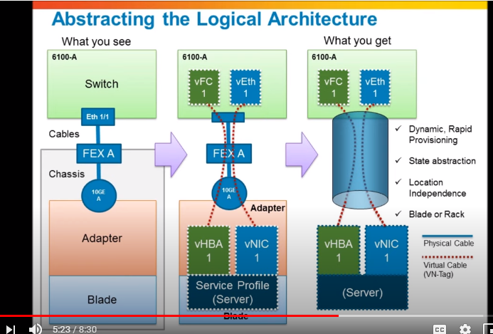

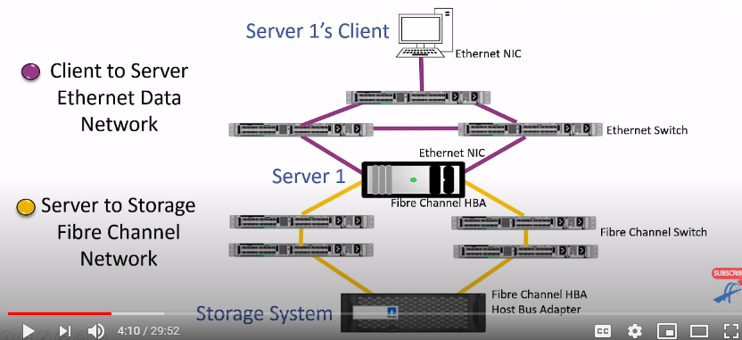

**WWN : world Wide Names Address**

**8 bytes made up of 16 hexadecimal characters.**

The common data communication protocol between servers and storage devices is the SCSI, and Fibre Channel. To achieve communication between the server and the storage device, the same communication protocol is required at both ends of the communication. A controller is typically available on a storage device, and the controller implements one or more communication protocols that enable the conversion between storage protocols such as SCSI, or Fibre Channel to the operating protocols of physical storage devices. The communication protocol of the server is implemented by an integrated circuit of the expansion card or motherboard, which is responsible for the conversion of the server bus protocol and the SCSI storage protocols.

If the disk only supports SCSI protocols, the disks cannot be directly connected to the PC. You need to insert a SCSI card on the PC expansion slot and the SCSI disk can be connected to the card. SCSI card enables PC bus to SCSI conversion. This kind of SCSI card realizes the function is the host Bus adapter card function. If the disk supports only Fibre Channel protocols, then the Fibre Channel protocol is required on the server because the high-speed characteristics of the Fibre Channel are not supported by the general Server Board and require a dedicated host bus adapter card. Once the server is plugged into the host bus adapter card, it can be connected to a Fibre Channel-enabled disk.

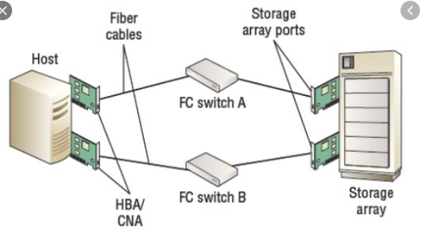

**LVM:**

**From different virtual disks to a physical disk, create a volume group, attached physical disk to volume group, from volume group to create logical volume.**

**Locks like a single volume from multiple volumes.**

# Q.) What Is IPMI (Intelligent Platform Management Interface)?

﻿IPMI is a series of specifications that provide standardized interfaces to the “platform management” services. The term “Platform Management” refers to monitoring hardware (system temperatures, fans, power supplies and so forth), their control (booting and shutting down the server) and the documentation (logging) of “out-of-range” states.

The primary IPMI features include:

* Monitoring (supervision of the hardware)
* Recovery Control (Recover/Restart the server)
* Logging (protocol „out-of-range“ states for the hardware)
* Inventory (list of hardware inventory)

IPMI provides these four functions independently from the server’s CPU, BIOS and operating system. The platform management features are also available when the server has been shut down.

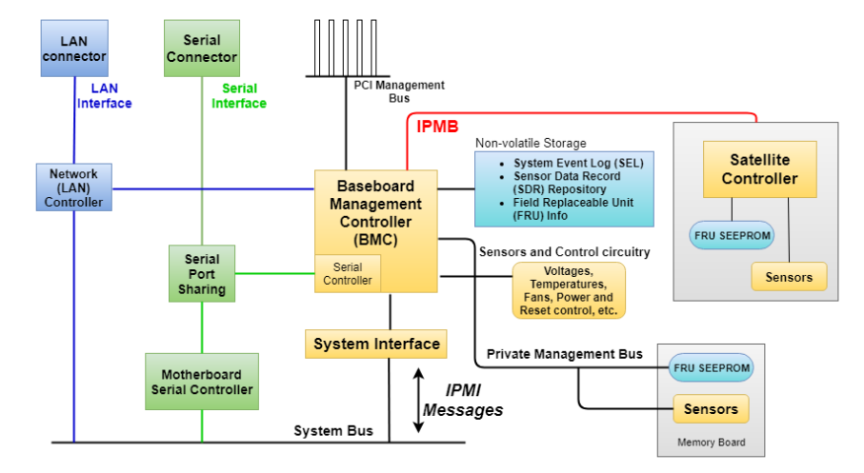

The satellite controllers within the same chassis connect to the BMC via the system interface called Intelligent Platform Management Bus/Bridge (IPMB). The BMC connects to satellite controllers or another BMC in another chassis via the Intelligent Platform Management Controller (IPMC) bus or bridge. It may be managed with the *Remote Management Control Protocol* (RMCP).

### Intelligent Platform Management Bus (IPMB):

IPMB makes connection with various boards inside of one chassis possible. It is used for communication to and between the management controllers (MCs). Additional MCs are often designated *Satellite Controllers*.

### Intelligent Chassis Management Bus (ICMB)

ICMB provides a standardized interface for communication and control between chassis.

## IPMI Memory Areas:

IPMI stores information into the System Event Log (SEL), Sensor Data Record (SDR) Repository and the Field Replaceable Units (FRUs).

**Satellite Controller:**

This controller will provide an interface to sensors to monitor the power supply and will physically attach to the IPMB (I2C) bus. The satellite controller will process IPMI commands that are communicated to the controller via the IPMB bus protocol.

**Sensors:**

Sensors are input devices that record data about the physical environment around it.

Magnetic field sensors, Motion (infra-red) sensors, Temperature Sensors etc.

### System Event Log (SEL):

The BMC contains a central, non-volatile *System Event Log* (SEL). Because this SEL is managed by the BMC, it can be accessed even after a CPU failure on the server, such as through IPMI LAN access for example.

A series of IPMI commands permits reading and deleting the SEL. Since the memory for the SEL is limited, it must be periodically checked and deleted, so that additional events can be documented.

### Sensor Data Record (SDR) Repository:

Sensor Data Records are records that contain information about the type and number of sensors. A sensor data record therefore describes a specific sensor.

The sensor data records are stored in a central, non-volatile storage area, which is managed by the BMC. This storage area is called the *Sensor Data Record Repository* (SDR Repository).

### Field Replaceable Unit (FRU) Information:

IPMI supports the storage of Field Replaceable Unit (FRU) information for various modules in the system. The FRU data contains information like serial numbers, part numbers, models and inventory numbers (sometimes called “asset tags”).

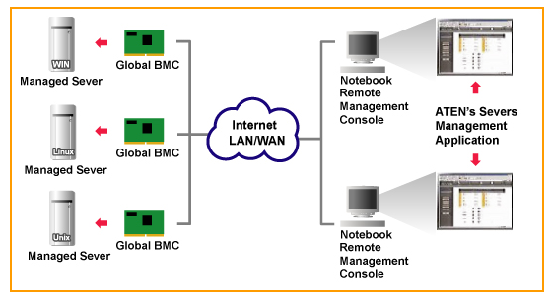

**Session and Authentication:**

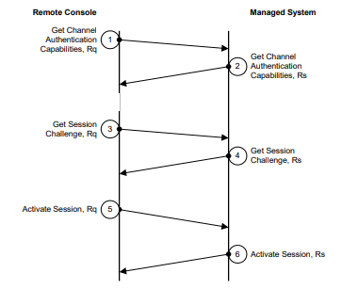

## IPMI command structure

* **Network Function (NetFn)** assigns the value of a cluster to the command to which the command belongs (chassis commands, events, storage, etc.)
* The **Request / Response Identifier** field is needed to distinguish between requests and responses.
* **Requester's ID** - information about the source of the message. For example, for IPMB, this information contains the LUN (Logical Unit Number) of the device.
* **Responder's ID** addresses the request to the desired responder.
* **Command** - unique within the Network Function commands
* **Data** - additional parameters (for example, the data returned in the response)

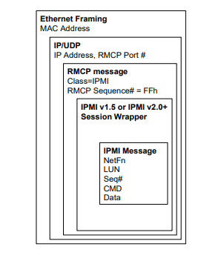

Remote Management and Control Protocol (RMCP) is a UDP based protocol for system control where packets are exchanged between a management console and a managed client.

A watchdog timer is an electronic timer that is used to detect and recover from computer malfunctions. During normal operation, the computer regularly resets the watchdog timer to prevent it from elapsing, or "timing out".

I2C (Inter-Integrated Circuit)

SEEPROM (Serial Electrically Erasable Programmable Read Only Memory)

PCI (Peripheral Component Interconnect)

