iSCSI

**IOM 0**

**IOM 1**

Both FC and iSCSI are used to encapsulate SCSI protocol commands for storage.

**Overview of SCSI**

SCSI (pronounced as "scuzzy") is an industry standard protocol for attaching various I/O peripherals such as printers, scanners, tape drives, and storage devices. The most common SCSI devices are disks and tape libraries.

Protocol through which host can communicate to the storage devices by using commands(read, write..)

SCSI has evolved from parallel, daisy-chained SCSI to serially attached SCSI

(commonly known as SAS). Older parallel SCSI specifications are defined as Ultra-1,

Ultra-2, Ultra-3, Ultra-320, and Ultra-640, whereas the new SAS specifications are defined as SAS 1.0, 2.0, and 3.0. These specifications differ in speed and other performance enhancements.

SCSI hard disks are superior in terms of performance and reliability as compared with ATA (PATA and SATA) drives.

In SAN world, SCSI is the core protocol to connect raw hard disk storage with the servers.

In order to add SAN to Server or control remote storage with the SCSI protocol, different technologies are used as wrappers to encapsulate these commands. These primarily include FC and iSCSI.

**Overview of iSCSI**

iSCSI is way of transporting SCSI commands across the network.

**Internet Small Computer System Interface** (**iSCSI**) is SCSI over IP which transmit SCSI commands using the TCP/IP protocol suite.

This means that the SCSI commands are encapsulated on top of IP which commonly runs on Ethernet.

iSCSI consists of the following

* **Hard disk arrays**: They provide raw storage capacity.
* **Storage processors**: They manage hard disks and provide storage LUNs and masking for the servers.
* **Ethernet switches**: They provide connectivity between storage processors and server HBAs.
* **iSCSI Host Bus Adapters**: They are installed in a computer and provide connectivity to the SAN. Most operating systems provide software implementation of iSCSI in order to utilize the regular Ethernet NICs, eliminating the need for hardware iSCSI HBAs.

Boot through iSCSI:

-storage array is connected via an IP connection to the network —SAN

If we want to do remote booting, we will need to use iSCSI.

Because iSCSI still used to transport SCSI row commands So my Network Card can still receive SCSI frame as I would inject another Disk in local SCSI Bus of the system.

This iSCSI encapsulation is done in hardware during the booting. This is called iSCSI offloading.

Offloading means let the processing of the SCSI header to the network card.

So this Host boot from SCSI bus, sends out the commands, Network card receive the SCSI packet/frame and start encapsulating it.

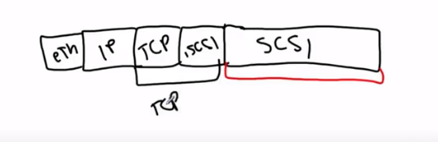

So when servers boots, it want to have local SCSI Disk. But it will use its network card to do that.

Network card will inject SCSI Disk inside the bus :

This NIC is configured to the Ethernet Switch.

Our storage array also has an IP.

Our NC also has IP because if Host does not have IP how it will set up TCP connection. So we need to assign an IP address to the Network card during the boot up of the server.

So now I can start exchanging info between these two devices.

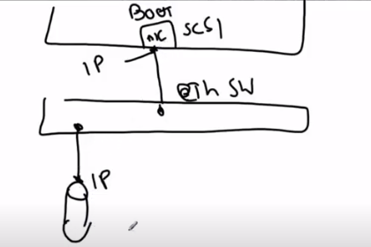

What else is required :-

In FC WWPN used to identify devices (server and storage disk).

In iSCSI we have IQN or symbolic node name.

Every device (Server and Disk) running iSCSI has an IQN.

So while configuring NC we have to assign an IP and IQN.

Boot Policy:

NC – IP, IQN, MAC

Remote IP

Remote IQN

Authentication:- once TCP is running bw NC and Storage Disk.

Host will send username password to the Disk, Disk will authenticate.

Similar Server also can authenticate.

Mutual authentication.

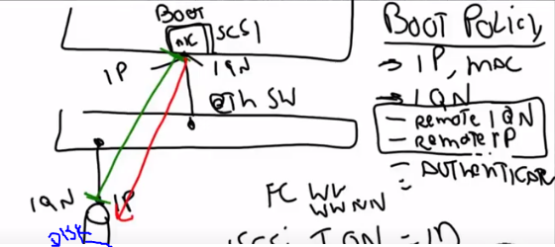

In case if we don’t have SCSI Disk array but we are having FC network to storage Disk :-

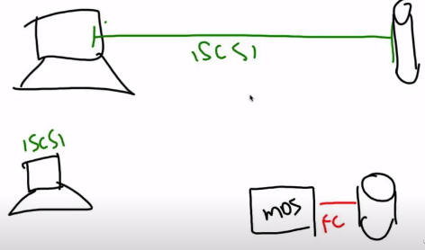

Our Host is talking through iSCSI but Disk is in FC network.

We have to convert these iSCSI packets in to FC Packets:

We have some IP storage switch(MDS) which are capable of doing this by spoofing them as iSCSI target.

So it will decapsulate the iSCSI header.

Start adding FC header.

