Based on the problem description, I would recommend using Amazon Web Services (AWS) as the cloud provider for hosting MineMap. AWS is a mature and reliable cloud provider with a wide range of cloud products and services that can meet the requirements of Mine-IT.

1. Reliability/Availability:

* Utilize multiple availability zones (AZs) to ensure high availability and fault tolerance.
* Use AWS Elastic Load Balancer (ELB) to distribute traffic across AZs and instances.
* Implement auto-scaling to handle fluctuations in traffic and load.

1. Cost Optimization:

* Use AWS EC2 Spot Instances to reduce costs for non-critical workloads, as these instances offer significant discounts compared to On-Demand instances.
* Use AWS Reserved Instances to save costs for long-running instances, as these instances offer significant discounts for committing to a period of usage.
* Implement instance right-sizing to optimize resource utilization and reduce costs.

1. Security:

* Use AWS Virtual Private Cloud (VPC) to create a private network for MineMap.
* Use AWS Security Groups and Network ACLs to control inbound and outbound traffic to instances and services.
* Use AWS Identity and Access Management (IAM) to manage user access to AWS resources.
* Use AWS Key Management Service (KMS) to encrypt data at rest and in transit.

1. Networking:

* Use AWS Direct Connect to establish dedicated network connections between Mine-IT's corporate network and the AWS VPC hosting MineMap.
* Implement VPN connections to allow remote access to MineMap.
* Use AWS Route 53 to manage DNS and routing between the VPC and corporate network.
* Use NAT Gateway to communicate for out traffic.

1. Performance Optimization for users in all locations:

* Use AWS Global Accelerator to optimize network performance for users across different regions.
* Deploy MineMap instances in multiple regions to improve performance for users in different geographies.
* Use AWS CloudFront to cache frequently accessed content closer to users.

1. Operational Best Practices:

* Use AWS CloudWatch to monitor the performance and health of MineMap and its components.
* Implement AWS CloudFormation to automate the deployment and management of infrastructure.
* Use AWS Systems Manager to manage patching, configuration, and automation of instances.

1. Clarity in Expressing the Solution: Please see the diagram below for a high-level architecture of the proposed solution:

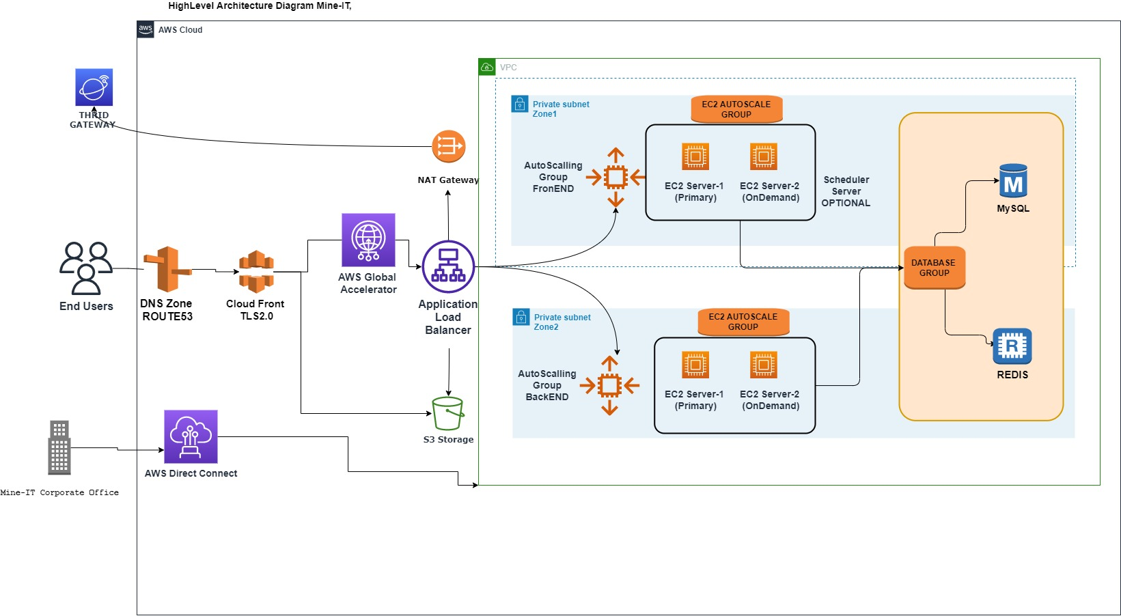

In summary, the proposed solution involves using AWS to host MineMap in a highly available, fault-tolerant, and secure environment. The solution utilizes a range of AWS services to optimize costs, improve network performance, and enable operational best practices. The architecture includes multiple regions to support users in different geographies and utilizes AWS Direct Connect to establish a dedicated network connection between Mine-IT's corporate network and the AWS VPC hosting MineMap.