RETAIL SALES ANALYSIS
Exploratory Data Analysis of the Sample Superstore Dataset
Project Report | Python • Pandas • Matplotlib
$2.30M  Total Sales | $286.4K  Total Profit | 12.5%  Overall Profit Margin | 5,009  Unique Orders

1. Executive Summary
This project explores the Sample Superstore retail dataset (9,994 rows, 21 columns) to understand sales and profit performance across categories, regions, sub-categories and months, and to test how discounting relates to profitability.
- Scale: $2.30 million in sales and $286.40 thousand in profit, a 12.5% overall margin, across 37,873 units and 5,009 unique orders.
- Category: Technology led in both sales ($836K) and profit ($145K). Furniture earned only $18K profit on $742K of sales, a margin of about 2.5%.
- Discounting: High discounts (roughly 0.5 to 0.8) were often associated with negative profit.
- Sales vs profit: Sales and profit show a moderate positive correlation (0.479), so higher sales do not guarantee higher profit.

Key takeaway Revenue growth alone does not drive profitability. Discount control and Furniture pricing are the clearest levers for improving profit.

2. Project Objectives
- Understand the structure and basic statistics of the retail dataset.
- Measure overall sales, profit, quantity sold and number of orders.
- Compare sales and profit across product categories and regions.
- Explore sub-category and monthly performance.
- Examine the relationship between sales and profit, and between discount and profit.
- Translate the findings into practical business recommendations.

3. Dataset and Methods
The analysis used Sample - Superstore.csv, which includes order dates, customer segments, regions, product categories and sub-categories, sales, quantity, discount and profit. The file was loaded with Pandas using Latin-1 encoding after a Unicode decoding error.
Item | Details
Environment | Python in Google Colab
Libraries | Pandas (loading, cleaning, grouping, summaries); Matplotlib (scatter plots and trends)
Technique | Exploratory Data Analysis: shape, head, info, grouped summaries, scatter plots
Key columns | Order Date, Category, Sub-Category, Region, Product Name, Sales, Profit, Quantity, Discount, Segment

4. Overall Business Metrics
Metric | Result
Total Sales | $2,297,200.86
Total Profit | $286,397.02
Overall Profit Margin | 12.47%
Total Quantity Sold | 37,873
Unique Orders | 5,009
Sales–Profit Correlation | 0.479 (moderate positive)

5. Category Performance
Category | Total Sales | Total Profit | Profit Margin
Furniture | $741,999.80 | $18,451.27 | 2.5%
Office Supplies | $719,047.03 | $122,490.80 | 17.0%
Technology | $836,154.03 | $145,454.95 | 17.4%
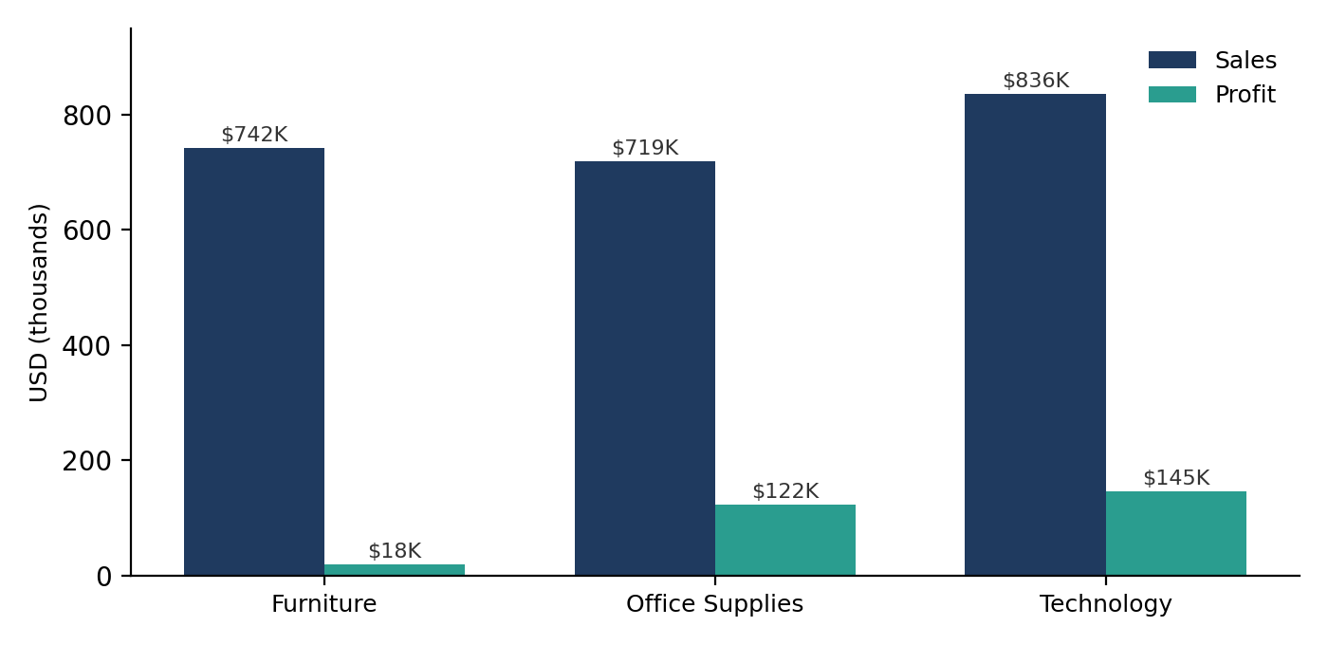
Figure 1. Sales and profit by category (USD thousands)
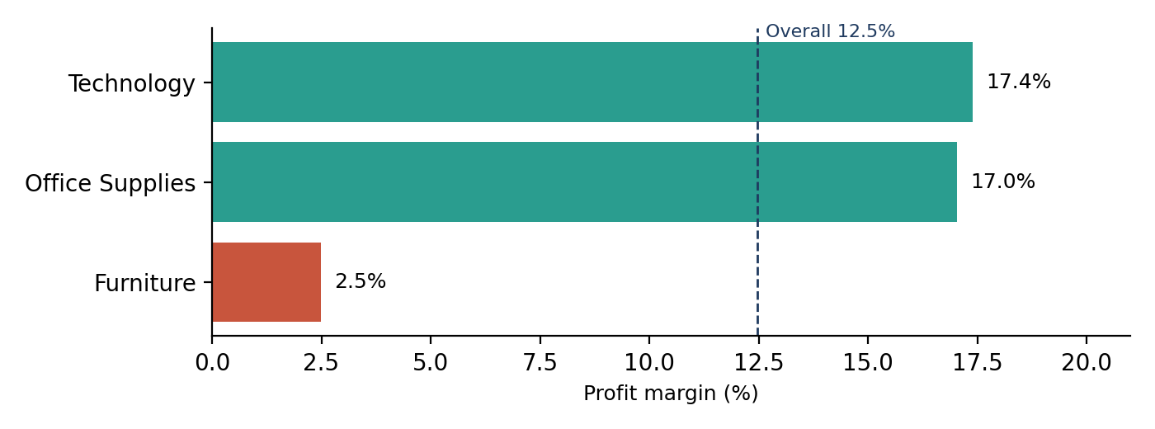
Figure 2. Profit margin by category, calculated as total profit ÷ total sales
Finding Technology had the highest sales and profit. Office Supplies earned about six times Furniture's profit on slightly lower sales. Furniture's pricing, discounting and product-level performance deserve further investigation.

6. Regional, Sub-Category and Monthly Analysis

Regional sales
West had the highest regional sales and South the lowest, so demand is not evenly distributed. Regional profit should be reviewed before drawing conclusions from sales alone.

Sub-category profit
Copiers had the highest profit and Envelopes the lowest; Chairs sat near the middle of the observed range. Comparing sales and margin by sub-category is a useful next step, since high sales do not always mean high profit.

Monthly patterns
Sales were highest in November and lowest in February, with May to August moderate. Profit peaked in December, was low in January and February, and was mid-range in March.
Note Grouping by month number combines the same month across years. For a true chronological trend, build a Year-Month field from Order Date and group by that.

7. Sales, Discount and Profit

Sales vs profit
The scatter plot shows a moderate positive correlation of about 0.479. Higher sales tend to come with higher profit, but some high-sales orders still have low or negative profit, so both metrics should be read together.

Discount vs profit
High discounts, especially around 0.5 to 0.8, were often associated with negative profit, while low-discount orders included many profitable ones with wide variation. This is an observed association, not proof of causation; category, product and order size may also contribute.

Profit margin
Margin is (Profit ÷ Sales) × 100. The row-level Profit_Margin column gives each transaction's margin, with negative values indicating a loss. For category comparisons, divide each category's summed profit by its summed sales rather than averaging row-level percentages.

8. Key Findings
- Total sales were about $2.30M and total profit about $286.4K (12.5% margin).
- Technology led the categories in both sales and profit.
- Furniture's margin (about 2.5%) is far below Office Supplies (17.0%) and Technology (17.4%).
- West had the highest regional sales; South had the lowest.
- November was the strongest month for sales and February the weakest.
- Higher discounts were frequently associated with losses.
- A moderate sales–profit correlation means sales volume alone does not explain profitability.

9. Business Recommendations
# | Action | Rationale
1 | Set discount limits | Review high-discount transactions and cap discounts where profit turns negative.
2 | Fix Furniture profitability | Investigate low or negative-profit products; review pricing, costs and discounts.
3 | Learn from Technology | Identify which product groups contribute most to profit and replicate the pattern.
4 | Track profit with sales | Evaluate regions, categories and products on profit as well as revenue.
5 | Use a Year-Month timeline | Analyse seasonality and compare trends across years.
6 | Reprice high-sales, low-profit items | Consider pricing or promotion changes for these products.
7 | Validate outliers | Check unusual and negative-profit orders before operational decisions.

10. Limitations and Further Work
This report covers the results produced during the analysis. Exact top-10 products, segment totals, shipping-mode results and per-category margins from the code were not part of those results, so only the category margins derived from the reported totals are included. The discount relationship is descriptive, not causal.
Suggested next steps: data-quality checks, segment and shipping-mode analysis, top-product ranking, Year-Month trend charts, and an interactive dashboard in Power BI or Tableau.

11. Conclusion
The analysis gives a clear overview of Superstore performance. Technology is a strong contributor to both sales and profit, while Furniture and heavily discounted transactions warrant closer attention. The central lesson is to evaluate profitability alongside sales, since more revenue does not automatically mean more profit.

Appendix: Main Python Code

Overall metrics
print("Total Sales:", df["Sales"].sum())
print("Total Profit:", df["Profit"].sum())
print("Total Quantity:", df["Quantity"].sum())
print("Unique Orders:", df["Order ID"].nunique())

Category sales and profit
print(df.groupby("Category")[["Sales", "Profit"]].sum())

Top 10 products by sales
print(df.groupby("Product Name")["Sales"].sum()
.sort_values(ascending=False).head(10))

Profit margin per row
df["Profit_Margin"] = (df["Profit"] / df["Sales"]) * 100

Discount vs profit plot
import matplotlib.pyplot as plt
plt.scatter(df["Discount"], df["Profit"])
plt.xlabel("Discount")
plt.ylabel("Profit")
plt.title("Discount vs Profit")
plt.show()

Chronological monthly sales
df["Year_Month"] = df["Order Date"].dt.to_period("M")
monthly_sales = df.groupby("Year_Month")["Sales"].sum()

