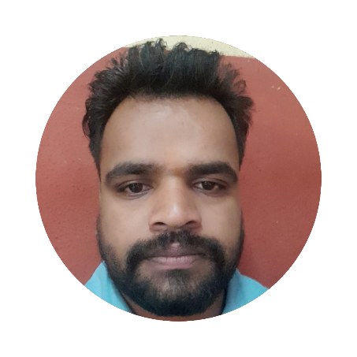Rahul Patidar

# SUMMARY

Energetic and motivated developer with 2 years of experience in building a website , including designing a user interface, testing, debugging, optimizing interactive, and maintaining function. A clear understanding of modern technologies and best practices. Ability to learn and collaborate in rapidly changing environments and

compositions.

# PERSONAL DETAILS

## Address

# CONTACT

# *rahulpatidar@gmail.com*



 7805916540

 [rahupatidar](https://in.linkedin.com/in/rahul-patidar-7a438a19a)

# EDUCATION

***Bachelor of* Electronics and Communications Engineering**

**Mahakal Institute of Management**, **Ujjain**

June 2016 - May 2020

# PROJECTS

## Usap Chat

[https://usap-chat.netlify.app](https://usap-chat.netlify.app/)

A Real-time web chat application with chat rooms. Users can enter specific chat rooms based on their interests or discussions, enabling multiple people to engage in real-time conversations within each room.

## PESO App

[https://mb.pesoapp.ph](https://mb.pesoapp.ph/)

A e-shopping mobile application to allows users to shop online for electronic gadgets, create wish lists, add items to cart and checkout product and can see the discounted products.

## My Portfolio Website

<https://kevinflor.es/>

A personal website you can see my details and my projects

# SKILLS

**Programming / Markup / Scripting languages:** HTML, CSS, SQL, JavaScript, TypeScript, SASS, JSON, REST API



**Frameworks / Libaries / Database / Tools:** Bootstrap, React.js, Node.js, TailwindCSS, Redux, Git, Jira, Next.js, Angular core and themes convert,

Express.js, MongoDB, MySQL

**Additional Skills:** Effective Communication, Problem-Solving, Time Management, Teamwork and Collaboration, Adaptability, Remote Collaboration.

# WORK EXPERIENCE

**Front-End Developer** [- Microsourcing](https://www.microsourcing.com/) Aug 2023 - Jan 2024 (6 mos)  Implemented user interfaces based on wireframes and design mockups.



 Created wireframes for both desktop and mobile designs, and translated them into static websites.  Integrated multimedia elements such as videos, slideshows, or animations into static websites.

 Built responsive email templates for marketing campaigns.

 Designed mobile-first website layouts for optimal performance on small screens.  Created wireframes and mockups to visualize website structure and design.

 Implemented responsive design principles to ensure compatibility across devices.  Collaborated with customer support teams to address user-reported issues.

 Contributed with cross-functional teams based in Australia, including developers and managers, to ensure project alignment and success.

**Software Engineer** [- Yondu](https://www.yondu.com/) Sep 2022 - Aug 2023 (1 yr)

 Collaborated closely with product managers to define and prioritize feature requirements, ensuring alignment with business objectives.

 Participated actively in Agile ceremonies such as sprint planning, stand-ups, and retrospectives, contributing to team coordination and project success.

 Conducted thorough codebase reviews to maintain coding standards and best practices.

 Implemented state management solutions to support on-demand booking and rider mobile applications.

 Integrated geolocation features using APIs like Google Maps, enhancing user experience and functionality within the applications.

 Collaborated seamlessly with international cross-functional teams within Agile or Scrum environments.  Developed custom UI components for specific feature requirements.

**Software Developer** [- Digital Doors Software Solutions Inc.](https://www.digitaldoorssoftware.com/) Jul 2019 - Sep 2022 (3 yrs 3 mos )  Worked closely with UI/UX designers to iterate on design prototypes.

 Developed RESTful APIs to facilitate smooth communication between services, enhancing overall system performance and scalability.

 Analyzed business requirements to determine project scope, ensuring alignment with organizational goals and objectives.

 Integrated email notification systems into customer order processes.

 Published Web and mobile apps to various platforms including the Play Store, App Store, and Web Hosting, ensuring timely updates and bug fixes.

 Integrated third-party APIs for features such as analytics, payment gateways, and social media sharing.  Utilized services like Firebase Cloud Messaging to implement push notifications.

 Created reusable components and libraries for future use.

 Mentored developers and provided guidance on best practices and coding techniques.

 Developed mobile applications for iOS and Android platforms using cross-platform frameworks.

 Developed e-commerce features such as carousel images, product lists, wishlists, shopping carts and checkout processes.

 Developed custom reporting solutions for data analysis and visualization.  Implemented deep linking and universal linking for better user experience.

 Troubleshooted and debugged issues across the stack, from front-end to back-end.  Collaborated with marketing teams to implement tracking pixels and analytics.

**Frontend Developer** - Freelance Mar 2023 - Jul 2023 (2 mos )

**MERN Stack interships** [-](https://jenusitsolutions.com/)  Universal Informatics July 2022 - Dce 2019 (6 mos )

* Applied responsive design principles within MERN stack projects to ensure consistent and user-friendly experiences across different devices and screen sizes.
* Developed and maintained content management features in MERN applications, enabling efficient website administration and real-time content updates.
* Utilized performance analysis tools like Google Lighthouse and WebPageTest to assess and enhance the speed and efficiency of MERN-based applications.
* Collaborated on building pharmacy management systems using the MERN stack, improving workflows and user interaction through effective front-end and back-end integration.
* Enhanced MERN application performance by refactoring code, minimizing assets, and optimizing server-side and client-side processes.