✅ Why Use SSO?
1. 🔐 Improved Security
- Fewer passwords to remember = less password reuse.
- Centralized identity provider (like Azure AD, Okta) can enforce:
  - Multi-Factor Authentication (MFA)
  - Conditional access (location/device-based)
  - Account lockout and monitoring
- Tokens are used instead of passing credentials around — more secure.
2. 👤 Better User Experience
- Users log in once and can access multiple apps without logging in again.
  - Example: Sign in to Office 365 → Access Teams, SharePoint, Outlook without re-authentication.
- Reduces login fatigue and improves productivity.
The stack we are going to use (Microsoft Authentication Library)
- Angular (ver.18) (SPA) with @azure/msal-angular
- Node.js (ver. 22.14) (API) with passport-azure-ad
🔐 Authentication Flow
- User opens Angular app → redirected to Azure AD
- Azure AD authenticates and redirects back with a token
- Angular uses token to make secured API calls
- Node.js backend verifies the token
- Angular calls protected-endpoint
- Node.js may query MSSQL for user info, roles, etc.
- Data is returned securely to the frontend

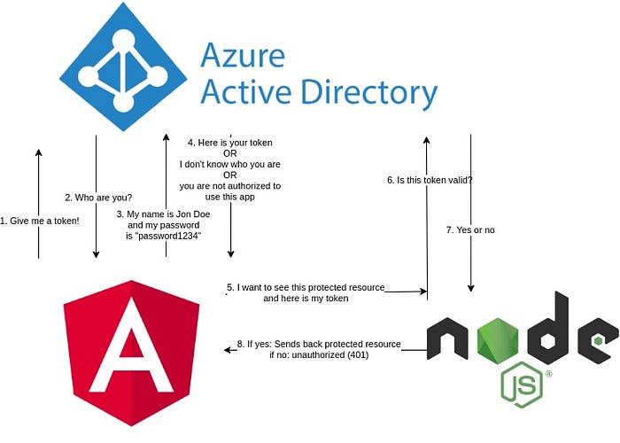
Angular app
Registration of an Angular app in Azure AD
First, we need to register a new app in the Azure portal:
https://portal.azure.com/#blade/Microsoft_AAD_IAM/ActiveDirectoryMenuBlade/RegisteredApps
Type in a name, configure whether the app should be accessible from your tenant only (e.g. only from your organization/company/etc.), from any tenant there is, or any other option that may fit the best for your use case.
For the sake of development, we are going to use http://localhost:4200 as redirect URI. You can add the production one later. It is possible to use multiple URIs at the same time, which makes it easy to use the authentication in different environments, like local, test, and production.
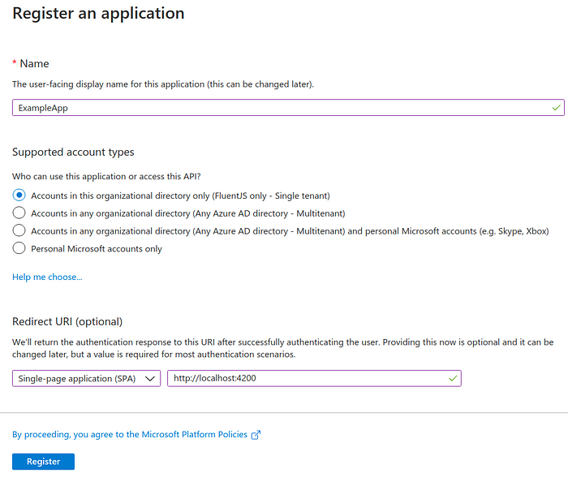
App registration in Azure AD for single tenant only
Now go to the authentication tab on the left panel and make sure that “Access tokens” and “ID tokens” are selected.
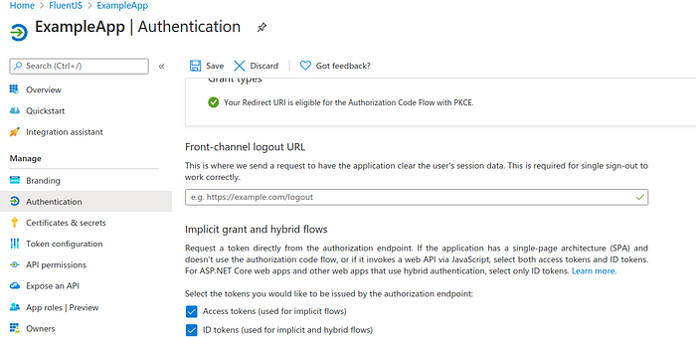
Enable access tokens and ID tokens options
Now select the tab ‘API permissions’ and grant admin consent:
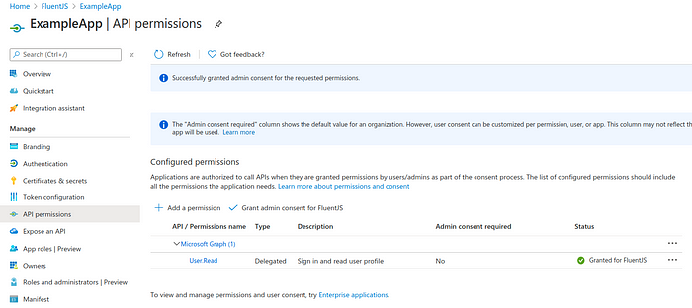
Azure AD grant admin consent.
If you don’t grant admin consent, users won’t be able to authenticate to the application, unless they are admins.
Also, we need to grant access to certain people. For that go back to your tenant overview, select ‘Groups’, and add a new group, which will contain a set of people, who will be able to access the Angular app and Node.js API.
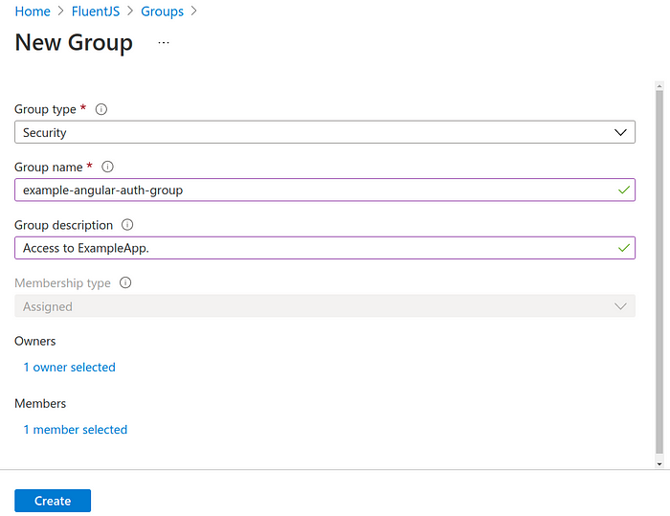
Create a new group in Azure AD
Now go back to tenant overview, select the ‘Enterprise applications’ tab, and then open your application. Under ‘Users and groups you can select the recently created group or users directly.
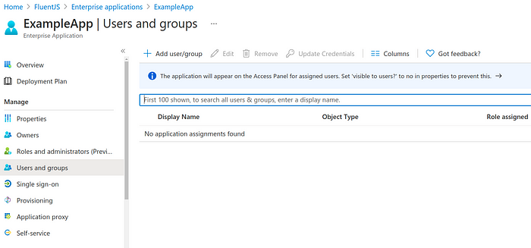
Select users and groups for application access.
Implement authentication in Angular
The goal is that a user is going to authenticate through the Angular application so he can receive a token, that can be used for getting protected resources from the backend. If somebody cannot provide a valid token the requests are going to be denied.
Run the following command to install dependencies:
npm install msal @azure/msal-angular
app.module.ts will contain the configuration to your registered Azure application:
-----------------------------------------------------------------------------------------------------------------
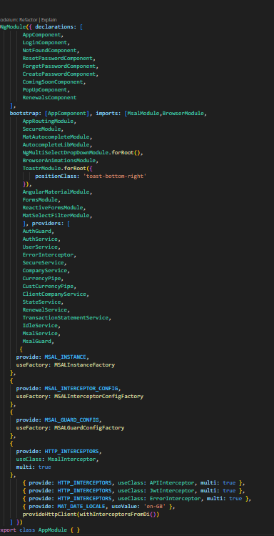

SSO intercepter.ts is
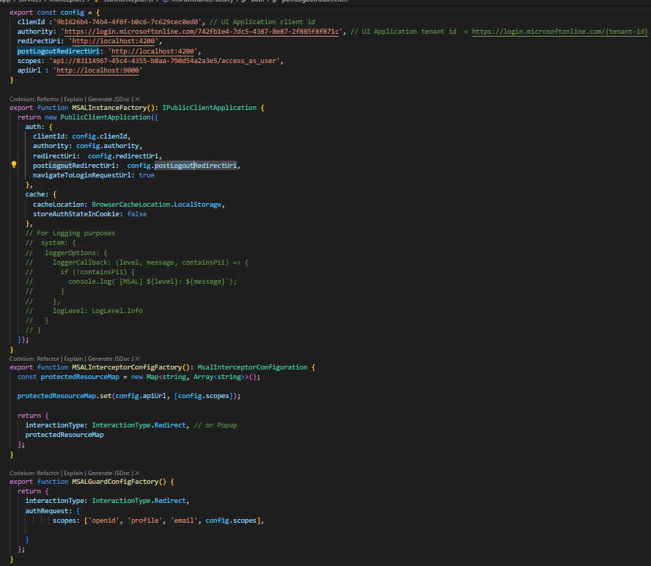
-------------------------------------------------------------------------------------------------------
Key Points :-
1 . PublicClientApplication: Used to create the MSAL instance for authenticating users.
- BrowserCacheLocation: Enum to define where the cache is stored (LocalStorage, SessionStorage).
- InteractionType: Enum for interaction type — Redirect or Popup.
- LogLevel: Enum for MSAL logging.
- MsalInterceptorConfiguration: Used to configure the HTTP interceptor for securing API calls.
🔹 MSALInstanceFactory
Purpose: This creates and returns the main MSAL instance used for authentication.
🔹 MSALInterceptorConfigFactory
Purpose: Configures the HTTP interceptor to automatically attach access tokens to outgoing HTTP requests.
🔹 MSALGuardConfigFactory
Purpose: Configures route guards that protect pages requiring login.
and also adjust app.component.ts:
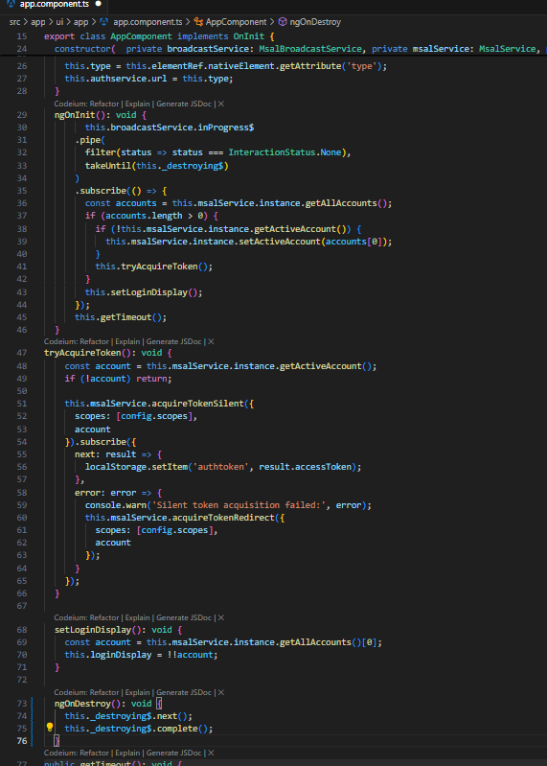
-----------------------------------------------------------------------------------------------------------

Now we need to protect the routes of our app. E.g. I have a component called ‘SSO, which you cannot reach when not authenticated.
And Routes.ts is
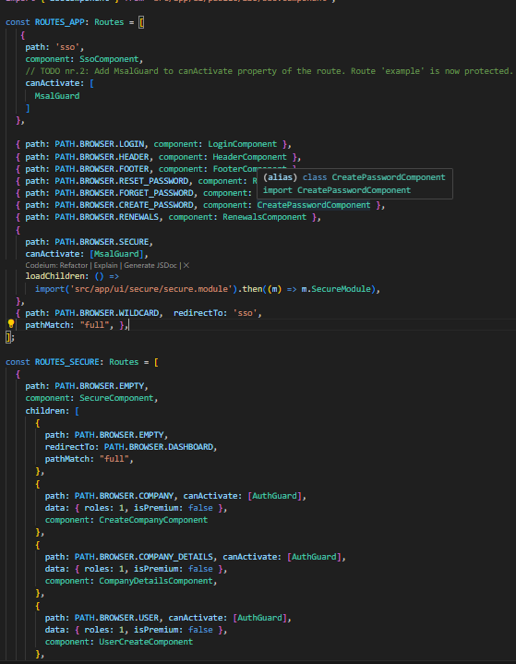
Protect Angular routes by using Azure AD authentication.

Node.js API
Registration of Node.js API in Azure AD
Now we need to register a separate application for the API.
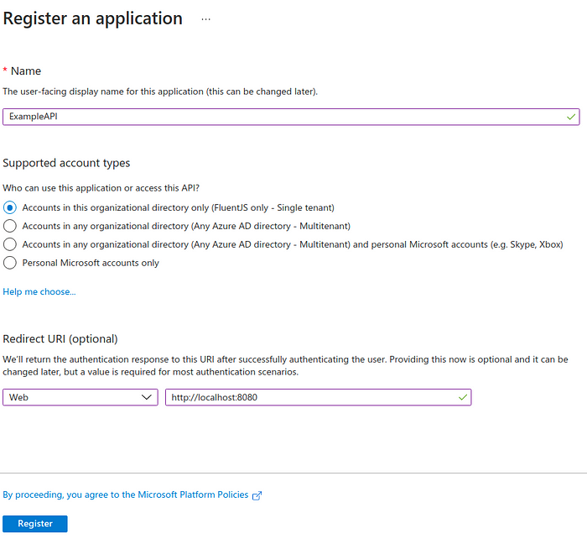
Under ‘Expose an API’ set the application ID URI.
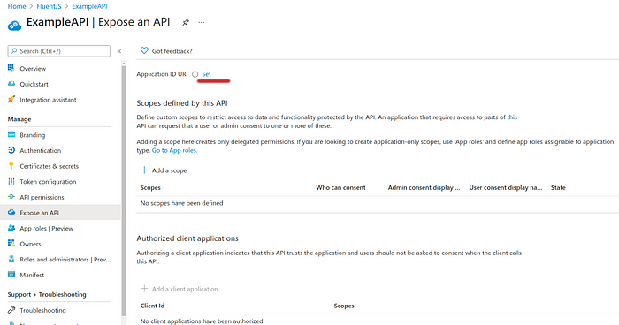
Expose an API > Set application ID URI
Just use the value Azure is recommending you. You can always change or delete the URI if you don’t like the default one.
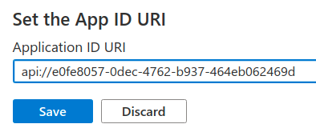
Azure AD default application ID URI
Add a scope. For the time being it is enough to define one scope with which access to all of the routes and resources of the API will be granted.
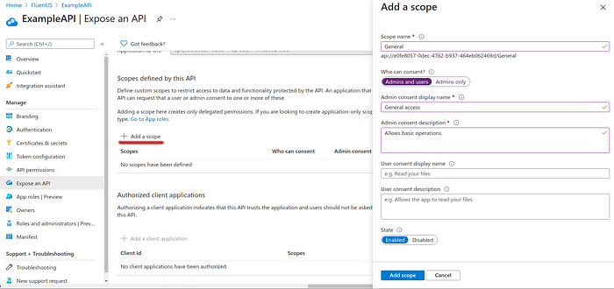
Add scope to Node.js API in Azure AD
Need to add the app ID URI to SSO.INTERCEPTOR.TS.
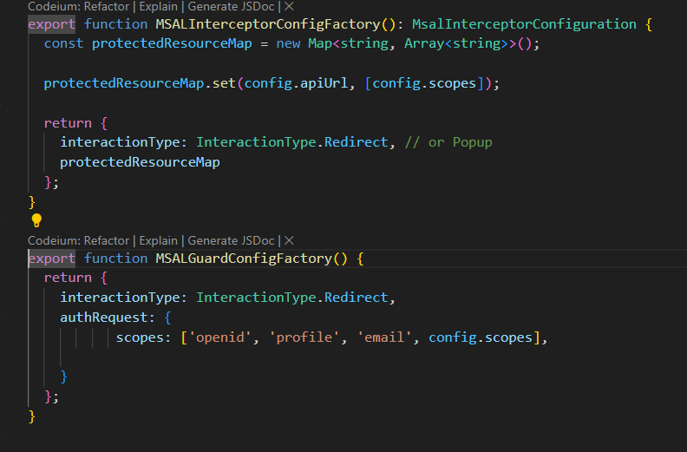
Now copy the Client ID from the Angular app registration
Application IDs in application registration overview.
Go back to the ‘Expose an API’ tab of your API app registration and click on ‘Add a client application’. Paste the Client ID into the field ‘Client ID’.
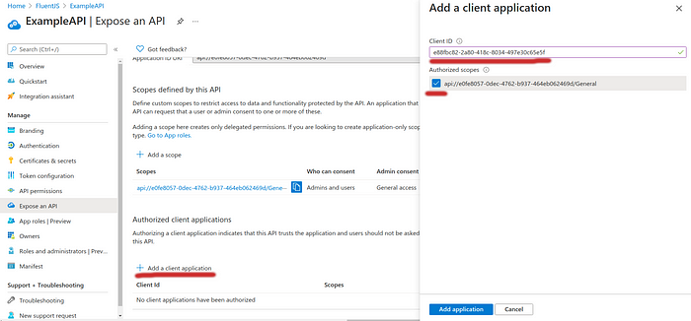
Add Angular app as a client application to your Node.js API
Implement authorization in Node.js API
In order for the Node.js API to be able to authorize requests from the client, Node needs to check the token, the client sends with each request, which contains a protected URI
Therefore we will use Passport with the Azure AD and Bearer Token strategy.
So let’s install the packages first.
- npm install passport
- npm install passport-azure-ad
Add a configuration file in config folder (mine is named azure.config.json and it lays in the root of the Node project directory) that contains all of the constants needed for authorizing the requests on the server-side.
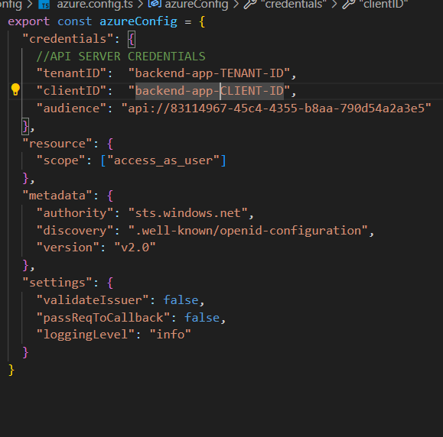
Fill out the tenant ID, and the client ID, which is the ID of Node.js backend application. Also, make sure to use the application ID URI we’ve created before for the Node.js API in “audience”.
Adjust the entry point of your Node.js API as follows:
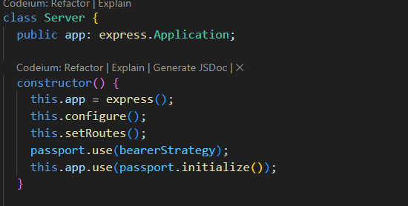
and routes
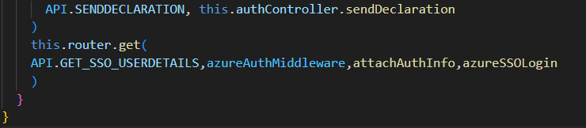
and create a middleware sso.ts
Response From Azure:
Key | Value (Example) | Description
`acr` | '1' | Authentication Context Class Reference — Indicates the authentication method strength. Value '1' generally indicates a basic level of authentication.
`aio` | 'AXQAi/...==' | Token Replay Protection Info — Internal Microsoft token used to detect token replay and ensure token uniqueness.
`amr` | ['pwd', 'mfa'] | Authentication Methods References — Methods used: `pwd`: Password, `mfa`: Multi-factor Authentication.
`appid` | '9b1626b4-74b4-4f8f-b0c6-7c629cec0ed0' | Application ID (Client ID) — Identifies the app used for login.
`appidacr` | '0' | App Auth Context Class Ref — '0' means public client (no secret).
`aud` | 'api://83114967-45c4-4355-b8aa-790d54a2a3e5' | Audience — Intended token recipient.
`email` | '*****.*** @****email.com' | User Email Address — The authenticated user's email.
`ipaddr` | '203.199.138.2' | IP Address — Where the user logged in from.
`iss` | 'https://sts.windows.net/742fb1e4-7dc5-4387-8e87-2f885f8f871c/' | Issuer — Azure AD tenant that issued the token.
`name` | 'Ram Shyam' | Full Name — The user's full name.
`nbf` | 1749117318 | Not Before — Unix timestamp when token becomes valid.
`oid` | '2603cf7a-9fe9-4be9-83ea-46d038148026' | Object ID — Unique user ID in Azure AD.
`preferred_username` | '*****.*** @****gital.com' | Preferred Username — Usually UPN/email.
`rh` | '1.AXIA5LEvd...AA.' | Refresh Token Handle — Internal use for secure token refresh.
`roles` | ['3', '1'] | Roles — App-defined user roles.
`scp` | 'access_as_user' | Scope — App permission scope.
`sid` | '005c58b9-a20a-1c68-90b8-e7b17957e285' | Session ID — Identifies current SSO session.
`sub` | '9_XXceaAlTeH_2avgKo4JJ5RfEwb0trb99I9CmU3yyk' | Subject — Unique user ID across apps.
`tid` | '742fb1e4-7dc5-4387-8e87-2f885f8f871c' | Tenant ID — Azure AD tenant identifier.
`unique_name` | '*****.*** @****gital.com' | Unique Name — Login identity string.
`upn` | '*****.*** @****gital.com' | User Principal Name — Azure AD login/email.
`uti` | 'YP6Ctxb7CkiHOz06wLs4AA' | Token Unique ID — For tracking/logging.
`ver` | '1.0' | Token Version — Format version of the token.
`xms_ftd` | 't5Afj_vpn5_kDdP00GjAmy3BhgiCg-8Glxeu4ucOl3sBYXNpYXNvdXRoZWFzdC1kc21z' | Front-End Token Data — Used internally by Microsoft for federation and SSO tracking.

Note:
___ 🔧 How to Add Optional Claims (email, name, preferred_username) in Azure AD
✅ Prerequisite
You must have an App Registration in Azure AD. If not, create one here.

📍 Step-by-Step Instructions
- Log in to Azure Portal:
Go to https://portal.azure.com.
- Navigate to Azure AD App Registration:
  - Go to Microsoft Entra ID > App registrations.
  - Click on your app from the list (or register a new one if needed).
- Open the Token Configuration tab:
  - In the left-hand sidebar, click on Token Configuration.
- Add Optional Claims:
  - Click on + Add optional claim.
  - Select the token type:
    - Choose ID token if you're using OpenID Connect (OIDC) for authentication.
    - Choose Access token if your backend API needs this info (usually for API authorization).
    - You can select both.
- Choose the claims to include:
  - From the list of available claims, check the following:
    - email
    - name
    - preferred_username
- Enable claim settings:
  - Make sure to check the box:
    - ✅ "Include in ID token"
    - ✅ "Include in Access token" (optional, if your backend needs it)
  - (You might also see an option to "Emit as a JSON object"—leave it unchecked unless needed.)
- Click Add.
- Consent if prompted:
  - You may be prompted to grant admin consent for these claims. Do it if you're an admin, or ask an admin to approve.
- 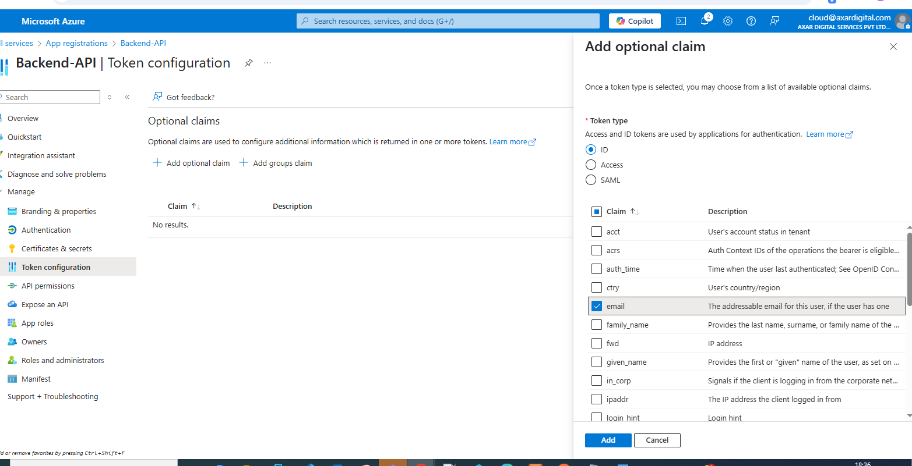

How to configure Redirect URL in both Azure and Code
For Frontend-App registry
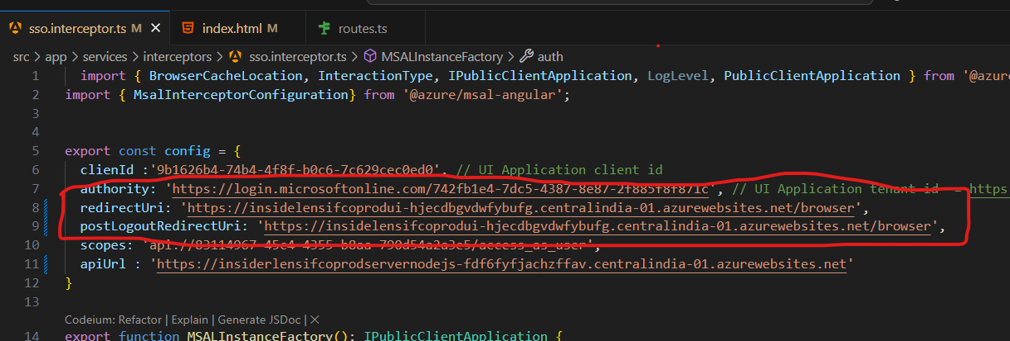
The RedirectUrl field is the same as
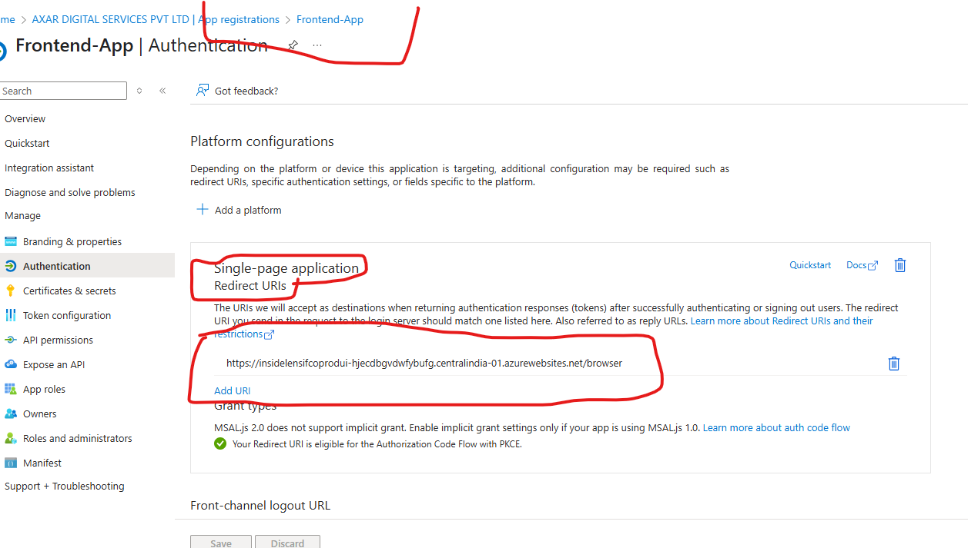

For Backend-App registry
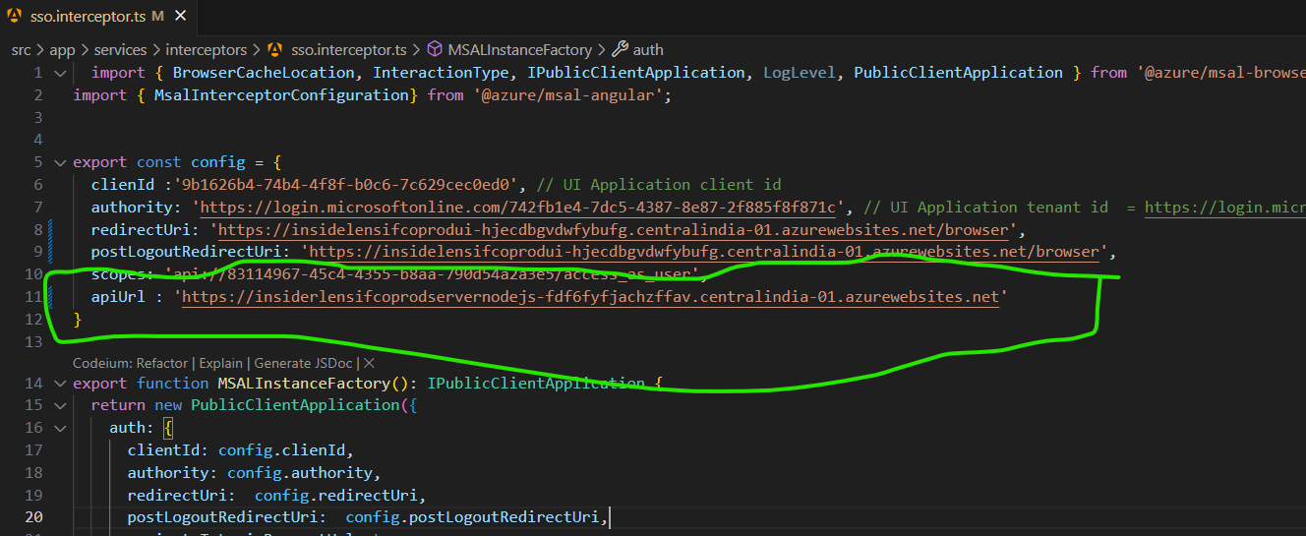
ApiUrl field is the same as
