**React Documentation**

(Version 0.1)

|  |  |  |  |
| --- | --- | --- | --- |
|  | **Name** | **Designation** | **Date** |
| Prepared by | Neha Malani | Software Engineer | 11/11/2019 |
| Reviewed By | Rajkumar Mandhniya | Module Lead | 11/14/2019 |

# **1.** **Objective**

The objective of this document is to provide team members with the basic idea of a React web application. This document covers the following items:

* Steps to build a basic React application
* Creating react components,
* Making Rest API call in react
* React routing
* Integration of react build with Spring boot.
* Useful commands

# **2. Overview**

ReactJS is an open-source , light weight JavaScript library which is **used for** building user interfaces specifically for single page applications. It is **used for** handling view layer for web and mobile apps. **React** also allows us to create reusable UI components.

# **3. Technology Stack to build a React application**

* Visual Studio Code
* Git
* Node js
* SVN

# **3. Building a React Application**

Steps to be followed for building a react application locally:

3.1 Install Git and open the git bash terminal.

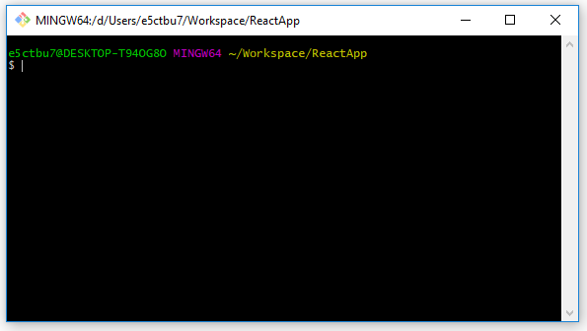

3.2. Install latest node version globally, it will by default install npm in your machine.

You can check the installed version with below commands:

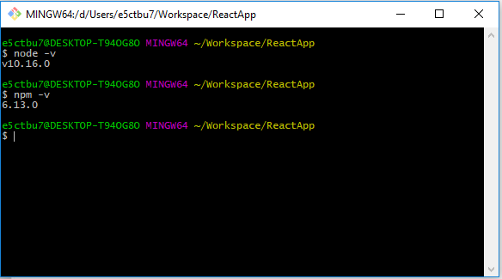

3.3 Open the react app’s root directory in terminal and run ‘**npm install**’ to install

dependencies.

3.4 Run ‘**npm start**’ to run dev server. This will start the application on default **localhost:3000**.

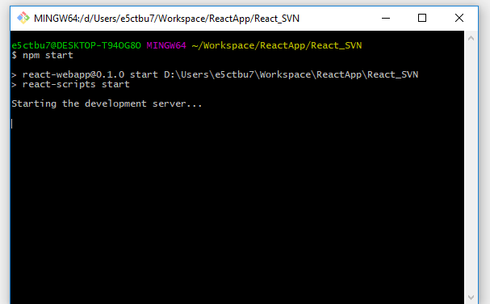

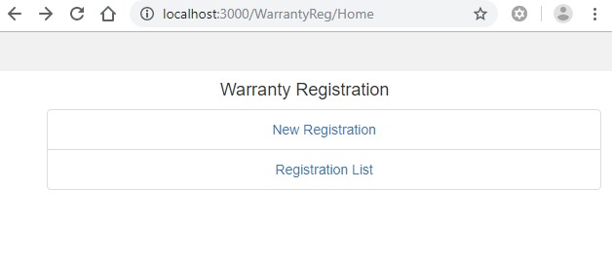

# **4. Creating React Components**

To create a react component , you need to:

1. create a .js file inside folder and define it as class.
2. import react library inside the file.
3. For any component to be a react component, it should extend React.Component
4. Prepare JSX elements inside the class and define ‘render()’ function in order to render the created JSX elements.

To access the react component in other components:

1. Export the react component with the syntax:

For ex: export default ‘Component name’

1. Import the component in other component and access it using component name as tags.

For ex: < Component name ></ Component name >

To know more about JSX element, refer <https://reactjs.org/docs/introducing-jsx.html>.

# **5. Calling Rest Api in React**

You need to configure ‘Axios’ HTTP Client in react application in order to make rest calls.

Package.json dependency - "axios": "^0.19.0"

Import ‘axios’ inside react component and define function to call rest API:

GET call --- axios.get(‘Endpoint url’);

POST call = axios.post((‘Endpoint url’,data)

Response from the API can be obtained by ‘then’ callbacks defined in the components and it can be stored locally in component’s state by using ‘setState()’ function.

To know more about Axios and state, refer :

<https://www.npmjs.com/package/react-axios>

<https://www.youtube.com/watch?v=oQnojIyTXb8>

<https://reactjs.org/docs/state-and-lifecycle.html>

# **6. React Routing**

1. Run the following command to install the Routing package:

npm install react-router-dom

1. Then in app.js file, import Switch, Route, Browser Router modules from 'react-router-package.
2. Finally, configure the navigation paths and the corresponding components inside <Router> tag.

4. As the routes are configured, you can navigate by switching to the correct path from

the present component.

Snapshot of the Route configuration:

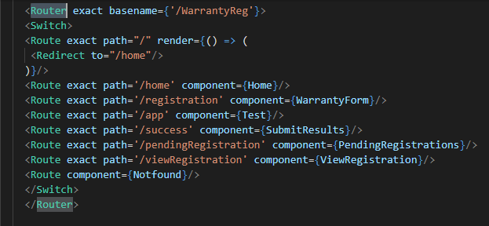

For more details on routing, you may refer:

<https://codeburst.io/getting-started-with-react-router-5c978f70df91>

# **7. Integration of React with Spring boot application**

By default, the React application is hosted on port 3000 while the spring boot application is being hosted on 8080 port. In order to host the both applications on common port, we need to integrate the react front end build in spring boot project.

Steps to be followed for integration are:

1. run command – ‘npm run build’ to generate react front-end build.

2. place the generated build files inside ‘static’ folder of spring boot application.

3. run the spring boot application.

This will host the spring boot app and react front end build on the common 8080 port.

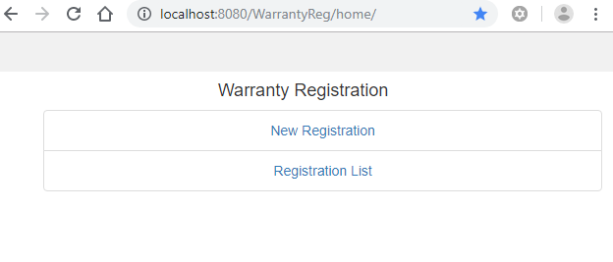

# **8. References**

Useful Commands:

|  |  |
| --- | --- |
| Command | Usage |
| node -v | to check global node version |
| npm -v | to check global npm version |
| npm init | to create package.json file if needed |
| npm install | to locally install dependencies listed in package.json file |
| npm install <package_name> --save-dev | to locally install any specific package |
| npm update | to update node module packages |
| npm update <package_name> | to update any specific package |
| npm list | to list all the installed packages |
| npm start | to run the development server |
| npm run build | to generate react front-end build |

Links:

* <https://reactjs.org/>
* <https://www.youtube.com/watch?v=MhkGQAoc7bc>
* <https://www.youtube.com/watch?v=Ke90Tje7VS0>