**PEACE SALOMY PHIRI**

**ST10163788**

**PROGRAMMING 2B**

**22ND NOVEMBER 2024**

**WORD DOC**

My Personal Github <https://github.com/Peacesalomyphiri/Montly_Claiming_System_Final_POE_Part.git>

My commits

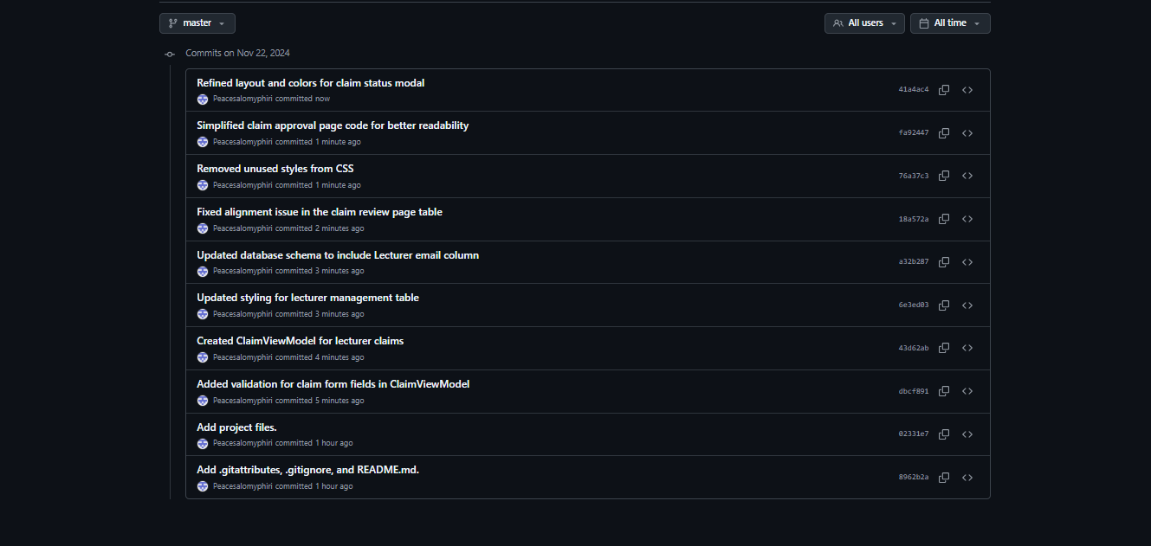

**Feedback from Lecturer**

1. **Add Reason of Rejection**
2. **Password Input**
3. **Validate Hourly rate and hours worked to avoid exceeding the actual figure**

**I added all this in my part 3 and it work, all thanks to the feedback given.**