**ST10163788**  **PEACE SALOMY PHIRI**

PROG6212 PART 1

PROGRAMMING 2B



September 10, 2024

IIEMSA RUIMSIG CAMPUS

POE PART 1

Table of Content

Documentation 2

UML Class Diagram 4

Project Plan 5

GUI 5

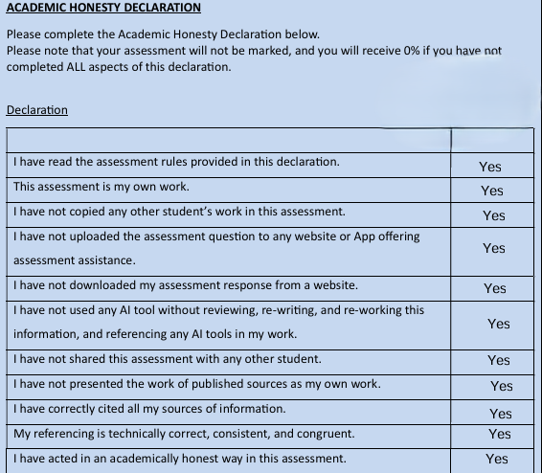

# Documentation

**My Design Choices**

My design of the CMCS prototype revolves around three key principles mainly, usability, data integrity, and efficiency. The systems development prioritizes user experience design while ensuring that data and information transfer between Lectures, Program Coordinators, and Academic Managers remains protected and effective.

1. **Usability**

* The Lecturer interface is designed for simplicity, allowing easy claim submissions byentering work hours, hourly rates, and uploading documents. This minimizes errors and streamlines the process.
* The Programme Coordinator and Academic Manager dashboard provides a clear, filtered view of submitted claims, enabling quick approval or rejection, making decision-making faster and more efficient***.***

1. **Data Integrity**

* The relational database design uniquely identifies each lecturer, ensuring claims are tied to their individual ID and properly tracked. Supporting documents are required for legitimacy, with file size limits in place to manage storage and prevent misuse.

1. **Efficiency**

* The system calculates claims automatically, saving time and reducing errors. It ensures a smooth approval process by notifying coordinators and managers about pending claims. The role-based dashboard helps users focus on their tasks, making the process more efficient and reducing admin work.

**Assumptions and Constraints**

1. **Assumptions**

* Each lecturer is identified by a unique LecturerID, ensuring claims are linked to the right person. All claims must include a supporting document in PDF or image format.
* Programme Coordinators and Academic Managers can approve or reject claims based on the provided evidence before payments are processed.

1. **Constraints**

* **File Size Limitation:** Supporting document uploads are limited to a maximum of 5MB per file to prevent storage overload and ensure faster upload times. This ensures that the system can handle a large number of claims efficiently without being burdened by excessive data.
* **Data Integrity:** system requires each field (hours worked, hourly rate, supporting document) to be filled out completely before a claim can be submitted. This prevents incomplete submissions and ensures that all necessary information is provided, thereby maintaining the quality and accuracy of the data.

**Database Structure**

The CMCS database is designed using a relational structure to ensure data consistency, integrity and scalability. Every entity in the system - such as Lecturer, Program Coordinator, Academic Manager, Claim or Supporting Document- is represented uniquely enabling clear relationships and

management of information.

1. **Entities and Relationships**

* **Lecture:** Holds details about lecturers (lecturerID, first name, last name, hourly rate) necessary for calculating claims.
* **Claim:** Records information related to claims (claimID, hours worked, total amount, status) and connects to lecturers, Programme Coordinators, and Academic Managers for the review and approval process.
* **Programme Coordinator:** Contains information (coordinatorID, first name, last name, email) about coordinators who initially assess claims.
* **Academic Manager:** Maintains details (managerID, first name, last name, email) of managers responsible for making the final decisions on claims.
* **Supporting Document:** Ensures that each claim includes a document (documentID, linked to claimID) for validation and auditing purposes.

**GUI Layout**

The graphical user interface (GUI) for CMCS has been designed to be intuitive and user-friendly, with a focus on ease of use for both lecturers and administrators.

1. **Lecture View**

* **Purpose:** Enables lecturers to submit their claims with minimal effort.
* **Design:** The lecturer's interface includes fields for "hours worked," "hourly rate," and a file upload section for attaching supporting documents. Once the form is completed, the user can submit their claim with just one click.
* **Rationale:** This simple and clear interface reduces user errors and ensures that lecturers can quickly complete their claims, thereby reducing friction in the submission process.

1. **Programme Coordinator/Academic Manager Dashboard**

* **Purpose:** This feature enables administrators to review, approve or reject claims.
* **Design:** The dashboard presents a list of all claims along with their current status, whether Pending, Approved or Rejected. The administrator can click on any claim to view its details including supporting documents and make decisions either approving or rejecting it.
* **Rationale:** The dashboard has been optimized to allow coordinators and managers to focus on verifying and processing claims without the need for extensive navigation. Filter options are available to help with sorting the claims.

**Rationale Behind Design Decisions**

* Every decision made while designing CMCS is motivated by the necessity to offer a system that is efficient and user-friendly. The unique separation of entities in the database ensures that the system can expand and adjust itself to future modifications, like incorporating additional roles or new claim categories.
* The user interface has been designed to reduce confusion and keep users focused on the task at hand. The inclusion of automated calculations, like determining total claim amounts, helps eliminate manual errors which improves accuracy and reliability within the system.

# UML Class Diagram

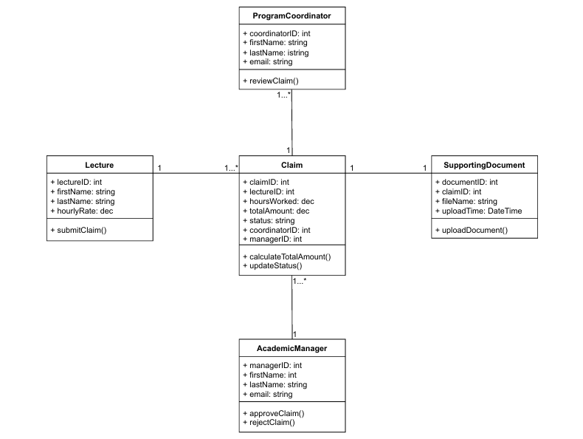

# Project Plan

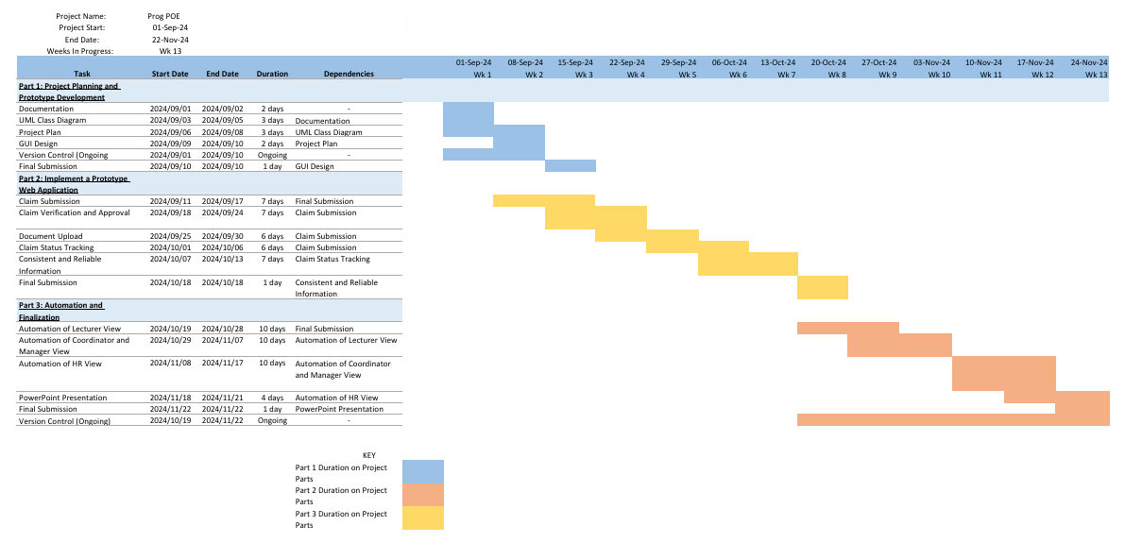

# GUI

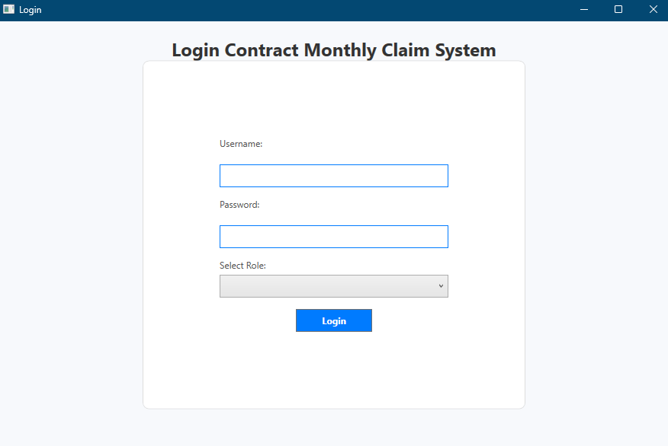

This is the login page where any of the users either, Lecture, Program Coordinator, or the Academic Manager can login using their username and password as well as selecting which role best describes them. When they log in it takes them to the role dashboard they selected.

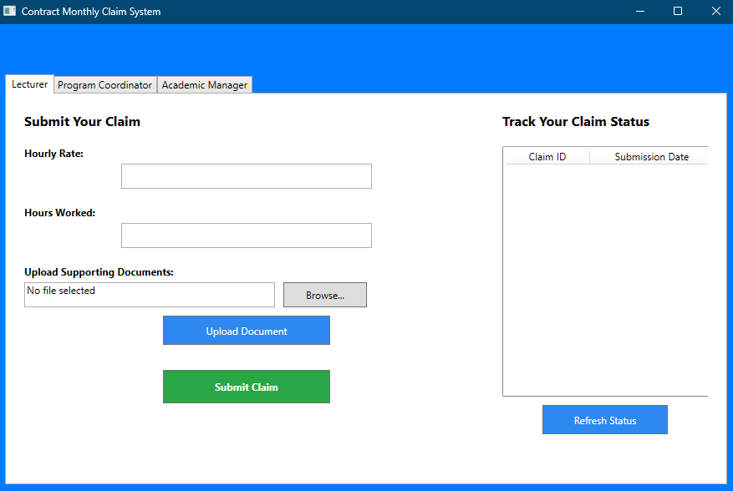

This is the lecture dashboard, it allows the user to enter the hours worked, the hourly rate, upload supporting documents, submit claims as well as track the status of the claims they submitted already.

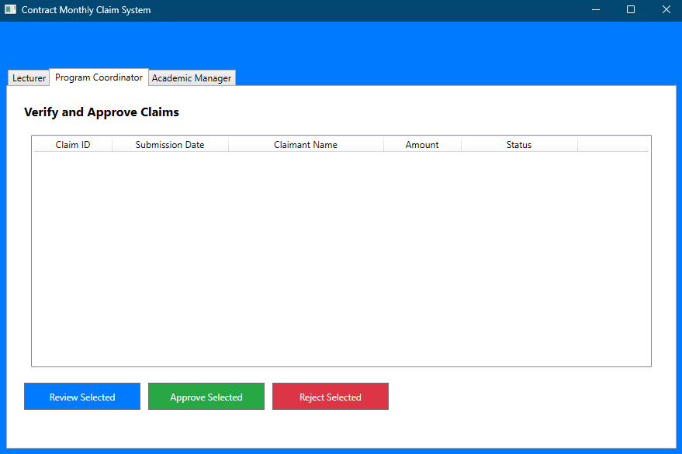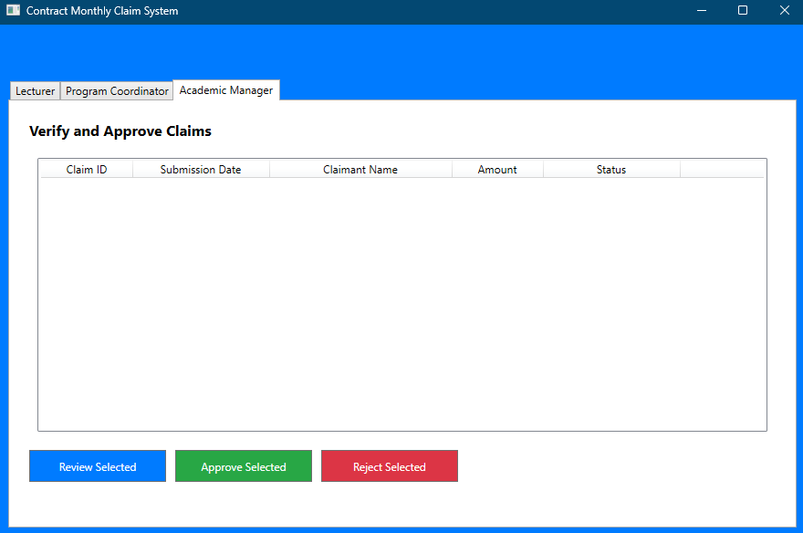

The above two shots are the interfaces for the program coordinator and the academic manager. They can both review, approve or reject the selected claim. The submitted claims will show in the grid above the decision buttons.

**Commits**

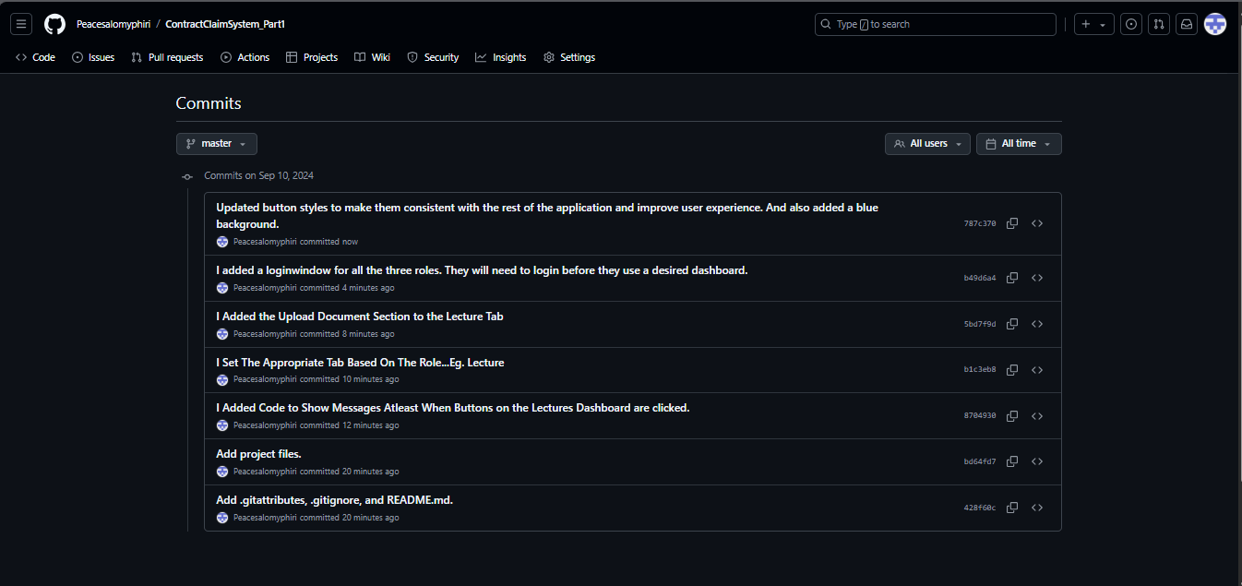

**GitHub Links**

<https://github.com/Peacesalomyphiri/ContractClaimSystem_Part1.git> **Personal Account**

<https://github.com/IIEMSA/poe-part-1-Peacesalomyphiri.git> **School Provisioned Account**

**THE END OF PART 1 PROGRAMMING 2B**