VISHWAKARMA INSTITUE OF TECHNOLOGY.

**(An autonomous institute to university of Pune)**



**Report on**

**“ANDROID APPLICATION: X-Split”**

**Guided by**

**Prof. G.D.BHUTKAR SIR**

**COMPUTER ENGINEERING DEPARTMENT**

**YEAR: 2014-2015**

**Submitted By:**

**Aishwarya Patil(TE-E-52)**

**Niranjan Patil (TE-E-54)**

**Paras Patodi (TE-E-55)**

**Amita Pingle (TE-E-56)**

**Vedika Rathi(TE-E-58)**

VISHWAKARMA INSTITUTE OF TECHNOLOGY,PUNE.

**(An autonomous institute affi. to University. of Pune)**



**CERTIFICATE**

**This to certify that,**

**“E12” group of computer engineering mini project, studing in TE computer department II ND shift has successfully completed project report on**

**“ANDROID APPLICATION: X-Split”**

**On 22 Nov.2014 under the guidance of Prof. G.D.BHUTKAR**

**PROJECT GUIDE H.O.D. COMP**

**Prof. G.D.BHUTKAR Prof.S.B.KARTHIK**

**PRINCIPAL**

**Prof.R.M.JALNEKAR**

**ACKNOWLEDGEMENT**

* **We take this great opportunity to thank everyone who has contributed to our project in some or the other way.**
* **We would firstly like to thank the H.O.D. of computer department Prof. S.B.Karthik for letting us get this great opportunity to test our skills.**
* **Special thanks to Prof. G.D.Bhutkar sir for his guidance in developing this project.**
* **Our sincere thanks and gratitude towards the faculty of our college for their kind cooperation.**
* **We also express our gratitude towards our director Prof. R.M.Jalnekar for encouraging us.**

**Contents**

**1. Introduction**  05

**2.** **Case Studies** 06

**3. Description**  18  **4. Problems faced and Solutions**  22

**5. Conclusion and Future scope**  23

**References** 24

**1.Introduction**

X-split is an android application , which is used to split the expenses whenever any complex calculations are involved.

When we go out for trip or tour , the money spend needs to be divided either equally or unequally among all the individuals . So this will require calculations and if calculations goes wrong somewhere in the middle we again need to start from beginning which would lead to irritation and frustration.

So keeping this in mind we have created this android application which would do all complex calculations in seconds and hence you will still be smiling at the end of your trip

We have experienced this type of situation where this calculation part lead to irritation amongst many of us .

Following are the two complex case studies which will give you a proper idea of what our android application program really does.

**2.Case Studies:**

**Case Study 1:**

Trip of 7 members

|  |
| --- |
| 1. Paras |
| 2.Niranjan |
| 3.Amita |
| 4.Aakash |
| 5.Aishwarya |
| 6.Vedika |
| 7.Yash |

**Expenses:**

1. Car - 300 Rs per person

Total Cost=300*7=2100 Rs

Paid By 3 persons

|  |  |
| --- | --- |
| 1. Paras | 700 |
| 2.Niranjan | 500 |
| 3.Amita | 900 |

2. Parking Charges - 70 Rs

Paid By

|  |  |
| --- | --- |
| 1. Yash | 70 |

3. Limbu Sharbat (Out of 7 peoples 5 peoples took) – 50Rs

Paid By:

|  |  |
| --- | --- |
| 1. Paras | 20 |
| 2.Niranjan | 20 |
| 3.Amita | 10 |
| 4.Aakash | 00 |
| 7.Yash | 00 |

4. Water Bottle(7 bottles among all) - 140 Rs

Paid By

|  |  |
| --- | --- |
| 1. Amita | 100 |
| 2. Vedika | 40 |

5. Breakfast - 210 Rs

All members individual share is different

Individual Share:

|  |  |
| --- | --- |
| 1. Paras | 25 |
| 2.Niranjan | 35 |
| 3.Amita | 30 |
| 4.Aakash | 40 |
| 5.Aishwarya | 20 |
| 6.Vedika | 25 |
| 7.Yash | 35 |

Paid By:

|  |  |
| --- | --- |
| 1. Paras | 55 |
| 2.Aakash | 45 |
| 3.Aishwarya | 60 |
| 4.Yash | 50 |

6. Lunch - 830 Rs

Individual Share:

|  |  |
| --- | --- |
| 1. Paras | 110 |
| 2.Niranjan | 130 |
| 3.Amita | 90 |
| 4.Aakash | 140 |
| 5.Aishwarya | 130 |
| 6.Vedika | 120 |
| 7.Yash | 110 |

paid by:

|  |  |
| --- | --- |
| 1.Amita | 400 |
| 2.Vedika | 200 |
| 3.Yash | 230 |

7. Soda - 5 People took - 150 Rs.

Paid By:

|  |  |
| --- | --- |
| 1. Paras | 50 |
| 2.Niranjan | 50 |
| 3.Aakash | 00 |
| 4.Aishwarya | 50 |
| 5.Yash | 00 |

8. Shopping (3 peoples involved in shopping) - 760 Rs.

Individual Share:

|  |  |
| --- | --- |
| 1.Amita | 160 |
| 2.Aishwarya | 270 |
| 3.Vedika | 330 |

Paid By:

|  |  |
| --- | --- |
| 1.Amita | 330 |
| 2.Vedika | 430 |

9. Meal (5 people) - 140 Rs.

Individual Share

|  |  |
| --- | --- |
| 1. Paras | 25 |
| 2.Amita | 35 |
| 3.Aakash | 25 |
| 4.Aishwarya | 35 |
| 5.Yash | 20 |

Paid By:

|  |  |
| --- | --- |
| 1.Aakash | 110 |
| 2.Aishwarya | 30 |

**Total Cost = 2100+70+50+140+210+830+150+760+140=4450Rs**

**Total Money Given By individual:**

|  |  |  |
| --- | --- | --- |
| 1. Paras | 700+0+20+0+0+0+50+0+0 | 770 |
| 2.Niranjan | 500+0+20+0+55+0+50+0+0 | 625 |
| 3.Amita | 900+0+10+100+0+400+0+330+0 | 1740 |
| 4.Aakash | 0+0+0+0+45+0+0+0+110 | 155 |
| 5.Aishwarya | 0+0+0+0+60+0+50+0+30 | 140 |
| 6.Vedika | 0+0+0+40+0+200+0+430+0 | 670 |
| 7.Yash | 0+70+0+0+50+230+0+0+0 | 350 |
| Total Cost |  | 4450 Rs. |

**Actual Amount To Be Given By Individual**

|  |  |  |
| --- | --- | --- |
| 1. Paras | 300+10+10+20+25+110+30+25 | 530 |
| 2.Niranjan | 300+10+10+20+35+130+30 | 535 |
| 3.Amita | 300+10+10+20+30+30+90+160+35 | 655 |
| 4.Aakash | 300+10+10+20+40+140+30+25 | 575 |
| 5.Aishwarya | 300+10+20+20+130+30+270+35 | 815 |
| 6.Vedika | 300+10+20+25+120+330 | 805 |
| 7.Yash | 300+10+10+20+35+110+30+120 | 535 |
| Total Cost |  | 4450 |

|  |  |  |
| --- | --- | --- |
|  | Amount To Get Back | Amount To Be Given |
| 1. Paras | 240 | 00 |
| 2.Niranjan | 90 | 00 |
| 3.Amita | 1085 | 00 |
| 4.Aakash | 00 | 420 |
| 5.Aishwarya | 00 | 675 |
| 6.Vedika | 00 | 135 |
| 7.Yash | 00 | 185 |

**Select the minimum amount from above cases and complete transactions.**

1. Vedika will give 90 Rs to Niranjan

Vedika remains with 45.

2. Vedika will give 45 + 185 from Yash +10 from Aakash=240

Amount to be given to Paras.

Remaining amount for Aakash =410.

3. Aakash will give 410 +675 from Aishwarya =1085

Amount to be given to Amita.

**Case Study 2:**

Trip of 5 members

|  |
| --- |
| 1. Aditya |
| 2.Nishant |
| 3.Shriya |
| 4.Tanay |
| 5.Raj |

**Expenses:**

1. Bus - 200 Rs per person

Total Cost=200*5=1000 Rs

Paid By 3 persons

|  |  |
| --- | --- |
| 1.Tanay | 400 |
| 2.Nishant | 100 |
| 3.Shriya | 500 |

2. Entry Fees -50 Rs. Each Total Cost=250 Rs

Paid By :

|  |  |
| --- | --- |
| 1.Aditya | 100 |
| 2.Raj | 150 |

3. Breakfast – 30 Rs each Total Cost=150 Rs

Paid By:

|  |  |
| --- | --- |
| 1. Aditya | 00 |
| 2.Nishant | 20 |
| 3.Shriya | 50 |
| 4.Tanay | 10 |
| 5.Raj | 70 |

3. Lunch – 130 Rs each Total Cost=650 Rs

Paid By:

|  |  |
| --- | --- |
| 1. Aditya | 250 |
| 2.Nishant | 100 |
| 3.Shriya | 00 |
| 4.Tanay | 00 |
| 5.Raj | 300 |

5. Shopping (3 peoples involved in shopping) - 1800 Rs.

Individual Share:

|  |  |
| --- | --- |
| 1.Shriya | 450 |
| 2.Aaditya | 600 |
| 3.Raj | 750 |

Paid By:

|  |  |
| --- | --- |
| 1.Shriya | 700 |
| 2.Raj | 1100 |

6. Return Bus - 220 Rs per person

Total Cost=220*5=1100 Rs

Paid By 3 persons

|  |  |
| --- | --- |
| 1.Tanay | 250 |
| 2.Nishant | 350 |
| 3.Raj | 500 |

7. Mid Day meal - 160 Rs

All members individual share is different

Individual Share:

|  |  |
| --- | --- |
| 1. Aditya | 40 |
| 2.Nishant | 35 |
| 3.Shriya | 30 |
| 4.Tanay | 25 |
| 5.Raj | 30 |

Paid By:

|  |  |
| --- | --- |
| 1. Shriya | 90 |
| 2. Aditya | 70 |

**Total Cost=1000+250+150+650+1800+1100+160=5110 Rs.**

**Total Money Given By individual:**

|  |  |  |
| --- | --- | --- |
| 1. Aditya | 0+100+0+250+0+0+70 | 420 |
| 2.Nishant | 100+0+20+100+0+350+0 | 570 |
| 3.Shriya | 500+0+50+0+700+0+90 | 1340 |
| 4.Tanay | 400+0+10+0+0+250+0 | 660 |
| 5.Raj | 0+150+70+300+1100+500+0 | 2120 |
| Total Cost |  | 5110 Rs. |

**Actual Amount To Be Given By Individual**

|  |  |  |
| --- | --- | --- |
| 1.Aditya | 200+220+50+30+130+600+40 | 1270 |
| 2.Nishant | 200+220+50+30+130+35 | 665 |
| 3.Shriya | 200+220+50+30+130+450+30 | 1110 |
| 4.Tanay | 200+220+50+30+130+25 | 655 |
| 5.Raj | 200+220+50+30+130+750+30 | 1410 |
| Total Cost |  | 5110 Rs |

|  |  |  |
| --- | --- | --- |
|  | Amount To Get Back | Amount To Be Given |
| 1. Aditya | 00 | 00 |
| 2.Nishant | 00 | 95 |
| 3.Shriya | 230 | 00 |
| 4.Tanay | 05 | 850 |
| 5.Raj | 710 | 00 |

**Select the minimum amount from above cases and complete transactions.**

1. Nishant will give 5 Rs to Tanay

Nishant remains with 90.

2. Nishant will give 90 + 140 from Tanay =230

Amount to be given to Shriya.

Remaining amount for Tanay =710.

3. Tanay will give 710 to Raj

**3.Description**

**1.For Creating a Group:**

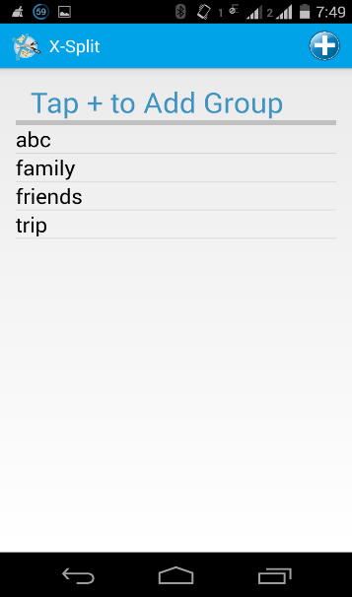 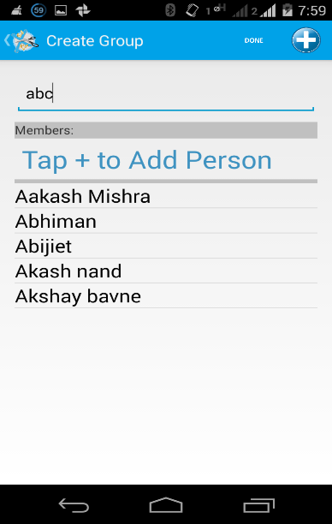

This is the main page of our application. It includes all groups that are created by user. If any body wants to add group then user needs to tap + button. After tapping on + button then user need to write group name. and after that user need to add contacts**.**

**2.For Adding group members:**

For adding group members in particular group ,user need to tap on + button ,after tapping on + button contacts will be retrieved ,then user need to select particular contacts. After adding all contacts user need to tap on done button.

 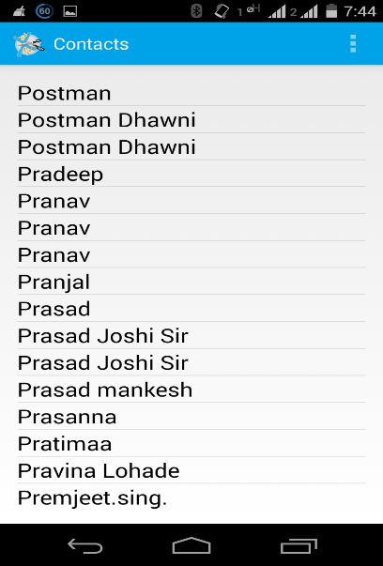

***3*.For Adding Expenses:**

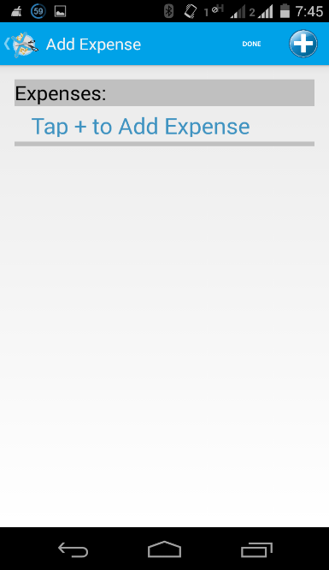

For adding expenses user need to tap on + button after tapping on + button ,user need to type expense name and total cost .

In splitting expenses we have two cases equally split or unequally split ,if user tap on unequally split then user need to give particular share for each member in the corresponding group.

And also user needs to provide paid amount by clicking on paid.

1. **Split Equally:**

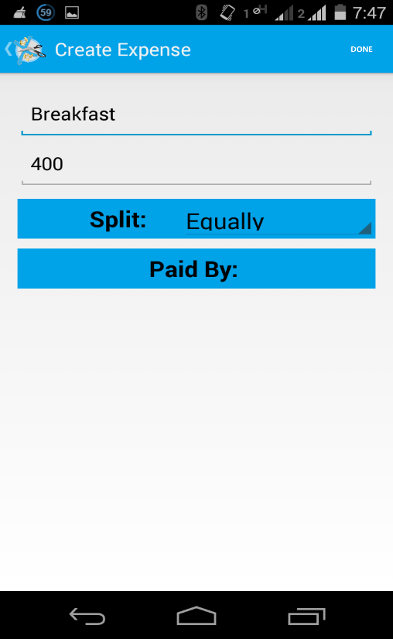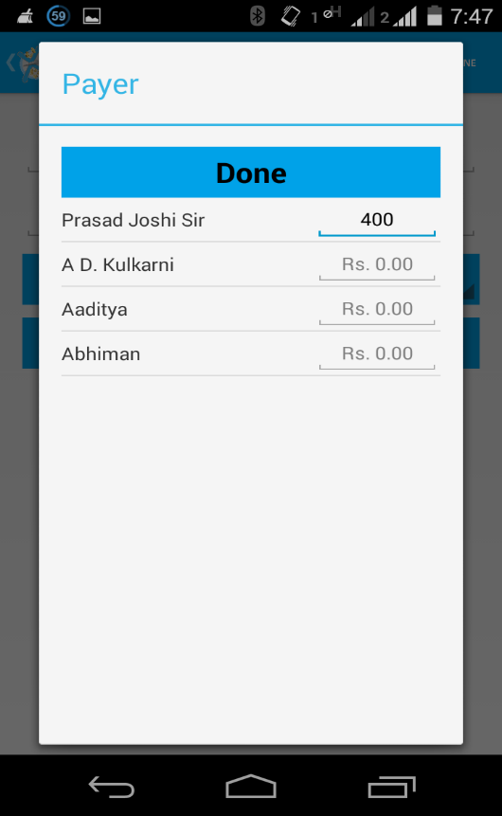

1. **Split Unequally:**

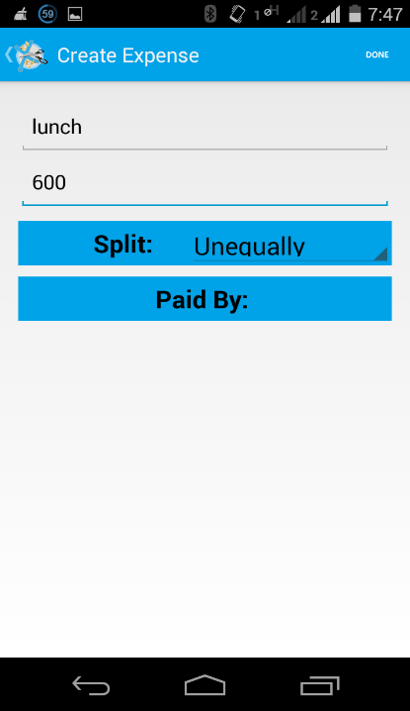 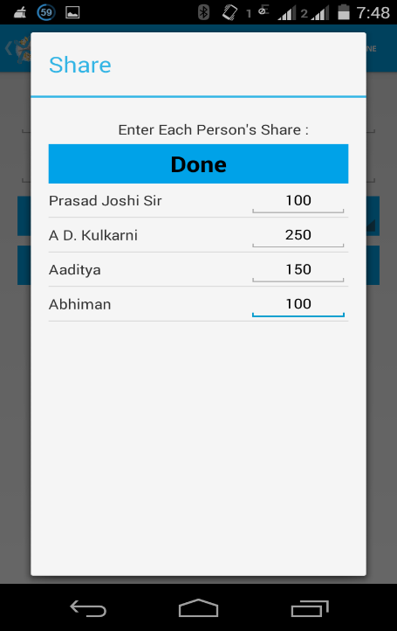 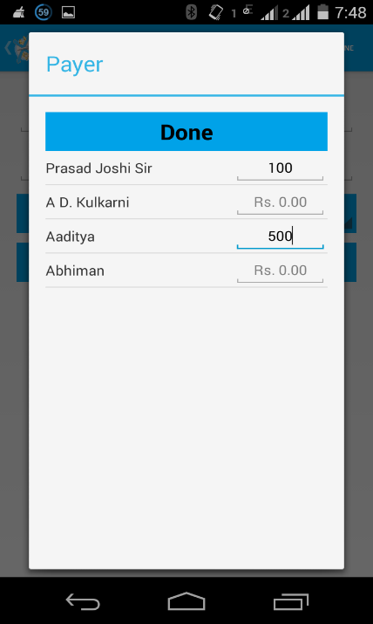

**4.Settle Up:**

**A) Equal: B) Unequal:**

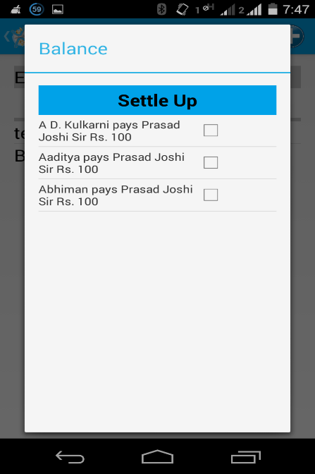 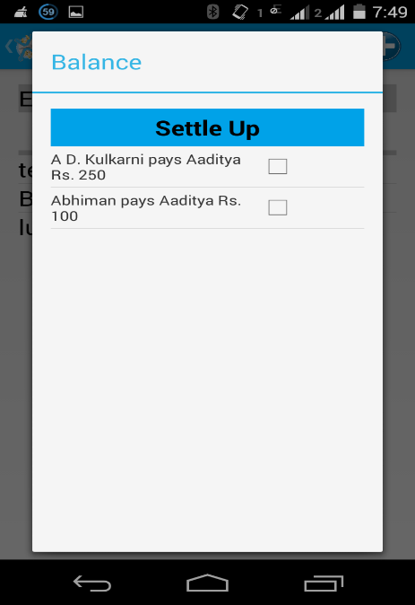

After adding expenses ,finally user gets who will pay another member how much money. and user can settle the transactions.

**4. PROBLEMS FACED AND SOLUTIONS**

1. Problems faced in understanding DBMS concepts as the course has yet not been taught.

2. Lack of resources such as powerful machines etc.

3. Working in team created redundancy.

Solutions :

Referred books and internet.

**5.CONCLUSION & FUTURE SCOPE**

**5.1 CONCLUSION**

In this hectic world nobody has that much time to invest in this complex calculations. So the complex calculation can be done in seconds with ease and at a very good comfort level using this application. No need of calculations to be done manually.

**5.2 FUTURE SCOPE**

1. We will add connectivity option for users to interact with each other (eg. SMS, e-mail, cloud database).

2. Users will be able to upload images to avoid any dispute.

3. Advanced GUI which will include animation etc.

4. Add some new features to the app.

**References**

1. www.google.com
2. developer.android.com
3. www.w3schools.com
4. www.stackoverflow.com