VIJAY DHANJIBHAI UGREJIYA

ugrejiyavijay15@gmail.com | 7285864375

# Objective

# Intend to build a career in a fast-spaced leading corporate which will allow me to explore myself fully by challenging my skills and offer professional growth while being resourceful, innovative and flexible.Work summary

# Overview

* Quick learner and very hard working
* Ability to work under time pressure and meet deadlines and challenges
* Excellent ability to understand and analyze client requirements
* Strong thought process, logical thinking, self-learner, good development skill

# Experience - 2 Years

**Sanket Enterprise**

Account assistant | April 2019 - Oct 2019

**Role and Responsibilities:**

* Account paybale,Sales purchase entry, receivable petty cash, ledger expenses book, bank reconciliation etc…

**Bharat tyres Gujrat Pvt LTD**

Account assistant | OCT 2019 – Current

**Role and Responsibilities:**

* Account paybale, bank reconciliation etc…

# **QUALIFICATIONS**

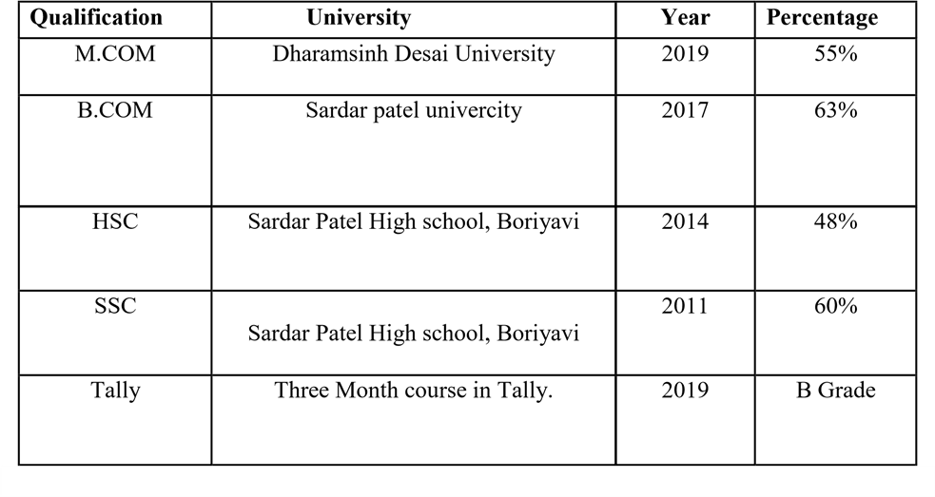

# Certification

* **Nice computer institution : Tally [GST](3 Months)**

# Personal Details

* **Name :** Vijay DhanjiBhaiUgrejiya
* **Date of Birth :** 15/12/1995
* **Gender :** Male
* **Language Known :** English, Hindi, Gujarati
* **Marital Status :** Single

**Permanent Address : 646, Chapa Talav N.r kanjari bus stand kanjari, TA_NADIAD, DIST-KHEDA, KHEDA-387325, Gujarat, India.**

**Declaration :** I do here by declare that the above information is true and complete to the Best of my knowledge and belief.

(Vijay DhanjiBhaiUgrejiya)