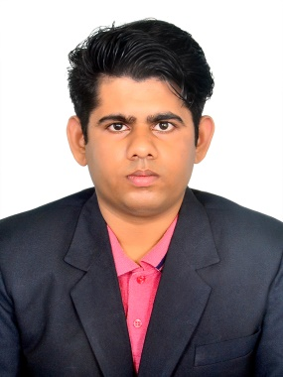Saswat Behera

[saswatsreenu@gmail.com](mailto:saswatsreenu@gmail.com) | 7008738061

* Web Designer Languages -:

HTML ------------ Exp. -: 1 year CSS ------------ Exp. -: 1 year JavaScript ------------ Exp. -: 1 year React. Js. ------------ Exp. -: 1 year

Node. Js. ------------ Exp. -: 1 year J. Query ------------ Exp. -: 1 year

Angular Js. ------------ Exp. -: 1 year

* Languages Known -:

English -: Professional - Writing , Reading , Speaking .

Hindi -: Professional - Writing , Reading , Speaking .

Oriya -: Basic - Speaking .

* Personal Projects -:

|  |  |
| --- | --- |
| The Tribute Website | This website describes about Dr A.P.J. Abdul Kalam Sir , his biographies . |
| Job Application Website | This website describes about job application where a student can provide their details . |
| Parallax Website | This website describes about where the user gets 3D experience by using Images . |
| Developer Landing Website | This website describes to show each and every thing a person need to know about my academics . |
| Restaurant Website | This website describes each and every thing a user need to know about their food and their problems can ne solved through website. |
| Music Website | This website describes to song , music , brand and further . |
| Blog Website | This website describes about a topic using a umber of videos , photos , passages . |

* Academic Projects -:

|  |  |
| --- | --- |
| Animating Video Player | In this project the system use RGB Colours to slow down and show us a well animated video but live animation is not possible so the video use to be in slow motion . |
| Animating Video Editor | It is a small project for beginners like me to understand and create an animated video which uses python as base and edit , animate a video with requirement of an user and provide best result . |

* Educational Qualification -:

|  |  |  |  |
| --- | --- | --- | --- |
| **Degree and Year** | **Institute** | **Board** | **Marks/CGPA** |
| B. Tech(CSE) | GIET , Gunpur | GIET UNIVERSITY | 7.46 CGPA |
| 12th Science in 2017 | Vikash  Sason Sambalpur | CBSE | 67 % |
| 10th in 2015 | Kendriya Vidyalaya Bhawanipatna | CBSE | 8.40 CGPA |

* **Personal Details -:**

|  |  |  |  |  |  |  |  |  |
| --- | --- | --- | --- | --- | --- | --- | --- | --- |
| |  |  | | --- | --- | | Date Of Birth | 02/02/2002 | | Phone Number | 7008738061 | | Programming Language Known | Python , Open CV , HTML , CSS , JavaScript , React JS. , Node JS. , J Query . | | Habits | Article , Essay Writing , | |
| **Place** -: Commander ‘ s Galaxy Apartment , MS Nagar , Agrahara Badavane, 560064 , Bengaluru , Karnataka . |
|  |