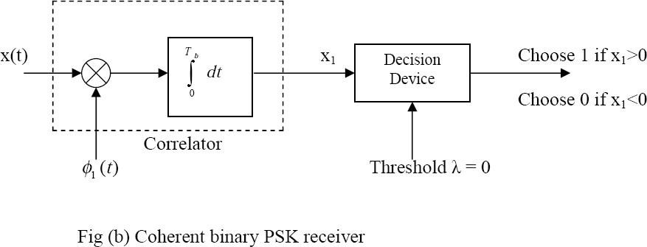
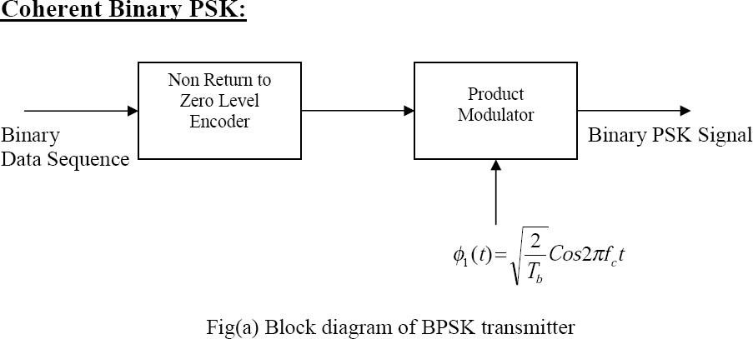
Sr.  No. | Name of Signal | Amplitude | Frequency
1 | P1:1000 | 5.6v | 200HZ
2 | P2:10100 | 5.03v | 200HZ
3 | Carrier signal; | 3.08v | 20HZ
4 | BPSK OP | 2.69v | 20HZ
5 | BPF | 3.3v | 40HZ
6 | SQ ckt OP | 5.7v | 40HZ
7 | % 2 N/W OP | 5.7v | 20HZ
8 | Filter OP | 3v | 40HZ
9 | Comparator OP | 8.87v | 200HZ

Sr.  No. | Name of Signal | Amplitude | Frequency
1 | IP b(t) :P1: | 8.20v | 1.57KHZ
2 | IP b(t) :P1: | 6.64v | 1.644KHZ
3 | Carreir signal Sin (Wct) | 1.83v | 1.563KHZ
4 | Carreir signal cos(Wct) | 2.28v | 16.3KHZ
5 | Odd data ::even data | 5.66v :8.89V | : 15.6KHZ:15.97KHZ
6 | be(t).sinwc(t)(A): bo(t)coswc(t)(A): | 2.344v :2.305V | 15.9KHZ
7 | QPSK OP | 2.42V | 1.57KHZ
8 | Demodulated :C:D | 5.24v:5.23V | 390KHZ
9 | Final Demodulated | 5.15v | 1.59KHZ
10 | Clock :even | 5.70v | 2KHZ
11 | Clock :odd | 5.85v | 2KHZ

PRACTILE 2 OBSERVATIONN TABLE
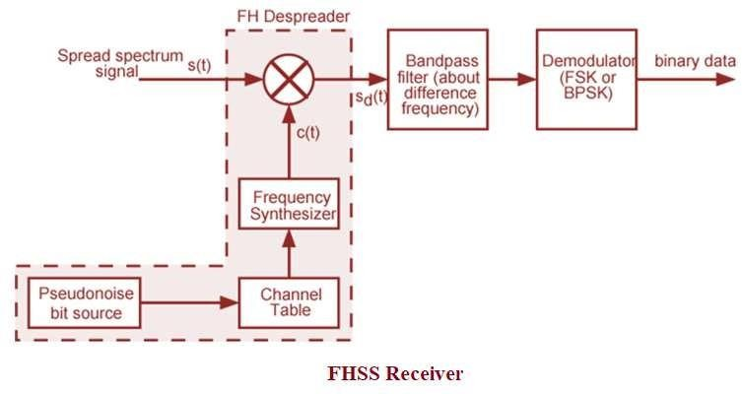
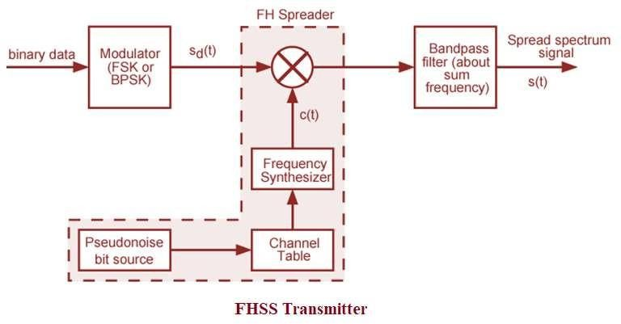

Sr.  No. | Name of Signal | Amplitude | Frequency
1 | P1] 1000 | 5.3v | 66.67HZ
2 | P2]10100 | 5v | 136.4HZ
3 | PN seq:111101011001000 | 5.70 v | 90HZ
4 | Fc1-df :Fc1+df | 5.07v:5.07v | 1.8HZ :2.02HZ
5 | Fc2-df : Fc2+df | 5v:5v | 2.25HZ:4.18HZ
6 | FSK AT fc1 | 5v | 2.02HZ
7 | FSK AT fc2 | 4.76v | 2.48HZ
8 | Modulated OP | 4.76v | 2.47HZ
9 | Demodulated OP | 12.1v | 66.56HZ

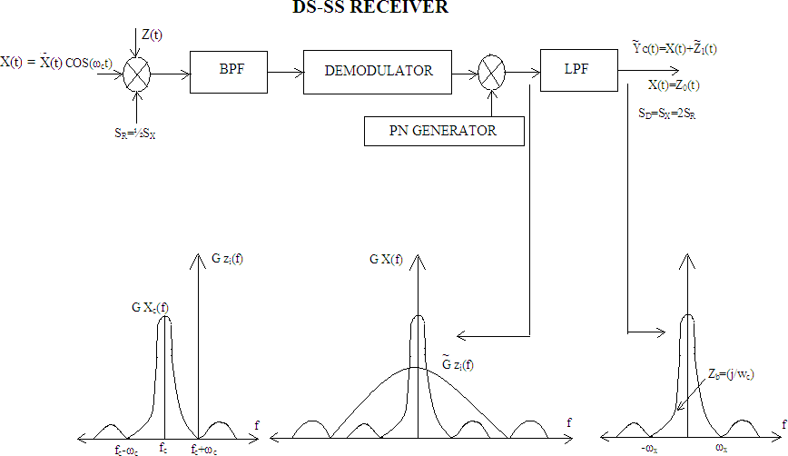
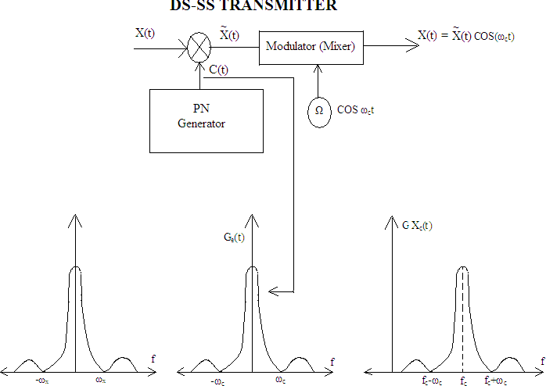

Sr.  No. | Name of Signal | Amplitude | Frequency
1 | P] : 1000 | 5.46V | 57.14 HZ
2 | P] : 10100 | 5.4V | 57.14 HZ
3 | PN seq] : 10001110 | 5.7V | 57.14 HZ
4 | Spread Seq : | 4.5V | 57.14 HZ
5 | Carrier | 2.34V | 20 HZ
6 | BPSK OP | 2.65V | 20.35 HZ
7 | Sq .CKT OP | 2.38V | 40HZ
8 | BPF | 6.05V | 40 HZ
9 | Frequency divider | 5.46V | 20 HZ
10 | LPF & comprator | 5.23V | 642HZ
11 | Reconstructed OP | 4.8V | 57 HZ

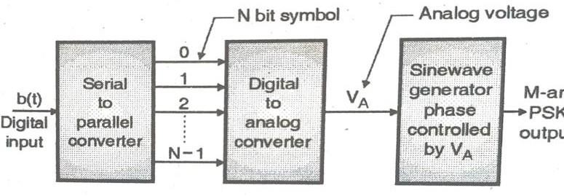
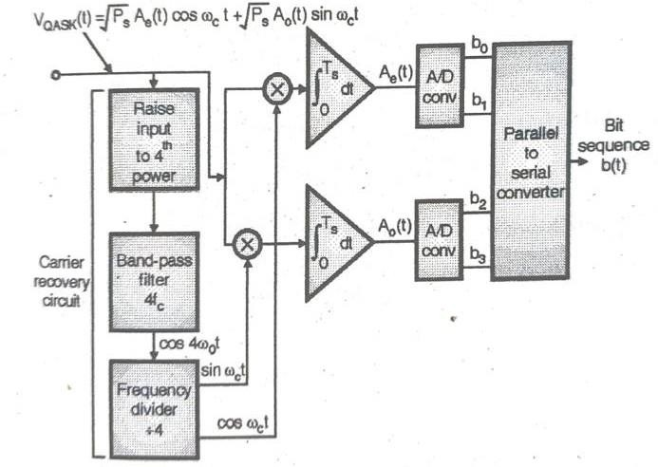

Experiment No. 05
clc;
clear all;
M = 16;
x = 0:M-1;
N = 1;
OFF = 0;
z = pskmod(x, M, OFF); % Modulate symbols using MPSK
% Scatter plot
figure(1)
scatterplot(z, N, OFF, 'r+');
title('16-PSK Constellation');
grid on;
%%%%%%%%%%%%%
clc;
clear all;
M = 16; % MPSK order
x = 0:M-1; % Symbol indices
phase_offset = 0; % Phase offset in radians
% Manual PSK modulation (same math as pskmod)
z = exp(1j * (2*pi*x/M + phase_offset));
% Scatter plot
figure(1);
scatter(real(z), imag(z), 'r+');
axis equal;
grid on;
title('16-PSK Constellation');
xlabel('In-phase');
ylabel('Quadrature');

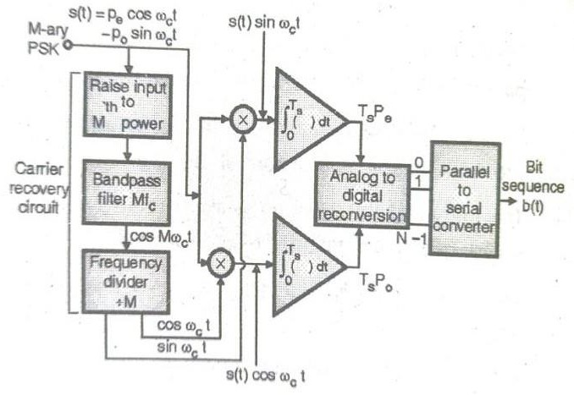
EXP 6
clc;
clear all;
close all;
choice=input('enter 1:BPSK,2:QPSK,3:MSK,4:16-QAM,5:MPSK;6:MFSK');
M=16;
N=4;
SNR=25;
if choice<4,
pe=0.5*erfc(sqrt(SNR));
end
if choice==4,
pe=2*erfc(sqrt(0.4*SNR));
end
if choice==5,
pe=0.5*erfc(sqrt(pi*pi*SNR/16));
end
if choice==6,
N=log2(M);
pe=erfc(sqrt(N*SNR)*sin(pi/M));
end
if choice==7,
N=log2(M);
pe=((M-1)/2)*erfc(sqrt(N*SNR/2));
end
Error_Probability=pe
OUTPUT:
enter 1:BPSK,2:QPSK,3:MSK,4:16-QAM,5:MPSK;6:MFSK 1
Error_Probability =7.6873e-13
enter 1:BPSK,2:QPSK,3:MSK,4:16-QAM,5:MPSK;6:MFSK 2
Error_Probability = 7.6873e-13
enter 1:BPSK,2:QPSK,3:MSK,4:16-QAM,5:MPSK;6:MFSK 3
Error_Probability = 7.6873e-13
enter 1:BPSK,2:QPSK,3:MSK,4:16-QAM,5:MPSK;6:MFSK 4
Error_Probability = 1.5488e-05
enter 1:BPSK,2:QPSK,3:MSK,4:16-QAM,5:MPSK;6:MFSK 5
Error_Probability = 1.3992e-08
enter 1:BPSK,2:QPSK,3:MSK,4:16-QAM,5:MPSK;6:MFSK 6
Error_Probability =1.1430e-22
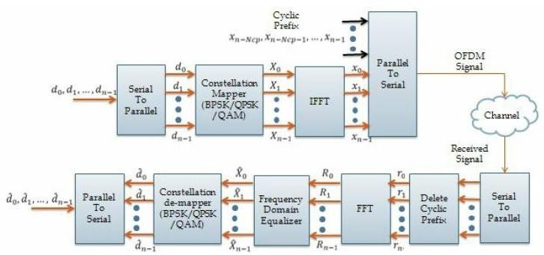
N = 64;
CP = 16;
% Number of subcarriers
% Length of cyclic prefix
numSym = 5; % Number of OFDM symbols
% Generate random bits (2 bits per QPSK symbol)
bits = randi([0 1], N*2*numSym, 1);
% QPSK modulation: map bits to symbols
bits_reshape = reshape(bits, 2, []).';
symbols = (1 - 2*bits_reshape(:,1)) + 1j*(1 - 2*bits_reshape(:,2));
symbols = symbols / sqrt(2); % Normalize power
% Group symbols into OFDM symbols (rows)
ofdm_symbols = reshape(symbols, N, numSym).';
% IFFT to get time domain OFDM signal
time_domain = ifft(ofdm_symbols, N, 2);
% Add cyclic prefix (copy last CP samples to front)
ofdm_with_cp = [time_domain(:, end-CP+1:end) time_domain];
% Received signal (ideal channel, no noise)
received = ofdm_with_cp;
% Remove cyclic prefix
received_no_cp = received(:, CP+1:end);
% FFT to recover frequency domain symbols
received_symbols = fft(received_no_cp, N, 2);
% Flatten for demodulation
received_symbols = received_symbols.';
% QPSK demodulation (decide bits from real and imag parts)
received_bits = zeros(length(bits), 1);
received_bits(1:2:end) = real(received_symbols(:)) < 0;
received_bits(2:2:end) = imag(received_symbols(:)) < 0;
% Calculate errors
numErrors = sum(bits ~= received_bits);
BER = numErrors / length(bits);
fprintf('Bit errors: %d\nBit error rate: %f\n', numErrors, BER);
symbol_idx = 1;
% Frequency domain (QPSK symbols on subcarriers)
figure;
stem(0:N-1, abs(ofdm_symbols(symbol_idx, :)));
title('OFDM Symbol in Frequency Domain (Magnitude)');
xlabel('Subcarrier Index');
ylabel('Magnitude');
grid on;
% Time domain OFDM symbol (with cyclic prefix)
figure;
plot(real(ofdm_with_cp(symbol_idx, :)));
title('OFDM Symbol in Time Domain (Real Part)');
xlabel('Sample Index');
ylabel('Amplitude');
grid on;
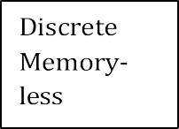
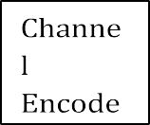
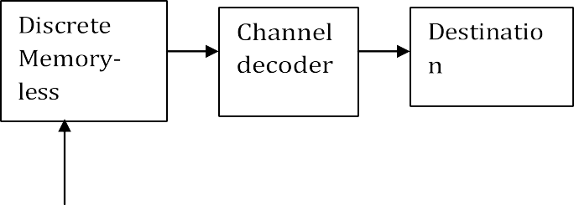
disp(H1);
% probability P(Y)
for n=1:i
w=0;
for m=1:i
s(n)=w+q(m,n);
2
w=s(n);
end
end
disp('P(Y):');
disp(s);
% entropy H(Y)
k=0;
for n=1:i
H2=k+(s(n)*log2(1/s(n)));
k=H2;
end
disp('H(Y): ');
disp(H2);
% MI
m=H2-H1;
disp('MI-');
disp(m);
Output:
Enter no. of elements=3
Enter joint probabilities matrix=[0.27 0.03 0;0 0.2 0.05;0 0.135 0.315]
EXPERIMENT 8
clc;
clear all;
close all;
i=input('Enter no. of elements=');
q=input('Enter joint probabilities matrix=');
sum=0;
%probability P(x)
for n=1:i
w=0;
for m=1:i
p(n)=w+q(n,m);
w=p(n);
end
end
disp('P(x):');
disp(p);
% entropy H(x)
for n=1:i
H=sum+(p(n)*log2(1/p(n)));
sum=H;
end
disp('H(x): ');
disp(H);
%conditional probability matrix
1
for n=1:i
for m=1:i
a(n,m)=q(n,m)/p(n);
end
end
disp('P(Y/X):');
disp(a);
% entropy H(Y/X)
d=0;
for n=1:i
for m=1:i
if(a(n,m)>0)
H1=d+(q(n,m)*log2(1/a(n,m)));
d=H1
end
end
end
disp('H(Y/X):');
disp(H1);
Transmitter
Receiver

clc;
clear all;
close all;
code_length=0;
symbols=[1:5]
p=[0.4 0.15 0.15 0.15 0.15];
[dict,avglen]=huffmandict(symbols,p)
avginfo=0;
for i=1:length(p)
avginfo=avginfo+p(i)*log2(1/p(i));
end
Efficiency=avginfo*100/avglen
sig=randsrc(1,100,[symbols;p]);
hcode=huffmanenco(sig,dict);
decode=huffmandeco(hcode,dict);
code_length=length(hcode)
display(avginfo);
display(Efficiency);
isequal(sig,decode)
Output:
symbols =
1 2 3 4 5

