FORMAL SOFTWARE TESTING REPORT
Chess.com – SDLC & STLC Practical
  - Evidence-based functional, UI, validation and navigation testing

Student Name | Bhavesh Patil
Program | BCA SEM 3
Subject | ST
Enrollment Number | 2504030100419
Practical | Tutorial-1: SDLC & STLC Phases
Application Under Test | Chess.com

Report prepared from all 6 uploaded practical screenshots.

1. Executive Summary
This report evaluates the supplied Chess.com practical screenshots using an evidence-based software-testing approach. Only information visibly supported by the screenshots is treated as verified. Hidden actions, masked values and transitions that are not captured are explicitly identified as incomplete rather than assumed.
Evidence Reviewed | Test Cases | Pass | Fail / Incomplete Evidence
6 screenshots | 10 | 7 | 3

Important tester note: The Fail statuses primarily represent missing or insufficient screenshot evidence. They do not, by themselves, establish a defect in Chess.com.
2. Testing Scope & Method
• Application: Chess.com web application.
• Evidence source: all six screenshots uploaded for the practical.
• Testing focus: UI elements, navigation, authentication validation, functional controls, puzzle execution and result validation.
• Evidence rule: no hidden input, action or result is assumed when it is not visible.
• Limitations: performance, backend/database, source code, security and full accessibility testing are outside the evidence available in these screenshots.
3. Detailed Test Cases & Screenshot Evidence
TC-01 | STLC – Test Environment / Application Launch
Testing Step | Verify that the Chess.com home page loads successfully.
Test Input | Open chess.com in a web browser.
Expected Result | The website should load correctly with the main navigation and primary user actions visible.
Actual Result | Chess.com home page is visible. Play, Puzzles, Learn, Train, Watch and Community navigation items are displayed, along with Sign Up and Log In.
Status (Pass/Fail) | Pass
Personal Comments & Suggestions | Clear launch and UI evidence. The browser address bar shows chess.com. No visible loading, alignment or rendering defect is evident.
Screenshot Evidence | Screenshot 1 – Chess.com Home Page
Evidence – Screenshot 1
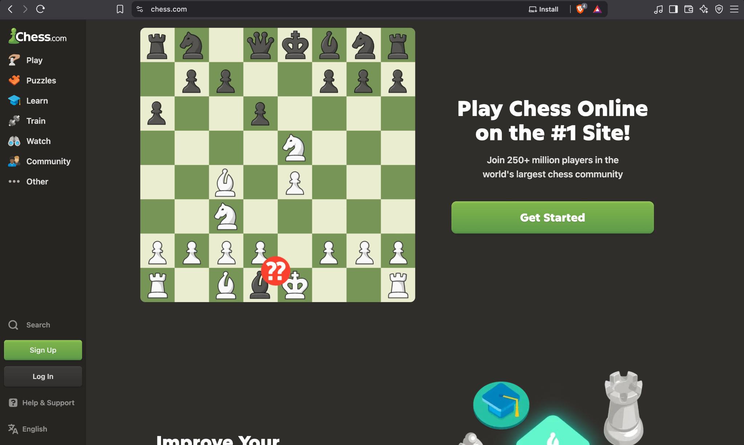

TC-02 | STLC – Authentication / Negative Testing
Testing Step | Verify that an incorrect password is rejected with an appropriate validation message.
Test Input | Username shown as “Dhananjay” with an incorrect password.
Expected Result | The system should reject invalid credentials and display a clear error/validation message.
Actual Result | A red validation message states that the password is incorrect and provides Forgot/Reset password options.
Status (Pass/Fail) | Pass
Personal Comments & Suggestions | Expected negative-test behavior is clearly demonstrated. The password is masked, so the exact password value cannot be independently verified.
Screenshot Evidence | Screenshot 2 – Invalid Login Validation
Evidence – Screenshot 2
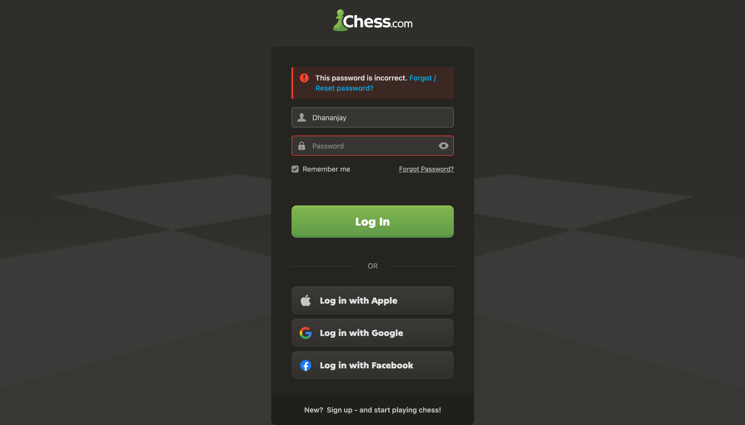

TC-03 | STLC – Authentication / Navigation
Testing Step | Verify that successful login redirects the user to the authenticated dashboard.
Test Input | Valid login credentials.
Expected Result | After successful authentication, the authenticated home/dashboard should be displayed.
Actual Result | A /home dashboard is visible with account controls and Play Online, Puzzles and other features. However, the valid credentials and login action are not captured.
Status (Pass/Fail) | Fail
Personal Comments & Suggestions | Evidence is incomplete for this test step. The dashboard state is visible, but successful authentication cannot be proven from the screenshot alone. This is an evidence gap, not proof of an application defect.
Screenshot Evidence | Screenshot 3 – Authenticated Dashboard / Play Online
Evidence – Screenshot 3
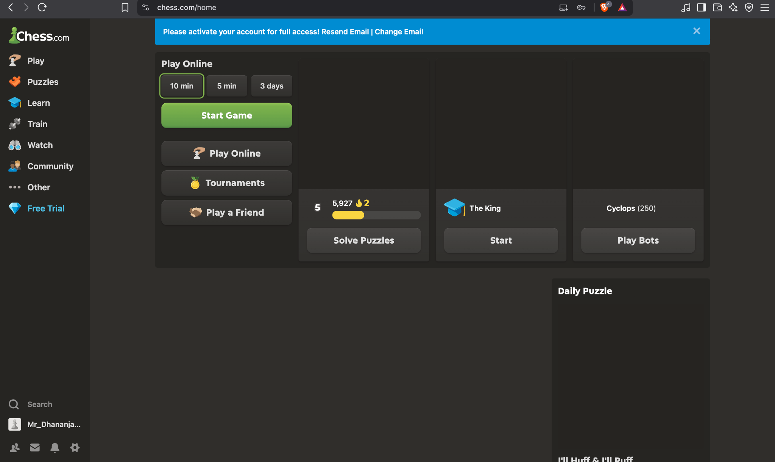

TC-04 | STLC – Functional Testing / Play Online
Testing Step | Verify that Play Online provides selectable game time controls and a Start Game action.
Test Input | Play Online section opened; 10 min option selected.
Expected Result | Available time controls should be displayed and the user should have an actionable Start Game control.
Actual Result | 10 min, 5 min and 3 days options are visible. 10 min is selected and Start Game is visible.
Status (Pass/Fail) | Pass
Personal Comments & Suggestions | The controls are clearly visible. The screenshot does not prove that Start Game was clicked or that a chess game actually started.
Screenshot Evidence | Screenshot 3 – Authenticated Dashboard / Play Online
Evidence – Screenshot 3

TC-05 | STLC – Functional Testing / Puzzles
Testing Step | Verify that the Puzzles module opens.
Test Input | Select/open Puzzles.
Expected Result | The Puzzles module should open and present its introductory/start state.
Actual Result | A Puzzles modal is displayed with puzzle information and an Ok button.
Status (Pass/Fail) | Pass
Personal Comments & Suggestions | Module opening is clearly evidenced. The subsequent Ok-button action is not shown.
Screenshot Evidence | Screenshot 4 – Puzzles Introduction
Evidence – Screenshot 4
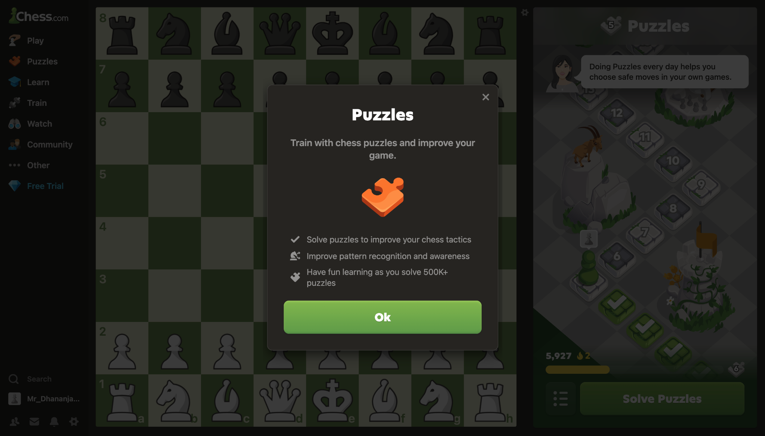

TC-06 | STLC – Functional Testing / Puzzle Execution
Testing Step | Verify that a puzzle position loads and identifies the side to move.
Test Input | Open a puzzle.
Expected Result | A chess position should load and clearly indicate whose turn it is.
Actual Result | A puzzle board is visible and the right panel states “White to move”. Hint and timer controls are also visible.
Status (Pass/Fail) | Pass
Personal Comments & Suggestions | Puzzle readiness is clearly shown. No incorrect rendering or visible UI error is evident.
Screenshot Evidence | Screenshot 5 – Puzzle Ready
Evidence – Screenshot 5
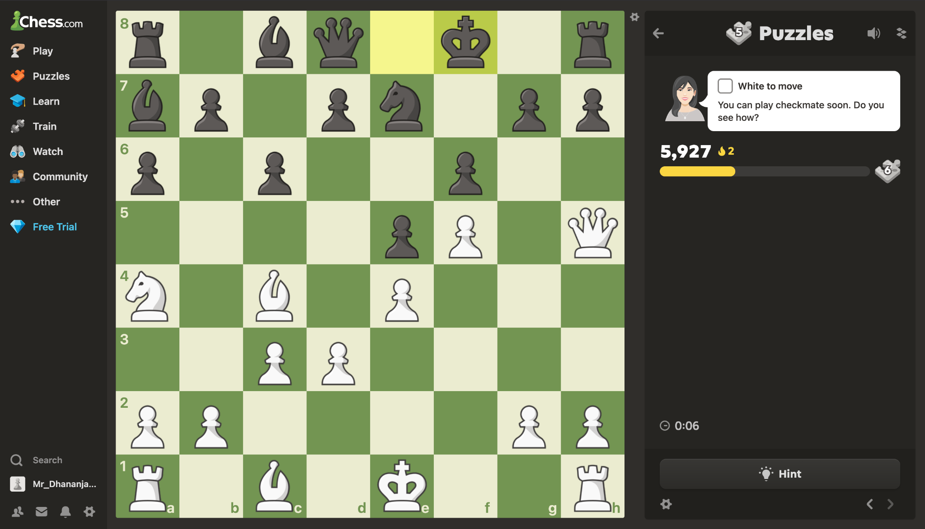

TC-07 | STLC – Functional Testing / Puzzle Input
Testing Step | Verify that the system accepts the tester’s puzzle move.
Test Input | Make the required chess move.
Expected Result | The entered move should be accepted and the puzzle should progress or provide appropriate feedback.
Actual Result | The screenshot shows the puzzle before the tester’s move; the exact move/input is not visible.
Status (Pass/Fail) | Fail
Personal Comments & Suggestions | The required input action is not captured, so this step cannot be verified from the supplied evidence. Add a screenshot immediately after the move is made.
Screenshot Evidence | Screenshot 5 – Puzzle Ready
Evidence – Screenshot 5

TC-08 | STLC – Functional Testing / Result Validation
Testing Step | Verify that a correctly solved puzzle is confirmed by the system.
Test Input | Correct puzzle solution.
Expected Result | The system should confirm the solution and update puzzle score/progress.
Actual Result | The screen displays “Solved”, a green check, a success message, and the score increases from 5,927 to 5,932 (+5).
Status (Pass/Fail) | Pass
Personal Comments & Suggestions | Strong result evidence. The exact move sequence is not shown as text, so the successful result—not the exact move input—can be verified.
Screenshot Evidence | Screenshot 6 – Puzzle Solved
Evidence – Screenshot 6
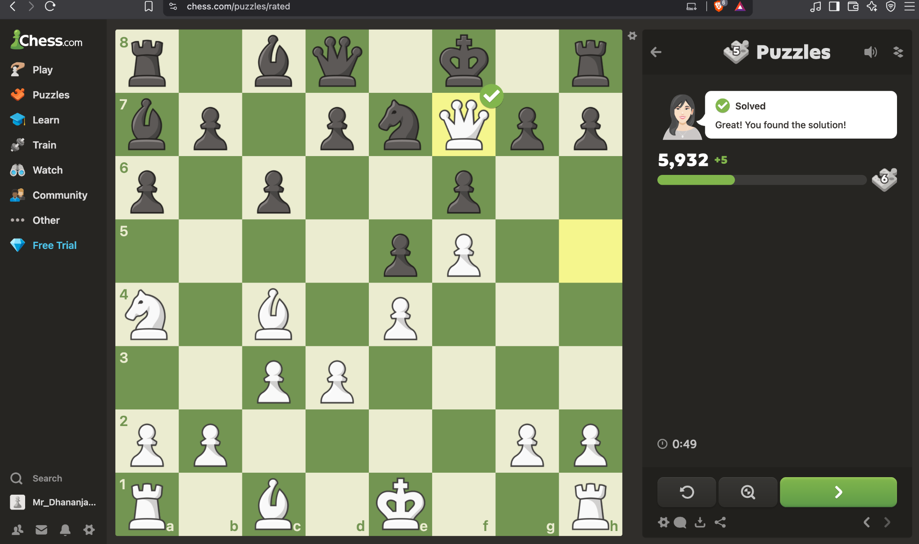

TC-09 | STLC – UI / Validation Review
Testing Step | Verify that visible validation and navigation elements are clear and identifiable.
Test Input | Review visible navigation items, buttons, labels and validation messages.
Expected Result | UI labels, buttons, navigation items and validation messages should be readable and distinguishable.
Actual Result | Visible labels and controls are generally clear. The login error is prominent and Play/Puzzles actions are identifiable.
Status (Pass/Fail) | Pass
Personal Comments & Suggestions | No obvious UI clarity defect is visible in the supplied screenshots. This is a visual review only and is not a full accessibility test.
Screenshot Evidence | Screenshot 2 – Invalid Login Validation
Evidence – Screenshot 2

TC-10 | STLC – Evidence Completeness / Test Reporting
Testing Step | Verify that each claimed user action is directly supported by screenshot evidence.
Test Input | Review all six uploaded screenshots against the test flow.
Expected Result | Each execution step should have visible input/action and corresponding result evidence.
Actual Result | Several states are shown, but valid-login execution, actual game start, puzzle move input and exact move notation are not directly captured.
Status (Pass/Fail) | Fail
Personal Comments & Suggestions | Evidence completeness issue. Capture the missing action/transition screenshots before treating those steps as fully tested.
Screenshot Evidence | Screenshot 3 – Authenticated Dashboard / Play Online
Evidence – Screenshot 3

4. Defects, Incomplete Steps & Required Corrections
Classification | Observation | Recommended Action
INCOMPLETE EVIDENCE | Successful login is not directly captured. | Add a screenshot showing valid credentials entered and the resulting authenticated dashboard transition.
INCOMPLETE EVIDENCE | Play Online is shown with Start Game, but no started game is shown. | Capture the chessboard immediately after clicking Start Game.
INCOMPLETE EVIDENCE | The puzzle move/input is not visible. | Capture the board immediately after making the required move.
INCOMPLETE EVIDENCE | Exact puzzle move notation is not visible in the solved screenshot. | Include move notation if the practical requires verification of the exact test input.
NO CONFIRMED DEFECT | The incorrect-password message is expected validation behavior. | Do not report this message itself as a defect; it demonstrates successful negative validation.
5. Overall Tester Assessment
The supplied screenshots provide good evidence for the Chess.com home page, invalid-login validation, Play Online controls, Puzzles module, puzzle readiness and successful puzzle completion. The principal weakness is evidence completeness: several user actions are implied by the sequence but are not directly captured. For a formal practical submission, the missing transition/action screenshots should be added before claiming complete end-to-end execution.
6. Screenshot Evidence Index
Screenshot | Visible Evidence | Primary Testing Use
1 | Chess.com home page and navigation | Application launch / UI
2 | Incorrect-password validation message | Negative authentication testing
3 | Authenticated dashboard and Play Online controls | Navigation / functional UI
4 | Puzzles introduction modal | Module opening
5 | Puzzle board; White to move; Hint/timer | Puzzle readiness / input setup
6 | Solved confirmation and +5 score | Result validation

End of Report

