SOFTWARE TESTING REPORT
TUTORIAL-2: TEST PLAN & RTM
Chess.com — Software Testing Practical Report

Name | Bhavesh Patil
Course | BCA SEM 3
Subject | Software Testing
Enrollment No. | 2504030100419
Practical Title | TUTORIAL-2: TEST PLAN & RTM
Application Under Test | Chess.com
Evidence Reviewed | 8 uploaded screenshots

Prepared from the supplied practical screenshots; unsupported details are marked as unverifiable.

1. Executive Summary
This report evaluates the supplied Chess.com practical screenshots from a software-testing perspective. The review covers visible navigation, UI elements, displayed inputs and outputs, page states, and evidence quality. Eight screenshots provide clear evidence for the landing page, logged-in dashboard, puzzles, user profile, bot screens, game review, and settings.
The supplied screenshot set does not contain a formal Test Plan, Requirement Traceability Matrix (RTM), requirement IDs, or the original source test-case document. These missing items are not guessed; they are explicitly identified as incomplete or unverifiable.
2. Test Scope & Evidence Basis
Application Under Test | Chess.com
Testing Type | Functional UI evidence and software-testing screenshot audit
Evidence Reviewed | 8 uploaded screenshots
Evidence Quality | High-resolution and generally readable
Known Limitation | Formal Test Plan/RTM source documentation is not visible in the supplied screenshots
3. Overall Test Result
Evidence-based UI test cases | 8
UI test cases passed | 8
Formal evidence checks failed/incomplete | 4
Conclusion | The visible application states are adequately evidenced, but the formal Test Plan and RTM documentation must be added for a complete submission.

TC-01: Home / Landing Page
Testing Step | Open the Chess.com website and verify that the primary landing page and navigation are displayed.
Test Input | Navigate to the Chess.com website.
Expected Result | The Chess.com landing page should load and display the primary navigation and a clear call-to-action.
Actual Result | The landing page is visible. The left navigation shows Play, Puzzles, Learn, Train, Watch, Community and Other; the main area shows the chessboard and a 'Get Started' button.
Status (Pass/Fail) | PASS
Personal Comments & Suggestions | Clear evidence of the landing page. No visible loading failure or broken navigation is shown in the screenshot.
Screenshot Evidence | Screenshot 1
Screenshot 1 — Evidence
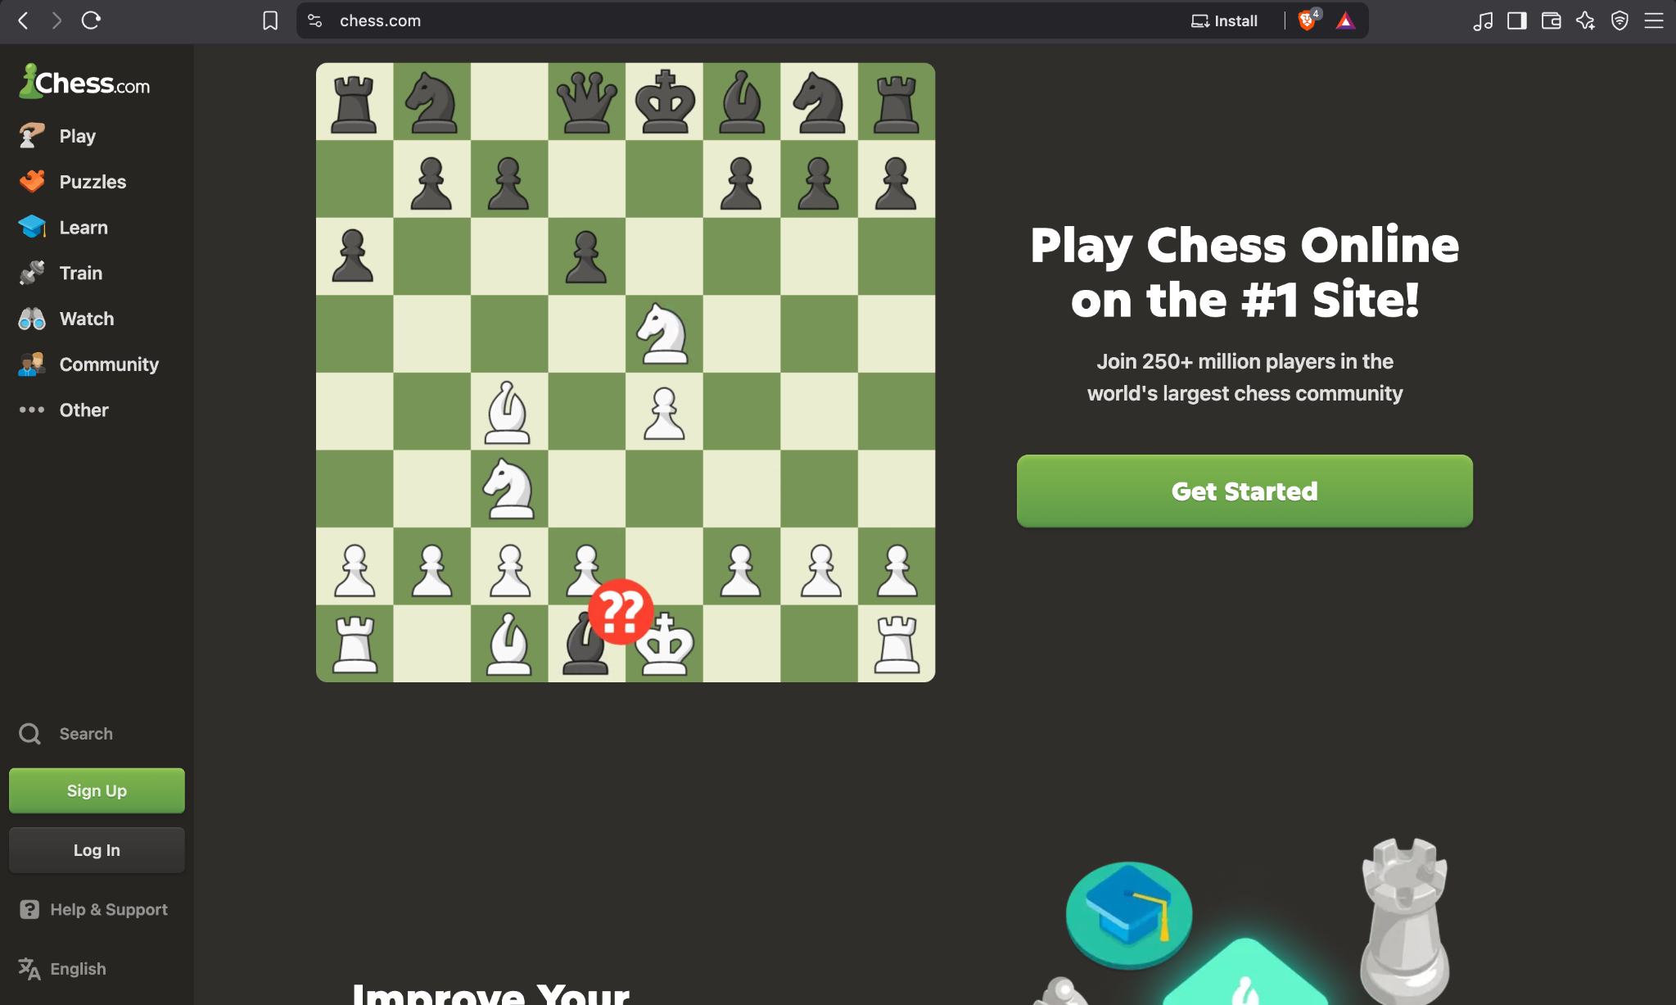
Screenshot 1
TC-02: Logged-in Home Dashboard
Testing Step | Open the logged-in home page and verify that the user dashboard is displayed.
Test Input | Open the Chess.com home/dashboard after account access.
Expected Result | The user dashboard should load with available play, puzzle, learning and bot options.
Actual Result | The dashboard is visible with Play Online, Start Game, Tournaments, Play a Friend, Solve Puzzles, The King and Play Bots. An account-activation banner is also visible.
Status (Pass/Fail) | PASS
Personal Comments & Suggestions | Dashboard evidence is clear. The activation banner shows that the account is not fully activated, but the dashboard itself is displayed successfully.
Screenshot Evidence | Screenshot 2
Screenshot 2 — Evidence
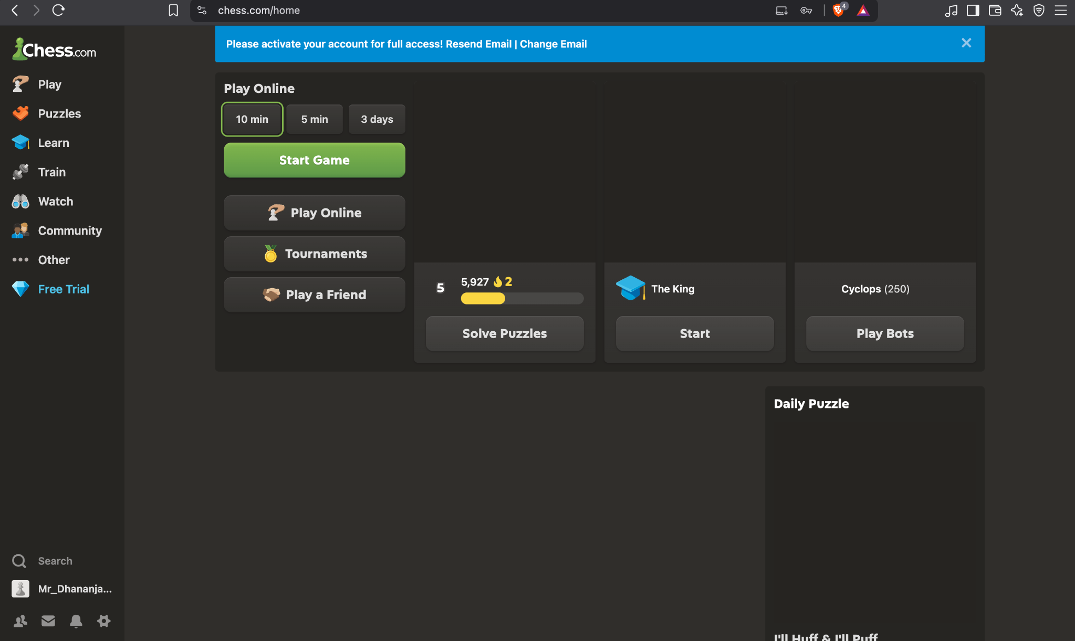
Screenshot 2

TC-03: Puzzles
Testing Step | Open the Puzzles section and verify that a rated puzzle is displayed and a solved result is shown.
Test Input | Select Puzzles from the left navigation.
Expected Result | The Puzzles page should display a chess position, puzzle controls and a visible result after a correct solution.
Actual Result | The rated puzzle interface is displayed. The side panel shows 'Solved' and 'Great! You found the solution!' with puzzle progress and controls.
Status (Pass/Fail) | PASS
Personal Comments & Suggestions | The solved-state evidence is clear. The screenshot does not independently prove every puzzle-validation rule, so only the visible solved state is assessed.
Screenshot Evidence | Screenshot 3
Screenshot 3 — Evidence
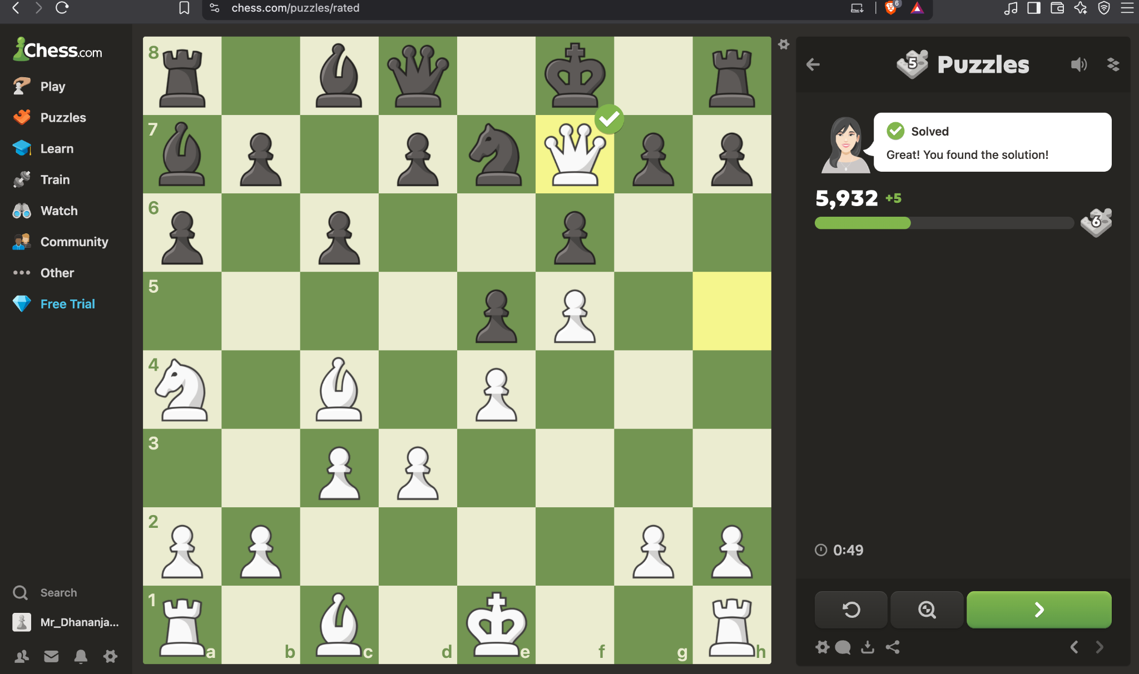
Screenshot 3
TC-04: User Profile
Testing Step | Open the user profile and verify profile information, ratings, tabs and game history are displayed.
Test Input | Open the logged-in user's profile.
Expected Result | The profile should display account information, ratings/statistics, navigation tabs and game history where available.
Actual Result | The profile shows the username, country indicator, joined date, friend/view counts, Overview/Games/Stats/Friends/Awards/Clubs tabs, Rapid and Puzzles ratings, Daily Games and Game History.
Status (Pass/Fail) | PASS
Personal Comments & Suggestions | Profile UI is complete and readable. Account-specific values are reported only as visibly displayed; their external correctness is not inferred.
Screenshot Evidence | Screenshot 4
Screenshot 4 — Evidence
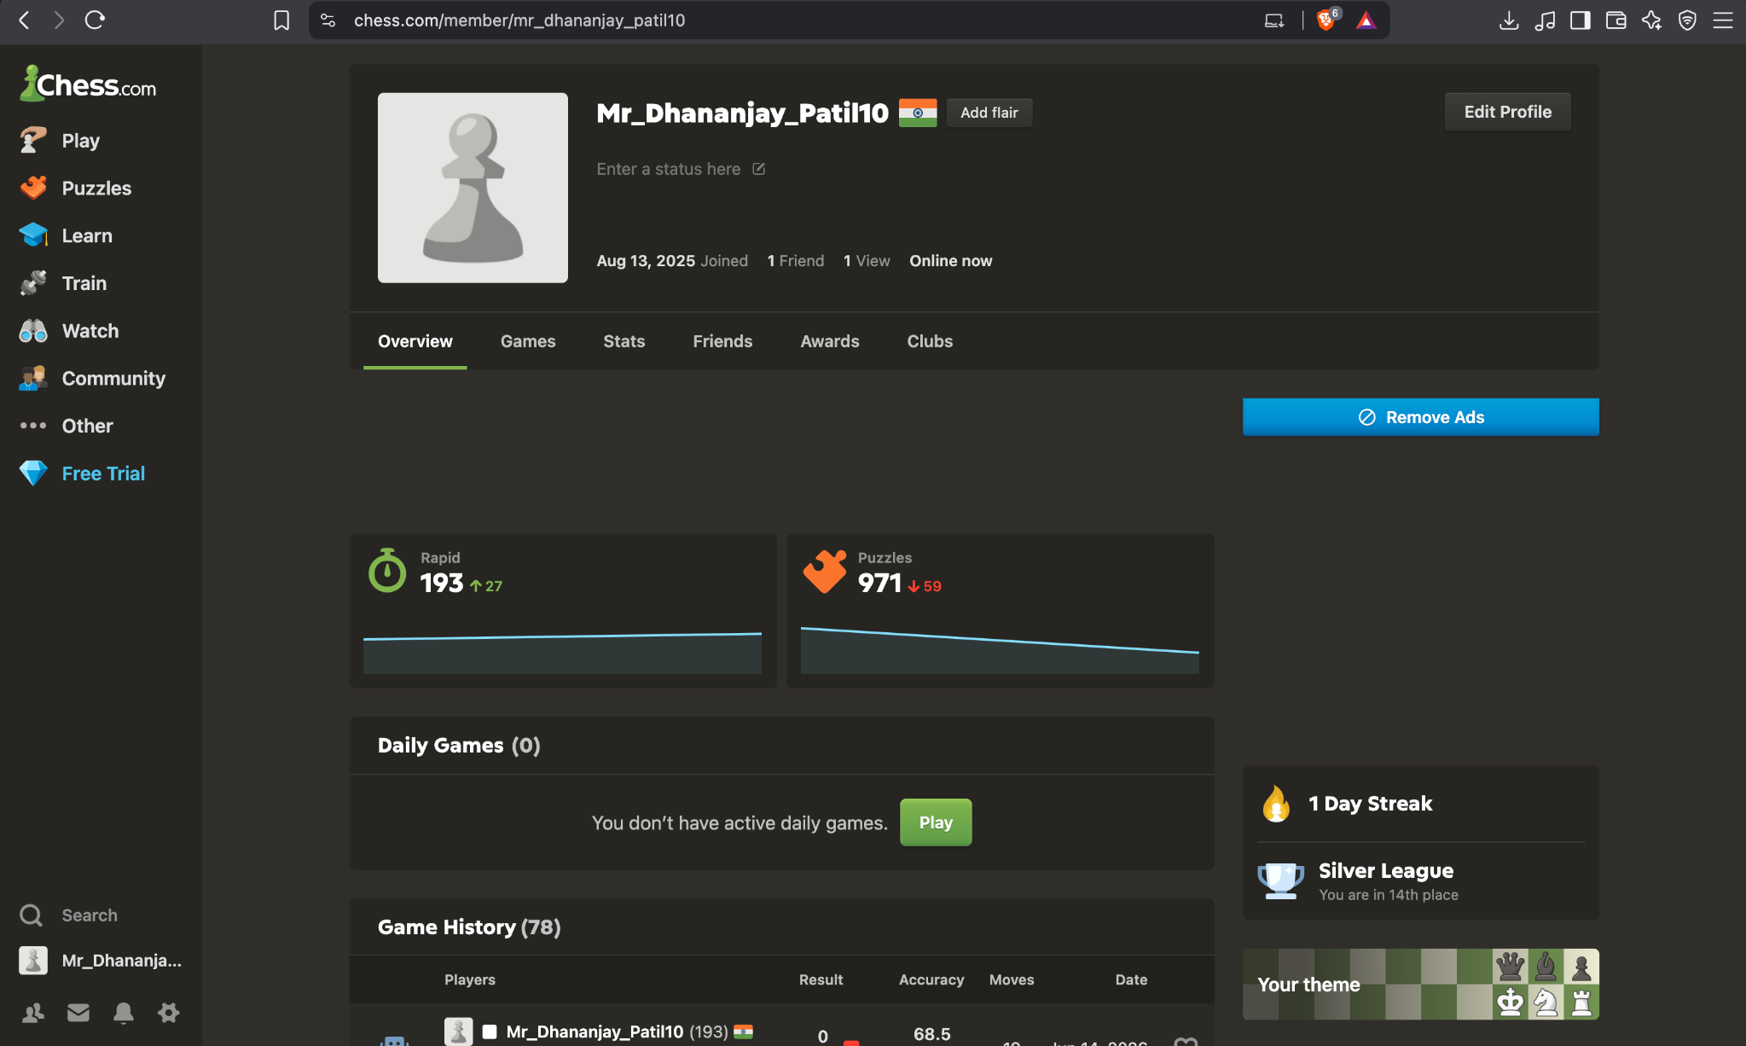
Screenshot 4

TC-05: Play Bots – Cyclops
Testing Step | Open Play Bots and verify that the selected computer opponent and starting chessboard are displayed.
Test Input | Select Play Bots / computer opponent and choose Cyclops.
Expected Result | The selected bot, bot rating, starting position and playable chessboard should be displayed.
Actual Result | The Cyclops bot page is visible with rating 250, a full starting chessboard, bot message and the user's side shown below the board.
Status (Pass/Fail) | PASS
Personal Comments & Suggestions | Strong visual evidence that the selected bot page and starting position loaded. No move submission is shown, so move execution is not claimed.
Screenshot Evidence | Screenshot 5
Screenshot 5 — Evidence
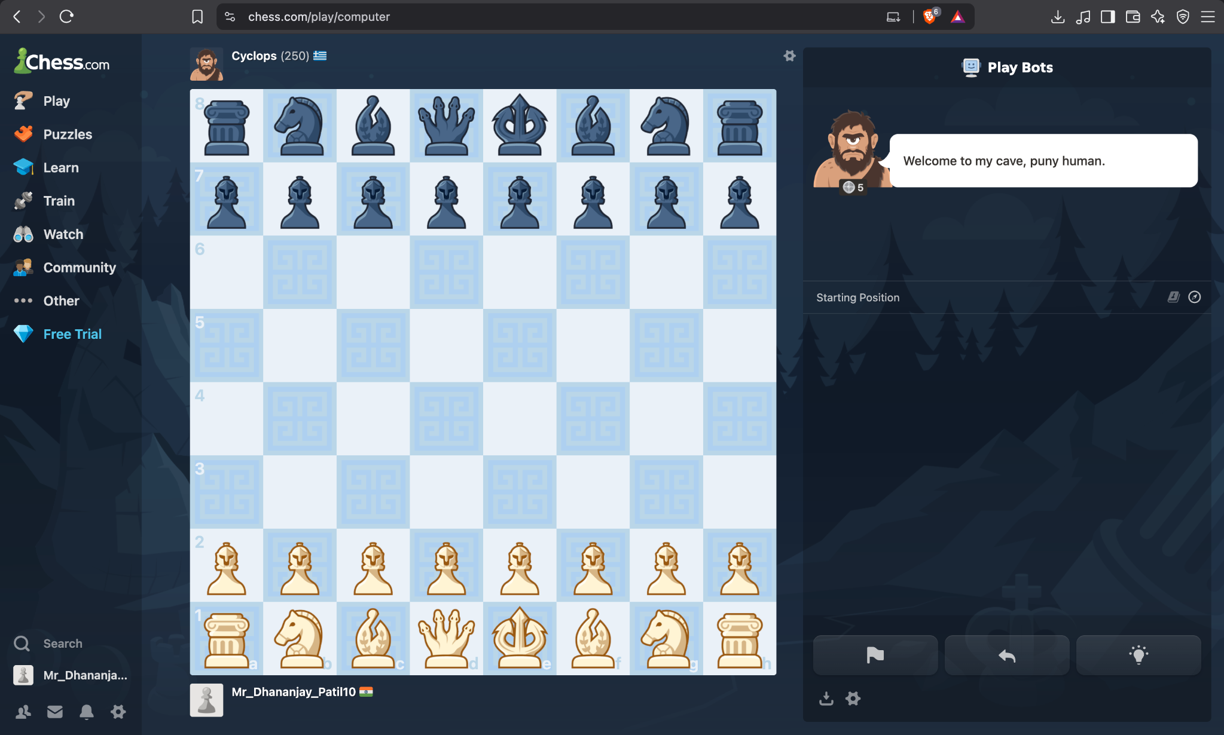
Screenshot 5
TC-06: Play Bots – Hikaru
Testing Step | Select another bot opponent and verify that the selected opponent and starting position are displayed.
Test Input | Select the Hikaru bot.
Expected Result | The selected Hikaru bot, rating, starting position and chessboard should be displayed.
Actual Result | The page shows Hikaru with rating 2820, the starting chessboard, the user's player label and the Play Bots panel.
Status (Pass/Fail) | PASS
Personal Comments & Suggestions | Opponent selection and board state are clearly visible. No chess move is shown, so move validation remains unverified.
Screenshot Evidence | Screenshot 6
Screenshot 6 — Evidence
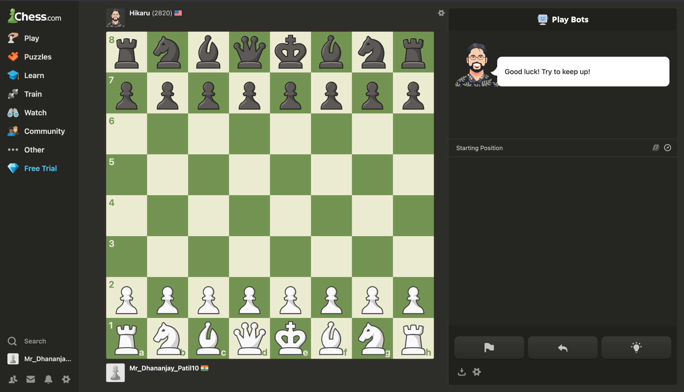
Screenshot 6

TC-07: Game Review
Testing Step | Open Game Review for the displayed game and verify that analysis statistics are shown.
Test Input | Open Game Review for the displayed game.
Expected Result | The review page should display player information, accuracy, move-quality categories, game rating and a review action.
Actual Result | The Game Review panel displays both players, accuracy values, Brilliant/Great/Best/Mistake/Miss/Blunder counts, Game Rating and a 'Start Review' button.
Status (Pass/Fail) | PASS
Personal Comments & Suggestions | Review statistics are clearly visible. The screenshot does not show the detailed move-by-move review after pressing 'Start Review', so that deeper step remains unverified.
Screenshot Evidence | Screenshot 7
Screenshot 7 — Evidence
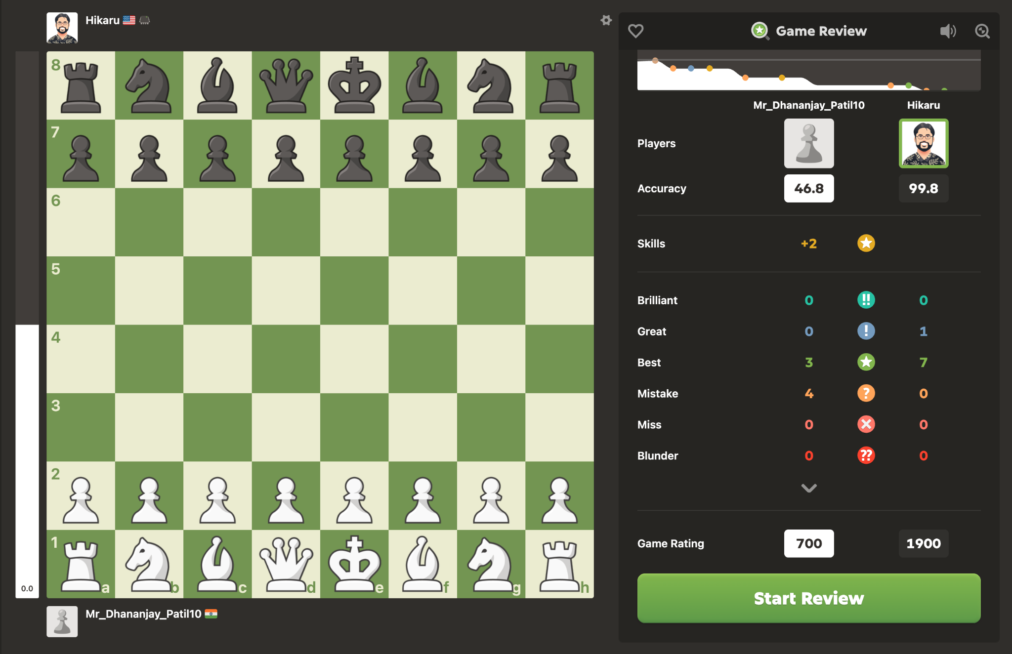
Screenshot 7
TC-08: Settings – Board & Pieces
Testing Step | Open Settings and verify that Board & Pieces customization options and board-coordinate settings are available.
Test Input | Navigate to Settings and open Board & Pieces.
Expected Result | Settings should display customization categories, board choices, a preview, Save/Cancel controls and board-coordinate settings.
Actual Result | The Settings page shows Board & Pieces selected, board theme choices, a preview board, Save/Cancel controls, the Show Board Coordinates toggle, Inside/Outside options and Highlight Last Move.
Status (Pass/Fail) | PASS
Personal Comments & Suggestions | The settings controls are clearly visible. The screenshot verifies presence of controls, not whether Save persists changes after being clicked.
Screenshot Evidence | Screenshot 8
Screenshot 8 — Evidence
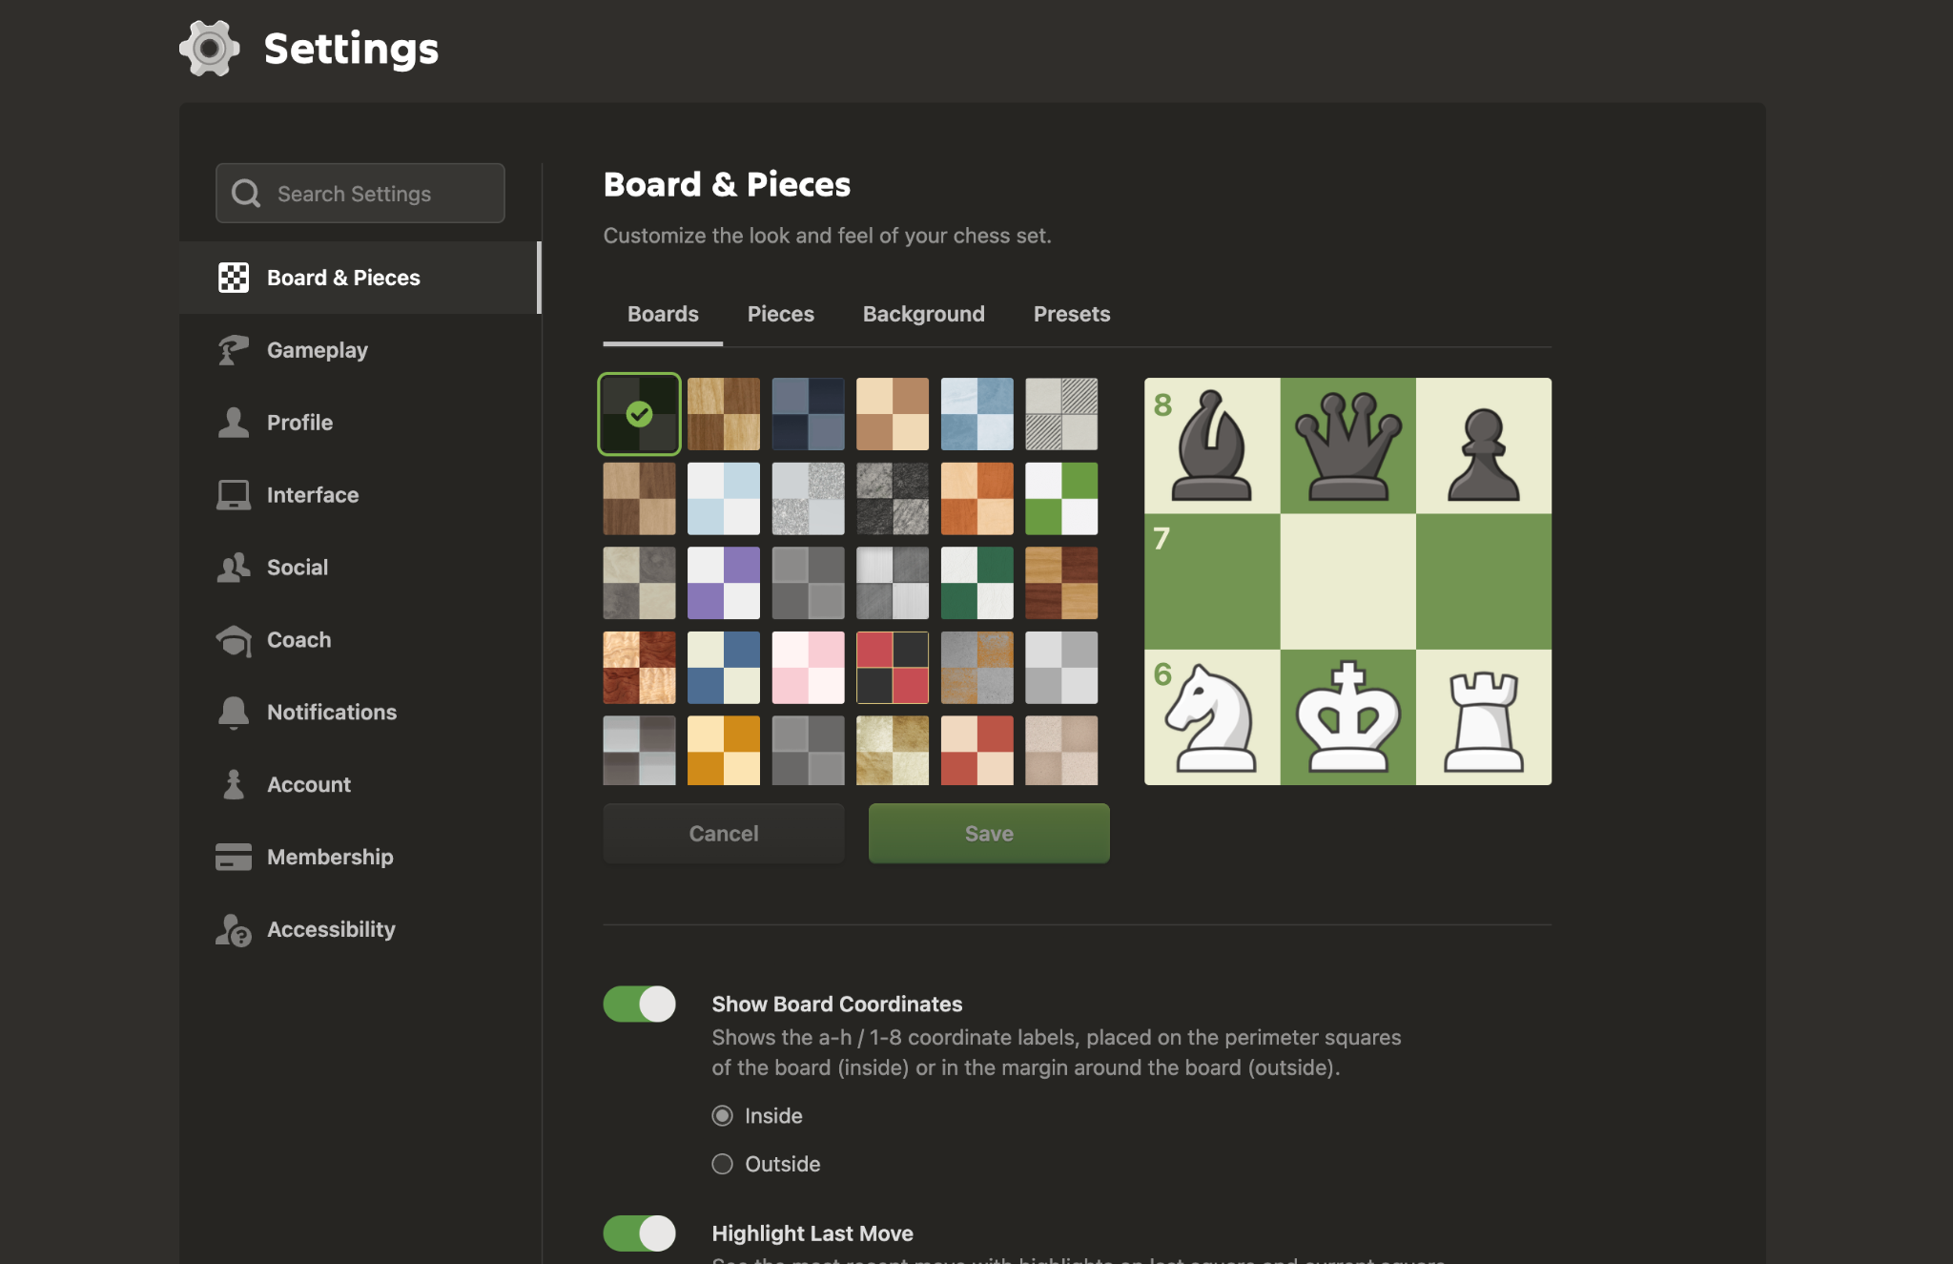
Screenshot 8

12. Incomplete / Unverifiable Evidence
The following checks cannot be verified from the supplied application screenshots. They are recorded as Fail/incomplete evidence checks because the required source documentation or evidence is absent—not because the underlying application feature is proven defective.
ID | Section | Actual Result | Correction Required
AUD-09 | RTM Evidence | Requirement IDs, test-case IDs and requirement-to-test mappings are not visible in the supplied screenshots. | Unverifiable from the supplied screenshots. Add the completed RTM showing Requirement ID → Test Case ID → Result → Screenshot Evidence.
AUD-10 | Formal Test Plan Evidence | No formal Test Plan page or screenshot containing these sections is present in the supplied evidence. | Add the completed Test Plan pages/screenshots. Do not infer missing sections from the application screenshots.
AUD-11 | Formal Test Case Evidence | The application screenshots show UI states, but no formal test-case table is included in the supplied screenshot evidence. | Add the formal test-case table to the practical submission. The Excel report now documents the observed evidence, but the original screenshot set does not prove the source test-case document.
AUD-12 | Screenshot Quality | All eight screenshots are high-resolution and the relevant UI is generally readable; no screenshot is visibly cropped in a way that prevents the stated visual check. | Evidence quality is suitable for the report. Keep the original full screenshots and preserve browser URL/UI context.
AUD-13 | Screenshot Sequencing | The sequence is coherent: landing page → dashboard → puzzle → profile → bots → game review → settings. | The sequence is suitable for a practical report. The corrected DOCX and evidence sheet explicitly number screenshots 1–8.
AUD-14 | RTM Coverage / Missing Evidence | Requirement IDs, traceability links and complete coverage evidence are absent from the supplied screenshots. | Add the missing RTM coverage matrix and evidence references. Mark any requirement without evidence as Not Verified rather than Pass.
13. Tester Observations & Recommendations
• Add the formal Test Plan with objectives, scope, test strategy, assumptions, entry criteria and exit criteria.
• Add the RTM with Requirement ID, Test Case ID, expected result, actual result, status and screenshot evidence.
• Add negative/validation test cases showing invalid input, error messages, boundary conditions or rejected actions where applicable.
• Capture post-action screenshots for actions such as starting a bot game or saving settings; the current screenshots show the available controls but not the completed action.
• Keep all eight original screenshots as evidence. Do not replace them with cropped images that hide the URL, navigation or relevant UI state.
• Use 'Not Verified' or 'Unverifiable from supplied evidence' when a result cannot be established from the screenshot.
14. Tester Conclusion
Based strictly on the supplied screenshots, the eight visible application UI checks pass because the expected visible page/state is present in each image. No unsupported application behavior has been assumed. The practical remains incomplete as a formal Test Plan & RTM submission until the missing Test Plan, RTM traceability and source test-case documentation are added.
15. Screenshot Evidence Index
Screenshot | Visible Evidence | Test Case
Screenshot 1 | Home / Landing Page | TC-01
Screenshot 2 | Logged-in Home Dashboard | TC-02
Screenshot 3 | Puzzles | TC-03
Screenshot 4 | User Profile | TC-04
Screenshot 5 | Play Bots – Cyclops | TC-05
Screenshot 6 | Play Bots – Hikaru | TC-06
Screenshot 7 | Game Review | TC-07
Screenshot 8 | Settings – Board & Pieces | TC-08

