Software Testing Report
Tutorial 3 – Requirement Reviews & Inspections
Swag Labs Demo E-Commerce Website
Student Name | Bhavesh Patil
Course | BCA
Subject | Software Testing
Project | Swag Labs Requirement Review
Enrollment No. | 2504030100419
Website | https://www.saucedemo.com
Module | Login Module
Testing Type | Static Testing (Requirement Review & Inspection)
Test Technique | Black Box Requirement Review
Browser / OS | Chrome / Windows 11

1. Objective
To verify that the Login Module requirements specified in the Software Requirement Specification (SRS) are correctly implemented in the Swag Labs application through requirement review, inspection, and walkthrough.

2. Test Environment
Parameter | Value
Application | Swag Labs
URL | https://www.saucedemo.com
Credentials | standard_user / secret_sauce
Expected Outcome | User redirected to Products (Inventory) page

3. Requirement Review Summary
During the inspection, the login functionality was compared against the documented requirements. The Username and Password fields were available, the password input was masked, authentication worked successfully using valid credentials, and the user was redirected to the Products page. Observed behavior matched the expected functional requirements.

4. Detailed Test Execution
Section | Testing Step | Test Input | Expected Result | Actual Result | Status | Tester Comments
Requirement Review | Review SRS | Login Requirements | Clear & complete requirements | Requirements understandable | PASS | No ambiguity found.
Launch Website | Open application | URL | Login page loads | Loaded successfully | PASS | Stable response.
Username | Enter username | standard_user | Accept valid input | Accepted | PASS | Validation correct.
Password | Enter password | secret_sauce | Password masked | Masked successfully | PASS | Security requirement met.
Authentication | Click Login | Login Button | Navigate to Products page | Products page displayed | PASS | Requirement satisfied.
Navigation | Open Cart | Cart icon | Cart page opens | Opened successfully | PASS | Navigation works.
Checkout | Proceed to Checkout Overview | Checkout | Overview displayed | Overview page displayed | PASS | Workflow successful.

5. Observations
- All mandatory login controls are present.
- Password field masks sensitive information.
- Valid credentials successfully authenticate the user.
- Products (Inventory) page loads after successful login.
- Cart page and Checkout Overview page were accessible after navigation.
- No missing or conflicting requirements were identified during inspection.

6. Screenshots (Evidence)
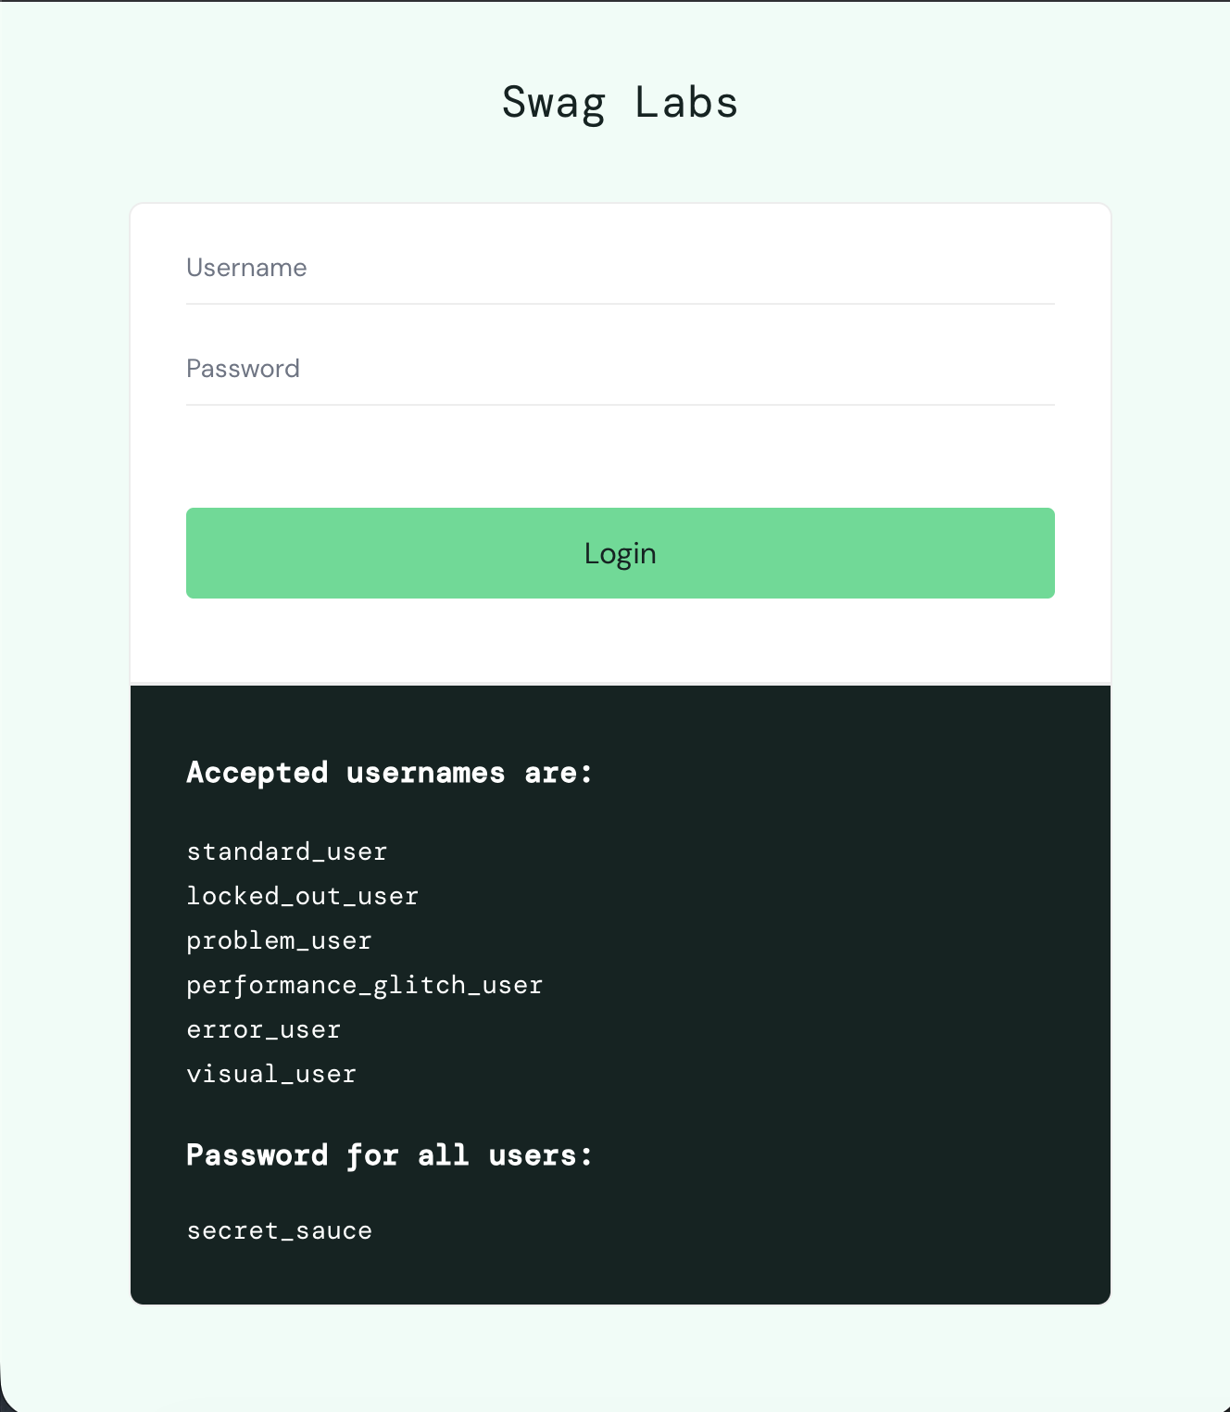
Figure 1: Swag Labs Login Page
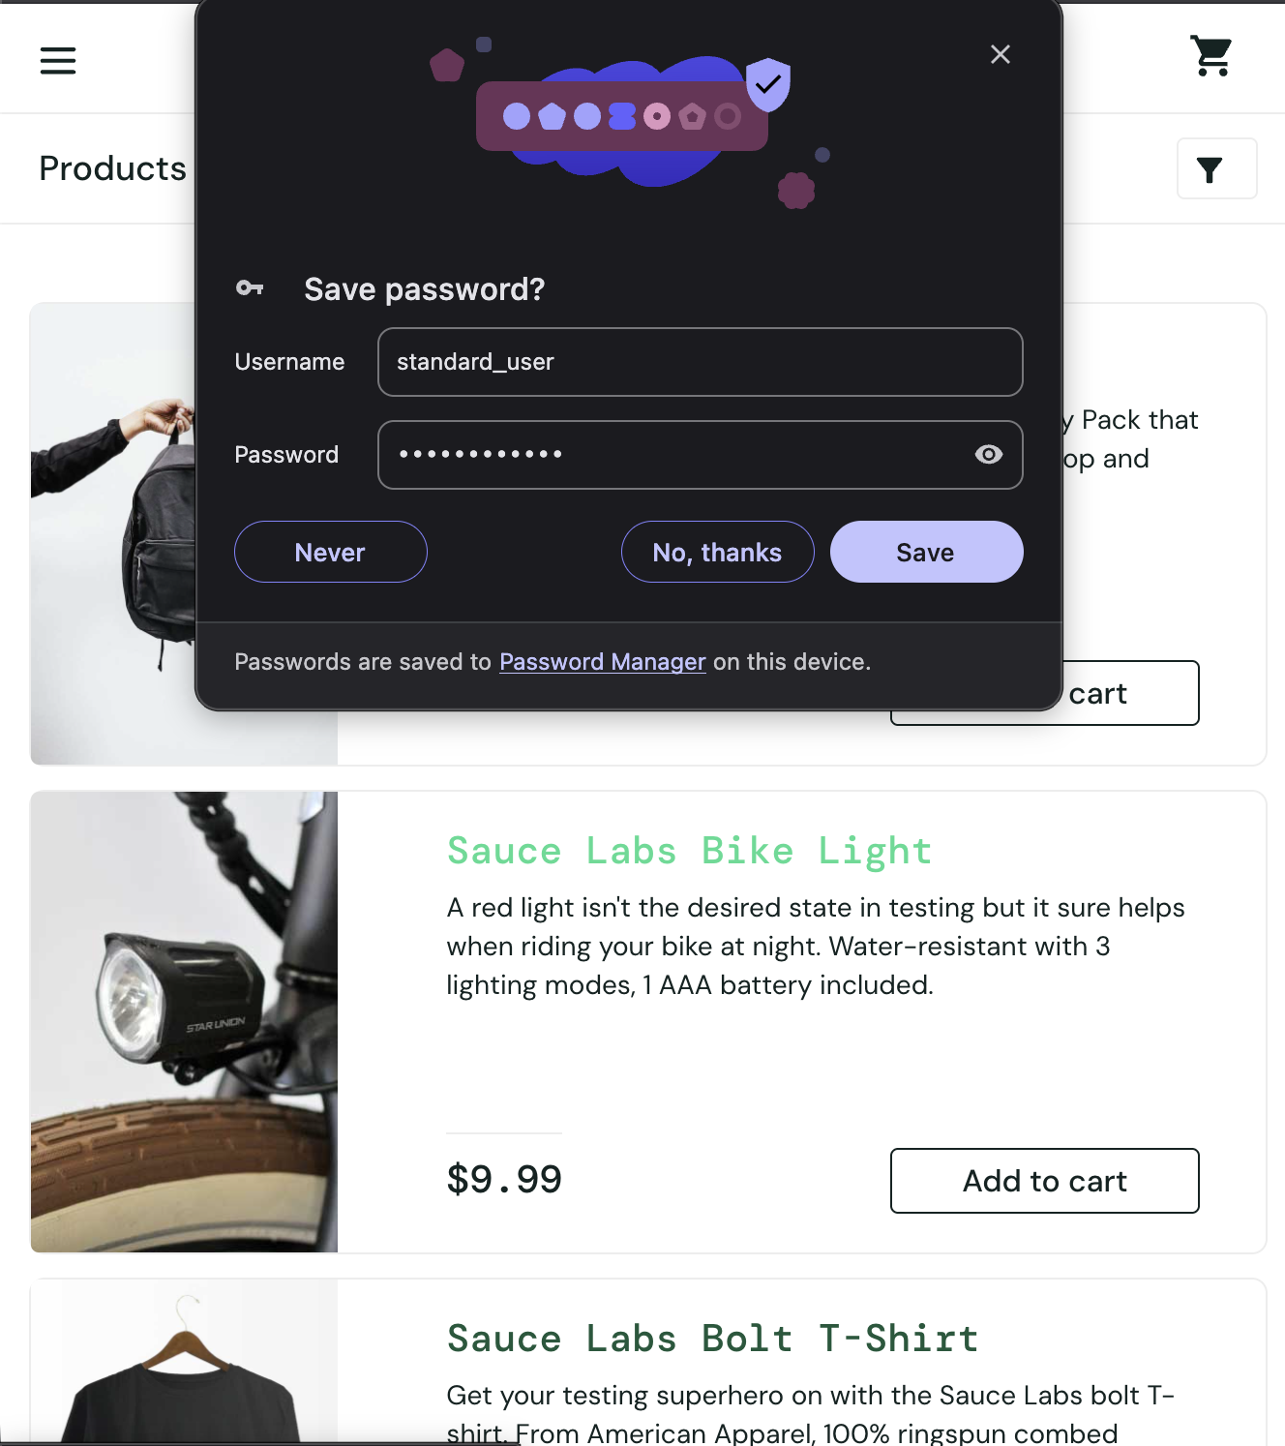
Figure 2: Login Successful (Password Manager Prompt Visible)
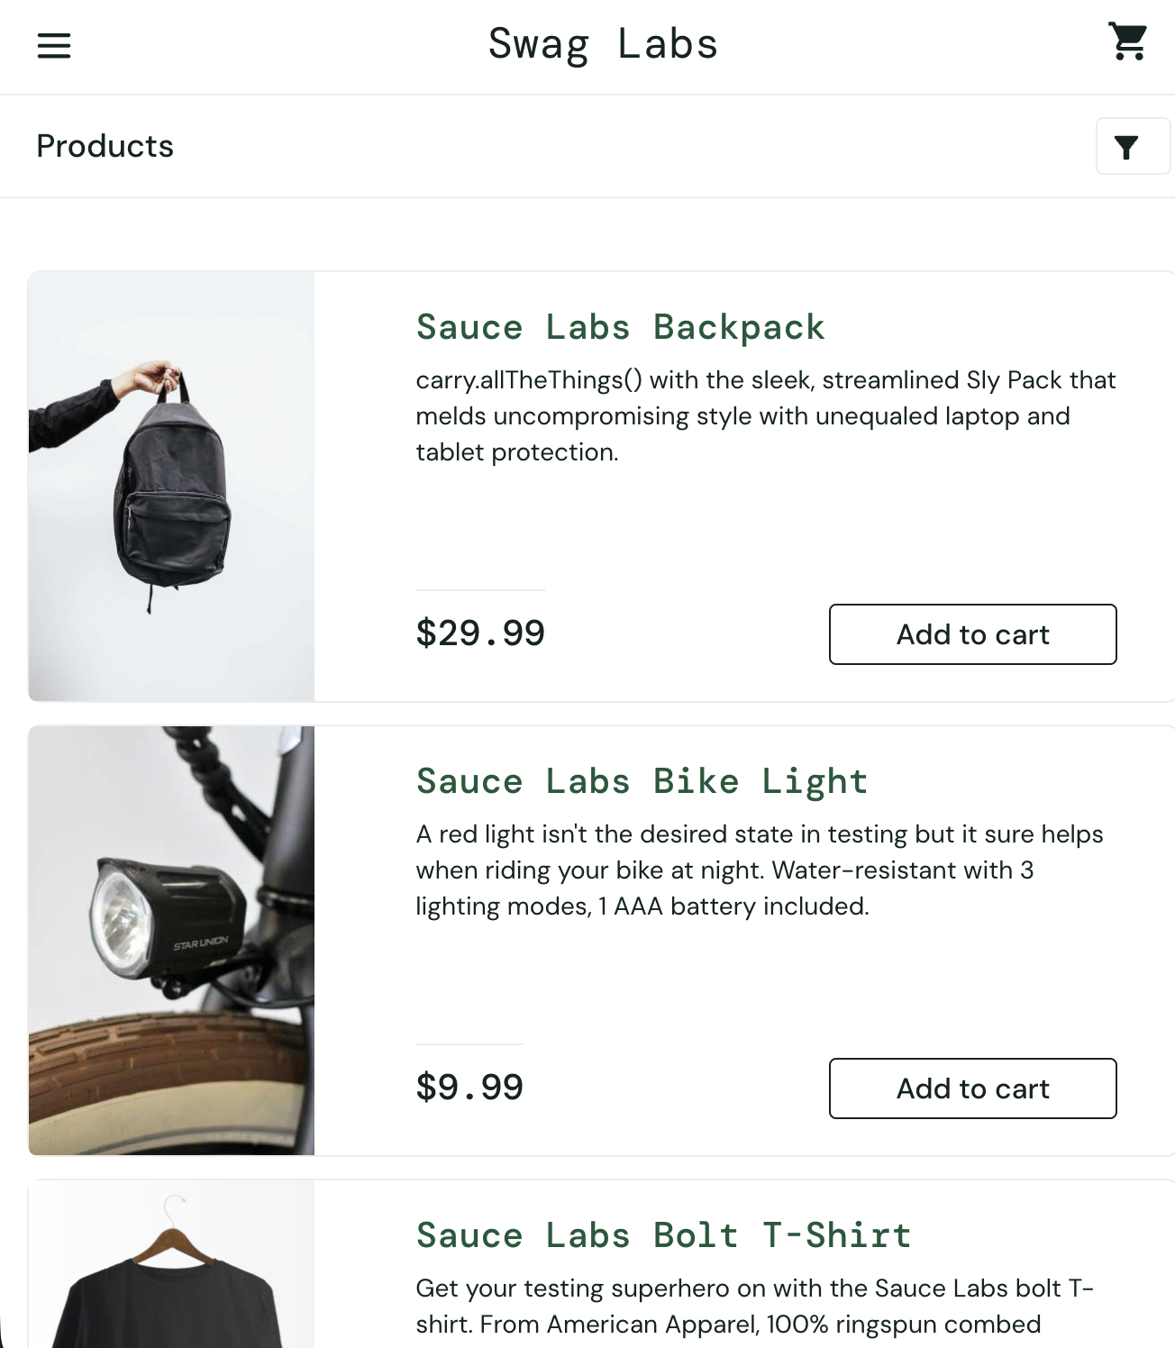
Figure 3: Products (Inventory) Page
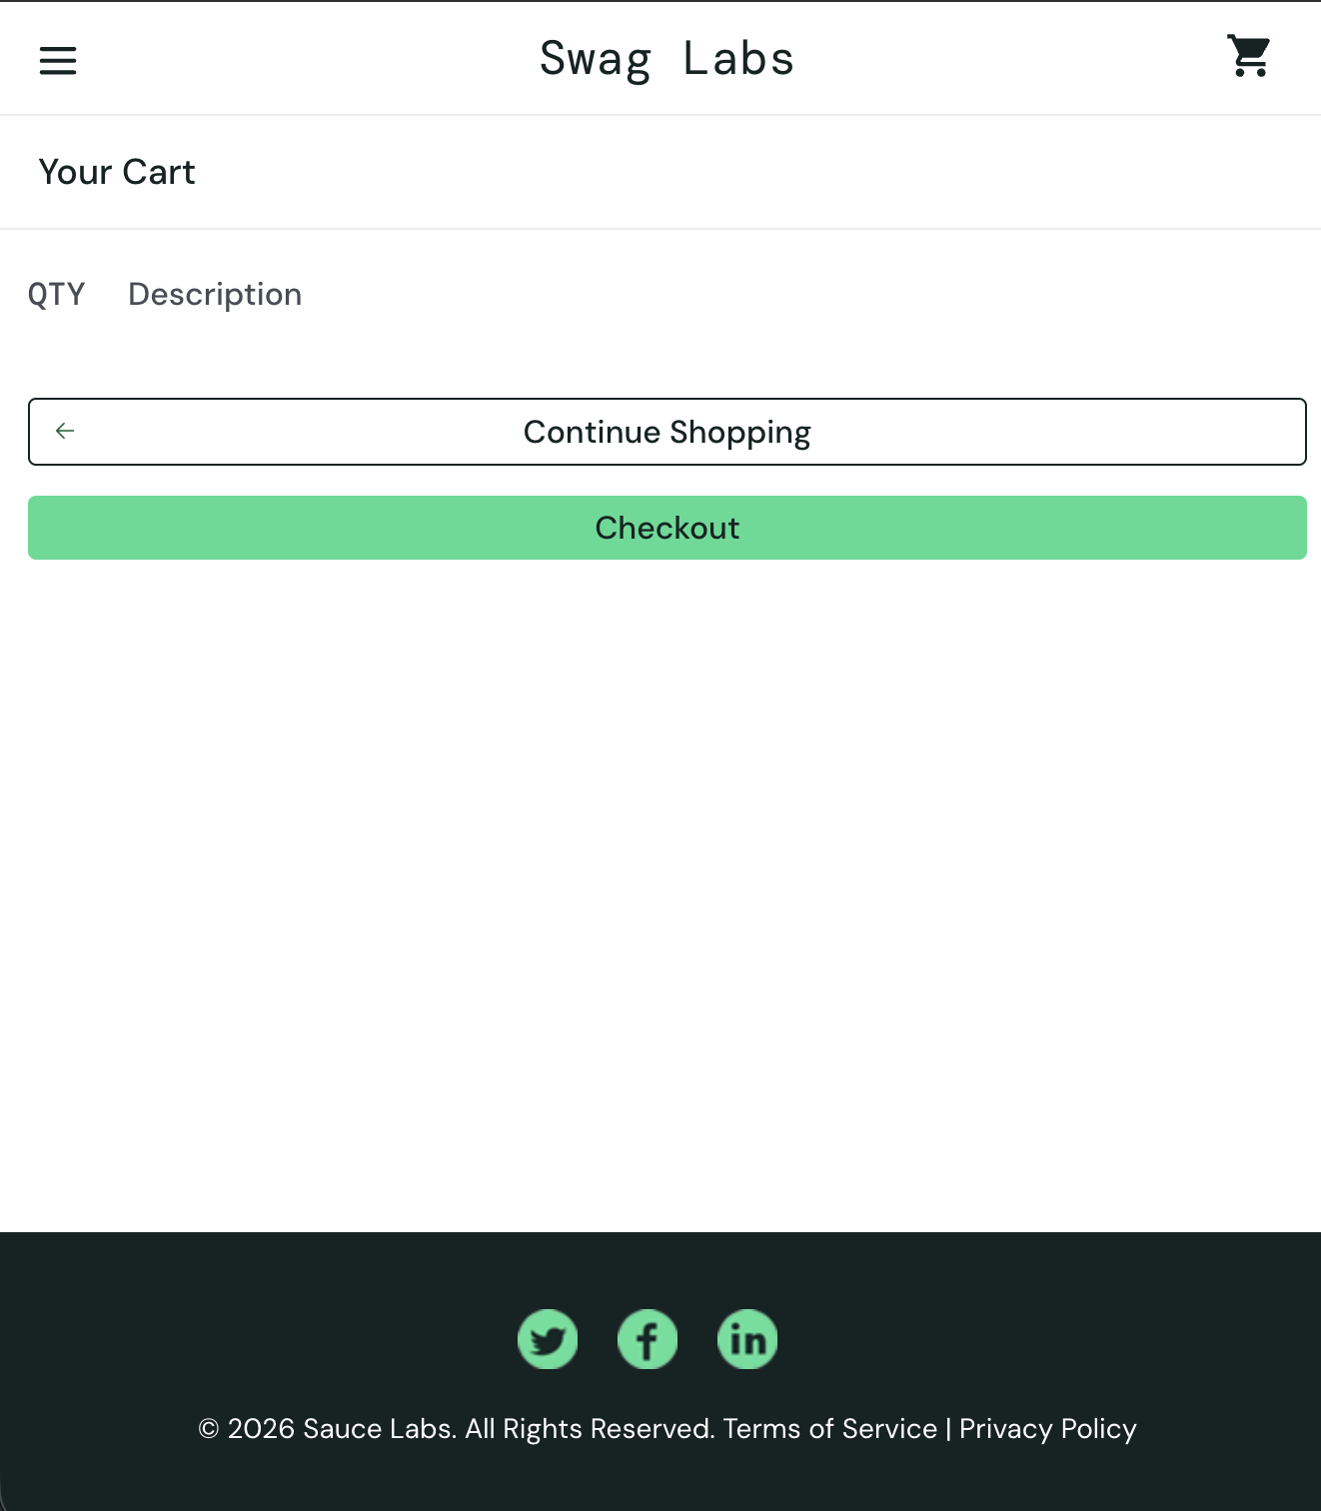
Figure 4: Cart Page
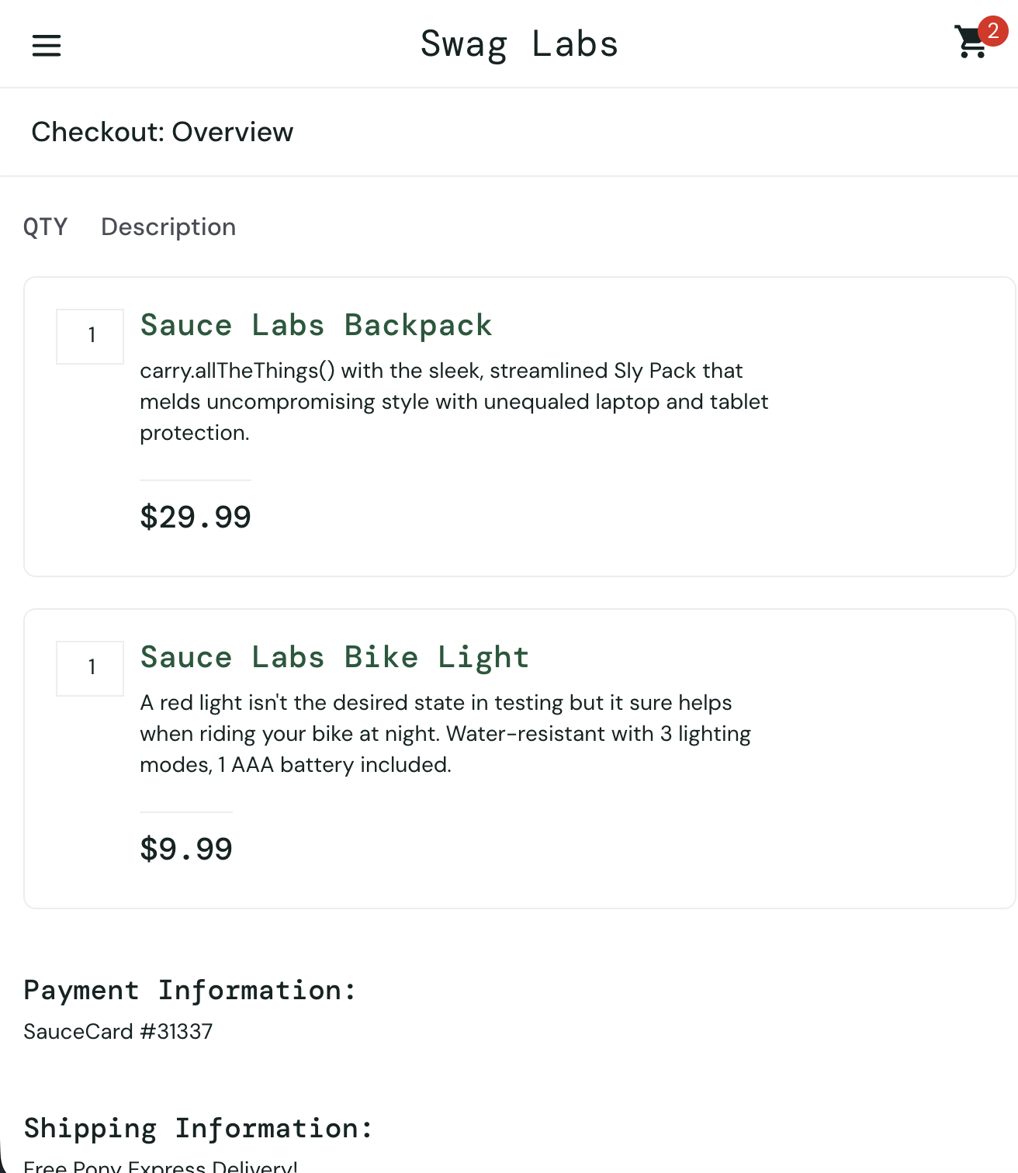
Figure 5: Checkout Overview Page

7. Conclusion
The Swag Labs Login Module meets the reviewed functional requirements specified in the SRS. The inspection confirmed correct implementation of authentication, secure password masking, successful navigation to the Products page after login, and proper workflow through Cart and Checkout Overview. No requirement gaps or functional inconsistencies were identified during the review. Based on the executed inspection, the module is recommended for acceptance.

