SOFTWARE TESTING REPORT
Tutorial 5 – Defect Reporting
Application: The Internet (Herokuapp)
Student Name: Bhavesh Patil
Course: BCA
Subject: Software Testing
Enrollment No.: 2504030100419

1. Introduction
This report presents the results of manual exploratory testing performed on selected modules of 'The Internet (Herokuapp)'. The objective was to identify observable software defects, verify the expected behaviour of different modules, and document the findings using professional software testing practices.

2. Test Environment
Parameter | Value
Application | The Internet (Herokuapp)
Version | 1.0
Browser | Chrome 126
Operating System | Windows 11
Testing Type | Manual Exploratory Testing
Tester | Bhavesh Patil

3. Test Scenarios

3.1 Homepage
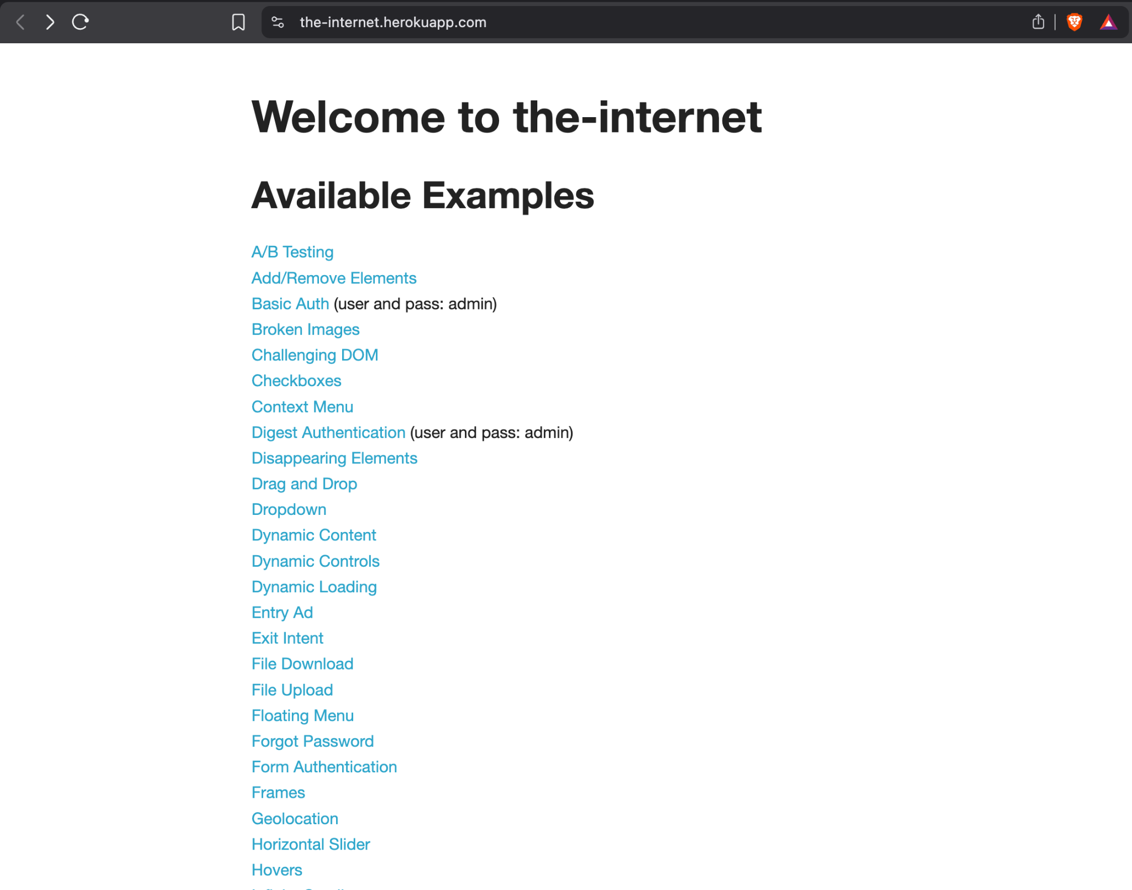
Figure 1: Homepage
Description: The homepage is the entry point of the application and lists all available testing modules used for manual testing.
Test Objective: Verify that the application launches successfully, all links are visible, and navigation is available.
Expected Result: Homepage should load successfully without errors and display all available modules.
Actual Result: Homepage loaded successfully. All listed modules were visible and clickable.
Status: PASS
Observation / Analysis: No functional issues were observed. The application was ready for testing.

3.2 Broken Images Module
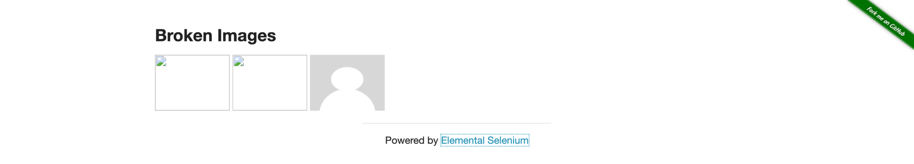
Figure 2: Broken Images Module
Description: The Broken Images module is designed to demonstrate broken image resources. In the screenshot, two images display broken image placeholders while one image loads correctly.
Test Objective: Verify that all image resources are loaded correctly.
Expected Result: Every image should render successfully without missing resources.
Actual Result: Two images failed to load and displayed broken-image icons.
Status: FAIL
Observation / Analysis: Confirmed reproducible defect.
Bug ID: BUG_001
Severity: Medium
Priority: Medium
Reason: Invalid or unavailable image resources.

3.3 Dropdown Module
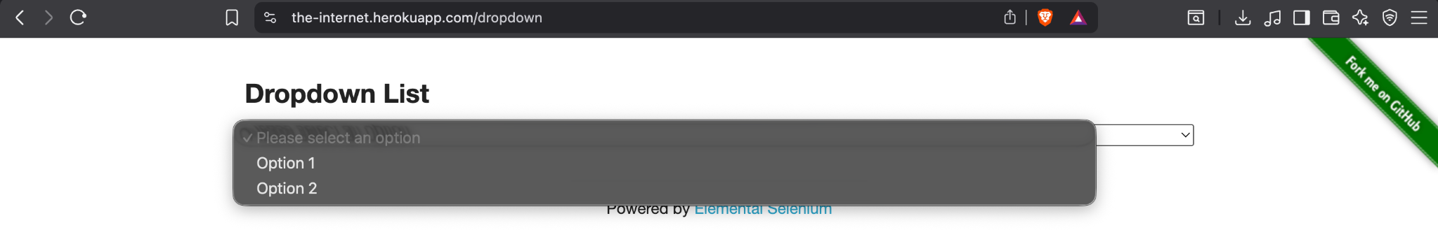
Figure 3: Dropdown Module
Description: The Dropdown module contains a standard HTML dropdown list with two selectable options.
Test Objective: Verify that the dropdown expands correctly and allows option selection.
Expected Result: Dropdown should open smoothly and display available options.
Actual Result: Dropdown expanded successfully and displayed Option 1 and Option 2.
Status: PASS
Observation / Analysis: No defect was observed in the captured evidence.

3.4 Basic Authentication

Figure 4: Basic Authentication
Description: The application requested HTTP Basic Authentication before granting access to the protected resource.
Test Objective: Verify that authentication is requested before accessing the protected page.
Expected Result: Browser should display an authentication dialog requesting valid credentials.
Actual Result: Authentication dialog appeared correctly.
Status: PASS
Observation / Analysis: Security behaviour is working as expected.

3.5 JQuery UI Menu
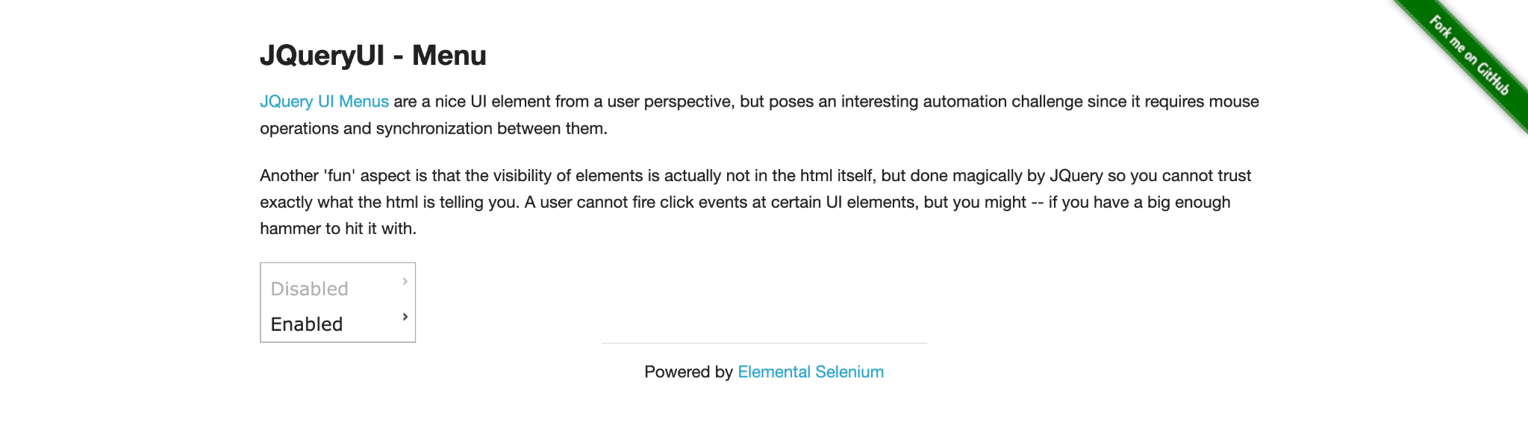
Figure 5: JQuery UI Menu
Description: The JQuery UI Menu demonstrates nested menu functionality.
Test Objective: Verify that the menu loads correctly and responds to user interaction.
Expected Result: Menu should display all items and allow navigation.
Actual Result: Menu loaded correctly with Enabled and Disabled options visible.
Status: PASS
Observation / Analysis: No functional issue observed.

4. Confirmed Defect Report
Only one confirmed defect is supported by the captured screenshots. Professional testing practice requires reporting only issues that can be reproduced and verified.
Bug ID | Module | Description | Severity | Priority | Status
BUG_001 | Broken Images | Two image resources failed to load and displayed broken image placeholders. | Medium | Medium | New

5. Overall Test Summary
Module | Result | Remarks
Homepage | PASS | Application loaded successfully.
Broken Images | FAIL | Broken image defect confirmed.
Dropdown | PASS | Working as expected.
Basic Authentication | PASS | Authentication dialog displayed.
JQuery UI Menu | PASS | Menu displayed correctly.

6. Conclusion
Manual exploratory testing was successfully completed on the selected modules. The Homepage, Dropdown, Basic Authentication, and JQuery UI Menu behaved according to the expected functionality observed during testing. The Broken Images module contained a reproducible functional defect where image resources failed to load correctly. This defect has been documented with an appropriate severity and priority. The report follows professional software testing practices by recording only defects that are supported by test evidence.

