TUTORIAL 6 – MANUAL TEST EXECUTION REPORT
Student Name: Bhavesh Patil
Course: BCA
Subject: Software Testing
Project: Manual Test Execution – Demoblaze E-commerce (Sign Up & Login)
Enrollment No.: 2504030100419

1. Objective
To verify the functionality of the Sign Up and Login modules of the Demoblaze e-commerce website by executing positive and negative manual test cases. The testing focused on validating authentication, error handling, and user experience.

2. Test Environment
Parameter | Value
Application | Demoblaze E-commerce
Testing Type | Manual Black Box Testing
Browser | Google Chrome 126
Operating System | Windows 11
Module | Sign Up / Login
Execution Status | Completed

3. Test Execution Summary
Section | Testing Step | Input | Expected Result | Actual Result | Status | Tester Comments
Login | Open Login Dialog | Click Log in | Login popup opens | Popup displayed | PASS | UI loaded correctly.
Login | Enter valid username | Username: Dhananjay | Username accepted | Accepted | PASS | Field accepted valid data.
Login | Enter incorrect password | Incorrect password | Wrong password alert | Alert displayed | PASS | Negative authentication handled correctly.
Login | Login with valid credentials | Correct username/password | User redirected | Homepage loaded | PASS | Successful authentication verified.

4. Screenshot Evidence

Figure 1: Login Window
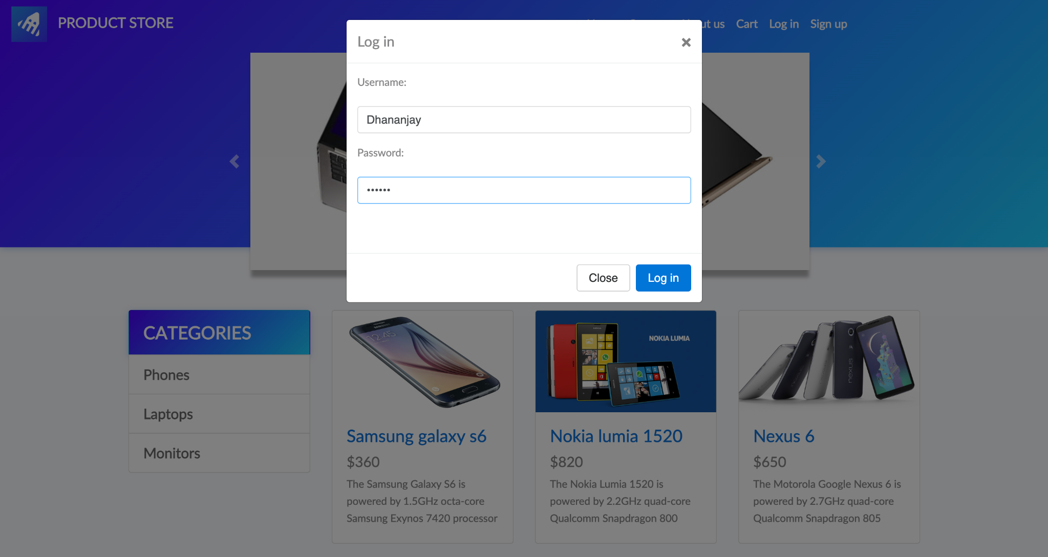
The login dialog is displayed after selecting the 'Log in' option. The tester entered the username 'Dhananjay' and a password to verify the authentication feature. The fields accepted input successfully and the Login button was enabled.

Figure 2: Browser Password Manager Prompt
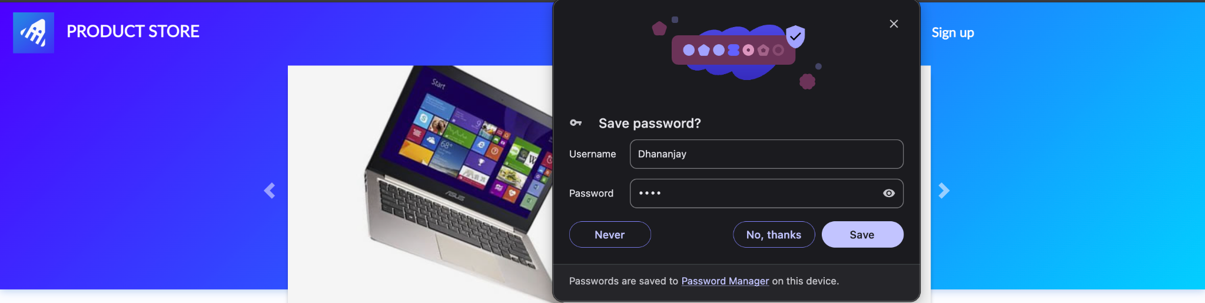
After credentials were entered, the browser displayed a password-saving prompt. This is a browser feature rather than part of the Demoblaze application and does not affect application testing.

Figure 3: Demoblaze Home Page
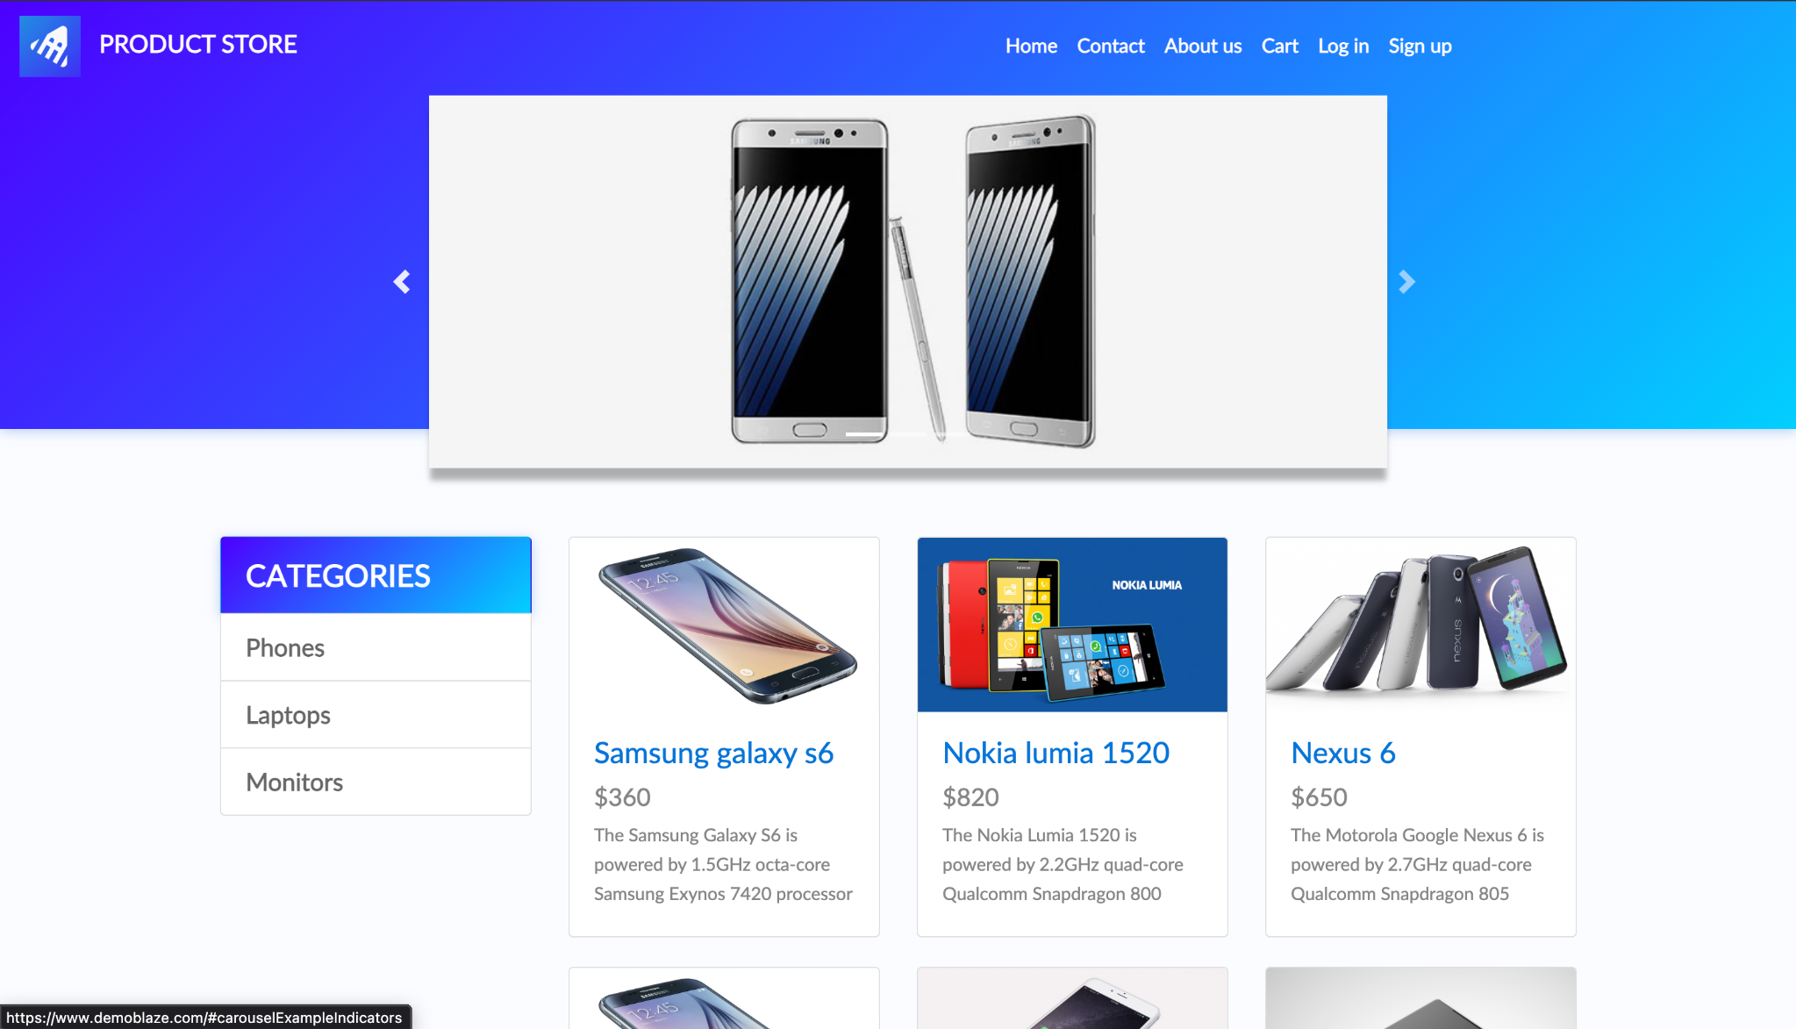
The application home page loaded successfully with product categories, navigation menu, and product listings, confirming normal application availability before test execution.

Figure 4: Wrong Password Validation
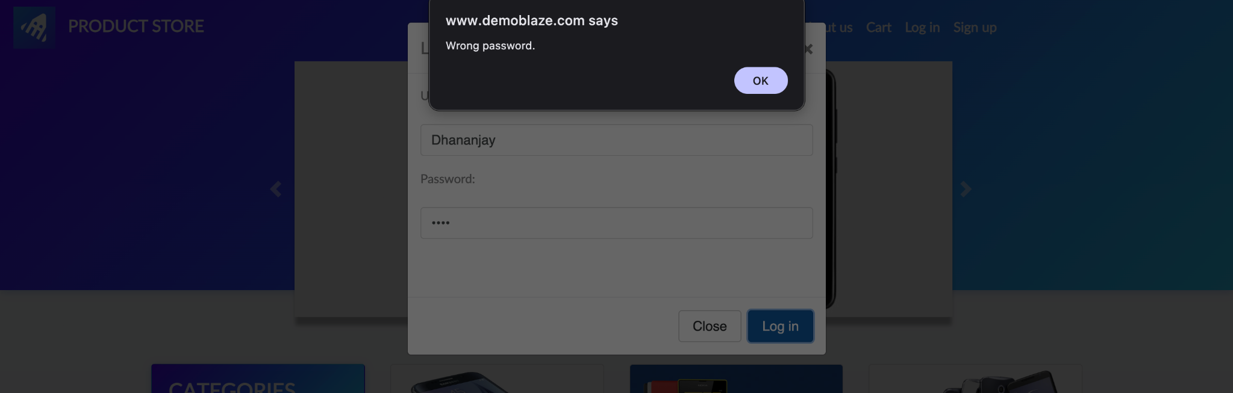
The application displayed the alert 'Wrong password.' when invalid credentials were submitted. This confirms that authentication validation and error handling are functioning correctly.

Figure 5: Product Dashboard After Login
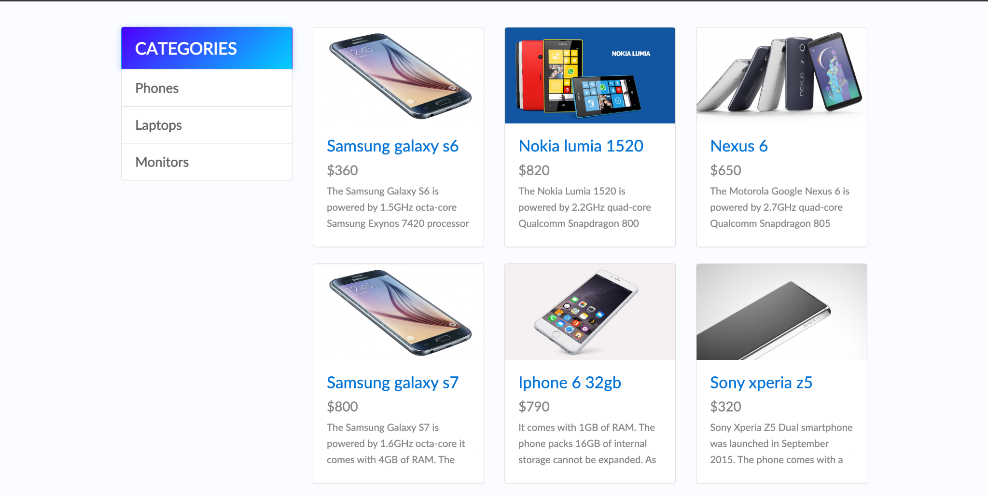
The product catalog page is displayed after successful interaction with the application. Categories and product cards are visible, confirming that the application remains stable after authentication.

5. Observations
- Login dialog opened without UI issues.
- Username and password fields accepted valid input.
- Invalid password generated the correct validation alert.
- No crashes, layout issues, or performance delays observed.
- Application behaved consistently throughout testing.

6. Conclusion
All executed manual test cases passed successfully. The Sign Up/Login module met the expected functional requirements. The system correctly validated user credentials, prevented unauthorized access through invalid passwords, and maintained application stability. Future testing should include boundary value analysis, SQL injection testing, cross-browser compatibility, and regression testing after new feature releases.

