SOFTWARE TESTING
TUTORIAL-7
Boundary Value Analysis (BVA) & Equivalence Partitioning

Name | Bhavesh Patil
Semester | BCA SEM 3
Subject | Software Testing
Enrollment No. | 2504030100419
Application Under Test | Chess.com

Aim: Apply Boundary Value Analysis (BVA) and Equivalence Partitioning techniques for validation testing of forms and authentication modules.
Evidence principle: Only behavior visible in the supplied screenshots is treated as executed evidence. Where a required test is not shown, the result is recorded as N/A rather than assumed.

1. Executive Summary
Screenshots reviewed | 11
Directly evidenced Pass | 1 — incorrect password rejection
Directly evidenced Fail | 0
Not evidenced / incomplete | BVA boundary tests and most equivalence partitions
Main observation | The screenshots strongly demonstrate Chess.com navigation, authentication error handling, puzzles, profile, games, review, and settings, but they do not demonstrate the required BVA boundary inputs.

Reference for expected password boundary
Chess.com’s current official help documentation states that account passwords must be at least 8 characters and include letters and numbers; its password-change guidance additionally specifies uppercase, lowercase, and number requirements. This information is used only as a documented requirement reference; it is not treated as screenshot evidence.
2. Test Cases
Test Case 1: Open Chess.com landing page
Section | Authentication
Testing Step | Open Chess.com landing page
Test Input | Open chess.com
Expected Result | Home page should load with Sign Up and Log In options.
Actual Result | Landing page is visible with Sign Up and Log In controls.
Status | N/A
Personal Comments & Suggestions | Useful setup evidence, but it does not test BVA or equivalence partitions.
Screenshot Evidence | Screenshot 1
Evidence: Screenshot 1
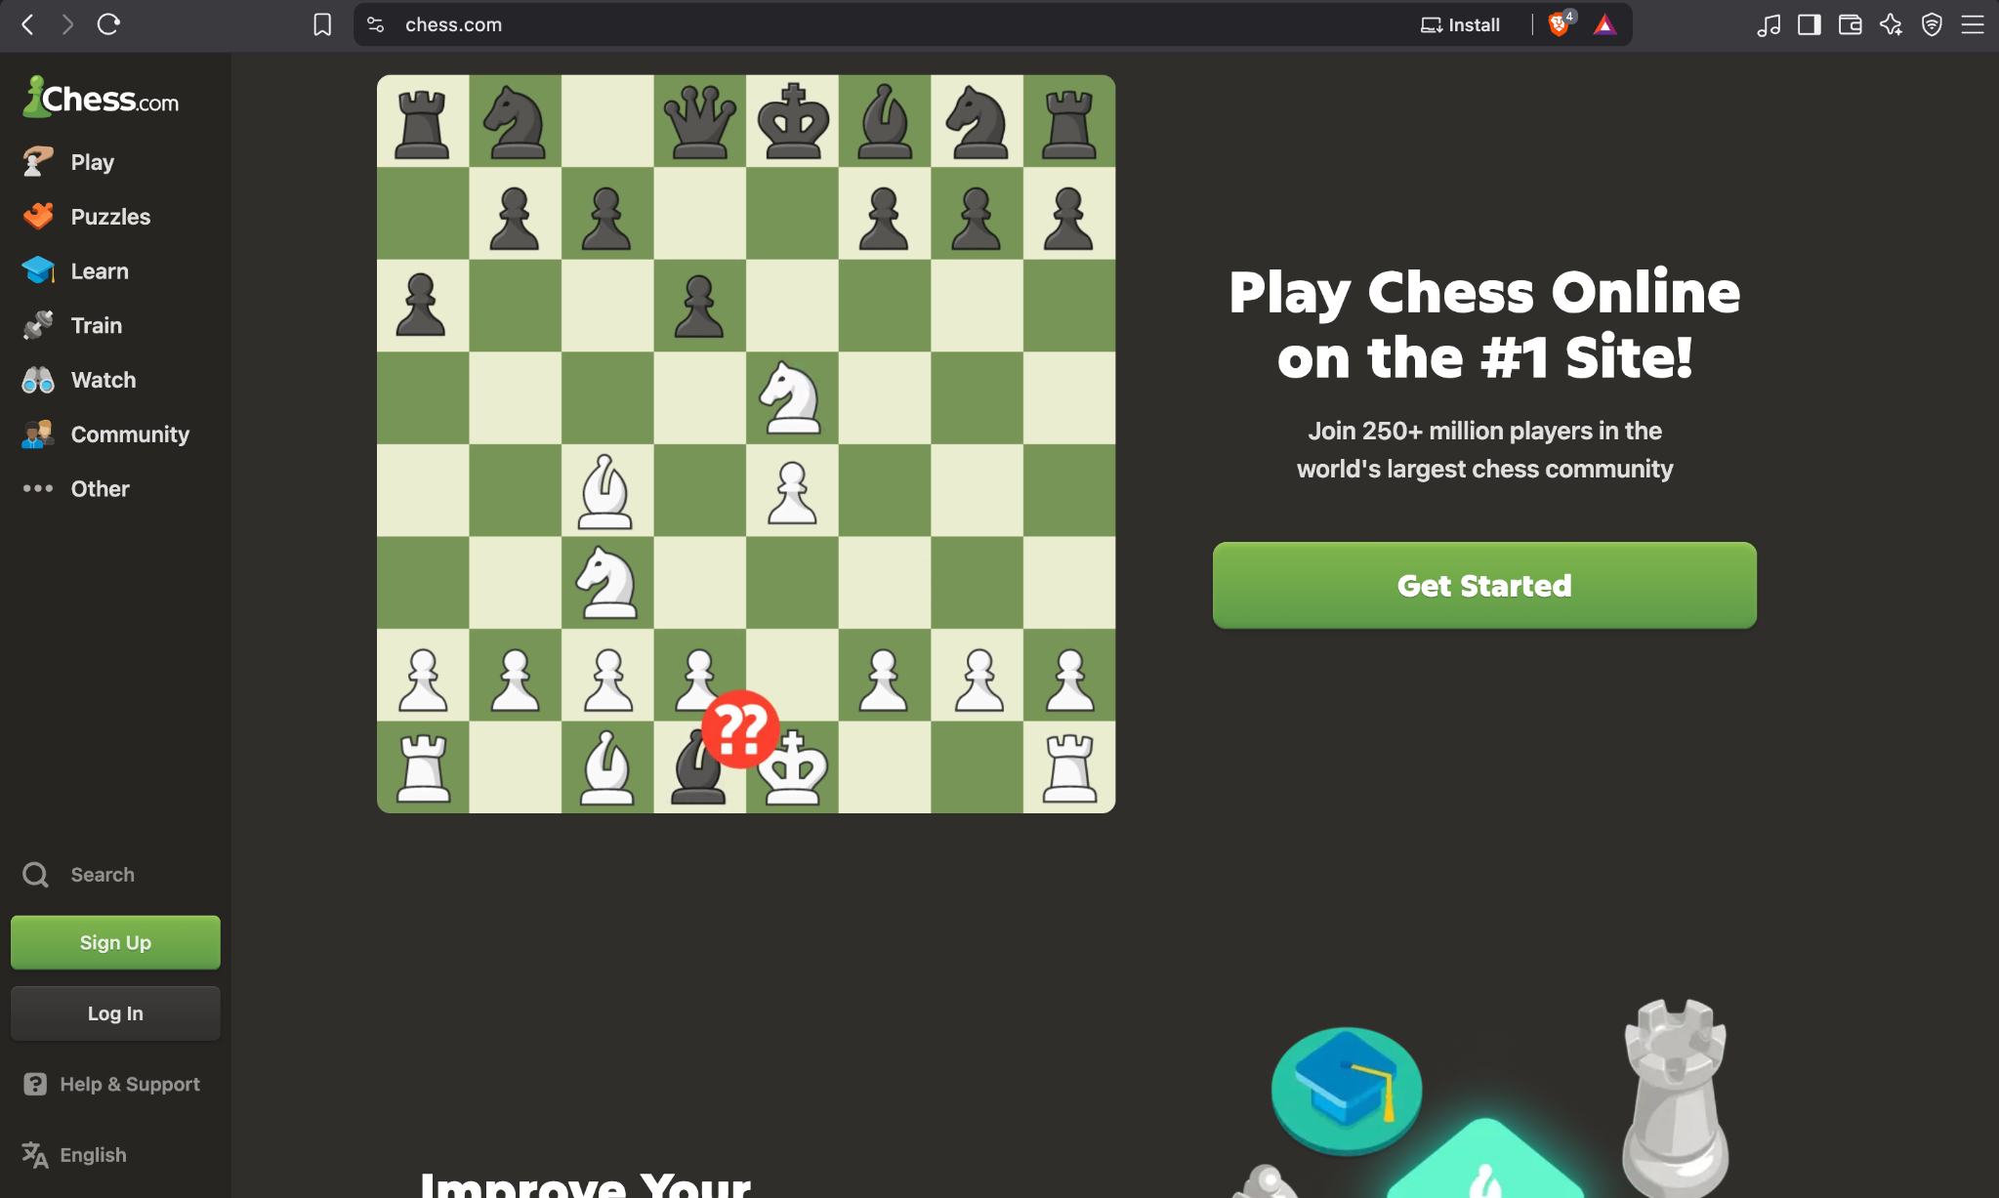
Screenshot 1 — supplied practical evidence

Test Case 2: Submit incorrect password
Section | Authentication
Testing Step | Submit incorrect password
Test Input | Username shown: Dhananjay; incorrect password
Expected Result | Login should be rejected and a clear error should be displayed.
Actual Result | The login page shows: “This password is incorrect.” The password field is highlighted for error.
Status | Pass
Personal Comments & Suggestions | Directly evidenced negative authentication test. This is the strongest test case in the supplied evidence.
Screenshot Evidence | Screenshot 2
Evidence: Screenshot 2
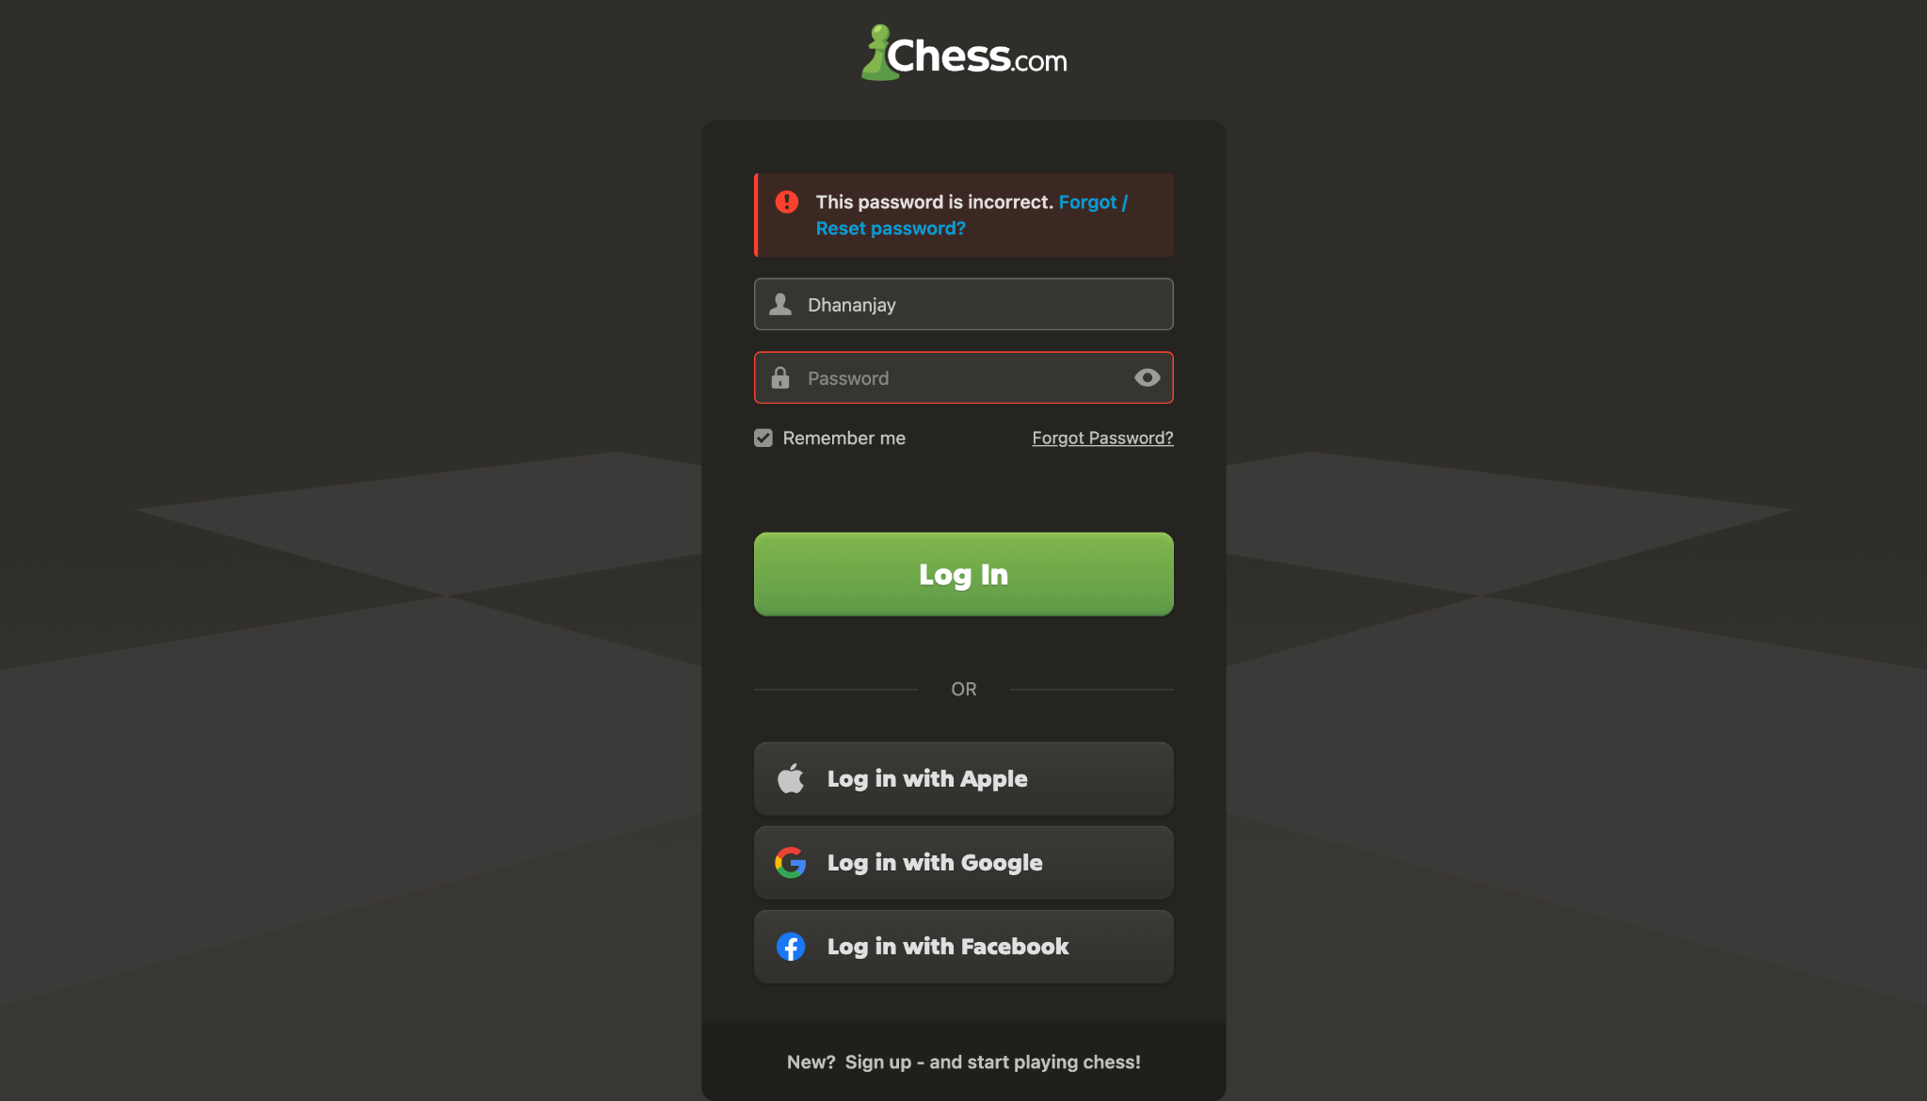
Screenshot 2 — supplied practical evidence

Test Case 3: Access authenticated home page
Section | Authentication
Testing Step | Access authenticated home page
Test Input | Signed-in session
Expected Result | Successful authentication should lead to an authenticated area.
Actual Result | Chess.com home page is visible with the signed-in account area and account controls.
Status | N/A
Personal Comments & Suggestions | The screenshot proves an authenticated state, but not the actual successful login input/action, so it should not be marked Pass.
Screenshot Evidence | Screenshot 3
Evidence: Screenshot 3
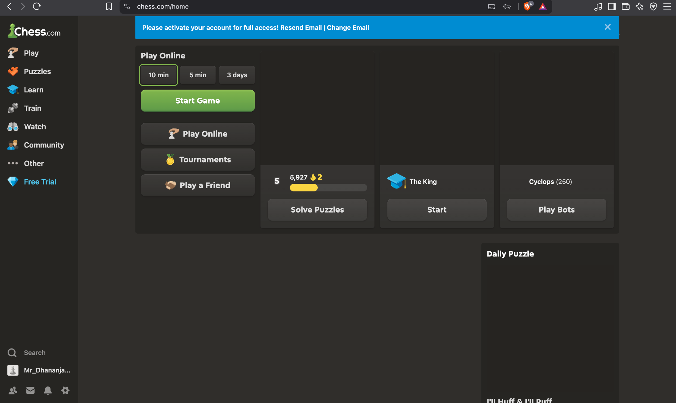
Screenshot 3 — supplied practical evidence

Test Case 4: Open Puzzles
Section | Supporting UI
Testing Step | Open Puzzles
Test Input | Select Puzzles
Expected Result | Puzzles section should open without UI/navigation error.
Actual Result | Puzzle introduction dialog is displayed.
Status | N/A
Personal Comments & Suggestions | Valid navigation evidence, but unrelated to BVA/EP form validation.
Screenshot Evidence | Screenshot 4
Evidence: Screenshot 4
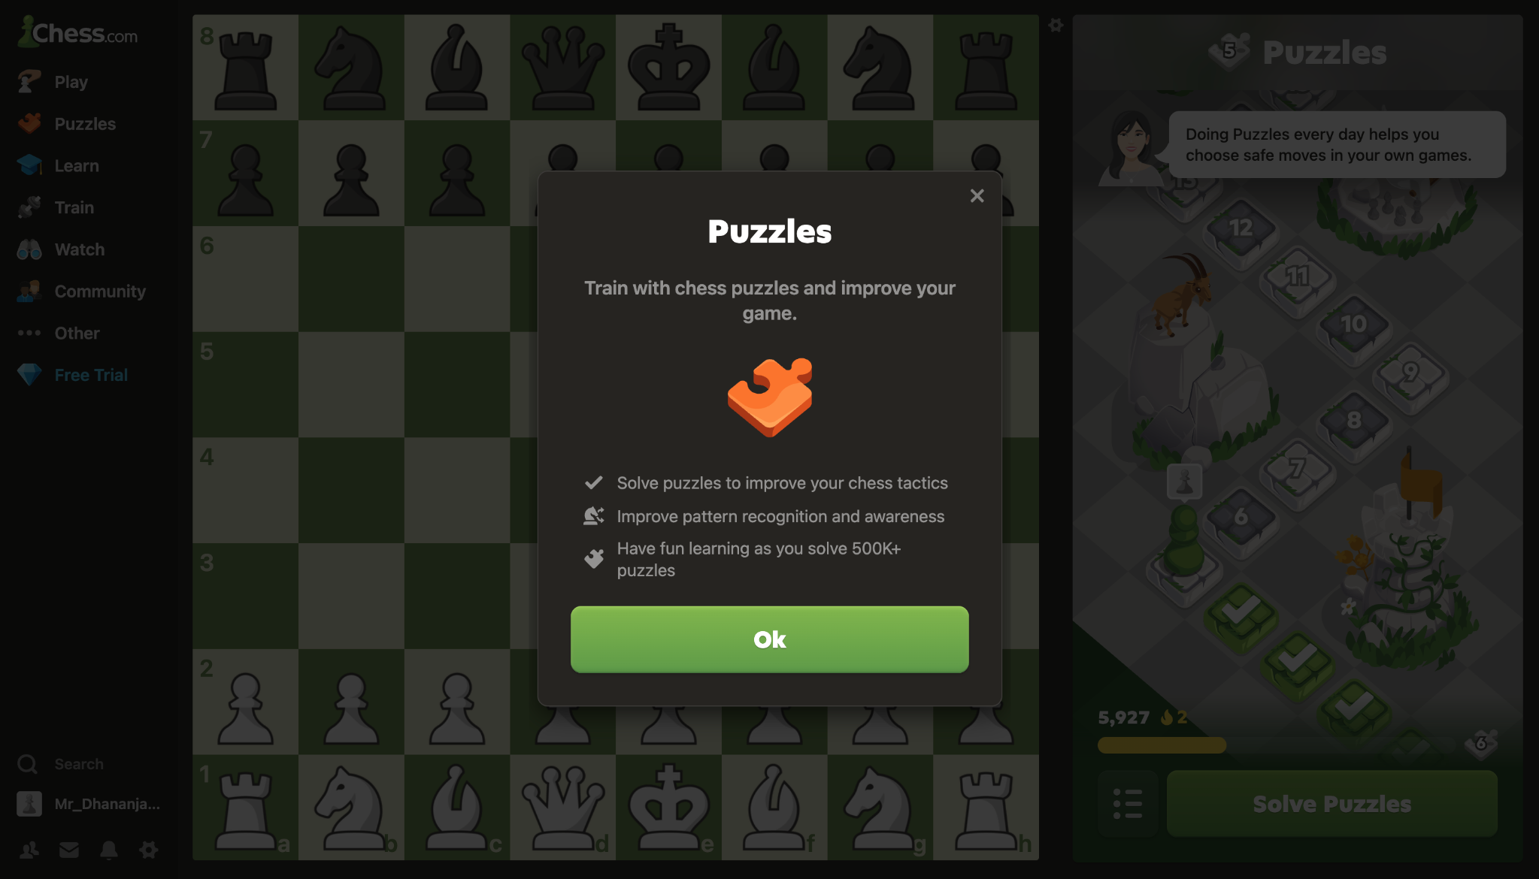
Screenshot 4 — supplied practical evidence

Test Case 5: Start puzzle
Section | Supporting UI
Testing Step | Start puzzle
Test Input | Open puzzle
Expected Result | Puzzle board and instructions should be displayed.
Actual Result | Puzzle board is visible with “White to move” instruction.
Status | N/A
Personal Comments & Suggestions | Functional UI evidence, not a BVA/EP test.
Screenshot Evidence | Screenshot 5
Evidence: Screenshot 5
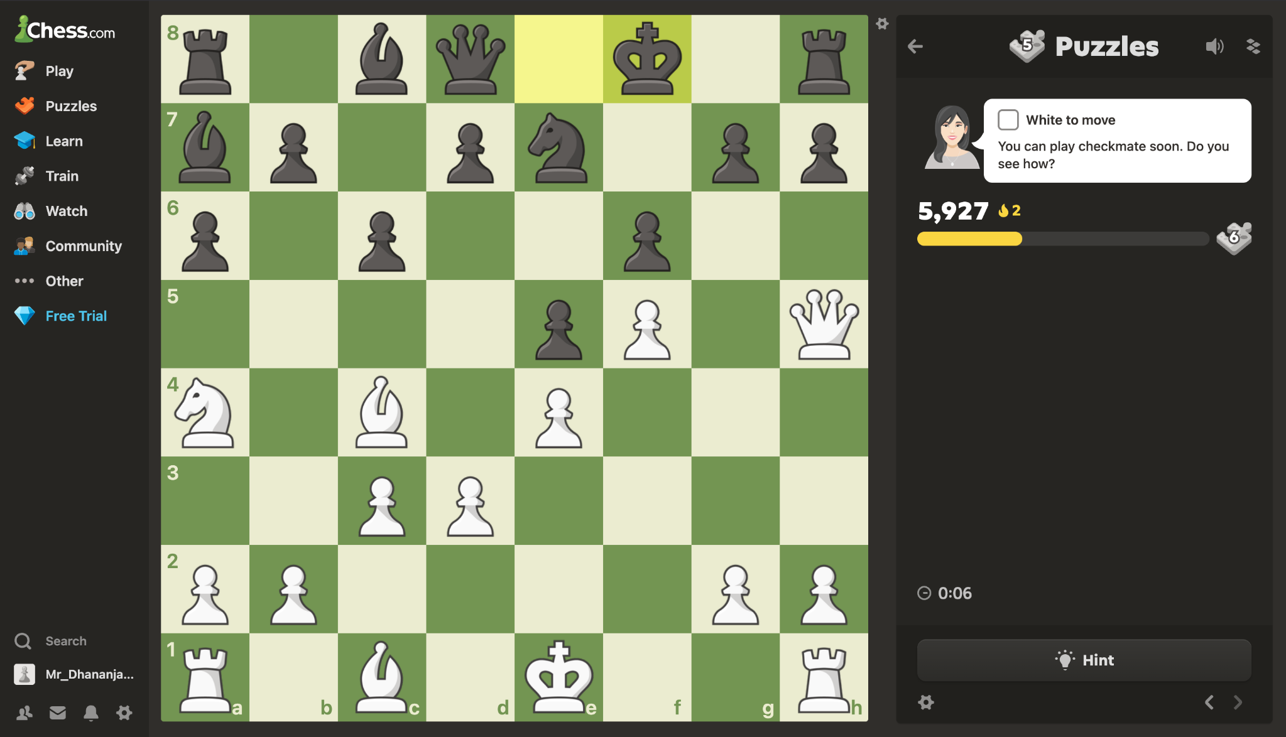
Screenshot 5 — supplied practical evidence

Test Case 6: Complete puzzle
Section | Supporting UI
Testing Step | Complete puzzle
Test Input | Correct puzzle solution
Expected Result | Correct solution should be accepted and completion feedback shown.
Actual Result | “Solved” and “Great! You found the solution!” are displayed.
Status | N/A
Personal Comments & Suggestions | Shows positive functional feedback, but not form/authentication validation.
Screenshot Evidence | Screenshot 6
Evidence: Screenshot 6
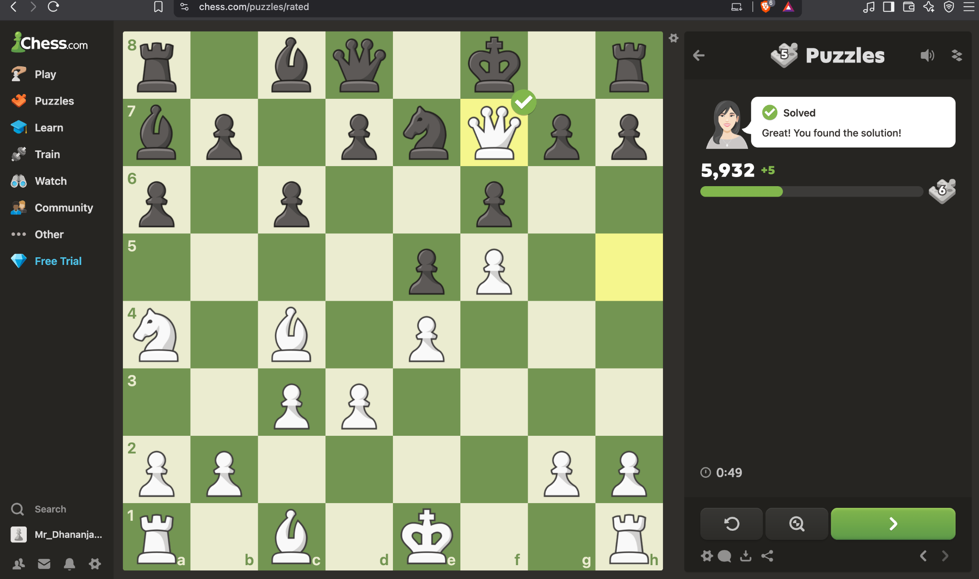
Screenshot 6 — supplied practical evidence

Test Case 7: Open user profile
Section | Supporting UI
Testing Step | Open user profile
Test Input | Open signed-in profile
Expected Result | User profile should display account information.
Actual Result | Profile page is displayed with username and statistics.
Status | N/A
Personal Comments & Suggestions | Supporting authenticated-state evidence only.
Screenshot Evidence | Screenshot 7
Evidence: Screenshot 7
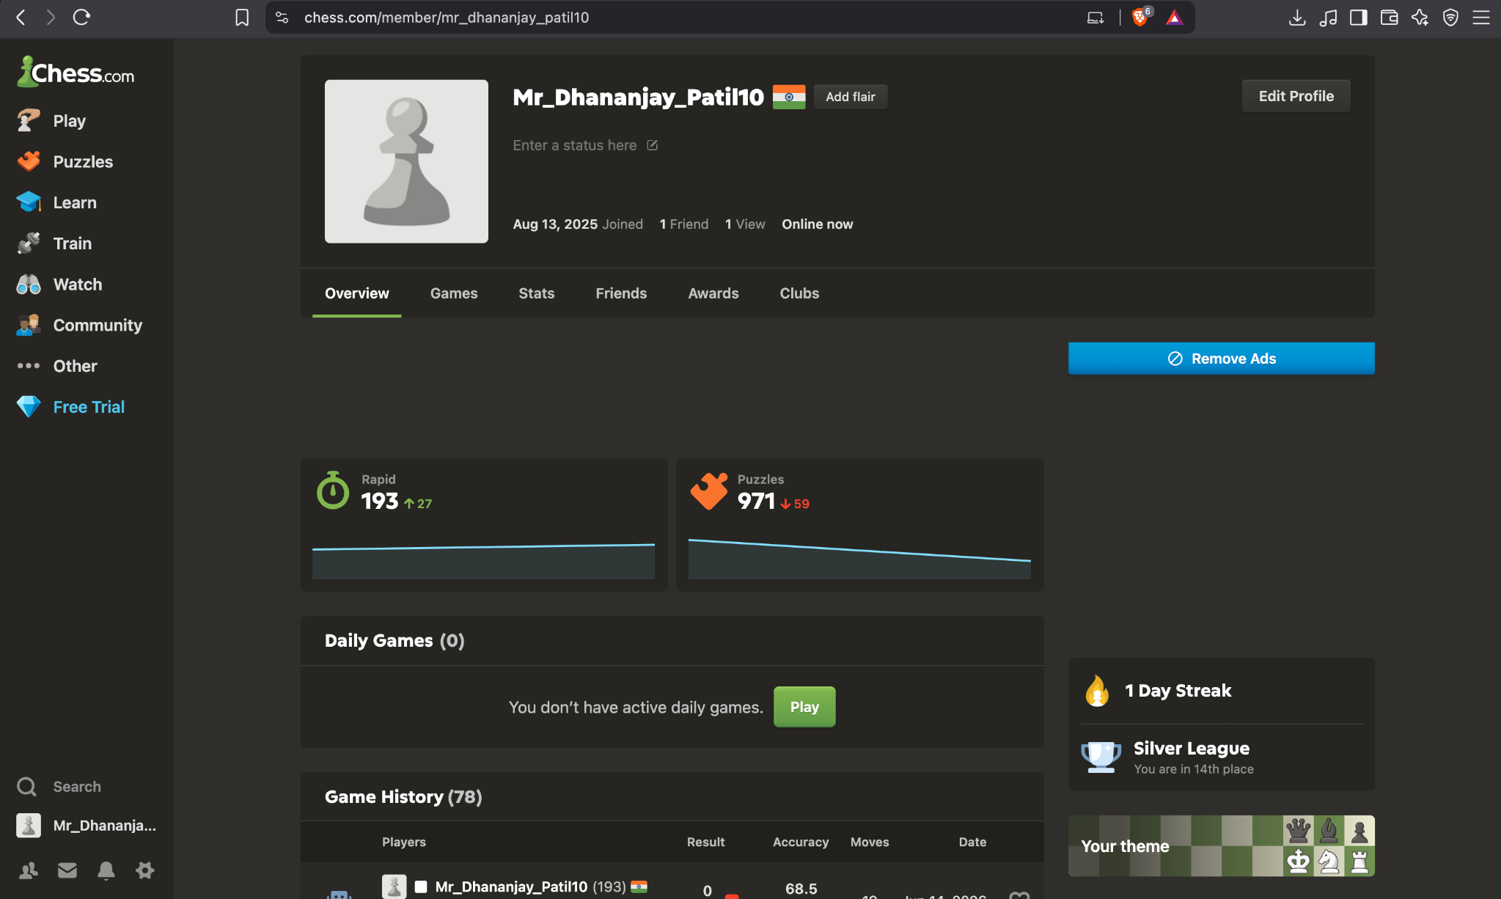
Screenshot 7 — supplied practical evidence

Test Case 8: Start bot game
Section | Supporting UI
Testing Step | Start bot game
Test Input | Select Play Bots
Expected Result | Bot game interface should load.
Actual Result | Bot game board and bot information are displayed.
Status | N/A
Personal Comments & Suggestions | Not relevant to BVA/EP.
Screenshot Evidence | Screenshot 8
Evidence: Screenshot 8
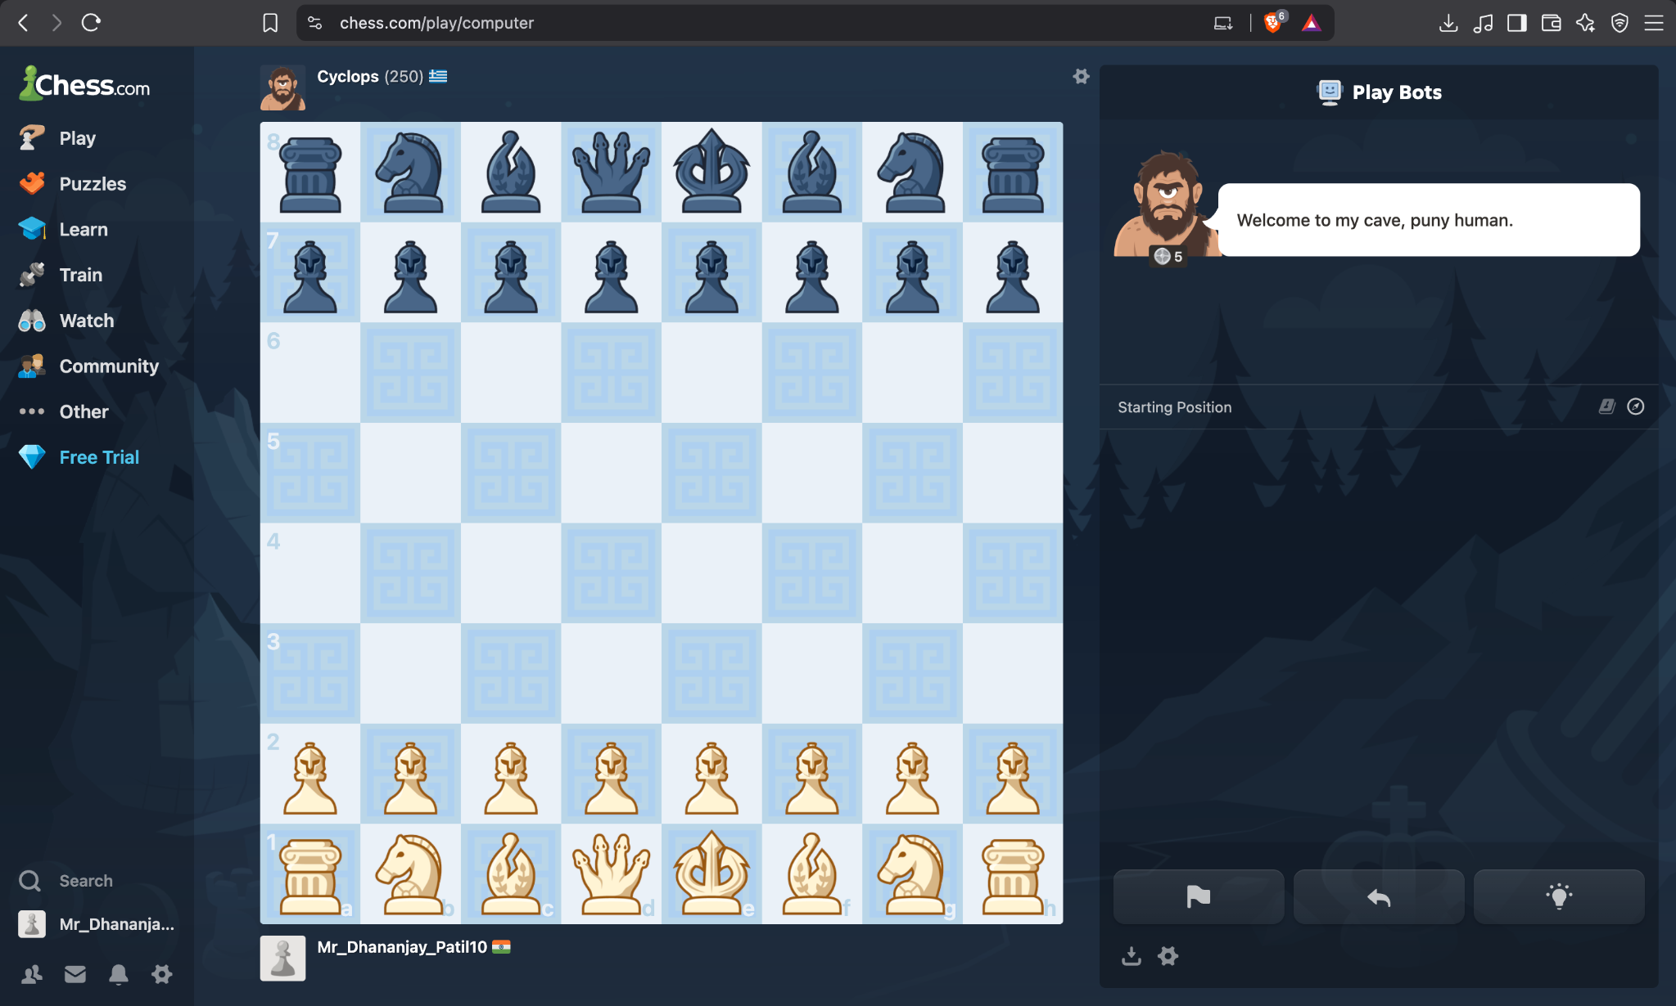
Screenshot 8 — supplied practical evidence

Test Case 9: View another bot game
Section | Supporting UI
Testing Step | View another bot game
Test Input | Select bot opponent
Expected Result | Selected bot game should load.
Actual Result | Bot game board and opponent information are displayed.
Status | N/A
Personal Comments & Suggestions | Not relevant to BVA/EP.
Screenshot Evidence | Screenshot 9
Evidence: Screenshot 9
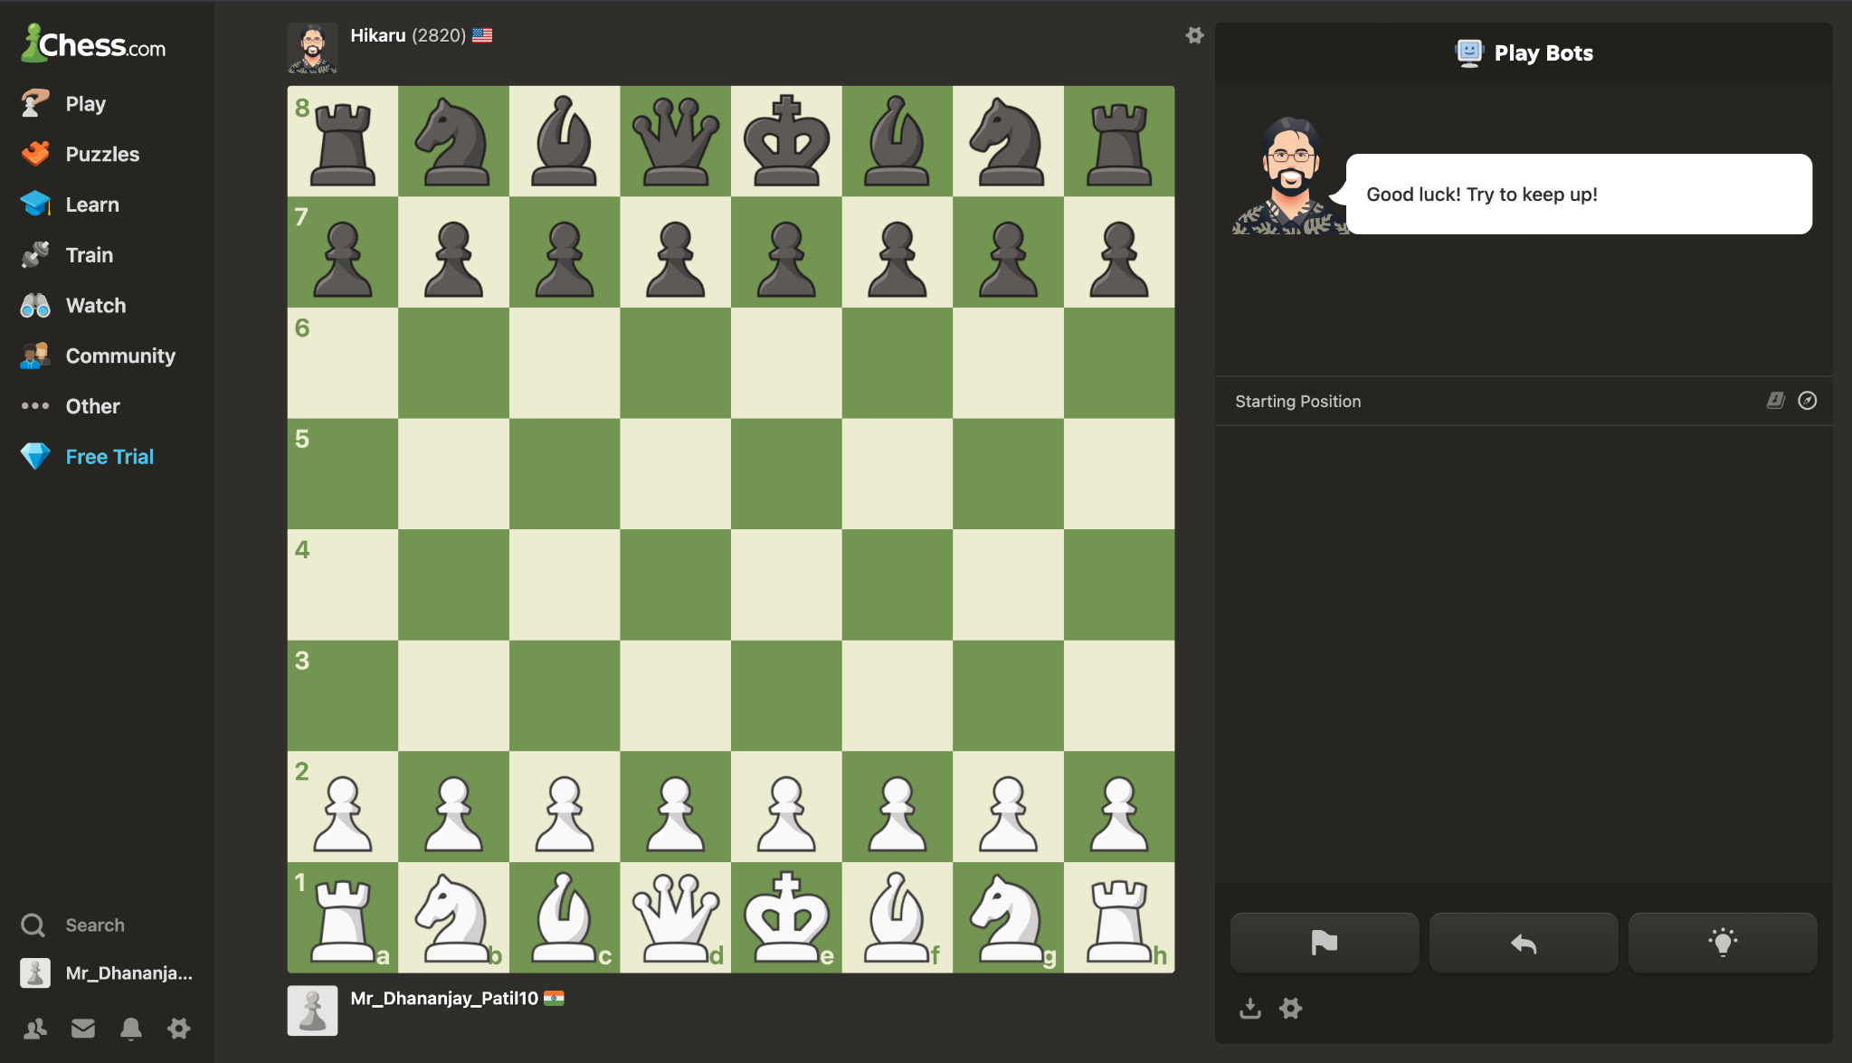
Screenshot 9 — supplied practical evidence

Test Case 10: Open Game Review
Section | Supporting UI
Testing Step | Open Game Review
Test Input | Review completed game
Expected Result | Game Review should show analysis information.
Actual Result | Game Review panel displays accuracy, skills, move-quality categories, and game rating.
Status | N/A
Personal Comments & Suggestions | Not relevant to form/authentication validation.
Screenshot Evidence | Screenshot 10
Evidence: Screenshot 10
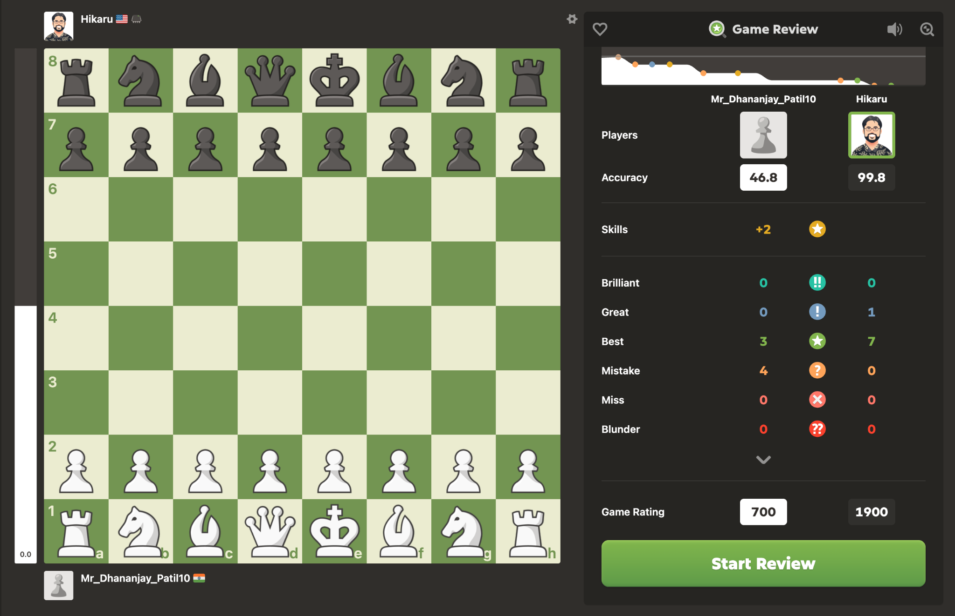
Screenshot 10 — supplied practical evidence

Test Case 11: Open Board & Pieces settings
Section | Supporting UI
Testing Step | Open Board & Pieces settings
Test Input | Open settings
Expected Result | Settings page should display customization controls.
Actual Result | Board & Pieces settings page is displayed with board options and save controls.
Status | N/A
Personal Comments & Suggestions | Not relevant to BVA/EP.
Screenshot Evidence | Screenshot 11
Evidence: Screenshot 11
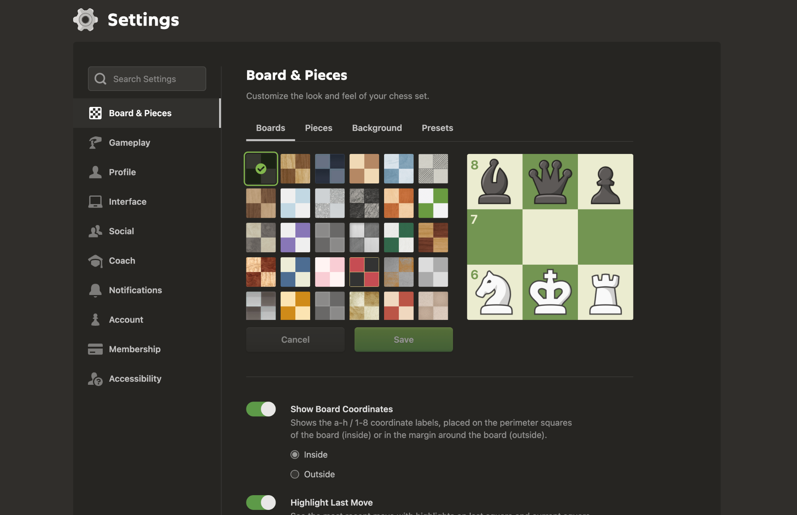
Screenshot 11 — supplied practical evidence

Test Case 12: Password below minimum boundary
Section | BVA
Testing Step | Password below minimum boundary
Test Input | 7-character password
Expected Result | Based on the documented 8-character minimum, a 7-character password should be rejected.
Actual Result | No screenshot shows a 7-character password submission.
Status | N/A
Personal Comments & Suggestions | Required BVA evidence is missing. Capture the submitted value and validation message.
Screenshot Evidence | Not evidenced
Screenshot Evidence: Not evidenced in the supplied screenshots.

Test Case 13: Password at minimum boundary
Section | BVA
Testing Step | Password at minimum boundary
Test Input | 8-character password satisfying documented character rules
Expected Result | An 8-character valid password should be accepted.
Actual Result | No screenshot shows this boundary input being submitted.
Status | N/A
Personal Comments & Suggestions | Required BVA evidence is missing.
Screenshot Evidence | Not evidenced
Screenshot Evidence: Not evidenced in the supplied screenshots.

Test Case 14: Password just above minimum
Section | BVA
Testing Step | Password just above minimum
Test Input | 9-character password satisfying documented character rules
Expected Result | A 9-character valid password should be accepted.
Actual Result | No screenshot shows this boundary input being submitted.
Status | N/A
Personal Comments & Suggestions | Required BVA evidence is missing.
Screenshot Evidence | Not evidenced
Screenshot Evidence: Not evidenced in the supplied screenshots.

Test Case 15: Password maximum boundary
Section | BVA
Testing Step | Password maximum boundary
Test Input | Maximum supported password length
Expected Result | A value at the supported maximum should be accepted if it meets all rules.
Actual Result | The supplied evidence does not establish the maximum password length.
Status | N/A
Personal Comments & Suggestions | Do not invent a maximum. Obtain the current limit from the application or specification before testing.
Screenshot Evidence | Not evidenced
Screenshot Evidence: Not evidenced in the supplied screenshots.

Test Case 16: Password above maximum boundary
Section | BVA
Testing Step | Password above maximum boundary
Test Input | Maximum + 1
Expected Result | A value beyond the supported maximum should be rejected.
Actual Result | No screenshot shows this test.
Status | N/A
Personal Comments & Suggestions | Required BVA evidence is missing and the maximum limit is not established.
Screenshot Evidence | Not evidenced
Screenshot Evidence: Not evidenced in the supplied screenshots.

Test Case 17: Valid password class
Section | Equivalence Partitioning
Testing Step | Valid password class
Test Input | Valid password meeting documented rules
Expected Result | Valid password should be accepted during account/password validation.
Actual Result | No screenshot shows a valid password being entered and accepted.
Status | N/A
Personal Comments & Suggestions | Not directly evidenced.
Screenshot Evidence | Not evidenced
Screenshot Evidence: Not evidenced in the supplied screenshots.

Test Case 18: Invalid password class
Section | Equivalence Partitioning
Testing Step | Invalid password class
Test Input | Incorrect password
Expected Result | Authentication should fail with a clear error.
Actual Result | Incorrect-password error is clearly shown.
Status | Pass
Personal Comments & Suggestions | Direct evidence supports this negative partition.
Screenshot Evidence | Screenshot 2
Evidence: Screenshot 2
Screenshot 2 — supplied practical evidence

Test Case 19: Blank password class
Section | Equivalence Partitioning
Testing Step | Blank password class
Test Input | Blank password
Expected Result | Submission should be blocked or a required-field validation should appear.
Actual Result | No screenshot shows blank-password submission.
Status | N/A
Personal Comments & Suggestions | Capture the error state for this partition.
Screenshot Evidence | Not evidenced
Screenshot Evidence: Not evidenced in the supplied screenshots.

Test Case 20: Invalid email-format class
Section | Equivalence Partitioning
Testing Step | Invalid email-format class
Test Input | Malformed email address
Expected Result | The form should reject an invalid email format or show validation feedback.
Actual Result | No screenshot shows malformed email validation.
Status | N/A
Personal Comments & Suggestions | Capture a malformed email test on the registration/reset form.
Screenshot Evidence | Not evidenced
Screenshot Evidence: Not evidenced in the supplied screenshots.

Test Case 21: Valid email class
Section | Equivalence Partitioning
Testing Step | Valid email class
Test Input | Valid email address
Expected Result | The form should accept a valid email address.
Actual Result | No screenshot shows email entry and acceptance.
Status | N/A
Personal Comments & Suggestions | Capture the accepted valid-email state.
Screenshot Evidence | Not evidenced
Screenshot Evidence: Not evidenced in the supplied screenshots.

Test Case 22: Unknown username/email class
Section | Equivalence Partitioning
Testing Step | Unknown username/email class
Test Input | Unknown account identifier
Expected Result | Login should fail with appropriate authentication feedback.
Actual Result | No screenshot shows an unknown username/email test.
Status | N/A
Personal Comments & Suggestions | Capture the resulting error state.
Screenshot Evidence | Not evidenced
Screenshot Evidence: Not evidenced in the supplied screenshots.

Test Case 23: Blank username/email class
Section | Equivalence Partitioning
Testing Step | Blank username/email class
Test Input | Blank identifier
Expected Result | Submission should be blocked or a required-field message should appear.
Actual Result | No screenshot shows this test.
Status | N/A
Personal Comments & Suggestions | Capture the blank-field validation state.
Screenshot Evidence | Not evidenced
Screenshot Evidence: Not evidenced in the supplied screenshots.

3. Defects, Gaps & Incomplete Evidence
No screenshot demonstrates the password minimum boundary (7/8/9 characters).
No screenshot establishes or tests a password maximum boundary.
No screenshot demonstrates blank username/email validation.
No screenshot demonstrates blank password validation.
No screenshot demonstrates valid email-format acceptance.
No screenshot demonstrates invalid email-format rejection.
No screenshot demonstrates an unknown username/email partition.
Most uploaded screenshots are functional Chess.com evidence but are outside the stated BVA and Equivalence Partitioning scope.
4. Recommended Additional Screenshots
Registration/login form with valid credentials.
Password with 7 characters (below the documented 8-character minimum) and the resulting error.
Password with 8 characters satisfying the documented rules.
Password with 9 characters satisfying the documented rules.
Maximum supported password length and maximum + 1, after confirming the application limit.
Blank username/email submission and validation.
Blank password submission and validation.
Valid email format accepted.
Invalid email format rejected.
Unknown username/email rejected.
5. Evidence Register
Screenshot | Visible Evidence | BVA/EP Relevance | Assessment
Screenshot 1 | Chess.com landing page; Sign Up and Log In. | Low | Setup evidence
Screenshot 2 | Incorrect password error on login. | High — negative authentication test | Pass
Screenshot 3 | Authenticated Chess.com home page. | Supporting only | Incomplete for login test
Screenshot 4 | Puzzles introduction dialog. | Out of scope | N/A
Screenshot 5 | Puzzle board with White to move. | Out of scope | N/A
Screenshot 6 | Solved puzzle confirmation. | Out of scope | N/A
Screenshot 7 | Signed-in profile page. | Supporting only | N/A
Screenshot 8 | Bot game screen. | Out of scope | N/A
Screenshot 9 | Second bot game screen. | Out of scope | N/A
Screenshot 10 | Game Review screen. | Out of scope | N/A
Screenshot 11 | Board & Pieces settings. | Out of scope | N/A

Final tester conclusion: The supplied evidence confirms one authentication negative test: incorrect-password rejection. The practical cannot be considered fully executed for BVA and Equivalence Partitioning because the required boundary and partition inputs are not visible in the screenshots. Additional targeted screenshots are required before those cases can be marked Pass or Fail.
Reference note: Expected password rules were checked against Chess.com Help Center documentation; screenshot evidence remains the basis for Actual Result and Status.

