SOFTWARE TESTING PRACTICAL REPORT
Practical 1: Web Page Title Verification Using Selenium WebDriver
Field | Details
Practical | 1
Testing Type | Automated Functional / UI Testing
Automation Tool | Selenium WebDriver
Programming Language | Python
Browser | Google Chrome
Application Under Test | ChatGPT Web Application
Test Objective | Open the application, retrieve the page title, and verify whether it contains the expected text “Google”.
1. Test Objective
To automate the launch of a Chrome browser, navigate to the ChatGPT web application, wait for the page to load, capture the page title, and validate the title against the expected value using a conditional PASS/FAIL check.
2. Test Case
Parameter | Test Details
Test Case ID | TC-01
Test Case | Verify webpage title
Precondition | Python, Selenium WebDriver, Chrome browser, and a compatible Chrome WebDriver are available.
Test Data | Expected title text: “Google”
Test Steps | 1. Launch Chrome  2. Open https://chatgpt.com/  3. Maximize the browser  4. Wait 10 seconds  5. Read page title  6. Verify whether title contains “Google”  7. Close browser
Expected Result | If the title contains “Google”, display “Test Passed”; otherwise display “Test Failed”.
3. Automation Source Code
#pr1
from selenium import webdriver
import time
# Create Chrome browser
driver = webdriver.Chrome()
# Open Google
driver.get("https://chatgpt.com/")
# Maximize browser
driver.maximize_window()
# Wait for page to load
time.sleep(10)
# Get page title
title = driver.title
print("Page Title:", title)
# Verify title
if "Google" in title:
print("Test Passed")
else:
print("Test Failed")
# Close browser
driver.quit()
4. Test Execution Result
The Selenium automation successfully launched Chrome, navigated to the ChatGPT web application, maximized the browser, waited for the page, and retrieved the page title. The validation condition checks for “Google”. Because the application under test is ChatGPT, the title does not meet that expected condition; therefore, the logical test result is FAIL.
Execution Check | Status
Chrome Browser Launch | PASS
Application Navigation | PASS
Browser Maximization | PASS
Page Load Wait | PASS
Page Title Retrieval | PASS
Title Validation | FAIL — expected due to incorrect expected value
Overall Test Status | FAIL
5. Test Evidence
The supplied screenshot confirms that Chrome was launched under Selenium automation, indicated by the browser message “Chrome is being controlled by automated test software”. The ChatGPT webpage is visible after navigation.
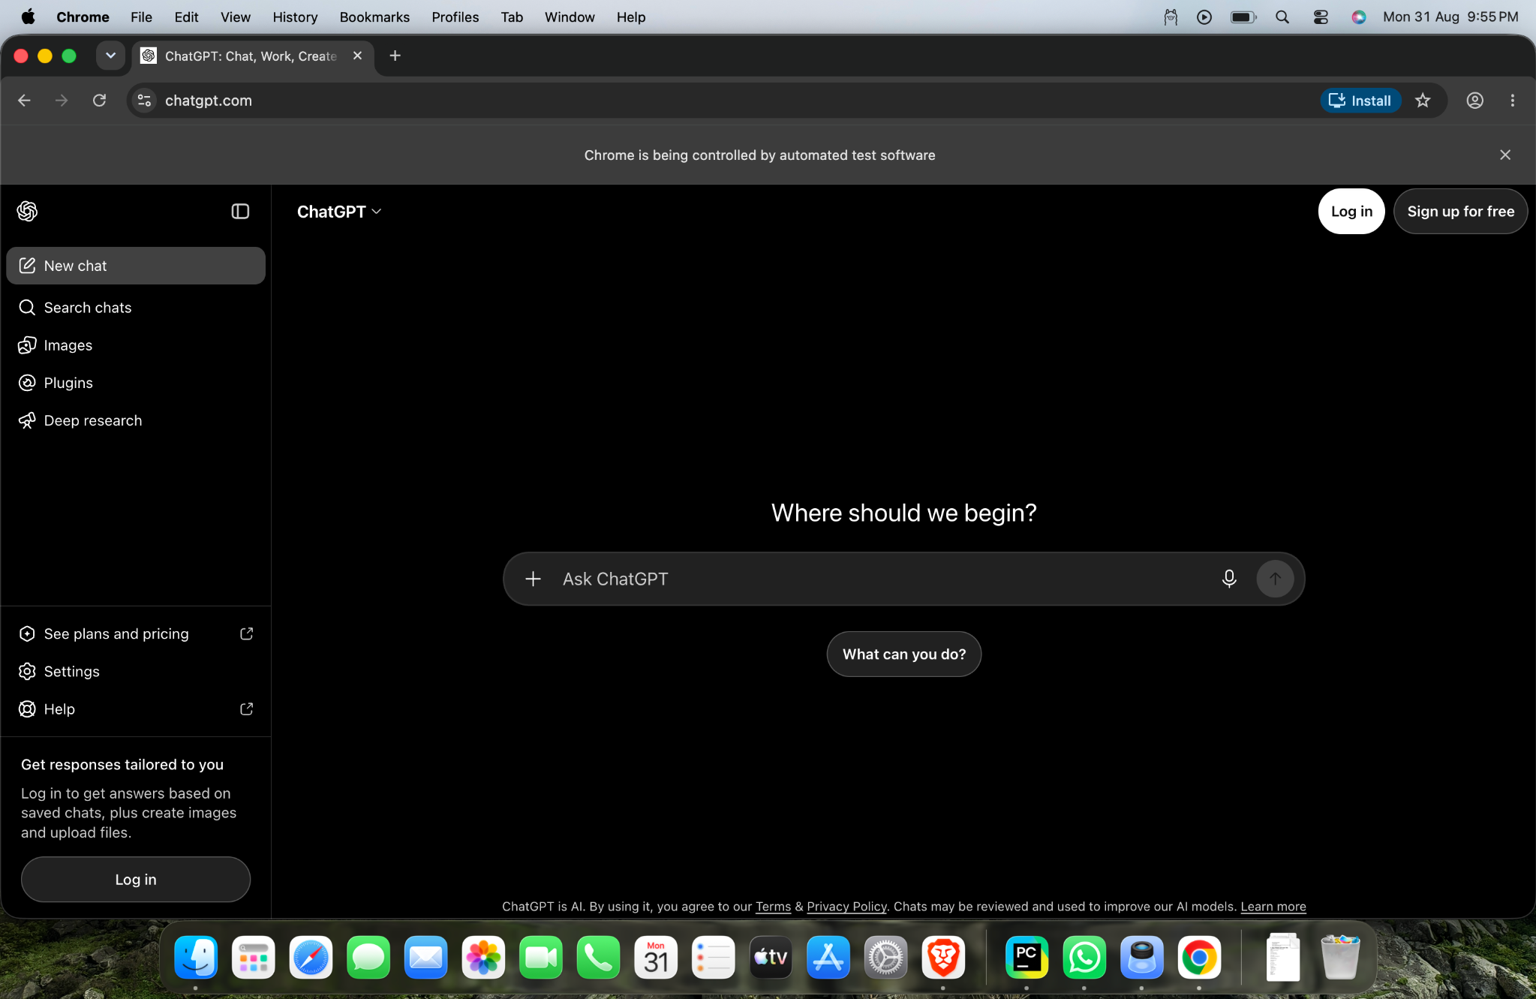
6. Defect / Test Observation
There is a mismatch between the application being opened and the expected title used for verification. The script opens https://chatgpt.com/ but checks for “Google”. From a software-testing perspective, this is an expected negative result if the objective is to demonstrate a FAIL test case. If the objective is to verify the ChatGPT page title, the expected value should be changed to the actual title observed during execution.
7. Conclusion
The practical successfully demonstrates basic Selenium WebDriver automation, including browser launch, navigation, window maximization, synchronization using a fixed delay, page-title retrieval, conditional verification, console reporting, and browser termination. The automation steps executed successfully, while the final validation failed because the expected title does not correspond to the application under test.
8. Tester Assessment
Test Result: FAIL (intentional negative validation)
Automation Execution: Successful
Primary Observation: Expected title “Google” does not match the ChatGPT application.
Recommendation: Use the correct expected title for a positive test, or retain “Google” when intentionally demonstrating a negative test.

