SOFTWARE TESTING PRACTICAL REPORT
Practical 10: Selenium + unittest – PASS and FAIL
Field | Details
Practical | 10
Concept | Selenium WebDriver with Python unittest
Testing Framework | unittest
Automation Tool | Selenium WebDriver
Programming Language | Python
Browser | Google Chrome
Application Under Test | Google Homepage
Test Cases | 1 PASS test and 1 intentional FAIL test
Purpose | Demonstrate automated assertions and PASS/FAIL reporting.
1. Objective
To create automated browser tests using Selenium and Python unittest. The practical verifies the Google page title with one passing test and one intentionally failing test, demonstrating assertion handling and test-result reporting.
2. Concept
Python's unittest framework organizes and executes test cases, while Selenium WebDriver controls Chrome. The first test uses assertIn() and passes. The second uses assertEqual() with the intentionally wrong expected title 'Facebook', so it fails as expected.
3. Test Case Details
Test Case ID | Test Description | Expected Result | Status
TC-10-01 | Open Google and verify the title contains 'Google'. | Assertion should pass. | PASS
TC-10-02 | Open Google and compare the title with 'Facebook'. | Assertion should fail because the actual title is Google. | FAIL (Intentional)
4. Automation Source Code
import unittest
from selenium import webdriver
class TestGoogle(unittest.TestCase):
def setUp(self):
self.driver = webdriver.Chrome()
self.driver.maximize_window()
def test_google_title_pass(self):
self.driver.get("https://www.google.com")
title = self.driver.title
print("Actual Title:", title)
self.assertIn("Google", title)
def test_google_title_fail(self):
self.driver.get("https://www.google.com")
title = self.driver.title
print("Actual Title:", title)
# Intentionally wrong expected value
self.assertEqual(title, "Facebook")
def tearDown(self):
self.driver.quit()
if __name__ == "__main__":
unittest.main()
5. Test Execution
The test suite runs two test cases. The first title check passes because the actual title is 'Google'. The second test fails because it compares 'Google' with the incorrect expected value 'Facebook'.
Execution Item | Observed Result
Browser launched | PASS
Google homepage opened | PASS
Actual page title | Google
Pass assertion | PASSED
Fail assertion | FAILED as expected
Total tests | 2
Failures | 1
Process result | Exit code 1
6. Expected Output
Actual Title: Google
Actual Title: Google
Ran 2 tests
FAILED (failures=1)
Process finished with exit code 1
7. Screenshot Evidence
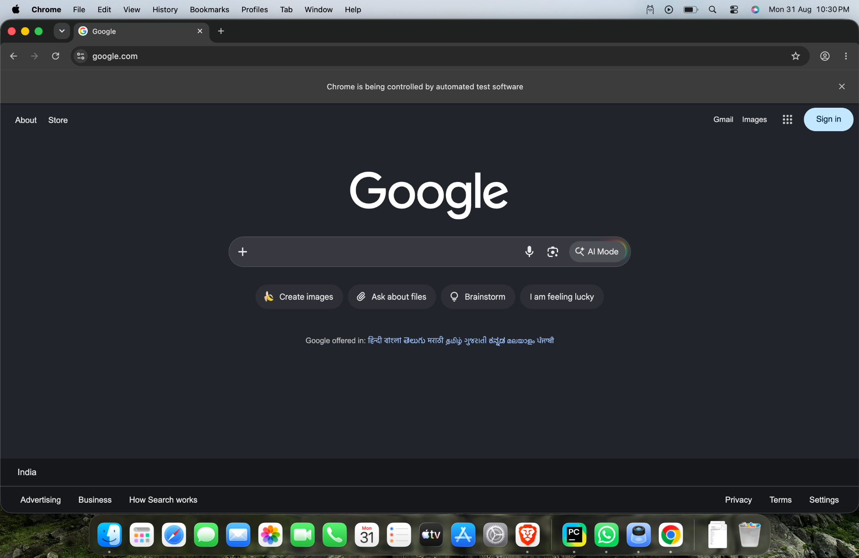
Figure 1: Google homepage opened in Chrome under Selenium automation.
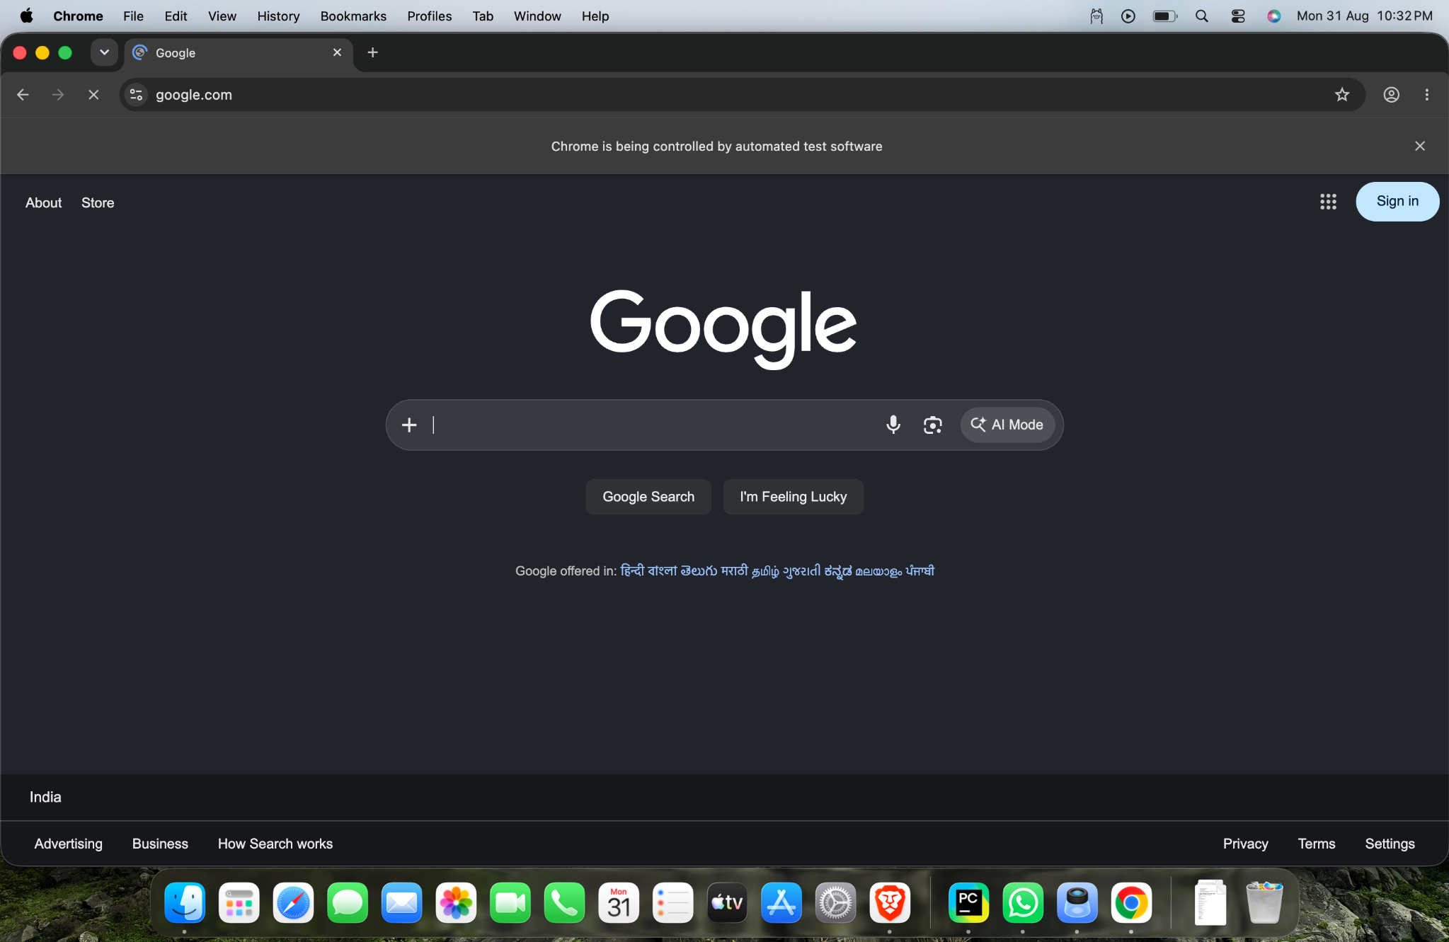
Figure 2: Google homepage during automated test execution.
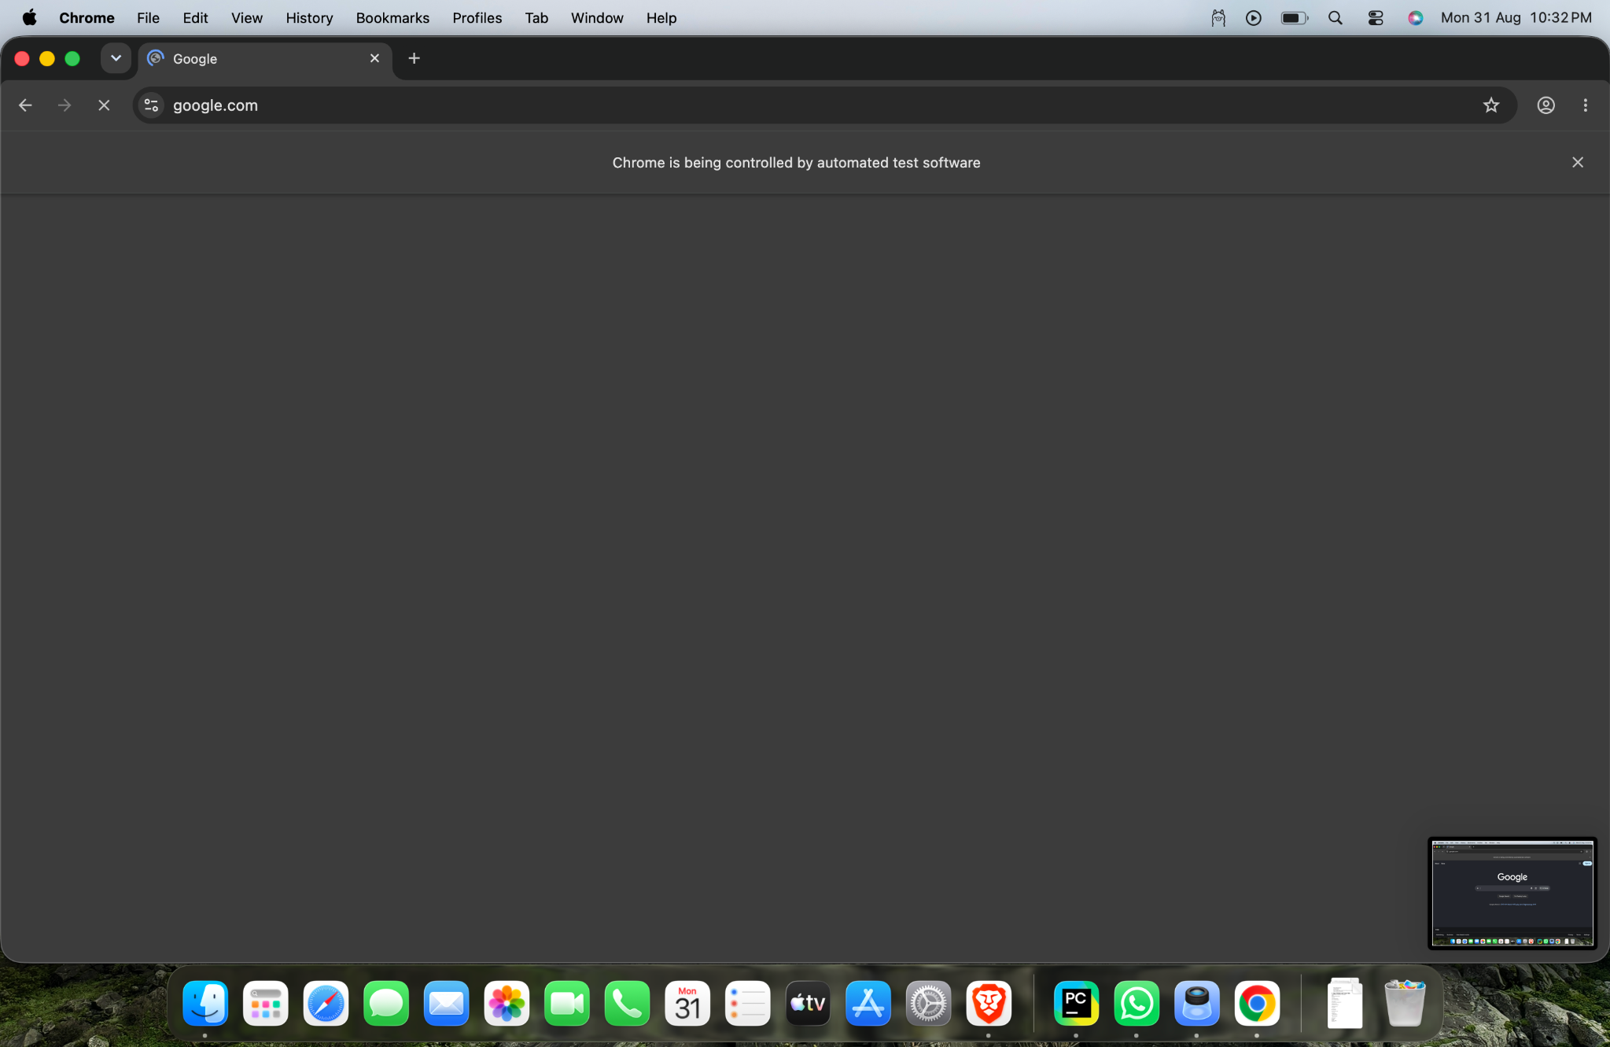
Figure 3: Google page during the second test execution.
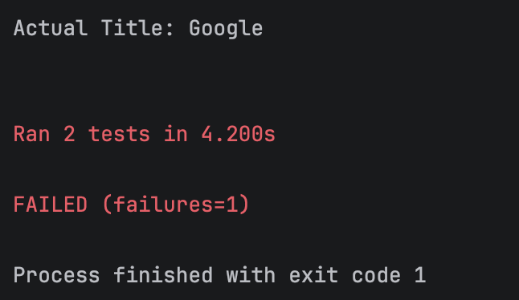
Figure 4: PyCharm/unittest result showing two tests and one intentional failure.
8. Important unittest Methods
Method | Purpose
setUp() | Runs before each test and creates the Chrome WebDriver.
test_*() | Defines an individual test case discovered by unittest.
assertIn() | Passes when expected text is contained in the actual value.
assertEqual() | Passes only when the two compared values are equal.
tearDown() | Runs after each test and closes the browser.
unittest.main() | Starts test discovery and execution.
9. Important Selenium Methods
Method | Purpose
webdriver.Chrome() | Starts Google Chrome through Selenium.
get() | Navigates to the specified URL.
maximize_window() | Maximizes the browser window.
title | Returns the current web page title.
quit() | Closes the browser and ends the WebDriver session.
10. PASS Test Explanation
The first test opens Google and stores the page title. Since the actual title is 'Google' and it contains the expected word 'Google', assertIn() succeeds and the test is reported as PASSED.
11. FAIL Test Explanation
The second test opens Google but intentionally expects 'Facebook'. The actual title is 'Google', so assertEqual() detects the mismatch and unittest reports a failure. This failure is intentional for demonstration.
12. Expected vs Actual Result
Item | Expected | Actual
Google title | Google | Google
Pass test | Should pass | PASSED
Fail test | Should fail with wrong expected value | FAILED
Number of tests | 2 | 2
Number of failures | 1 intentional failure | 1
Final execution | Failure expected for demonstration | FAILED (failures=1)
13. Conclusion
Practical 10 successfully demonstrates Selenium browser automation combined with Python unittest. One test case passes by correctly checking the Google title, while the second test intentionally fails by expecting 'Facebook'. The execution result confirms that unittest correctly identifies both PASS and FAIL conditions.
14. Final Assessment
Practical: 10 – Selenium + unittest – PASS and FAIL
Test Cases: 2
Passed: 1
Failed: 1 (Intentional)
Actual Title: Google
Final Observation: The framework correctly detected the intentional assertion failure.
Testing Skills Demonstrated: Selenium WebDriver, unittest, setup/teardown, assertions, browser automation, and result analysis.

