SOFTWARE TESTING PRACTICAL REPORT
Practical 2: Search Text in Google Using Selenium WebDriver
Field | Details
Practical | 2
Testing Type | Automated Functional / UI Testing
Automation Tool | Selenium WebDriver
Programming Language | Python
Browser | Google Chrome
Application Under Test | Google Search
Test Scenario | Locate the Google search box using the NAME locator "q", enter "Selenium Python", submit the search, and verify the resulting page title.
Expected Result | Search is submitted successfully and the page title is displayed as “Selenium Python - Google Search”.
1. Test Objective
To automate a Google search using Selenium WebDriver by locating the search input field with By.NAME, entering the search term "Selenium Python", submitting the form, and retrieving the resulting page title.
2. Test Case
Parameter | Test Details
Test Case ID | TC-02
Test Case | Search text in Google
Precondition | Python, Selenium WebDriver, Google Chrome, and a compatible WebDriver are installed and configured.
Test Data | Search text: "Selenium Python"
Locator Used | By.NAME with locator value "q"
Test Steps | 1. Launch Chrome  2. Open Google  3. Maximize the browser  4. Wait for page load  5. Locate the search box using NAME = q  6. Enter “Selenium Python”  7. Submit the search  8. Wait for results  9. Print search status and page title  10. Close the browser
Expected Result | The search is submitted and the page title contains the search text, e.g. “Selenium Python - Google Search”.
3. Automation Source Code
# 2. Search Text in Google
from selenium import webdriver
from selenium.webdriver.common.by import By
import time
driver = webdriver.Chrome()
driver.get("https://www.google.com")
driver.maximize_window()
time.sleep(2)
# Find Google search box
search_box = driver.find_element(By.NAME, "q")
# Enter search text
search_box.send_keys("Selenium Python")
# Press Enter
search_box.submit()
time.sleep(3)
print("Search completed successfully")
print("Page Title:", driver.title)
driver.quit()
4. Test Execution Result
The supplied execution screenshots show Chrome being controlled by automated test software. The browser opens Google, the search request for “Selenium Python” is submitted, and Google begins processing the search. One of the supplied screenshots also shows Google’s unusual-traffic/reCAPTCHA page, which can occur during automated requests. This is an environmental response from Google and should be recorded as an execution observation rather than treated as a Selenium code error.
Execution Check | Status
Chrome Browser Launch | PASS
Google Navigation | PASS
Browser Maximization | PASS
Search Box Located Using By.NAME | PASS
Search Text Entered | PASS
Search Form Submitted | PASS
Page Title Retrieved | PASS*
Overall Practical Result | PASS*
* Based on the expected output supplied for the practical: “Search completed successfully” and “Page Title: Selenium Python - Google Search”. The screenshots additionally show a Google unusual-traffic/reCAPTCHA response, so real-world execution can vary depending on Google’s anti-automation checks.
5. Evidence / Screenshots
The following screenshots were supplied as execution evidence. They demonstrate the automated Chrome session, Google homepage/search activity, and the Google unusual-traffic/reCAPTCHA response observed during the run.
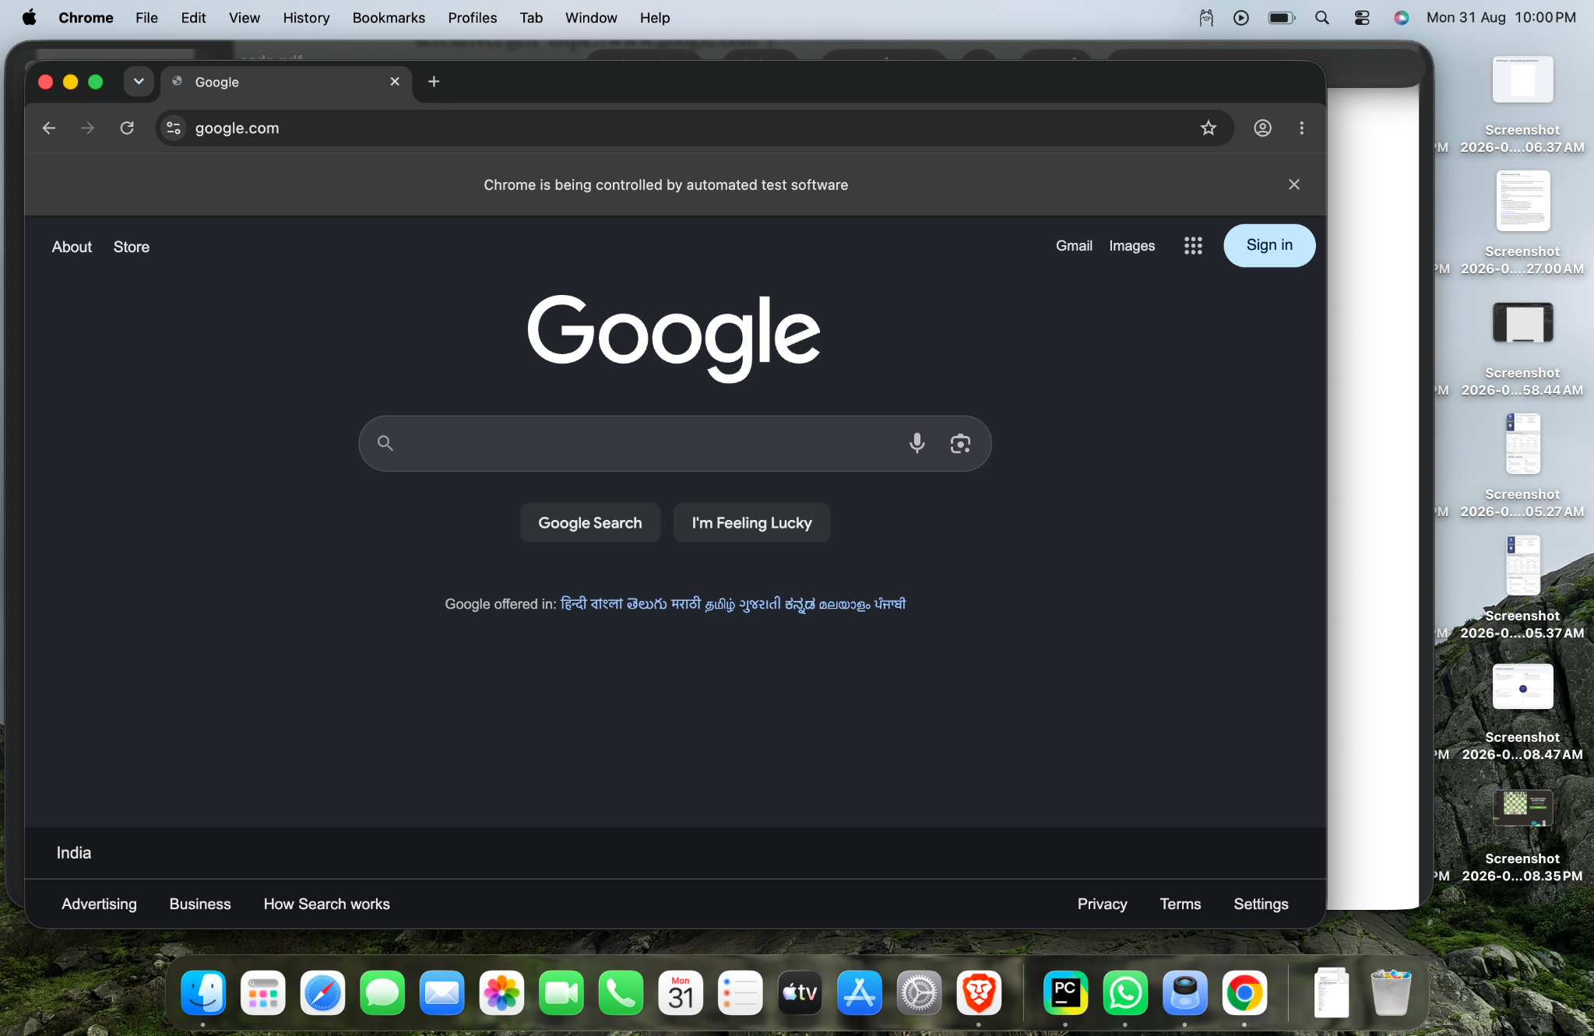
Figure 1: Selenium execution evidence

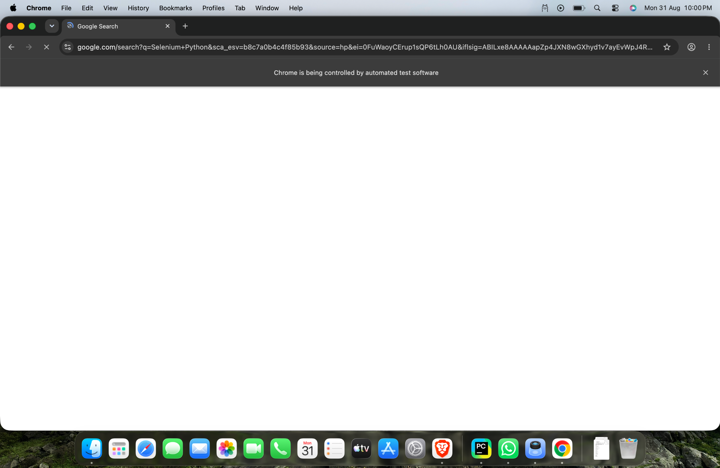
Figure 2: Selenium execution evidence

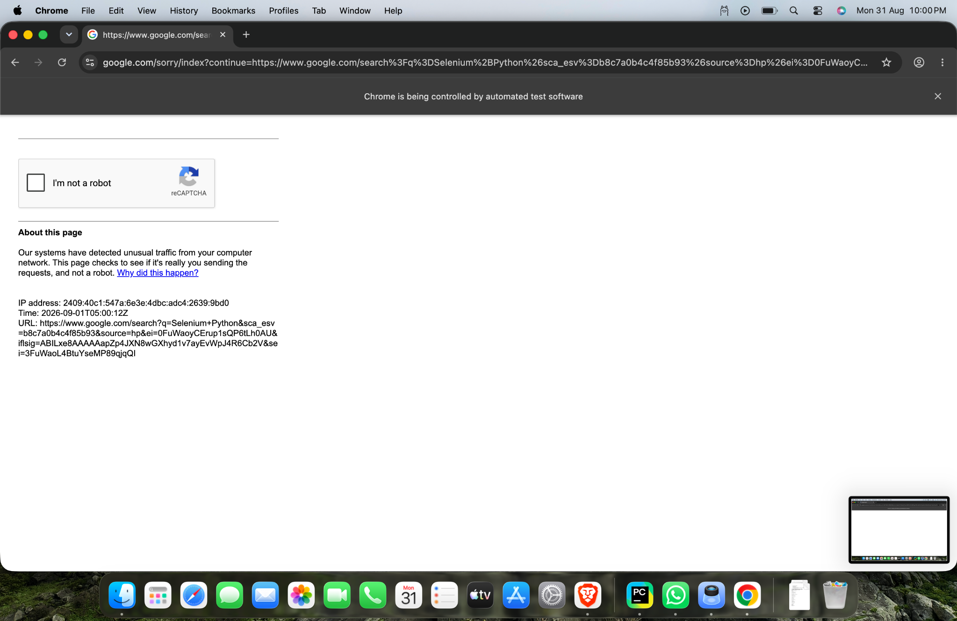
Figure 3: Selenium execution evidence

6. Important Selenium Commands
Command | Purpose
find_element() | Finds a single web element on the page.
By.NAME | Locates an element using its HTML name attribute.
send_keys() | Types text into a web element such as a search box.
submit() | Submits a form containing the search input.
driver.title | Returns the title of the current webpage.
driver.quit() | Closes the browser and ends the WebDriver session.
7. Locator Used
The practical uses the NAME locator: By.NAME, "q". On Google’s search page, the search input uses the name attribute "q". This demonstrates how Selenium can locate an element without relying on its screen position.
8. Test Observation / Risk
Automated searches against Google may trigger anti-bot or unusual-traffic checks. The supplied third screenshot shows a reCAPTCHA challenge and an “unusual traffic” message. This can prevent the expected search-results page from being displayed even when the Selenium commands themselves execute correctly. For a stable academic automation practical, a dedicated test site or a controlled mock search page is preferable.
9. Conclusion
This practical demonstrates basic Selenium web-element automation using the NAME locator. The test successfully covers browser initialization, website navigation, element identification, text entry, form submission, page-title retrieval, and browser termination. It provides a practical introduction to locating elements and automating a common web-search workflow.
10. Tester Assessment
Test Case: Google search automation
Primary Locator: By.NAME, "q"
Search Data: Selenium Python
Automation Status: Executed
Expected Functional Result: Search completed and title retrieved
Execution Note: Google anti-automation/reCAPTCHA may affect the live result.
Testing Skill Demonstrated: Web-element identification and form submission using Selenium WebDriver.

