SOFTWARE TESTING PRACTICAL REPORT
Practical 4: Login Automation – PASS Test
Field | Details
Practical | 4
Testing Type | Automated Functional / UI Testing
Automation Tool | Selenium WebDriver
Programming Language | Python
Browser | Google Chrome
Application Under Test | The Internet – Login Page
Test Scenario | Automate a valid login using the provided credentials and verify successful navigation to the secure area.
Expected Result | Login should succeed and the current URL should contain “secure”. The console should display “Login Test Passed”.
1. Test Objective
To automate a positive login test using Selenium WebDriver. The test identifies the username and password fields by ID, locates the login button using a CSS Selector, enters valid credentials, submits the form, and verifies successful login using the current URL.
2. Test Case
Parameter | Test Details
Test Case ID | TC-04
Test Case | Login Automation – PASS Test
Precondition | Python, Selenium WebDriver, Google Chrome, and a compatible Chrome WebDriver are installed and configured.
Test Data | Username: tomsmith  Password: SuperSecretPassword!
Locators Used | By.ID – "username", "password"  By.CSS_SELECTOR – "button[type='submit']"
Test Steps | 1. Launch Chrome  2. Open the login page  3. Maximize the browser  4. Wait for the page to load  5. Locate username field using ID  6. Enter valid username  7. Locate password field using ID  8. Enter valid password  9. Locate Login button using CSS Selector  10. Click Login  11. Wait for navigation  12. Verify current URL  13. Print PASS/FAIL result  14. Close browser
Expected Result | The user is authenticated successfully and redirected to the Secure Area. The test displays “Login Test Passed”.
3. Automation Source Code
# 4. Login Automation – PASS Test
from selenium import webdriver
from selenium.webdriver.common.by import By
import time
driver = webdriver.Chrome()
try:
driver.get("https://the-internet.herokuapp.com/login")
driver.maximize_window()
time.sleep(2)
username = driver.find_element(By.ID, "username")
password = driver.find_element(By.ID, "password")
login_button = driver.find_element(
By.CSS_SELECTOR,
"button[type='submit']"
)
username.send_keys("tomsmith")
password.send_keys("SuperSecretPassword!")
login_button.click()
time.sleep(2)
if "secure" in driver.current_url:
print("Login Test Passed")
else:
print("Login Test Failed")
finally:
driver.quit()
4. Test Execution Result
The supplied screenshots show the automated Chrome session on the login page and the subsequent Secure Area after valid credentials were submitted. The application displays the green confirmation message “You logged into a secure area!” and the browser URL changes to /secure. This confirms that the positive login scenario executed successfully.
Execution Check | Status
Chrome Browser Launch | PASS
Login Page Navigation | PASS
Browser Maximization | PASS
Username Located Using By.ID | PASS
Password Located Using By.ID | PASS
Valid Credentials Entered | PASS
Login Button Located Using CSS Selector | PASS
Login Button Clicked | PASS
Redirect to /secure | PASS
Login Verification | PASS
Overall Test Status | PASS
5. Test Evidence / Screenshots
The following screenshots were supplied as execution evidence for the positive login test.
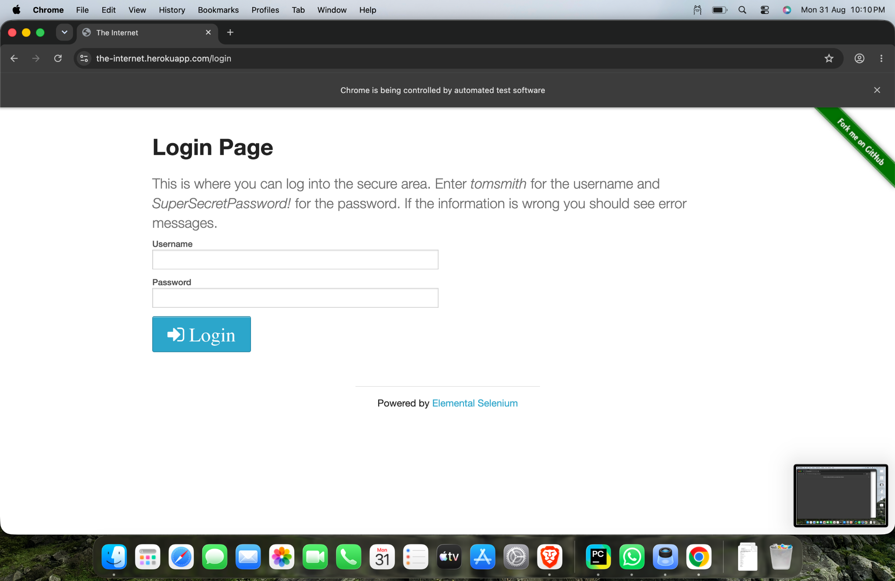
Figure 1: Login automation execution evidence

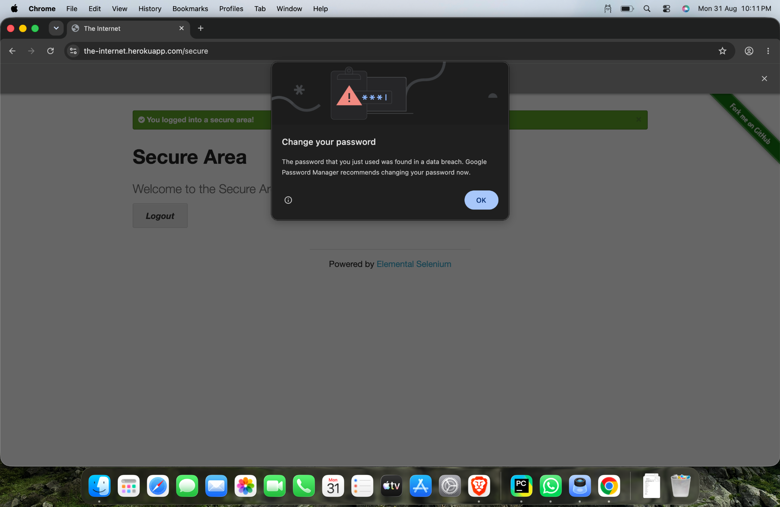
Figure 2: Login automation execution evidence

6. Why try...finally?
Block | Purpose
try | Contains the Selenium automation steps, including opening the page, entering credentials, clicking Login, and verifying the result.
finally | Ensures that driver.quit() is executed so Chrome is closed even if an error occurs during the automation.
7. Main Selenium Concepts
Concept | Purpose
By.ID | Locates an HTML element using its ID attribute.
By.CSS_SELECTOR | Locates an element using a CSS selector.
send_keys() | Enters text into an input field.
click() | Clicks a web element such as the Login button.
current_url | Returns the URL of the current browser page.
try...finally | Provides cleanup so the browser is closed after execution.
driver.quit() | Closes the browser and ends the WebDriver session.
8. Expected vs Actual Result
Item | Result
Expected URL | https://the-internet.herokuapp.com/secure
Observed URL | https://the-internet.herokuapp.com/secure
Expected Console Message | Login Test Passed
Observed Application State | Secure Area displayed with successful-login confirmation
Final Result | PASS
9. Tester Observation
The test successfully validates the positive login flow using valid test credentials. Selenium correctly located the form elements, entered the credentials, clicked the Login button, and verified the redirect. The supplied evidence confirms that the expected secure area was reached.
10. Conclusion
The practical successfully demonstrates positive login automation using Selenium WebDriver. It covers element identification using ID and CSS Selector, text entry, button interaction, URL verification, exception-safe cleanup with try...finally, and browser termination. The actual result matches the expected result; therefore, the test case is PASS.
11. Tester Assessment
Test Case: Login Automation – PASS Test
Primary Locator: By.ID
Secondary Locator: By.CSS_SELECTOR
Test Data: Valid username and password
Observed Result: Successful login and redirect to /secure
Overall Status: PASS
Testing Skill Demonstrated: Positive functional UI automation using Selenium WebDriver.

