SOFTWARE TESTING PRACTICAL REPORT
Practical 5: Login Automation – FAIL Test Case
Field | Details
Practical | 5
Testing Type | Negative Functional / UI Testing
Automation Tool | Selenium WebDriver
Programming Language | Python
Browser | Google Chrome
Application Under Test | The Internet – Login Page
Test Scenario | Attempt login with a valid username and an intentionally incorrect password, then verify that access to the secure area is rejected.
Expected Application Behaviour | The application should reject the invalid password and remain on the Login Page with an appropriate error message.
1. Test Objective
To perform negative login testing using Selenium WebDriver. The test enters a valid username and an intentionally incorrect password, submits the login form, and checks that the user is not redirected to the secure area.
2. Test Case Details
Parameter | Test Details
Test Case ID | TC-05
Test Case | Login Automation – FAIL Test Case
Test Type | Negative Testing
Precondition | Python, Selenium WebDriver, Google Chrome, and a compatible Chrome WebDriver are installed and configured.
Test Data | Username: tomsmith  Password: WrongPassword (intentionally incorrect)
Locators Used | By.ID – "username", "password"  By.CSS_SELECTOR – "button[type='submit']"
Test Steps | 1. Launch Chrome  2. Open the login page  3. Maximize the browser  4. Locate username field using ID  5. Enter valid username  6. Locate password field using ID  7. Enter incorrect password  8. Locate Login button using CSS Selector  9. Click Login  10. Wait for the response  11. Verify that the URL does not contain “secure”  12. Print the test result  13. Close the browser
Expected Result | Invalid login must be rejected. The browser should remain on the Login Page and display an error message such as “Your password is invalid!”.
3. Automation Source Code
# 5. Login Automation – FAIL Test Case
from selenium import webdriver
from selenium.webdriver.common.by import By
import time
driver = webdriver.Chrome()
try:
driver.get("https://the-internet.herokuapp.com/login")
driver.maximize_window()
time.sleep(2)
username = driver.find_element(By.ID, "username")
password = driver.find_element(By.ID, "password")
login_button = driver.find_element(
By.CSS_SELECTOR,
"button[type='submit']"
)
username.send_keys("tomsmith")
# Wrong password intentionally
password.send_keys("WrongPassword")
login_button.click()
time.sleep(2)
if "secure" in driver.current_url:
print("Test Failed: Invalid login was accepted")
else:
print("Test Passed: Invalid login was correctly rejected")
finally:
driver.quit()
4. Execution Result
The supplied screenshots show that the incorrect password was rejected by the application. The browser remained on the Login Page and an error notification appeared stating that the password was invalid. Therefore, the application behaved correctly for this negative test scenario.
Execution Check | Status
Chrome Browser Launch | PASS
Login Page Navigation | PASS
Username Located Using By.ID | PASS
Valid Username Entered | PASS
Incorrect Password Entered | PASS
Login Button Located Using CSS Selector | PASS
Login Button Clicked | PASS
Invalid Login Rejected | PASS
Error Message Displayed | PASS
Secure Area Not Opened | PASS
Negative Test Objective | PASS
5. Test Evidence / Screenshots
The following screenshots were provided as execution evidence for the negative login test.
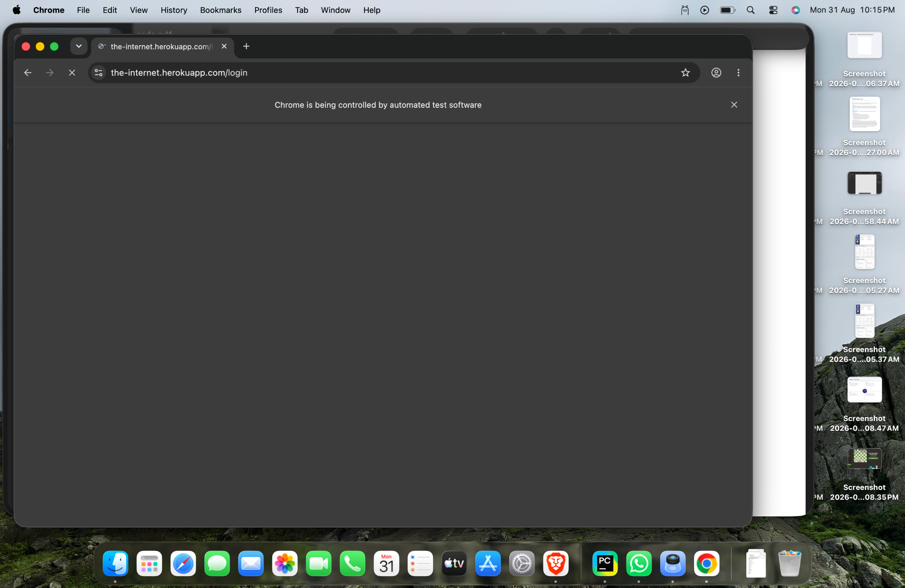
Figure 1: Login Page before entering the test credentials.

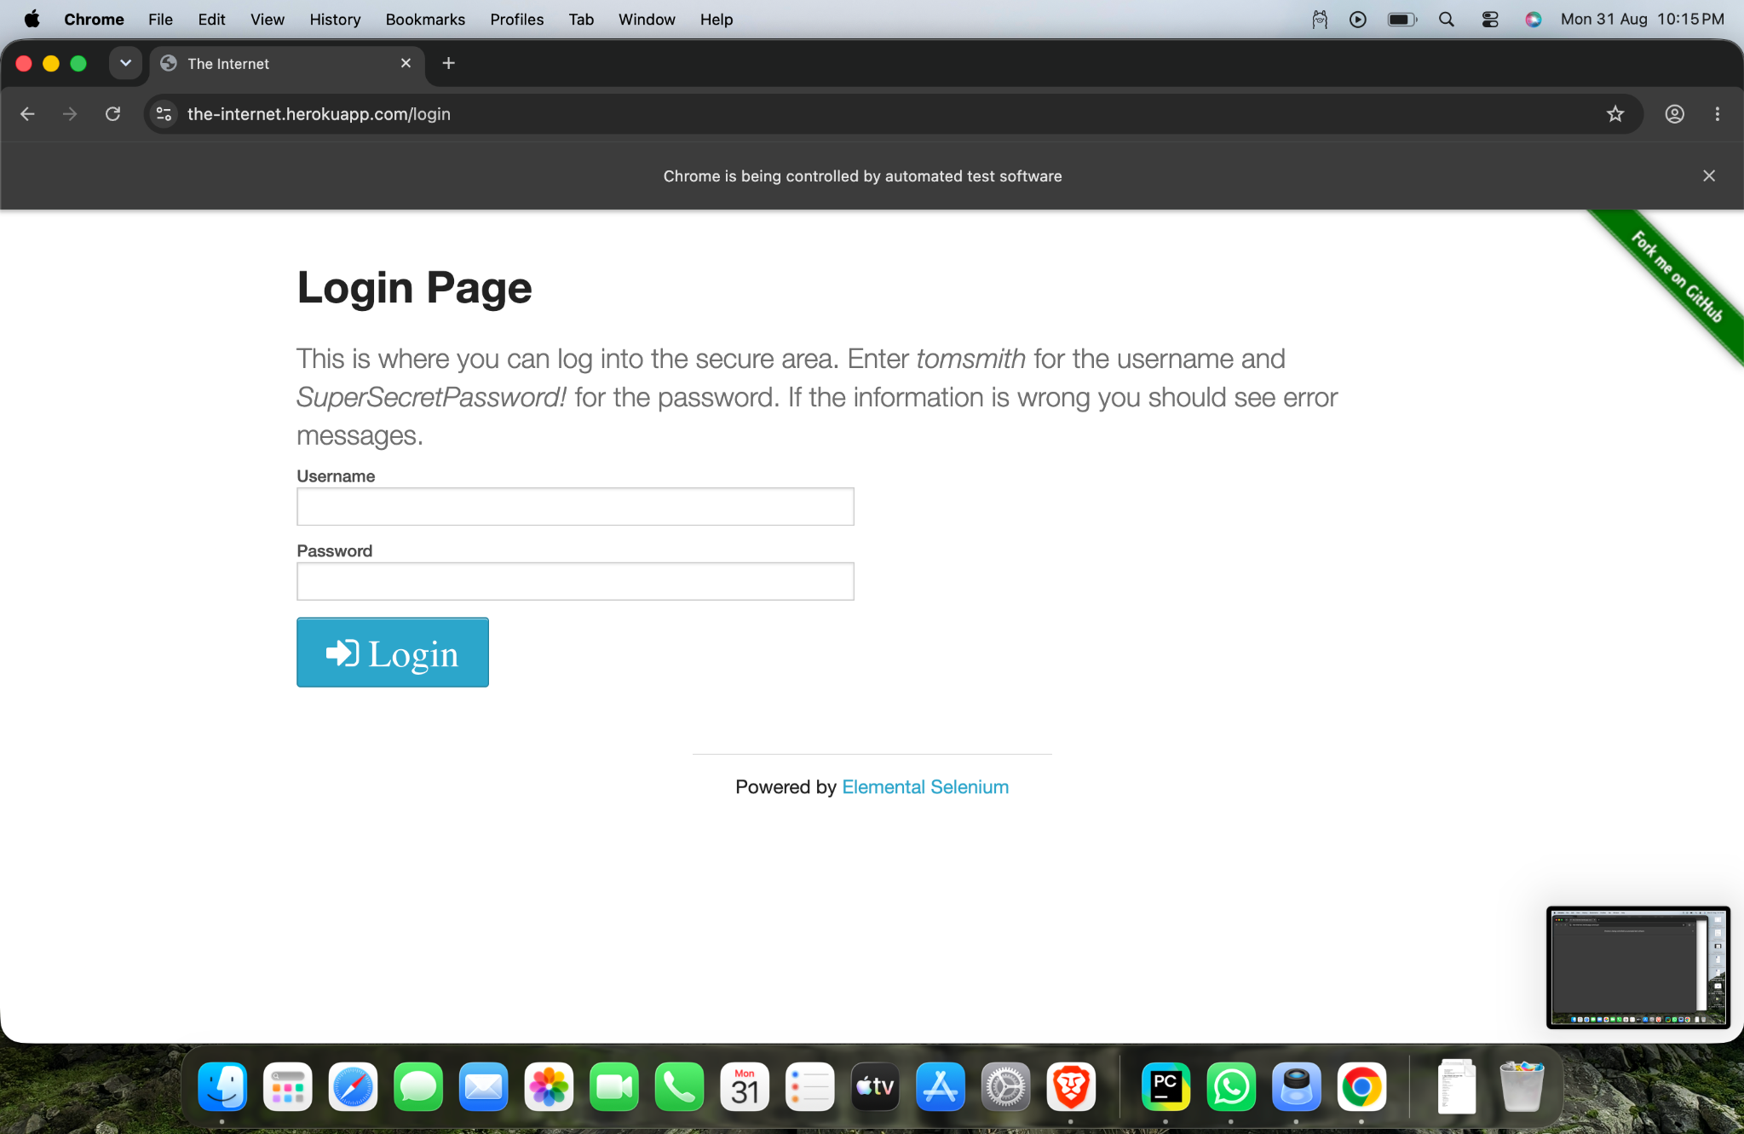
Figure 2: Automated login attempt using the invalid password.

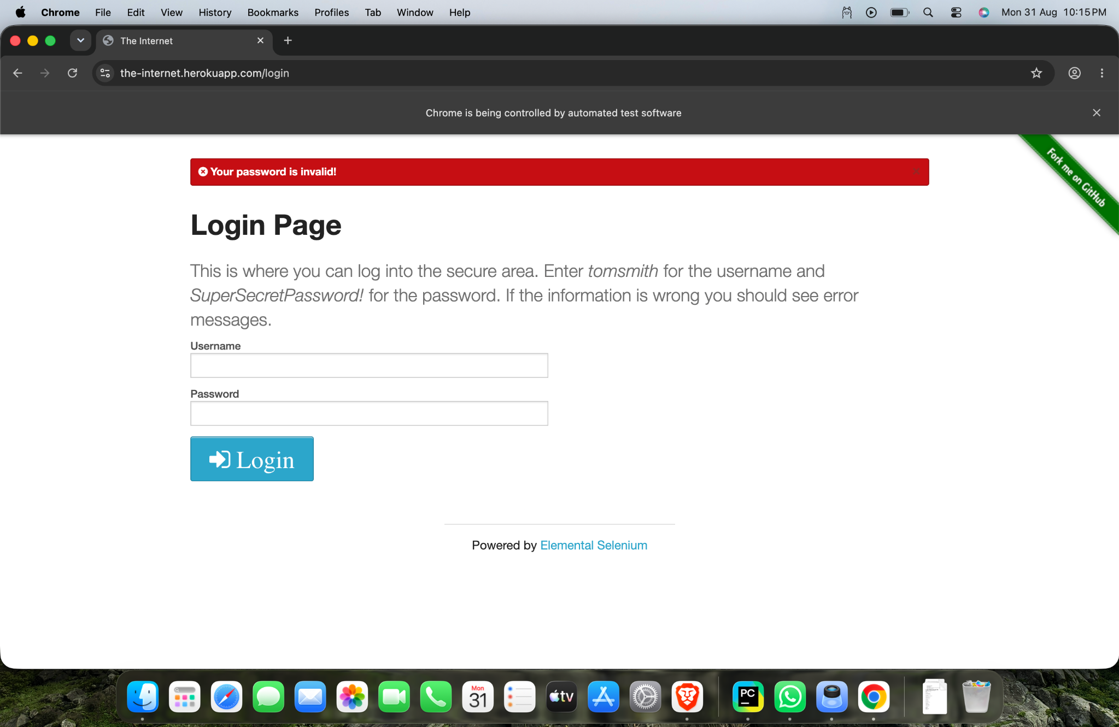
Figure 3: Application rejects the login and displays the invalid-password error message.

6. Important Testing Interpretation
The word “FAIL” in the practical title refers to the login scenario being intentionally invalid, not necessarily to a failure of the application. Since the application correctly rejected the wrong password, the negative test itself passes. A professional test report should distinguish between a failed login attempt and a failed test case.
Situation | Interpretation
Wrong password is accepted | Test Case FAIL – security/functional defect detected.
Wrong password is rejected | Test Case PASS – application behaves as expected.
Error message is displayed | Expected negative behaviour confirmed.
User reaches /secure | Unexpected behaviour; test should FAIL.
7. Why try...finally?
Block | Purpose
try | Contains the complete Selenium test flow and result verification.
finally | Ensures driver.quit() executes so Chrome closes even if an automation error occurs.
8. Main Selenium Concepts
Concept | Purpose
By.ID | Locates the username and password fields using their HTML ID.
By.CSS_SELECTOR | Locates the Login button using a CSS selector.
send_keys() | Enters the username and intentionally incorrect password.
click() | Submits the login form.
current_url | Checks whether the browser was redirected to the secure area.
try...finally | Provides safe cleanup of the browser session.
driver.quit() | Closes Chrome and terminates the WebDriver session.
9. Expected vs Actual Result
Item | Expected | Actual
Login with wrong password | Rejected | Rejected
Current page | Login Page | Login Page
Secure Area | Must not open | Did not open
Error message | Invalid password message | “Your password is invalid!” displayed
Overall Test Case | PASS | PASS
10. Tester Observation
The negative login scenario was executed successfully. The application did not allow authentication with an invalid password and displayed an appropriate error message. This confirms that the tested login validation works as expected for the supplied invalid credential.
11. Conclusion
The practical successfully demonstrates negative login testing using Selenium WebDriver. The test verifies that invalid credentials are rejected and that the secure area cannot be accessed. Based on the supplied execution evidence, the application response matches the expected behaviour and the test case is PASS.
12. Tester Assessment
Test Case: TC-05 – Login Automation – FAIL Test Case
Scenario: Invalid password
Observed Result: Login rejected with an error message
Security/Functional Check: PASS
Final Test Status: PASS
Testing Skill Demonstrated: Negative functional UI automation using Selenium WebDriver.

