SOFTWARE TESTING PRACTICAL REPORT
Practical 6: Click a Link
Field | Details
Practical | 6
Concept | Link automation using By.LINK_TEXT
Automation Tool | Selenium WebDriver
Programming Language | Python
Browser | Google Chrome
Application Under Test | The Internet – Example Links Page
Target Link | Form Authentication
Test Objective | Locate the “Form Authentication” link using its exact visible text, click it, and verify that the browser opens the Login Page.
1. Concept
By.LINK_TEXT is used in Selenium when the exact visible text of an HTML link is known. In this practical, Selenium searches for the link whose visible text is “Form Authentication” and clicks it.
2. Test Case Details
Parameter | Test Details
Test Case ID | TC-06
Test Case | Click a Link
Test Type | Functional UI Automation
Precondition | Python, Selenium WebDriver, Google Chrome, and a compatible Chrome WebDriver are installed and configured.
Starting URL | https://the-internet.herokuapp.com/
Target Element | Form Authentication link
Locator Strategy | By.LINK_TEXT
Locator Value | "Form Authentication"
Expected Result | The Form Authentication link should be clicked successfully and the Login Page should open.
Actual Result | The Login Page opened successfully. The current URL became https://the-internet.herokuapp.com/login.
3. Automation Source Code
# 6. Click a Link
from selenium import webdriver
from selenium.webdriver.common.by import By
import time
driver = webdriver.Chrome()
driver.get("https://the-internet.herokuapp.com/")
driver.maximize_window()
time.sleep(2)
# Click "Form Authentication"
link = driver.find_element(
By.LINK_TEXT,
"Form Authentication"
)
link.click()
time.sleep(2)
print("Current Page:", driver.title)
print("Current URL:", driver.current_url)
driver.quit()
4. Execution Result
Verification | Result
Chrome launched | PASS
Starting page opened | PASS
“Form Authentication” link located | PASS
Link clicked | PASS
Login Page opened | PASS
Page title | The Internet
Current URL | https://the-internet.herokuapp.com/login
Overall Test Case | PASS
The supplied screenshots show the Selenium-controlled Chrome browser opening The Internet homepage, navigating to the Login Page, and displaying the Login Page after the Form Authentication link was clicked.
5. Test Evidence / Screenshots
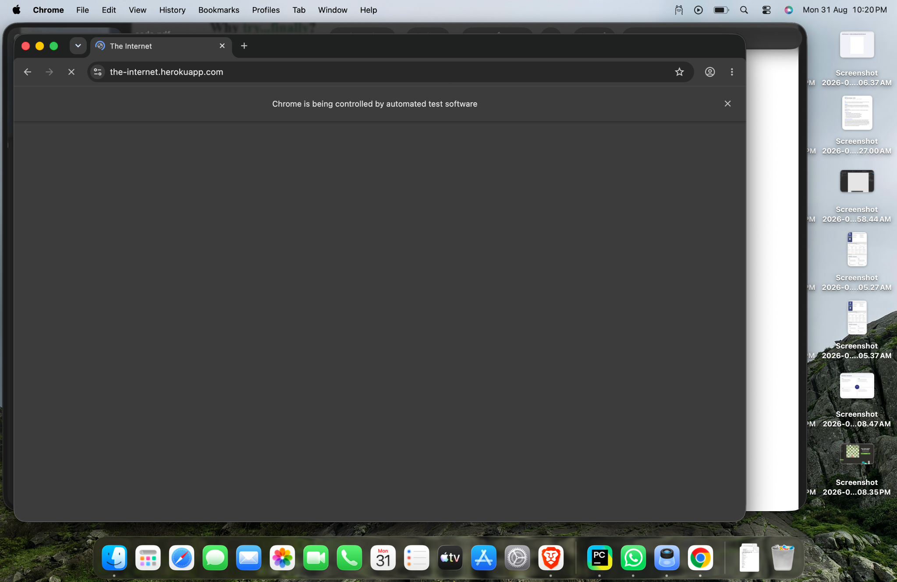
Figure 1: Chrome browser opened by Selenium before navigating to the target link.

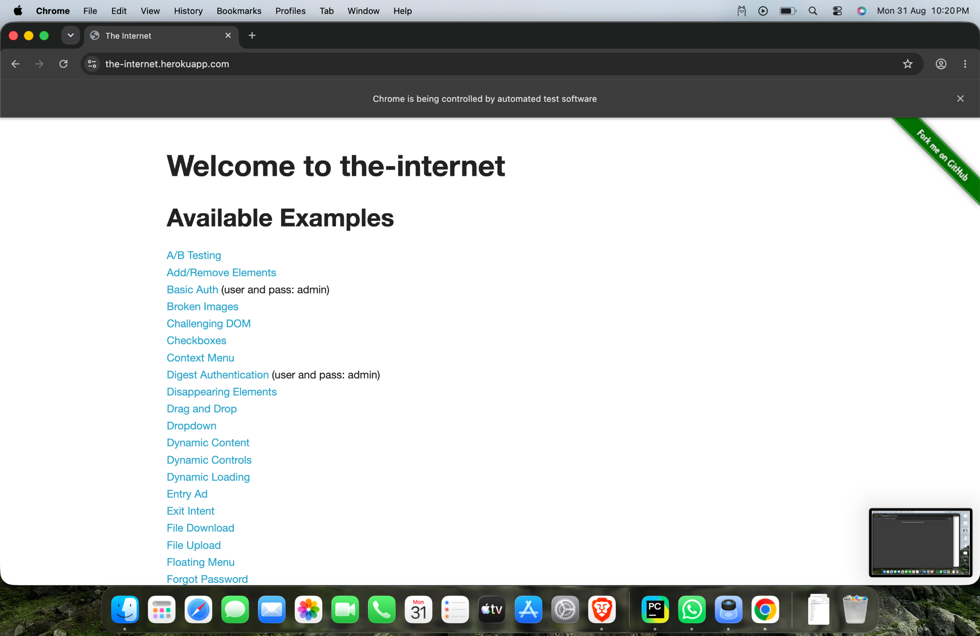
Figure 2: The Internet homepage showing the available examples, including Form Authentication.

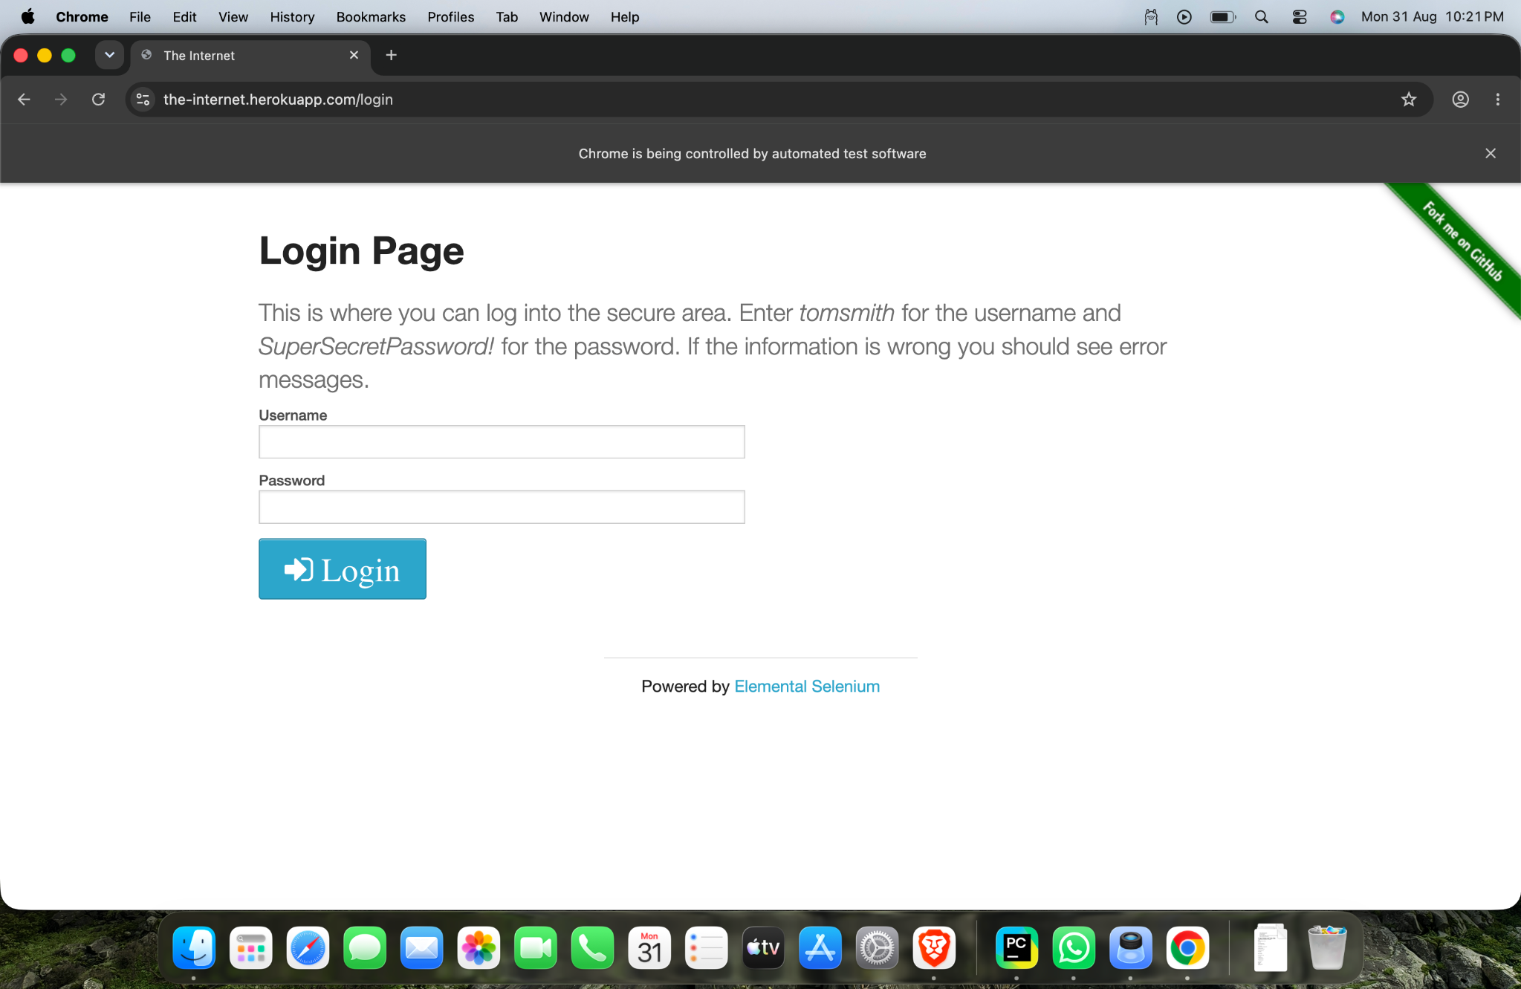
Figure 3: Login Page opened after clicking the Form Authentication link.

6. How By.LINK_TEXT Works
Code | Meaning
By.LINK_TEXT | Tells Selenium to search for a link using its exact visible text.
"Form Authentication" | The exact text displayed for the target link.
find_element() | Finds the matching link element on the page.
click() | Performs the click action on the located link.
7. Expected vs Actual Result
Item | Expected | Actual
Target link | Form Authentication | Form Authentication found
Action | Click the link | Link clicked
Destination | Login Page | Login Page
Page title | The Internet | The Internet
URL | https://the-internet.herokuapp.com/login | https://the-internet.herokuapp.com/login
Overall Test Case | PASS | PASS
8. Important Point
By.LINK_TEXT works when the exact visible text of the link is known. If the link text changes, contains extra spaces, or is not an exact match, By.LINK_TEXT may not locate the element. In such cases, another locator such as By.PARTIAL_LINK_TEXT or By.CSS_SELECTOR can be considered.
9. Main Selenium Concepts
Concept | Purpose
webdriver.Chrome() | Launches the Google Chrome browser through Selenium.
get() | Opens the specified web page.
maximize_window() | Maximizes the browser window.
By.LINK_TEXT | Locates a link using its exact visible text.
find_element() | Finds the required web element.
click() | Clicks the selected link.
current_url | Returns the URL of the current page.
title | Returns the title of the current web page.
driver.quit() | Closes the browser and ends the WebDriver session.
10. Tester Observation
The link was successfully located using By.LINK_TEXT and clicked. The browser navigated from the main The Internet examples page to the Login Page. The observed URL matched the expected destination.
11. Conclusion
Practical 6 successfully demonstrates link automation in Selenium WebDriver using By.LINK_TEXT. The “Form Authentication” link was identified using its exact visible text, clicked, and verified by checking the resulting page and URL. The test case PASS condition was achieved.
12. Final Assessment
Test Case: TC-06 – Click a Link
Locator Used: By.LINK_TEXT
Target: Form Authentication
Observed Result: Login Page opened successfully
Final Test Status: PASS
Testing Skill Demonstrated: Selenium link identification and click automation.

