SOFTWARE TESTING PRACTICAL REPORT
Practical 7: Dropdown Automation
Field | Details
Practical | 7
Concept | Selecting an option from a dropdown
Automation Tool | Selenium WebDriver
Programming Language | Python
Browser | Google Chrome
Application Under Test | The Internet – Dropdown Example
Target Element | HTML Select dropdown
Selected Value | Option 2
Test Objective | Locate the dropdown, select “Option 2” by its visible text, and verify that the selected option is correct.
1. Objective
To automate the selection of an item from an HTML <select> dropdown using Selenium WebDriver and verify that the required option, “Option 2”, has been selected successfully.
2. Concept
Selenium provides the Select class for working with standard HTML <select> dropdown elements. In this practical, the dropdown is first located using By.ID. A Select object is then created and select_by_visible_text() is used to select “Option 2”.
3. Test Case Details
Parameter | Test Details
Test Case ID | TC-07
Test Case | Dropdown Automation
Test Type | Functional UI Automation
Precondition | Python, Selenium WebDriver, Google Chrome, and a compatible Chrome WebDriver are installed and configured.
Starting URL | https://the-internet.herokuapp.com/dropdown
Target Element | Dropdown List
Locator Strategy | By.ID
Locator Value | "dropdown"
Action | Select Option 2
Selection Method | select_by_visible_text()
Expected Result | Option 2 should be selected from the dropdown.
Actual Result | Option 2 was selected successfully and displayed as the selected value.
Overall Status | PASS
4. Automation Source Code
# 7. Dropdown Automation
from selenium import webdriver
from selenium.webdriver.common.by import By
from selenium.webdriver.support.ui import Select
import time
driver = webdriver.Chrome()
driver.get("https://the-internet.herokuapp.com/dropdown")
driver.maximize_window()
time.sleep(2)
# Locate dropdown
dropdown = driver.find_element(By.ID, "dropdown")
# Create Select object
select = Select(dropdown)
# Select Option 2
select.select_by_visible_text("Option 2")
time.sleep(2)
# Print selected option
selected = select.first_selected_option.text
print("Selected Option:", selected)
driver.quit()
5. Execution Result
Verification | Result
Chrome browser launched | PASS
Dropdown page opened | PASS
Dropdown located using By.ID | PASS
Select object created | PASS
Option 2 selected | PASS
Selected option verified | PASS
Displayed selected value | Option 2
Overall Test Case | PASS
The test successfully located the Dropdown List, selected “Option 2”, and verified the selected value. The execution matched the expected result.
6. Test Evidence / Screenshots
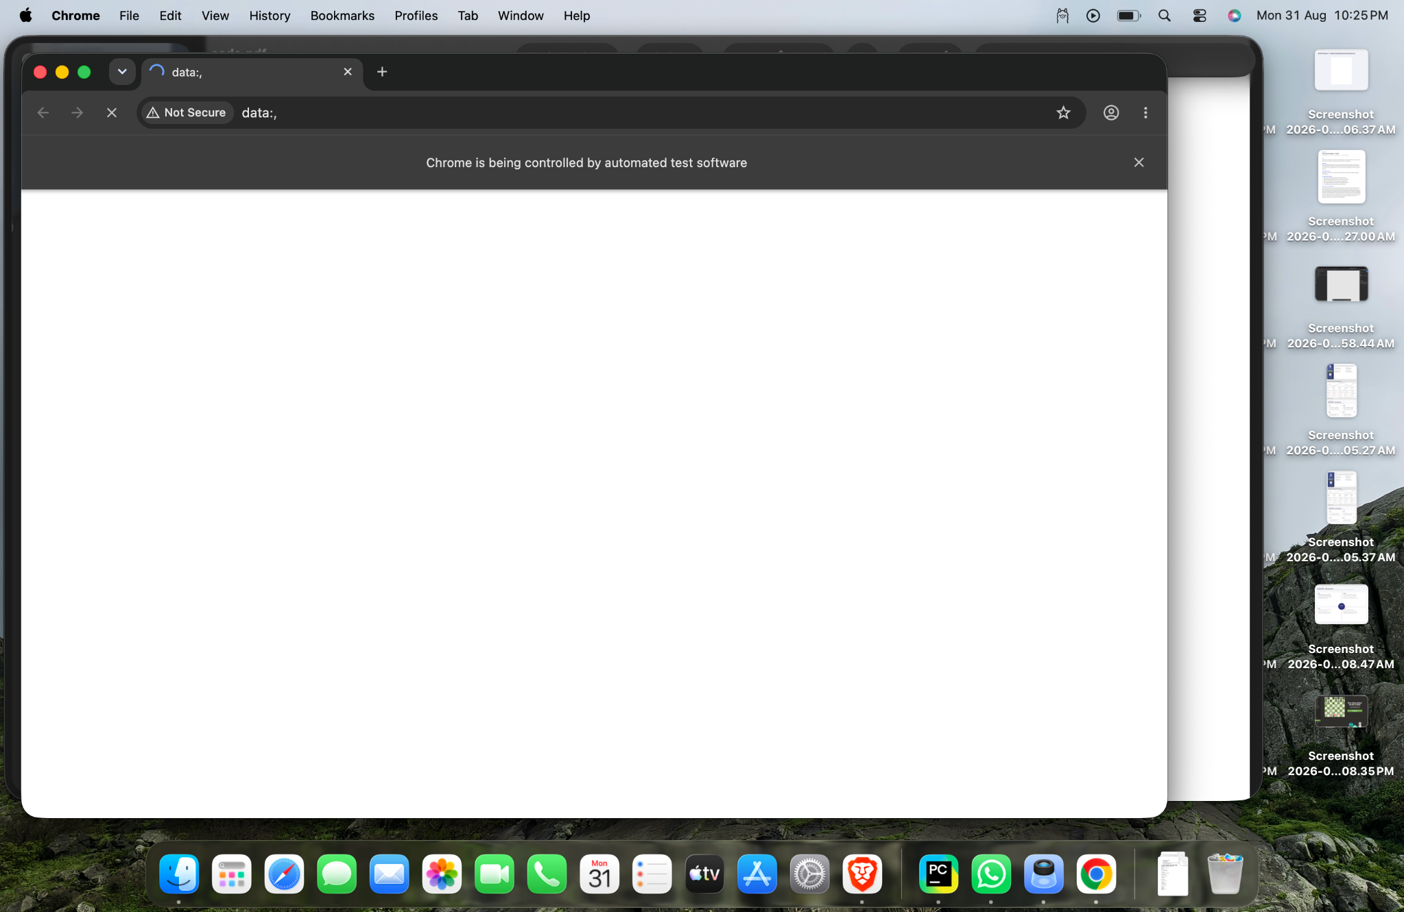
Figure 1: Chrome browser opened by Selenium on the Dropdown List page.
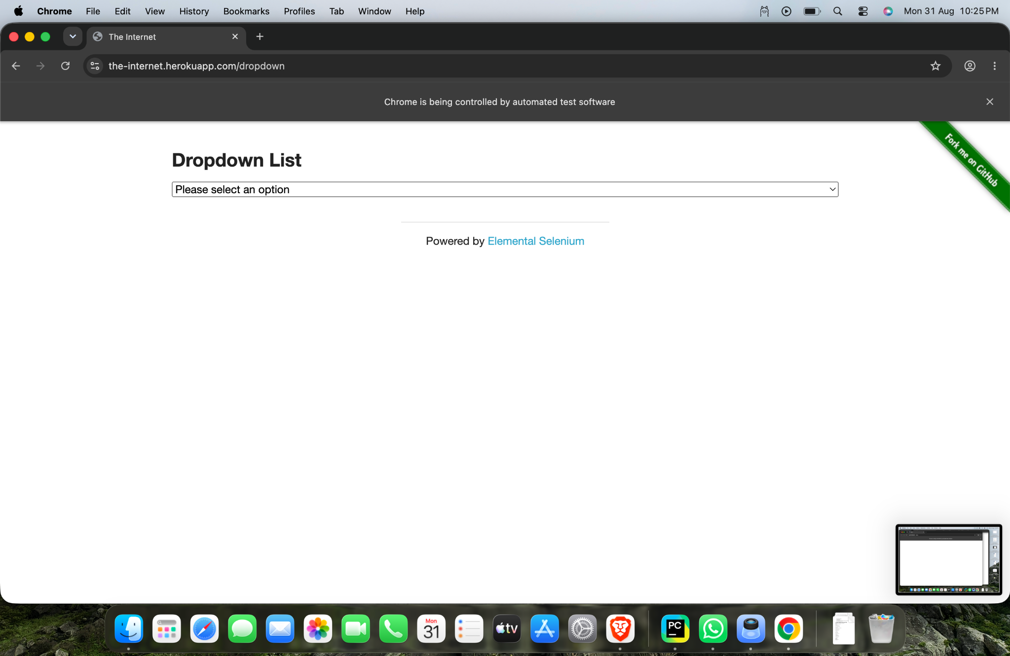
Figure 2: Dropdown List page before selecting an option.
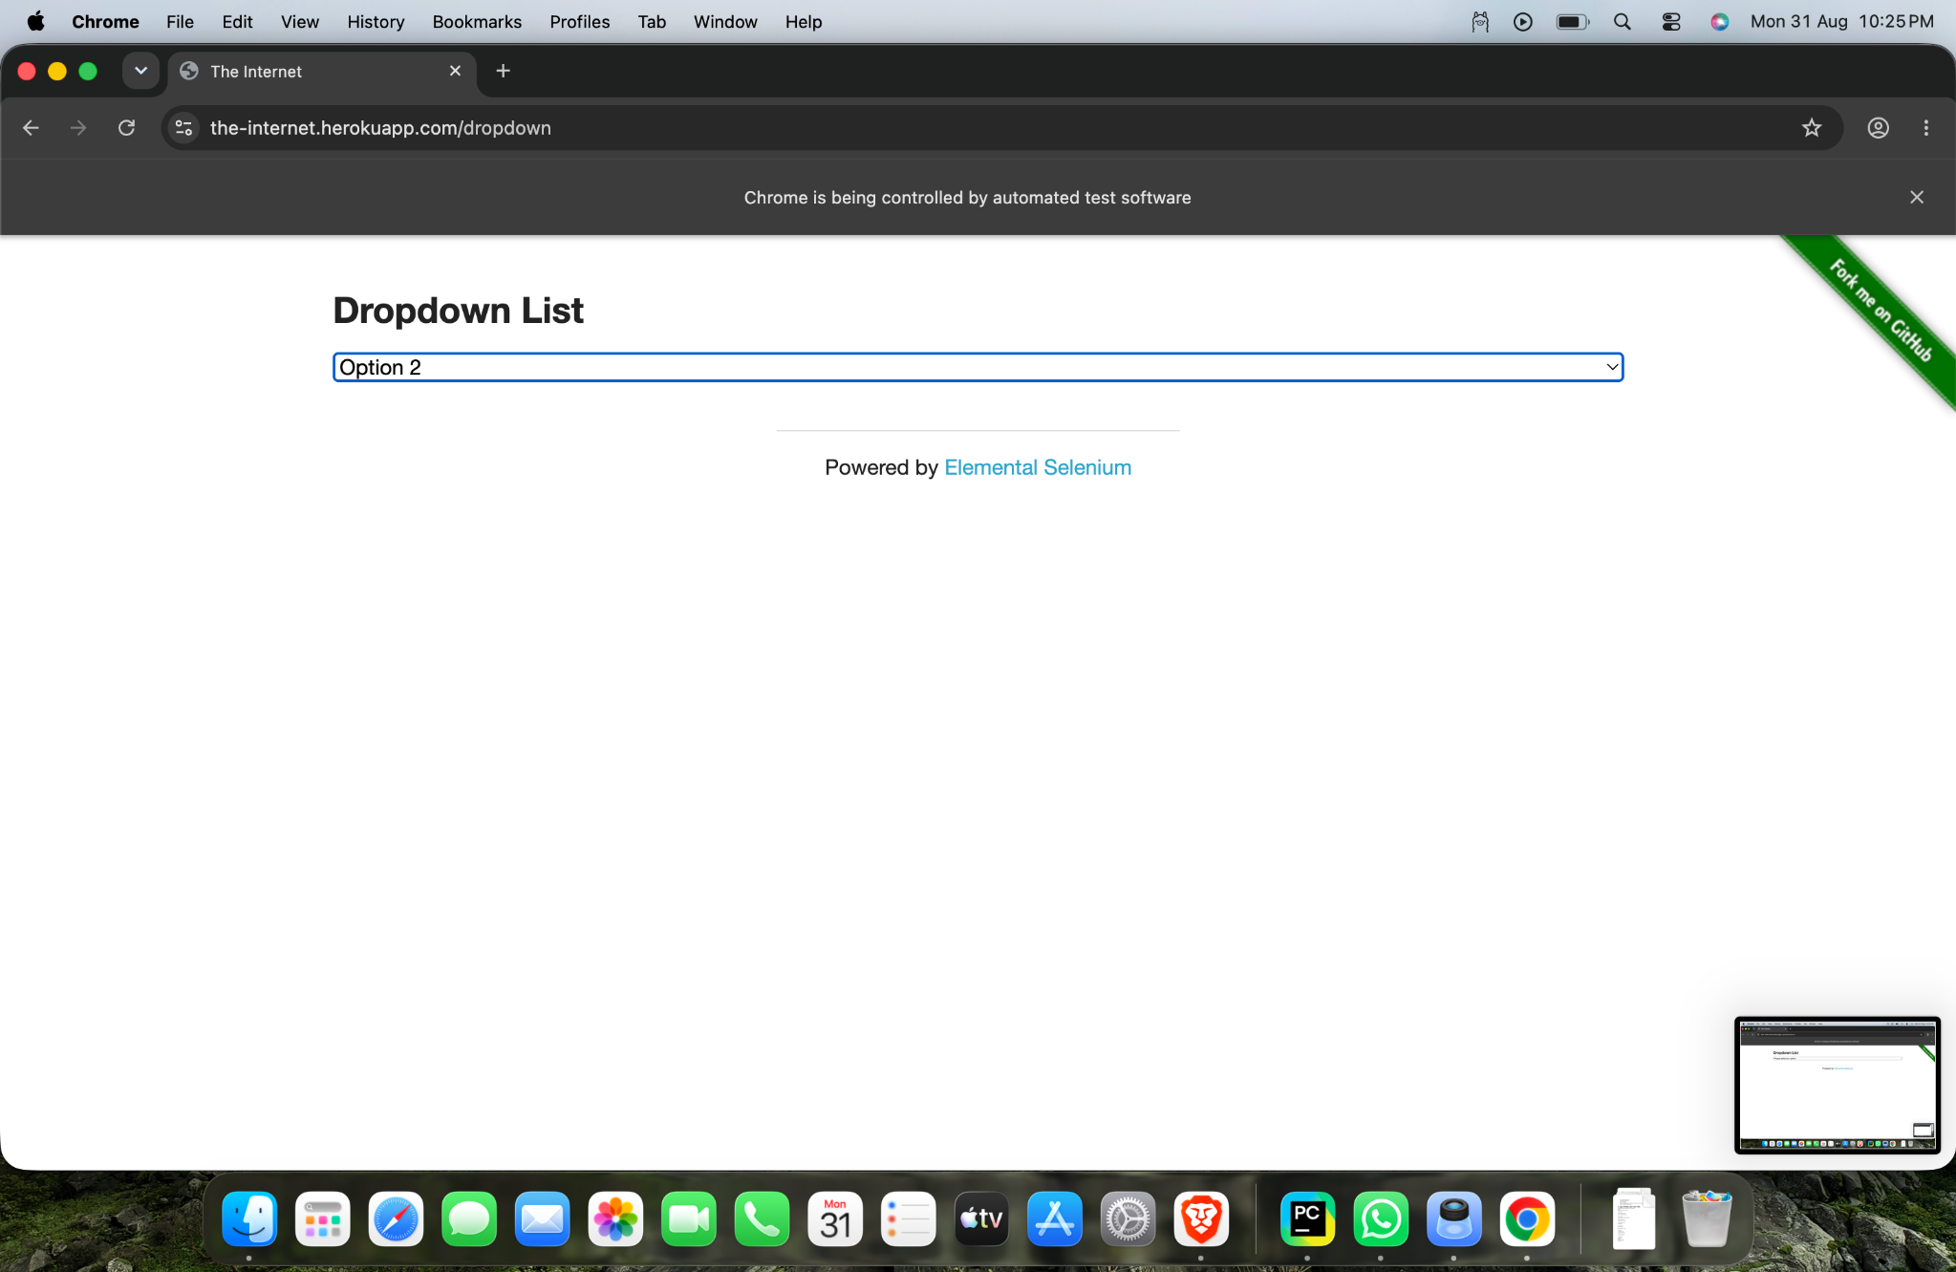
Figure 3: Dropdown List showing “Option 2” selected successfully.
7. Expected vs Actual Result
Item | Expected | Actual
Dropdown | Dropdown should be located | Dropdown located successfully
Selection | Option 2 should be selected | Option 2 selected
Verification | Selected value should be Option 2 | Selected value was Option 2
Test Status | PASS | PASS
8. Important Selenium Class – Select
The Select class is specifically designed to interact with standard HTML <select> dropdowns. It provides convenient methods for selecting and reading options.
Command | Purpose
Select(dropdown) | Creates a Select object for the HTML dropdown.
select_by_visible_text("Option 2") | Selects an option using its visible text.
first_selected_option | Returns the currently selected option.
first_selected_option.text | Returns the visible text of the selected option.
9. Main Selenium Concepts
Concept | Purpose
webdriver.Chrome() | Launches Google Chrome through Selenium.
get() | Opens the specified web page.
maximize_window() | Maximizes the browser window.
By.ID | Locates the dropdown using its HTML id attribute.
find_element() | Finds the required web element.
Select | Provides methods for interacting with HTML select dropdowns.
select_by_visible_text() | Selects an option using the displayed text.
first_selected_option | Gets the currently selected option.
driver.quit() | Closes Chrome and ends the WebDriver session.
10. Tester Observation
The dropdown was identified correctly using its ID, and Selenium’s Select class successfully selected “Option 2”. The selected value was then retrieved and displayed in the console. No functional issue was observed during the test.
11. Conclusion
Practical 7 successfully demonstrates dropdown automation using Selenium WebDriver and Python. The HTML dropdown was located using By.ID, “Option 2” was selected using select_by_visible_text(), and the selected value was verified. The test case passed successfully.
12. Final Assessment
Test Case: TC-07 – Dropdown Automation
Locator Used: By.ID
Dropdown ID: dropdown
Selected Option: Option 2
Observed Result: Option 2 selected successfully
Final Test Status: PASS
Testing Skill Demonstrated: HTML dropdown identification, option selection, and result verification.

