SOFTWARE TESTING PRACTICAL REPORT
Practical 8: Checkbox Automation
Field | Details
Practical | 8
Concept | Selecting and unselecting checkboxes
Automation Tool | Selenium WebDriver
Programming Language | Python
Browser | Google Chrome
Application Under Test | The Internet – Checkboxes Example
Target Elements | HTML checkbox input elements
Test Objective | Find all checkboxes, select each checkbox when it is not already selected, and verify the selected state.
1. Objective
To automate checkbox selection using Selenium WebDriver. The test identifies all checkbox elements on the page, checks their current state using is_selected(), clicks any unchecked checkbox, and verifies that both checkboxes are selected.
2. Concept
Checkbox automation is used to test whether checkboxes can be selected and unselected correctly. Selenium’s find_elements() method is used when multiple matching elements are required. The is_selected() method checks whether a checkbox is currently selected.
3. Test Case Details
Parameter | Test Details
Test Case ID | TC-08
Test Case | Checkbox Automation
Test Type | Functional UI Automation
Precondition | Python, Selenium WebDriver, Google Chrome, and a compatible Chrome WebDriver are installed and configured.
Starting URL | https://the-internet.herokuapp.com/checkboxes
Target Elements | Checkbox 1 and Checkbox 2
Locator Strategy | By.CSS_SELECTOR
Locator Value | "input[type='checkbox']"
Action | Select unchecked checkboxes
Verification Method | is_selected()
Expected Result | Both checkboxes should be selected.
Actual Result | Both checkboxes were selected successfully.
Overall Status | PASS
4. Automation Source Code
# 8. Checkbox Automation
from selenium import webdriver
from selenium.webdriver.common.by import By
import time
driver = webdriver.Chrome()
driver.get("https://the-internet.herokuapp.com/checkboxes")
driver.maximize_window()
time.sleep(2)
# Find all checkboxes
checkboxes = driver.find_elements(
By.CSS_SELECTOR, "input[type='checkbox']"
)
print("Number of checkboxes:", len(checkboxes))
# Select first checkbox if not selected
if not checkboxes[0].is_selected():
checkboxes[0].click()
print("First checkbox selected:",
checkboxes[0].is_selected())
# Select second checkbox if not selected
if not checkboxes[1].is_selected():
checkboxes[1].click()
print("Second checkbox selected:",
checkboxes[1].is_selected())
driver.quit()
5. Execution Result
Verification | Result
Chrome browser launched | PASS
Checkbox page opened | PASS
All checkboxes located | PASS
Number of checkboxes | 2
First checkbox selected | True
Second checkbox selected | True
Selected state verified | PASS
Overall Test Case | PASS
The test successfully found two checkboxes. Checkbox 1 was initially unchecked and was selected by the automation. Checkbox 2 was already selected, so the script left it unchanged. The final verification confirmed that both checkboxes were selected.
6. Test Evidence / Screenshots
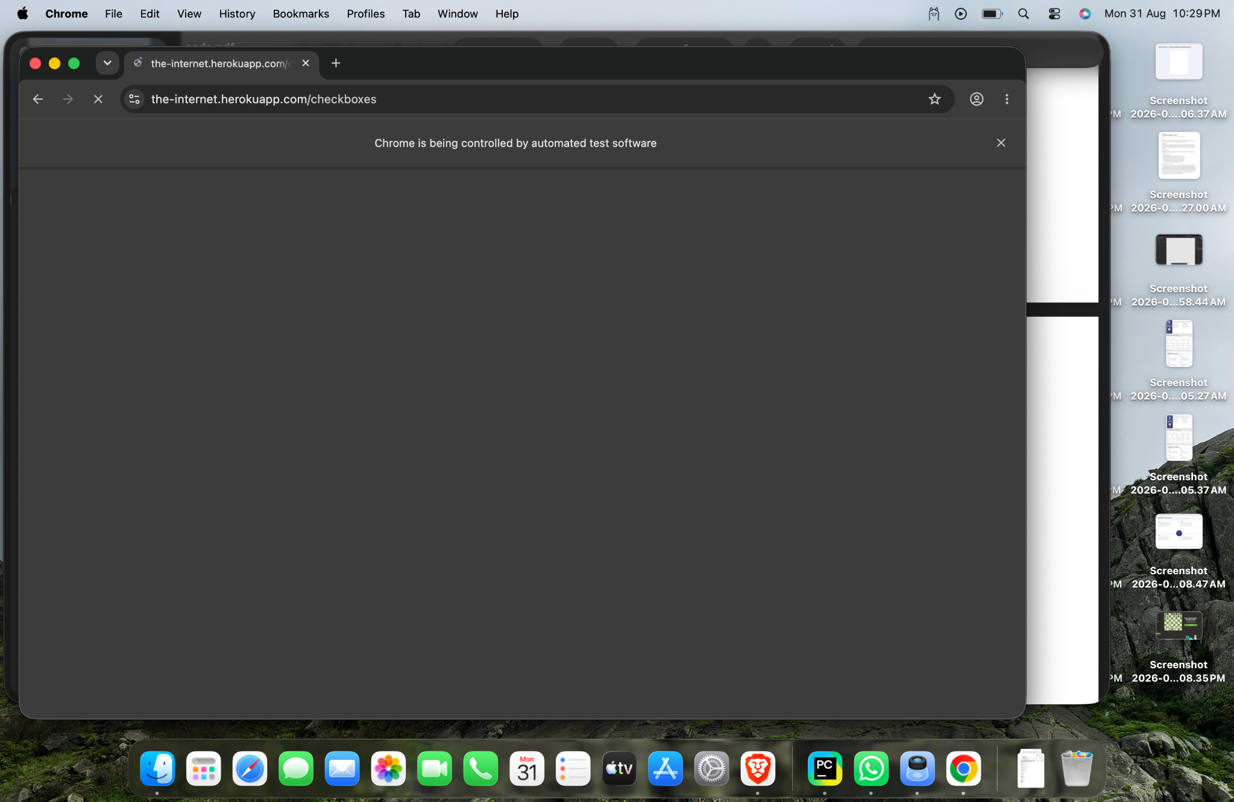
Figure 1: Chrome browser opened by Selenium on the Checkboxes page. Checkbox 1 is unchecked and Checkbox 2 is already selected.
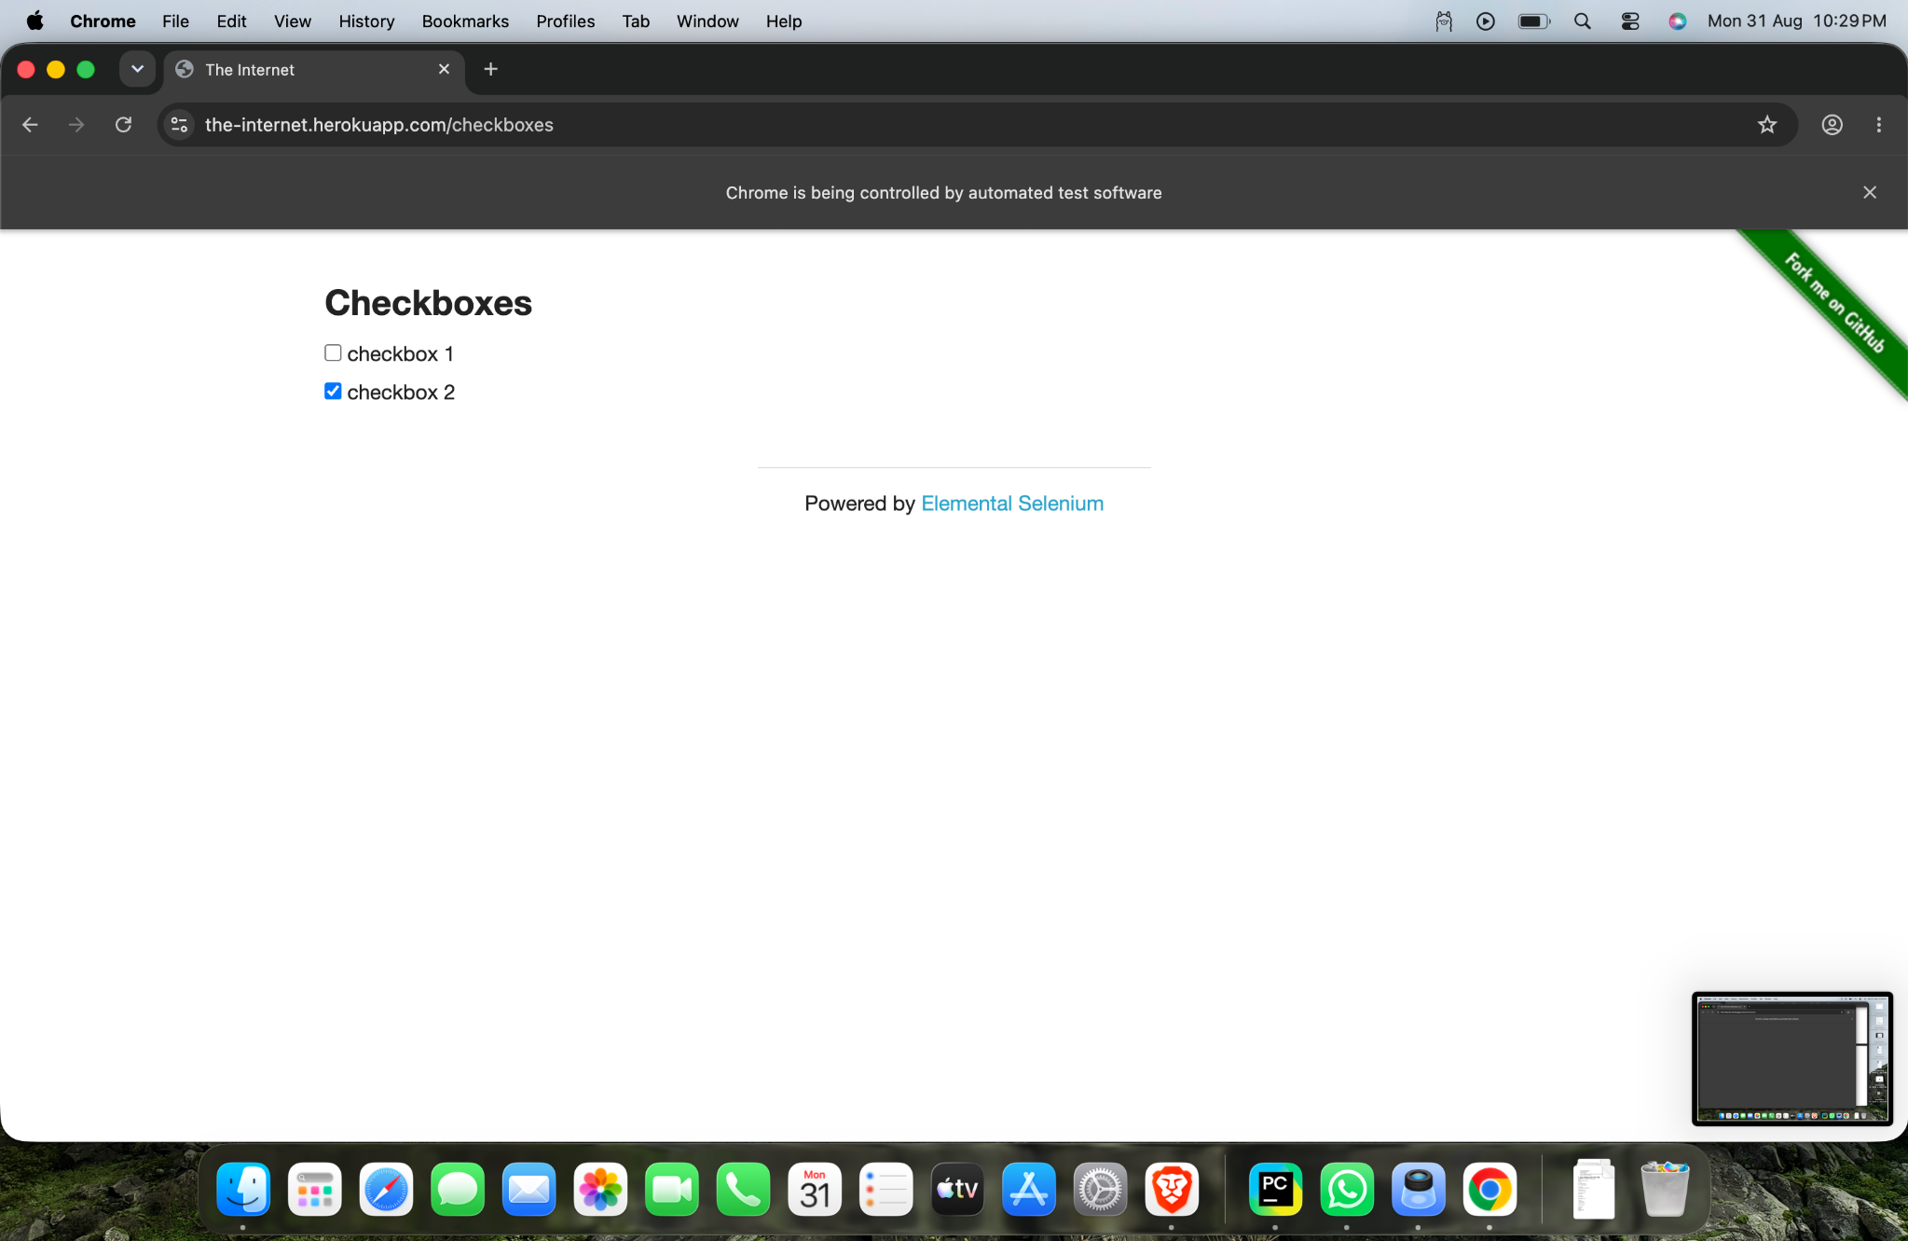
Figure 2: Checkboxes page after automation, showing the checkbox state used for verification.
7. Expected vs Actual Result
Item | Expected | Actual
Checkbox elements | Two checkboxes should be located | 2 checkboxes located
Checkbox 1 | If unchecked, it should be selected | Selected successfully
Checkbox 2 | If already selected, it should remain selected | Remained selected
Final state | Both checkboxes selected | Both selected
Test Status | PASS | PASS
8. Important Selenium Methods
Method / Command | Purpose
find_elements() | Finds multiple matching web elements.
By.CSS_SELECTOR | Locates elements using a CSS selector.
"input[type='checkbox']" | Targets HTML input elements whose type is checkbox.
is_selected() | Checks whether a checkbox is currently selected.
click() | Clicks and changes the checkbox state.
len(checkboxes) | Returns the number of checkbox elements found.
9. Main Selenium Concepts
Concept | Purpose
webdriver.Chrome() | Launches Google Chrome through Selenium.
get() | Opens the specified web page.
maximize_window() | Maximizes the browser window.
find_elements() | Returns multiple matching elements.
By.CSS_SELECTOR | Uses a CSS selector to locate checkbox elements.
is_selected() | Returns True when a checkbox is selected.
click() | Selects an unchecked checkbox.
driver.quit() | Closes Chrome and ends the WebDriver session.
10. Tester Observation
The automation correctly handled different initial checkbox states. Checkbox 1 was selected because it was unchecked, while Checkbox 2 was already selected and did not need another click. The final state of both checkboxes was verified as True.
11. Conclusion
Practical 8 successfully demonstrates checkbox automation using Selenium WebDriver and Python. The script located multiple checkbox elements, checked their current states using is_selected(), selected the unchecked checkbox, and verified the final state. The test case passed successfully.
12. Final Assessment
Test Case: TC-08 – Checkbox Automation
Locator Used: By.CSS_SELECTOR
Selector: input[type='checkbox']
Number of Checkboxes: 2
Final State: Both checkboxes selected
Observed Result: First checkbox selected and second checkbox remained selected
Final Test Status: PASS
Testing Skill Demonstrated: Multiple-element identification, checkbox state verification, conditional clicking, and result validation.

