SOFTWARE TESTING PRACTICAL REPORT
Practical 9: Screenshot Automation
Field | Details
Practical | 9
Concept | Taking a screenshot during testing
Automation Tool | Selenium WebDriver
Programming Language | Python
Browser | Google Chrome
Application Under Test | Google Homepage
Target | Browser page screenshot
Test Objective | Open Google, maximize the browser, capture a screenshot, and verify that the screenshot is saved successfully.
1. Objective
To automate screenshot capture using Selenium WebDriver. The script opens Google in Chrome, maximizes the browser window, waits for the page to load, saves a screenshot as google_homepage.png, displays a success message, and closes the browser.
2. Concept
Screenshot automation is useful in software testing for recording the visual state of an application during test execution. Selenium provides the save_screenshot() method to capture the current browser page and store it as an image file.
3. Test Case Details
Parameter | Test Details
Test Case ID | TC-09
Test Case | Screenshot Automation
Test Type | Functional UI Automation
Precondition | Python, Selenium WebDriver, Google Chrome, and a compatible Chrome WebDriver are installed and configured.
Starting URL | https://www.google.com
Browser Action | Open and maximize Google Chrome
Screenshot Method | driver.save_screenshot()
Screenshot File | google_homepage.png
Expected Result | Screenshot should be saved successfully in the project's working directory.
Actual Result | Screenshot saved successfully.
Overall Status | PASS
4. Automation Source Code
# 9. Screenshot Automation
from selenium import webdriver
import time
driver = webdriver.Chrome()
driver.get("https://www.google.com")
driver.maximize_window()
time.sleep(2)
# Take screenshot
driver.save_screenshot("google_homepage.png")
print("Screenshot saved successfully")
driver.quit()
5. Execution Result
Verification | Result
Chrome browser launched | PASS
Google homepage opened | PASS
Browser maximized | PASS
Page wait completed | PASS
Screenshot captured | PASS
Screenshot filename | google_homepage.png
Success message displayed | Screenshot saved successfully
Browser closed | PASS
Overall Test Case | PASS
The automation successfully opened Google in Chrome and captured the browser page as an image. The screenshot was saved using Selenium's save_screenshot() method, and the console displayed the expected success message.
6. Test Evidence / Screenshot
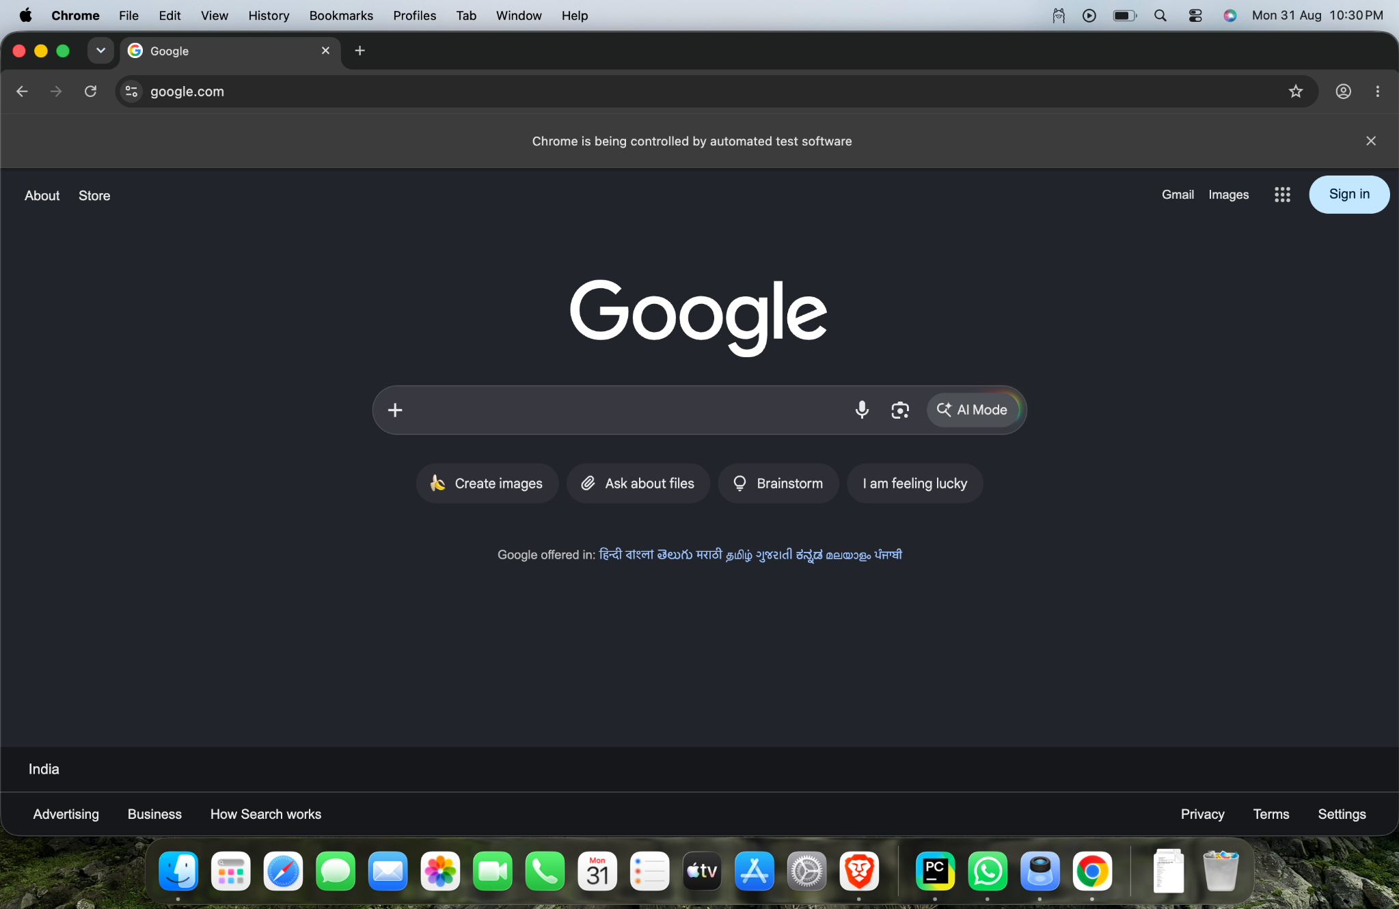
Figure 1: Google homepage captured during Selenium screenshot automation.
7. Expected vs Actual Result
Item | Expected | Actual
Web page | Google homepage should open | Google homepage opened
Browser | Chrome should be maximized | Chrome was maximized
Screenshot | Screenshot should be captured | Screenshot captured
File | google_homepage.png should be created | Screenshot saved successfully
Test Status | PASS | PASS
8. Important Selenium Method
Method / Command | Purpose
webdriver.Chrome() | Launches Google Chrome through Selenium.
get() | Opens the specified web page.
maximize_window() | Maximizes the browser window.
save_screenshot() | Captures the current browser page and saves it as an image file.
quit() | Closes the browser and ends the WebDriver session.
9. Main Selenium Concepts
Concept | Purpose
WebDriver | Controls the browser automatically.
Navigation | Opens Google using driver.get().
Window Management | Maximizes Chrome using maximize_window().
Screenshot Capture | Uses save_screenshot() to create an image of the current page.
File Output | Stores the captured screenshot as google_homepage.png.
Console Verification | Prints a message confirming successful screenshot saving.
10. Screenshot File Location
The screenshot is saved in the project's current working directory with the filename: google_homepage.png
11. Tester Observation
The test successfully demonstrated screenshot capture during automated browser testing. The Google homepage was visible when the screenshot was taken, providing visual evidence of the test execution state.
12. Conclusion
Practical 9 successfully demonstrates screenshot automation using Selenium WebDriver and Python. The script opened Google, maximized Chrome, captured the page, saved the screenshot as google_homepage.png, and displayed a successful execution message. The test case passed.
13. Final Assessment
Test Case: TC-09 – Screenshot Automation
Locator Used: Not required
Screenshot Method: driver.save_screenshot()
Output File: google_homepage.png
Observed Result: Screenshot saved successfully
Final Test Status: PASS
Testing Skill Demonstrated: Browser automation, screenshot capture, evidence collection, and basic execution verification.

