SOFTWARE TESTING PRACTICAL
Software Testing Audit, Automation & Regression Analysis of Strava Website
Tutorial 10 – Automation & Regression Analysis
(Application Under Test substituted: Strava, in place of the Student Management System)

Course: BCA Semester 3 – Software Testing Practical
Application Under Test: Strava (Fitness / Activity Tracking Web Application)
Browser: Google Chrome | Automation Tool (recommended): Selenium with Python
Date of Testing: August 2026

1. Aim
To analyze the suitability of Strava's website modules for Automation Testing and to perform Regression Testing on the application by identifying automation candidates, preparing a regression test suite, and evaluating automation feasibility, following the methodology of Tutorial 10 (Automation & Regression Analysis).

2. Objectives
This practical was carried out with the following objectives:
- Perform functional (black-box) testing of key Strava modules that could be reached and verified during this session.
- Identify modules that are suitable candidates for test automation, and modules that are better suited to manual testing.
- Prepare a Regression Test Suite covering the stable, repeatable flows of the application.
- Evaluate automation feasibility using the criteria taught in Tutorial 10 (critical functionality, frequency of execution, stability, business importance).
- Record genuine test execution results, clearly separating Pass, Fail, and Blocked/Not Testable outcomes.
- Report any real defects or inconsistencies observed, without inventing issues.
- Present the analysis in a professional Word report and a supporting Excel workbook.

3. Application Under Test
Parameter | Details
Website | Strava (www.strava.com)
Application Type | Fitness / Activity Tracking Web Application
Testing Type | Functional Testing, Black-Box Testing, Regression Testing, Automation Feasibility Analysis
Account State | Logged-in athlete account (personal, low-activity test profile)
Testing Approach | Manual functional testing on the live website, followed by automation feasibility analysis
Note: In the original Tutorial 10, the Student Management System was used as the sample application. For this practical, Strava was substituted as the real-world application under test, while retaining the same testing concepts, structure, and terminology.

4. Testing Environment
Item | Details
Operating System | Windows / macOS (Desktop)
Browser | Google Chrome (latest version)
Application URL | https://www.strava.com
Network | Standard broadband connection
Test Data | Sample personal athlete account with 3 recorded activities

5. Testing Tools
Purpose | Tool
Manual functional testing | Google Chrome DevTools, manual navigation
Automation feasibility (recommended) | Selenium with Python
Test documentation | Microsoft Word, Microsoft Excel
Evidence capture | Native OS screenshot tool

6. Strava Module Identification
The following modules/pages were targeted for this audit, based on Strava's actual navigation. Modules that could be reached and verified with evidence are marked 'Tested'; modules that could not be reached, or that were intentionally not exercised to avoid destructive actions, are marked 'Blocked/Not Tested'.
# | Module | Status | Notes
1 | Dashboard / Home Feed | Tested | Fully verified with screenshot evidence
2 | Activity Recording / Activity Details | Tested | Verified via an existing recorded activity
3 | Splits, Map & Elevation Analysis | Tested | Verified within Activity Details
4 | Profile | Tested | Overview and stats verified
5 | Following / Suggested Athletes | Tested (partially) | List verified; Follow action not clicked (destructive to social graph)
6 | Subscription / Upgrade Flow | Tested (partially) | Landing and checkout pages verified; payment not submitted
7 | Help / Glossary | Tested | Verified via Relative Effort and Perceived Exertion definitions
8 | Login | Blocked/Not Tested | Session was already authenticated; not logged out to preserve state
9 | Registration / Sign Up | Blocked/Not Tested | Creating a real new account was outside the permitted scope
10 | Explore | Blocked/Not Tested | Page not reached during this session
11 | Routes (standalone module) | Blocked/Not Tested | Only the in-map 'Create Route' control was observed
12 | Clubs | Blocked/Not Tested | Only the Dashboard promo card was observed
13 | Search | Blocked/Not Tested | Search icon present but not exercised
14 | Settings | Blocked/Not Tested | Not opened, to avoid altering real account settings
15 | Logout | Blocked/Not Tested | Avoided to keep the session active for the rest of the audit

7. Functional Testing Audit
This section documents the functional testing carried out on the modules that were reachable during the session, with supporting screenshot evidence. The complete, itemised test log (41 test steps) is provided in the accompanying Excel workbook, sheet 'Test Audit', using the exact columns required: Section | Testing Step | Test Input | Expected Result | Actual Result | Status (Pass/Fail) | Personal Comments & Suggestions.

7.1 Dashboard / Home Feed
The Dashboard loaded correctly for the authenticated athlete, showing the top navigation bar (Dashboard, Training, Maps, Challenges), a 'Start Trial' call-to-action, notification and profile icons, the athlete's activity feed, and a sidebar summarising Following/Followers/Activities counts, the latest activity, and the current streak. A 'Relative Effort' widget included a help icon that opened a Glossary modal explaining the metric.
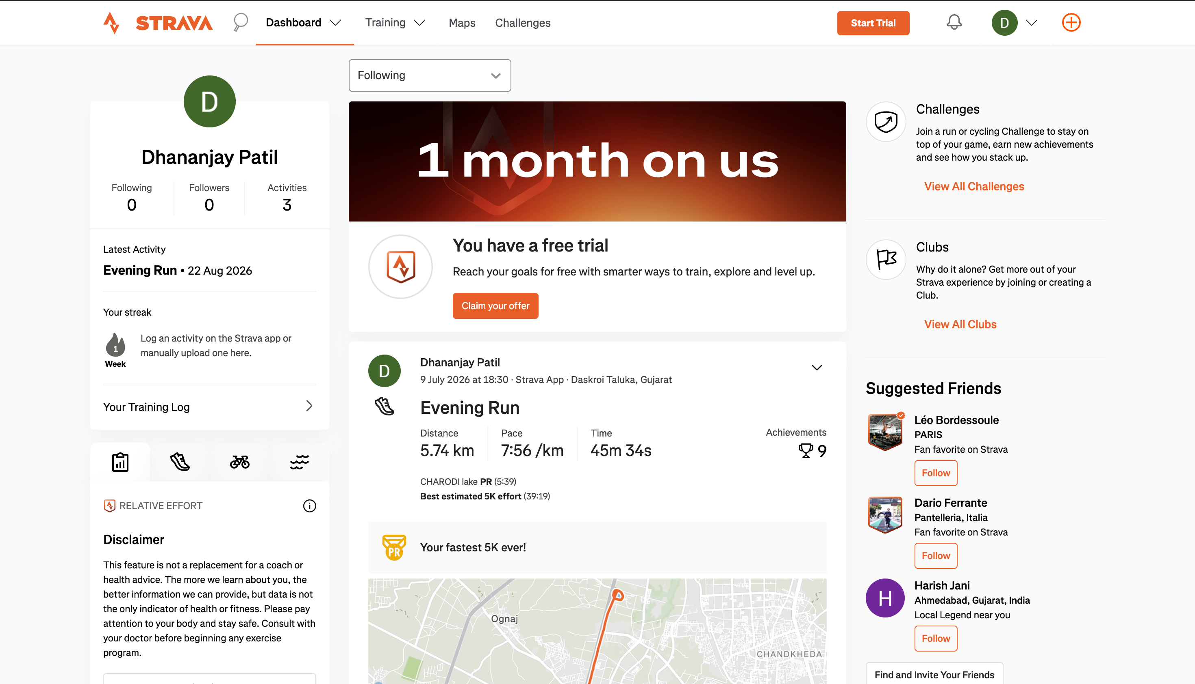
Figure 1 – Strava Dashboard (Home Feed) for the authenticated athlete

7.2 Activity Details, Splits & Map
Opening the athlete's most recent activity ('Evening Run') displayed a detailed overview: distance, moving time, pace, elevation, calories and elapsed time, together with Personal Record ('Top Results') badges, a per-kilometre Splits table, and an embedded interactive map with zoom, 'Create Route', GPX export and fullscreen controls.
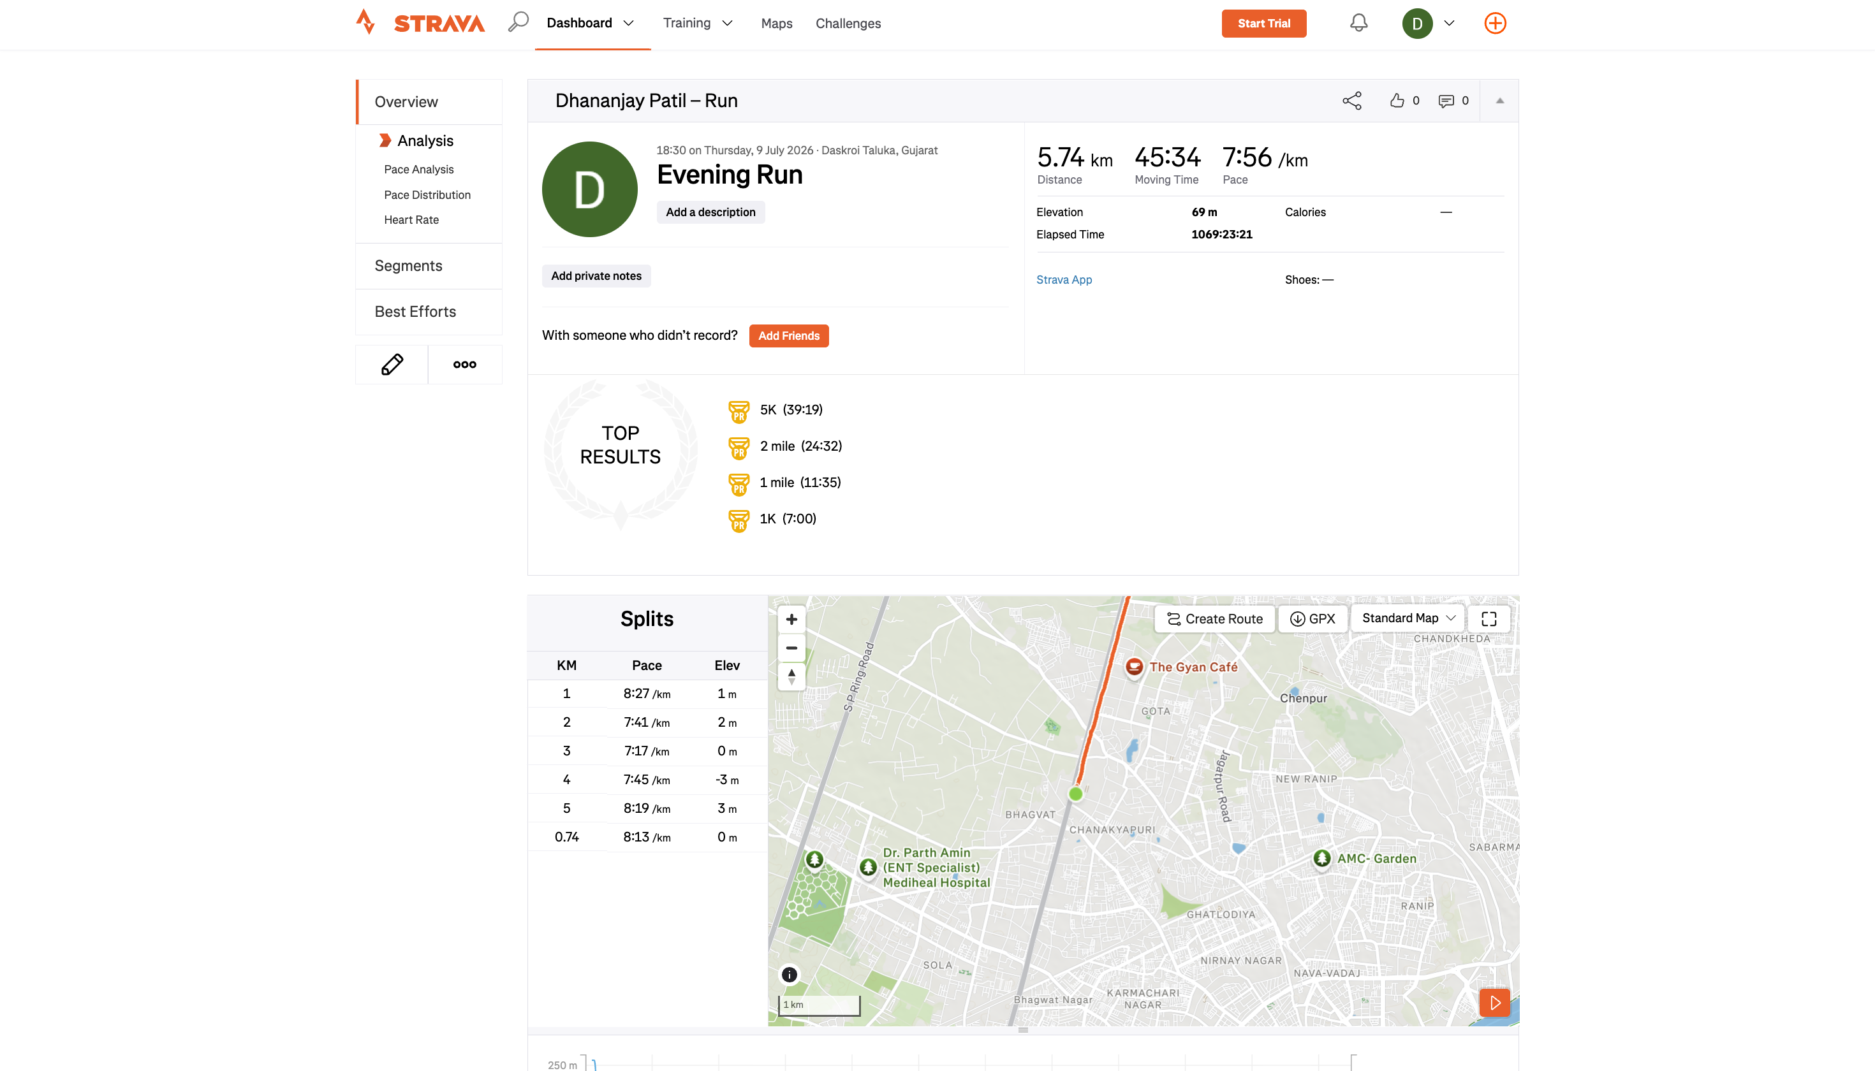
Figure 2 – Activity Details overview, splits and map for 'Evening Run'
One inconsistency was observed here: the Elapsed Time field read '1069:23:21' (about 44.5 hours) while the Moving Time for the same run was only 45:34. This is documented as Defect DEF001 in Section 12.
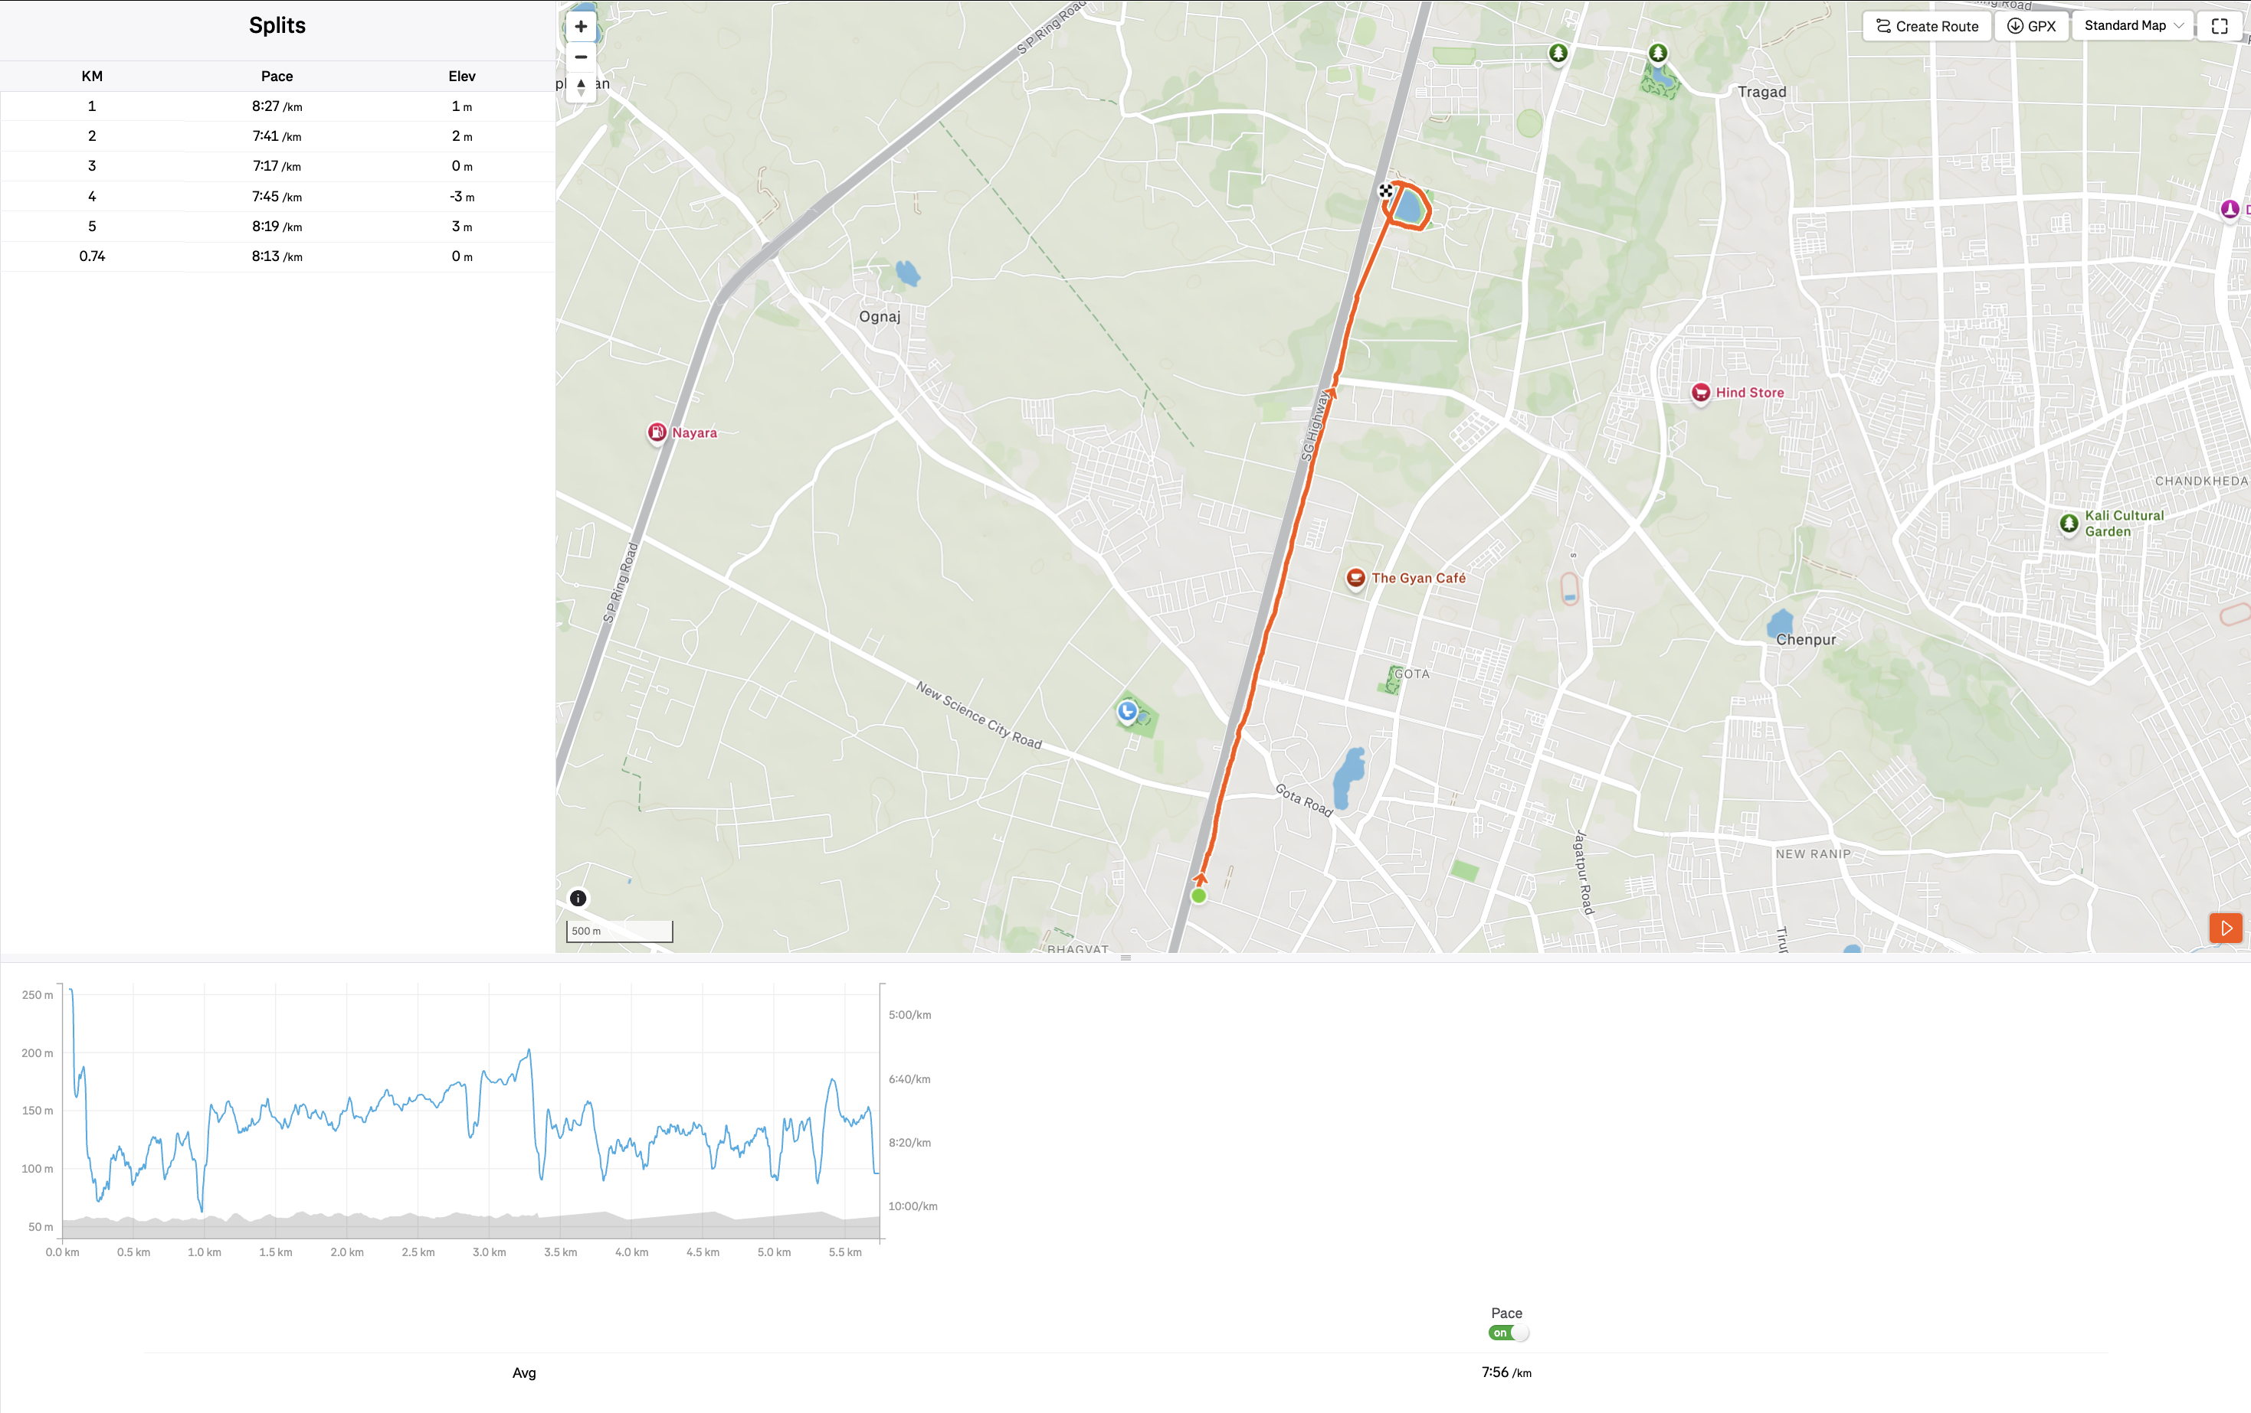
Figure 3 – Expanded Splits table, route map and elevation/pace chart
Scrolling further down the activity page revealed the elevation-vs-distance chart with a working 'Pace' overlay toggle, plus a 'Your Recent Activities' widget and a 'Strava Stories' promotional section in the footer.
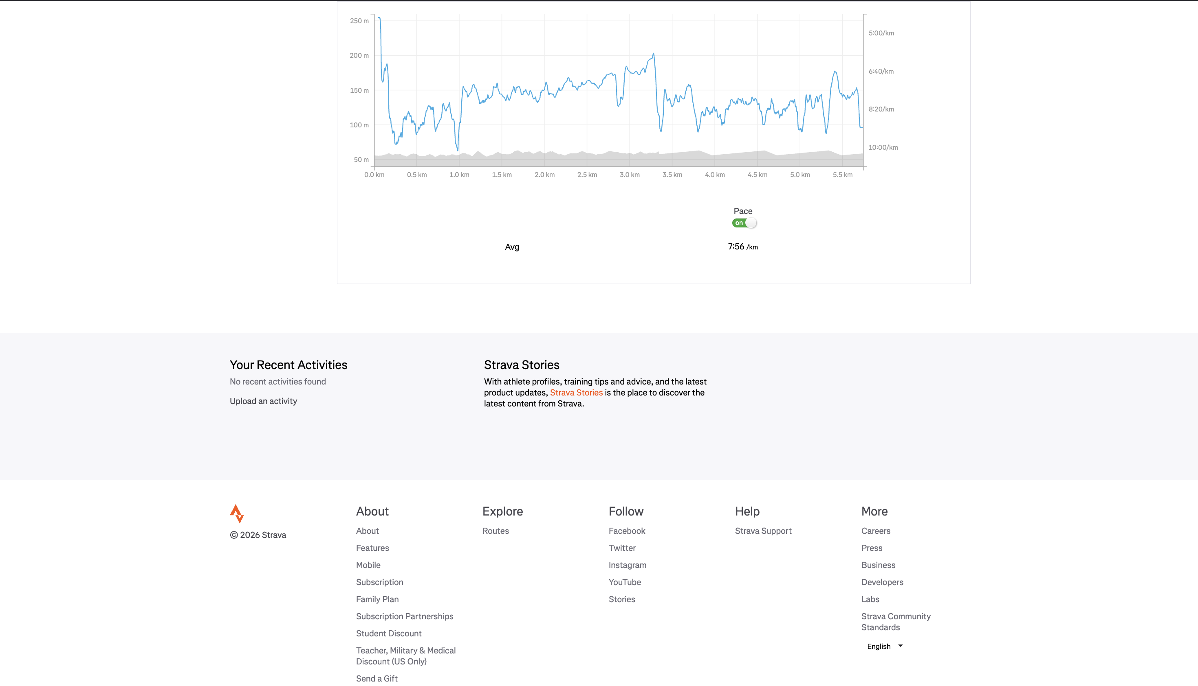
Figure 4 – Elevation/pace chart and page footer on the Activity Details page
A second inconsistency was observed here: the 'Your Recent Activities' widget displayed 'No recent activities found', even though the athlete's Dashboard and Profile both confirmed 3 logged activities. This is documented as Defect DEF002 in Section 12.

7.3 Help / Glossary
Strava provides an in-app Glossary that explains scoring and effort-related terminology. Clicking the info icon next to 'Relative Effort' opened a modal with a left-hand list of terms (Relative Effort, Perceived Exertion, Energy Output, Average Power, VAM, Intensity, Segments, All-time Personal Records, Best Efforts) and a right-hand definition panel that updated correctly when a different term was selected.
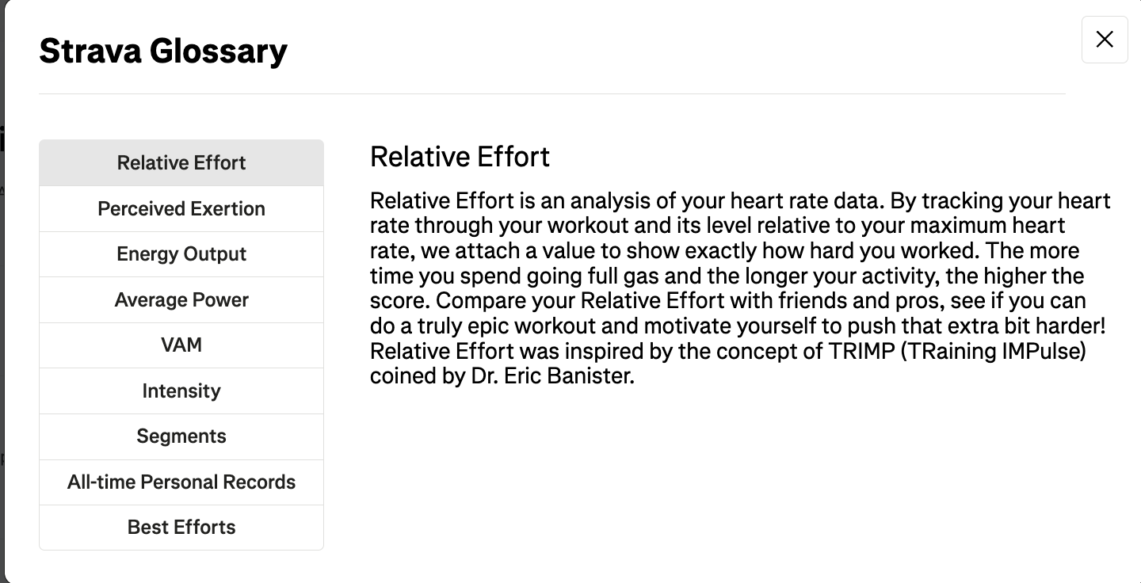
Figure 5 – Glossary modal showing the 'Relative Effort' definition
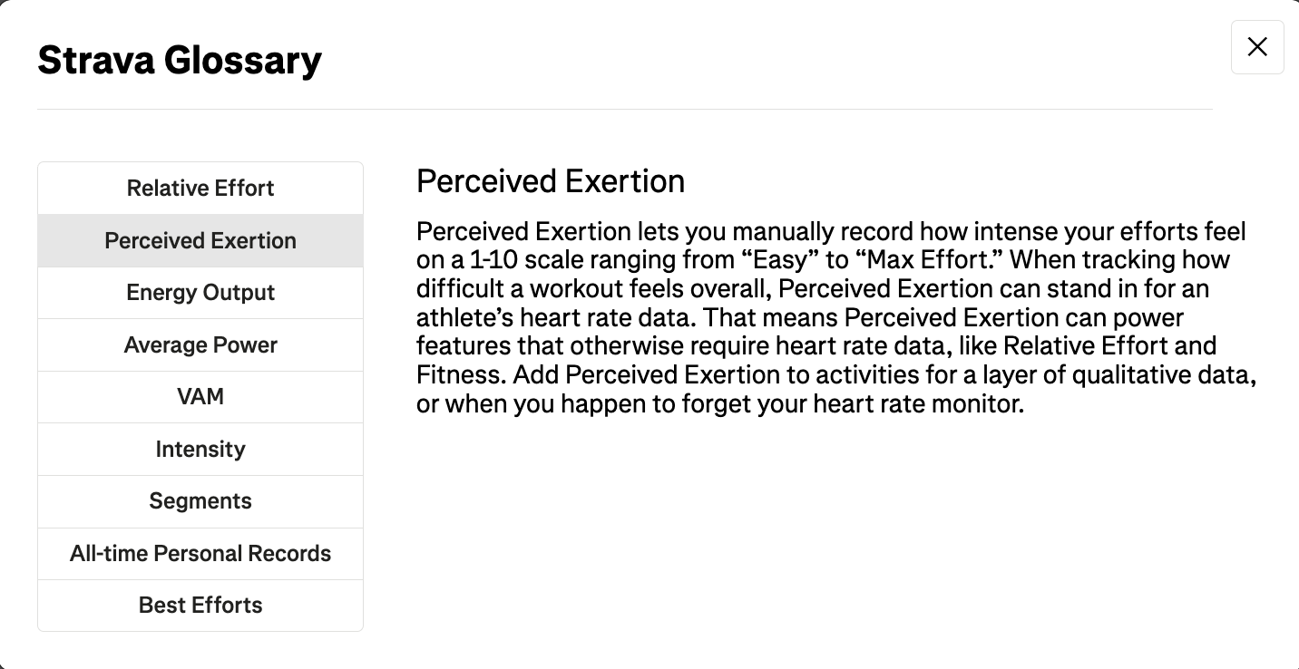
Figure 6 – Glossary modal after switching to the 'Perceived Exertion' tab

7.4 Profile & Following
The athlete's Profile page exposed tabs for Overview, Trophy Case, Following, KOMs/CRs/Top 10s, Local Legends and Posts. The 'Following' tab (shown below) displayed a 'Find Your Friends On Strava' promotion and a 'Who to Follow' list of suggested athletes, each labelled either 'Fan favorite on Strava' or 'Local Legend near you'. The sidebar's 'My Stats' panel showed Last-4-Weeks activity, All-Time Personal Records, and year-over-year totals that matched the account's actual activity count (3 activities, 17.1 km, 2h 17m).
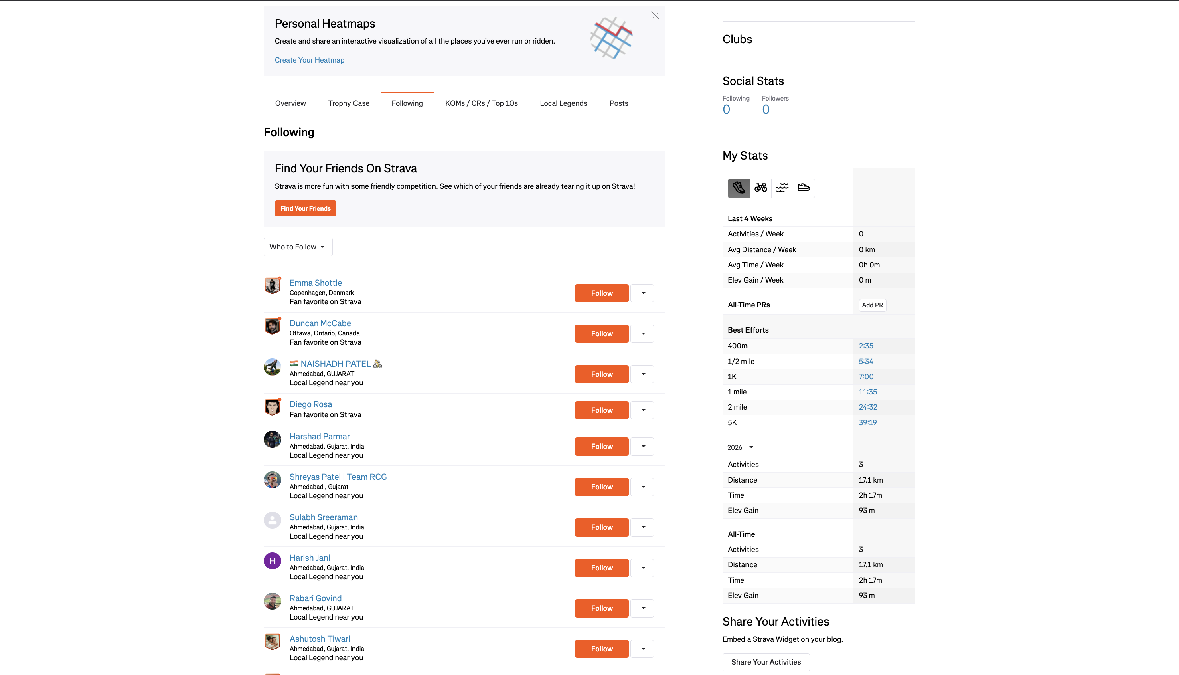
Figure 7 – Profile > Following tab, with suggested athletes and personal stats
The 'Follow' buttons on suggested athlete cards were visually verified but intentionally not clicked, since following a real person's account is a genuine, hard-to-reverse social action outside the scope of a safe testing exercise.

7.5 Subscription / Upgrade Flow
The 'Start Trial' call-to-action led to a Subscription landing page describing the paid plan ('The best of Strava. Built for your goals.') and a clear three-step trial timeline: features unlock today, a reminder appears two days before the trial ends, and billing occurs after 30 days unless cancelled.
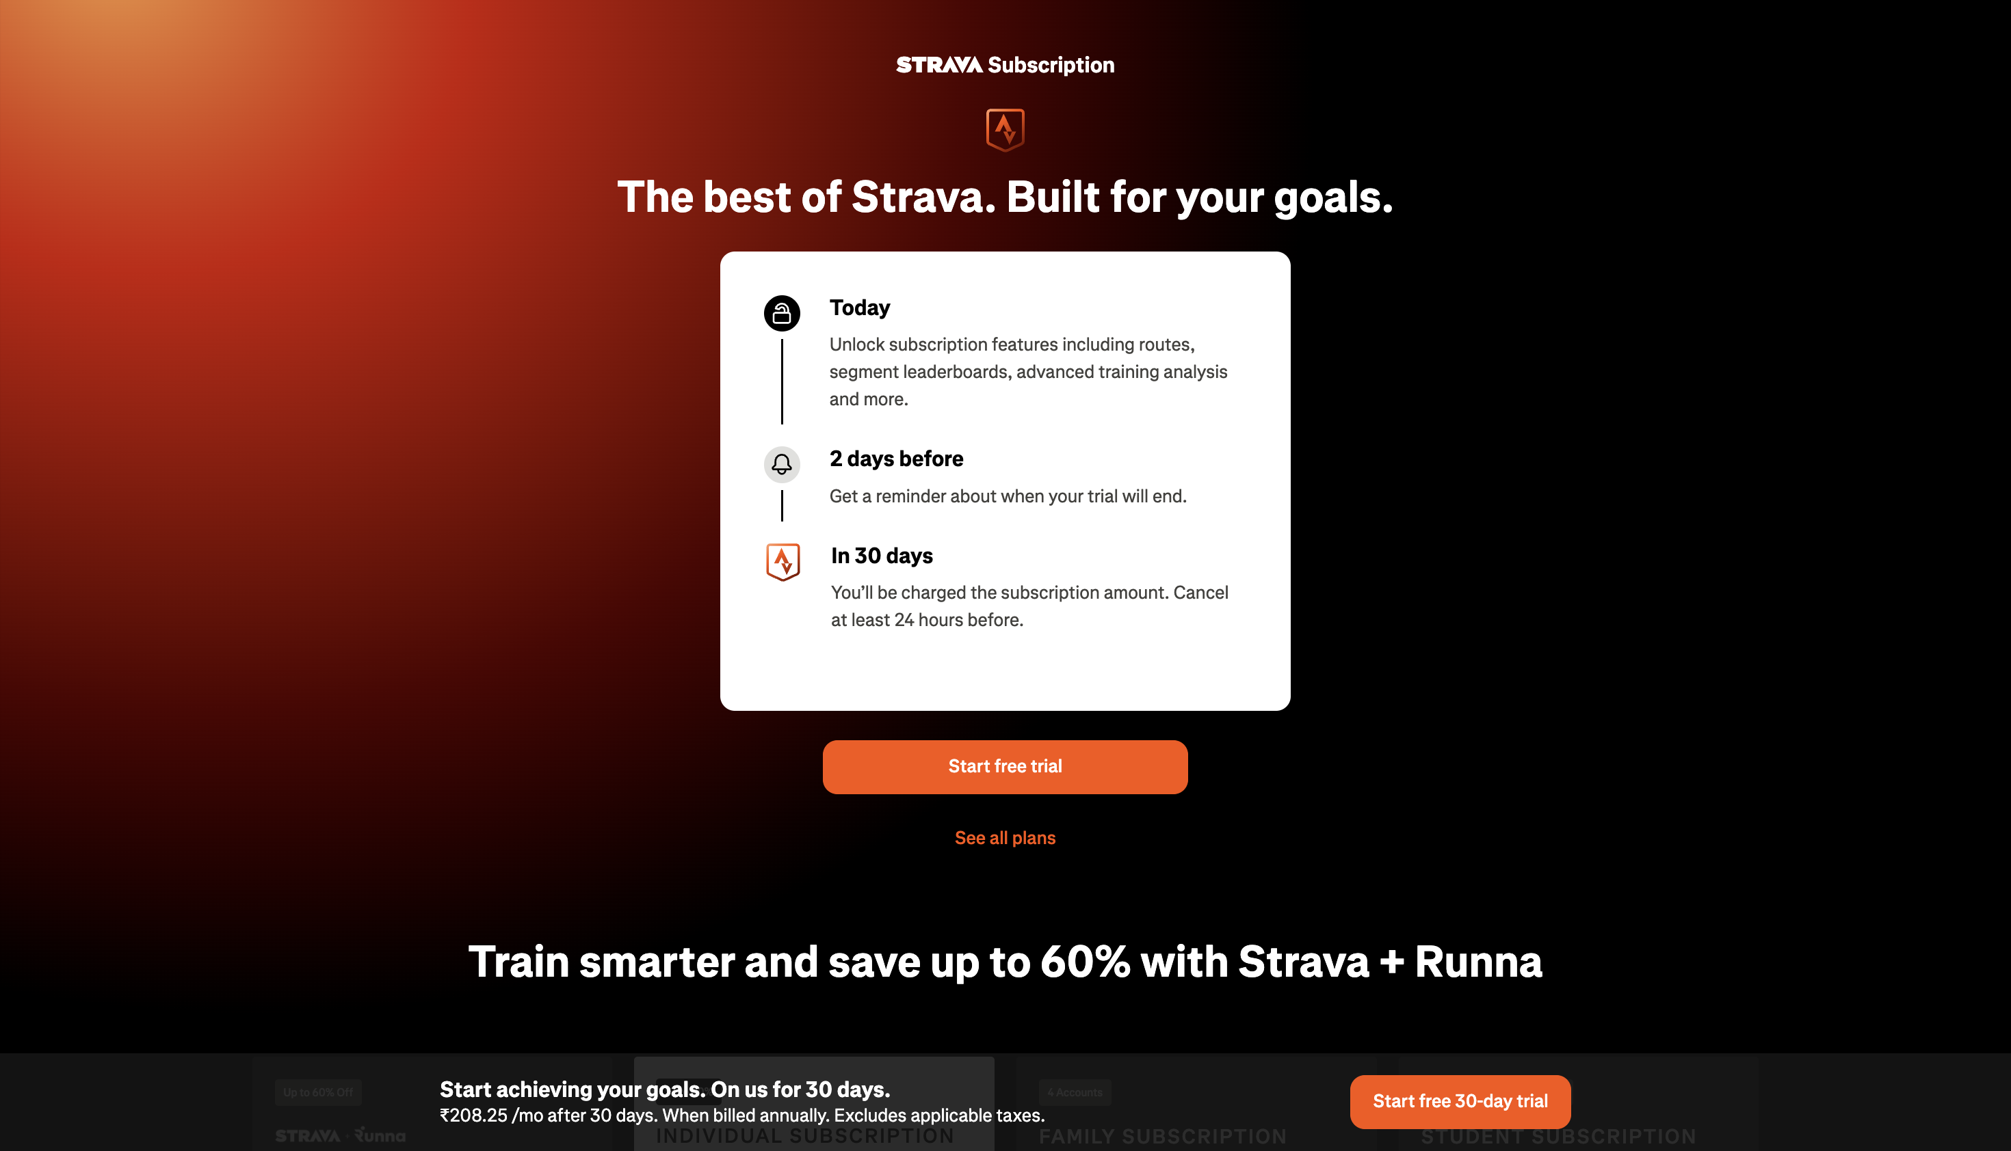
Figure 8 – Subscription landing page with the free-trial timeline
Proceeding to checkout displayed a benefits summary (grouped under 'Train', 'Explore', 'Compete'), a billing panel supporting Apple Pay, Google Pay, and Card payments, and a pricing summary ('Billed today ₹0.00', 'Annual subscription ₹2,499.00', 'Total billed on Sep 24, 2026'). No real payment details were entered and the form was not submitted, in order to avoid starting an actual paid subscription on the account.
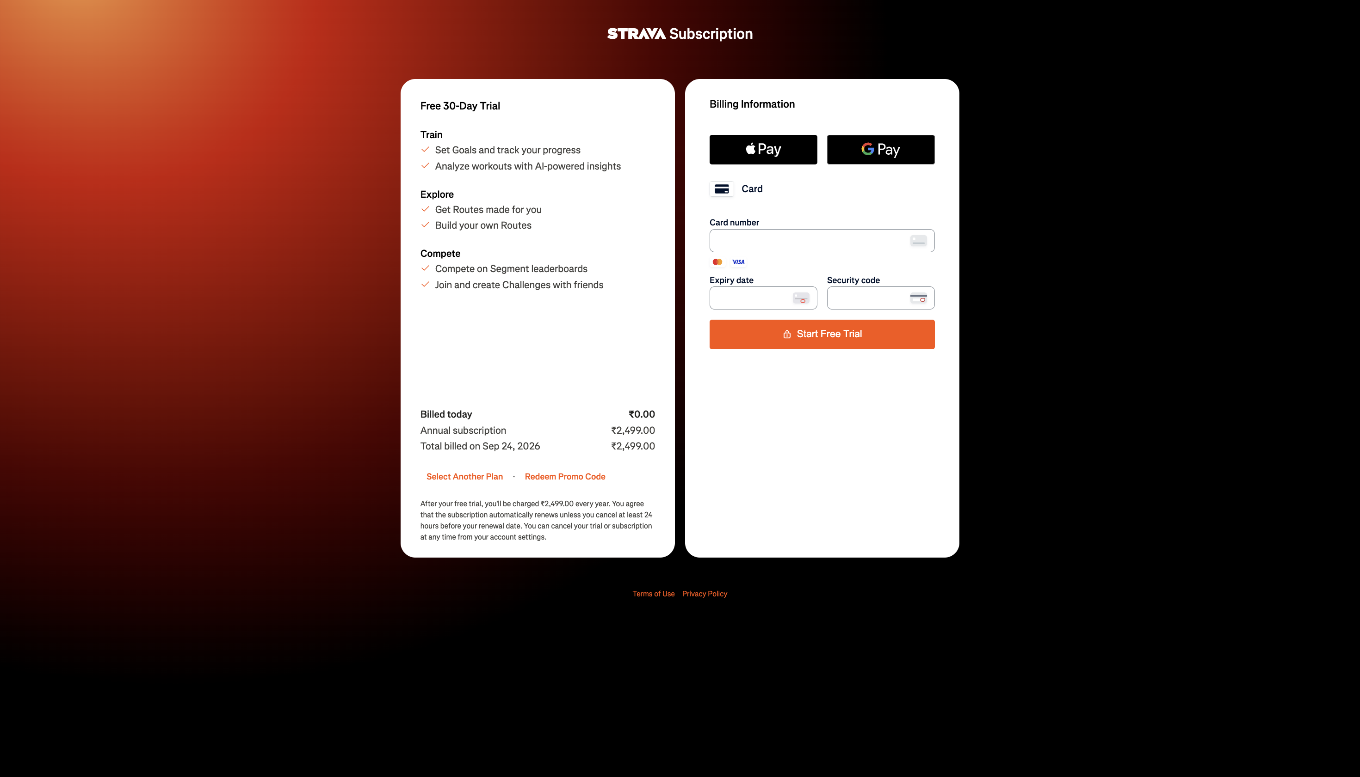
Figure 9 – Subscription checkout page with billing form and pricing summary

8. Detailed Test Execution
High-priority flows were executed step-by-step, in the style of Tutorial 10's detailed execution record.

8.1 Activity Details Flow
Step No. | Testing Step | Input | Expected Result | Actual Result | Status
1 | Launch Strava dashboard | - | Dashboard displayed with the athlete's feed | Dashboard displayed correctly | Pass
2 | Open the latest activity from the feed | Click 'Evening Run' | Activity Details page opens | Activity Details page opened with full stats | Pass
3 | Verify distance, time and pace | - | Distance/time/pace should be realistic and consistent | 5.74 km, 45:34, 7:56/km – consistent with Splits table | Pass
4 | Verify Elapsed Time | - | Should be close to Moving Time | Showed 1069:23:21 vs Moving Time 45:34 | Fail
5 | Scroll to Splits table and Map | - | Splits and route map should render | Splits (6 rows) and route map rendered correctly | Pass
6 | Verify 'Your Recent Activities' widget | - | Should list the athlete's 3 activities | Displayed 'No recent activities found' | Fail

8.2 Subscription / Upgrade Flow
Step No. | Testing Step | Input | Expected Result | Actual Result | Status
1 | Open Strava Dashboard | - | Dashboard with 'Start Trial' CTA visible | CTA visible in header | Pass
2 | Click 'Start Trial' | Click | Subscription landing page opens | Landing page opened with trial timeline | Pass
3 | Proceed to checkout | Click 'Start free trial' | Checkout page with billing form opens | Checkout page opened with plan summary and billing form | Pass
4 | Review pricing summary | - | Billed-today and future billing amount should be shown clearly | 'Billed today ₹0.00', 'Total billed on Sep 24, 2026 – ₹2,499.00' shown | Pass
5 | Submit payment form | Not submitted (real card data withheld) | N/A | Not tested – avoided to prevent starting a real paid subscription | Blocked

8.3 Glossary (Help) Flow
Step No. | Testing Step | Input | Expected Result | Actual Result | Status
1 | Open Dashboard | - | Dashboard with Relative Effort widget visible | Widget visible in sidebar | Pass
2 | Click info icon on Relative Effort | Click | Glossary modal opens | Modal opened with 'Relative Effort' definition | Pass
3 | Click 'Perceived Exertion' tab | Click | Definition panel updates | Panel updated to show 'Perceived Exertion' definition | Pass
4 | Close the modal | Click 'X' | Modal closes, returns to Dashboard | Close control present and consistent across both views | Pass

9. Automation Candidate Identification
Following the Tutorial 10 methodology, each tested module was evaluated against four criteria: whether it is critical, frequently executed, stable, and therefore suitable for automation. Selenium with Python is recommended as the automation tool, matching the tutorial's example and Strava's nature as a standard browser-rendered web application.
Test Case ID | Functionality | Automation Recommended | Reason | Automation Tool
TC001 | Login | Yes | Critical, frequently executed, stable form – ideal for automated regression, once run against a disposable test account | Selenium
TC002 | Registration | Yes | Stable form fields; automate against disposable test accounts only | Selenium
TC003 | Search | Yes | Frequently used, stable input/output pattern | Selenium
TC004 | Activities / Activity Details | Yes | Core, frequently executed, stable data display (stats, splits table) | Selenium
TC005 | Profile | Yes | Repetitive navigation across stable tabs | Selenium
TC006 | Logout | Yes | Simple, stable, repetitive action for the end of every regression cycle | Selenium
TC007 | Dashboard Load & Navigation | Yes | Executed on every visit; stable layout; good smoke-test candidate | Selenium
TC008 | Glossary Modal | Yes | Small, stable, repetitive UI component; reliable to script | Selenium
TC009 | Subscription Landing Page Load | Yes | Business-critical, stable layout; good for a load/rendering regression check | Selenium
TC010 | Activity Map & Elevation Chart | No | Highly interactive canvas/SVG widget with dynamic third-party map tiles; brittle locators | Manual Testing
TC011 | Subscription Checkout / Payment | No | Involves real billing gateways (Apple Pay/Google Pay/Card, tokenised iframes); unsafe/impractical to automate a live purchase | Manual Testing
TC012 | Following / Suggested Athletes | No | Suggested-user list changes per session/algorithm; weak, unstable assertions | Manual Testing
TC013 | Explore | No | Not yet explored in enough depth to judge stability | Manual Testing
TC014 | Routes (standalone module) | No | Involves interactive map/route drawing, similar risk profile to TC010 | Manual Testing
TC015 | Clubs | No | Social/community content changes frequently; not yet explored in depth | Manual Testing
TC016 | Settings | No | Infrequently used but contains sensitive account actions; safer as manual/exploratory testing | Manual Testing

10. Automation Feasibility Analysis
Stable, repetitive, and business-critical workflows (Login, Registration, Search, Activities, Profile, Logout, Dashboard load, and the Glossary widget) are good automation candidates because their layout and behaviour do not change often, and they are exercised on almost every visit. In contrast, highly interactive or third-party-dependent features — the embedded route map, the elevation/pace chart, and the payment/checkout flow — involve dynamic rendering, canvas/SVG elements, or live financial transactions, making them harder to automate reliably and riskier to script against a real account. These are recommended for manual or exploratory testing, or for automation only with additional safeguards (e.g., mocked payment gateways in a staging environment).
Criteria | Observation
Repetitive Test Cases | Yes – Login, Search, Activity viewing, Profile navigation, and Logout are repeated on almost every session
Stable Functionality | Yes for core navigation and data display; No for the interactive map/chart and payment components
High Business Priority | Yes – Login, Activity tracking, and Subscription are core to Strava's business model
Frequently Executed | Yes – Dashboard, Activity Details, Profile, and Search-type flows are used constantly by athletes
Suitable Automation Tool | Selenium with Python
Recommended Modules (Automate) | Login, Registration, Search, Activities/Activity Details (data & navigation only), Profile, Logout, Dashboard load, Glossary modal, Subscription page load
Manual Testing Required | Activity Map & Elevation Chart, Subscription Checkout/Payment, Following/Suggested Athletes list, Explore, Routes, Clubs, Settings
Overall Recommendation | Adopt a hybrid strategy: automate stable navigation and data-display flows with Selenium + Python for every regression cycle, while keeping payment, mapping, and social-suggestion features under manual/exploratory testing

11. Regression Test Suite
Regression testing verifies that existing functionality continues to work correctly after the application changes or updates. The suite below covers the modules that could be safely re-verified during this practical.
Regression Test ID | Module | Scenario | Expected Result | Status
RT001 | Dashboard | Reload Dashboard and verify layout/widgets | Nav bar, feed, and sidebar widgets intact | Pass
RT002 | Activity Details | Re-open an activity and verify stats/splits/map | Stats, splits and map render exactly as before | Fail
RT003 | Activity Details | Re-check the 'Your Recent Activities' widget | Should list the athlete's existing activities | Fail
RT004 | Profile | Re-open Profile and verify stats/tabs | Profile stats match Dashboard counts | Pass
RT005 | Following | Re-open Following tab and verify suggestions load | 'Who to Follow' list populates correctly | Pass
RT006 | Subscription | Re-open Subscription landing page | Pricing/timeline render identically | Pass
RT007 | Glossary | Re-open Glossary modal and switch tabs | Modal opens and tab-switching still works | Pass
RT008 | Login | Re-verify login after a future update | N/A – not executed this cycle | Blocked
RT009 | Search | Re-verify search after a future update | N/A – not executed this cycle | Blocked
RT010 | Logout | Re-verify logout after a future update | N/A – not executed this cycle | Blocked

12. Defect / Issue Analysis
Two genuine inconsistencies were observed directly from the captured evidence. No defects were invented to fill this section.
Defect ID | Module | Issue Description | Severity | Priority | Status
DEF001 | Activity Details | Elapsed Time shows '1069:23:21' (~44.5 hrs) for a run whose Moving Time is only 45:34 | Medium | Medium | Open
DEF002 | Activity Details – Recent Activities widget | 'No recent activities found' is shown even though the account has 3 logged activities | Low | Low | Open
No other functional defects were identified within the tested scenarios during this practical.

13. Usability & Compatibility Observations

13.1 Usability Observations
- Navigation was clear and consistent across the Dashboard, Activity Details, and Profile pages, with a persistent top navigation bar.
- Buttons and calls-to-action (e.g., 'Start Trial') were visible, but the same CTA is repeated in the header, in-feed banner, and sidebar, which can feel repetitive.
- The Glossary modal is a good usability aid – it explains technical terms (Relative Effort, Perceived Exertion) in plain language, in-context.
- Data-dense pages (Activity Details) use good sub-navigation (Overview/Analysis/Segments/Best Efforts tabs) to avoid overwhelming the user.
- Error/validation messaging could not be evaluated, since no form was submitted with invalid data during this practical.

13.2 Compatibility Observations
- All testing in this practical was performed on Google Chrome (desktop) only.
- Responsive/mobile-browser behaviour and cross-browser testing (Firefox, Safari, Edge) were not carried out and are not claimed in this report.

14. Regression Testing Summary
The figures below are taken directly from the 'Test Audit' sheet of the accompanying Excel workbook (Strava_Software_Testing_Audit.xlsx) and are computed with formulas, so they will always match the Excel file.
Metric | Value
Total Test Cases | 41
Passed | 29
Failed | 2
Blocked / Not Testable | 10
Executed Test Cases (Pass + Fail) | 31
Pass Percentage (Passed ÷ Executed × 100) | 93.5%
Automation Candidates | 9
Manual Testing Candidates | 7
Regression Test Cases | 10
Defects Logged | 2
Blocked/Not Testable cases (Login, Registration, Explore, Routes, Clubs, Search, Settings, Logout, plus the intentionally-unclicked Follow button and the un-submitted payment form) are excluded from the Pass Percentage calculation, as instructed, since they represent tests that could not be safely or completely executed rather than functional failures.

15. Overall Result
- Automation and Regression Analysis concepts from Tutorial 10 were successfully applied to the Strava website.
- Of the modules that could be reached and safely tested, 29 of 31 executed test steps passed (93.5%).
- Two genuine defects/inconsistencies were found and logged (DEF001, DEF002) — both related to the Activity Details page.
- 9 functionalities were identified as strong automation candidates (stable, repetitive, business-critical); 7 were identified as better suited to manual/exploratory testing (interactive, dynamic, or financially sensitive).
- 8 modules (Login, Registration, Explore, Routes, Clubs, Search, Settings, Logout) could not be tested in this session and are marked Blocked/Not Testable, with the reason recorded for each.

16. Recommendations
- Investigate and fix the Elapsed Time calculation/display bug on the Activity Details page (DEF001) before it misleads athletes reviewing their training history.
- Investigate why the 'Your Recent Activities' widget on the Activity Details page does not reflect the account's actual activity list (DEF002).
- Build a Selenium + Python regression suite for the stable, high-frequency flows identified in Section 9 (Login, Search, Activities, Profile, Logout, Dashboard load, Glossary modal, Subscription page load) and run it on every release.
- Keep the interactive map/elevation chart and the payment/checkout flow under manual or specialised automated testing (e.g., using a sandboxed payment gateway) rather than standard Selenium locators.
- Complete this audit in a follow-up session covering Login, Registration, Explore, Routes, Clubs, Search, Settings, and Logout, ideally using a disposable test account so that destructive actions (account creation, following strangers, submitting payment) can be safely exercised.

17. Conclusion
This practical applied the Automation Testing and Regression Testing concepts from Tutorial 10 to the Strava website in place of the Student Management System. Important modules were identified for automation, with stable and repetitive functions (Dashboard load, Activity Details navigation, Profile, Glossary, Search, Login, Logout) considered better automation candidates than highly interactive or financially sensitive features (the route map, elevation chart, and payment checkout). Regression testing was performed on the modules that were safely reachable within the session, and genuine test results — including two real inconsistencies — were recorded rather than invented. Manual testing was recommended where automation is difficult or unsuitable, and several modules were explicitly marked Blocked/Not Testable rather than assumed to work. Based only on the scenarios actually tested, the Strava website performed reliably, with two minor data-display inconsistencies identified for follow-up; this report does not claim that the entire Strava platform is defect-free or fully tested.

