SOFTWARE TESTING
AUDIT REPORT
Strava Fitness & Activity-Tracking Platform
Web Application Functional Testing • Evidence-Based Review
━━━━━━━━━━━━━━━━━━━━━━━━━━━━━━━━
APPLICATION | Strava
APPLICATION TYPE | Fitness / Activity Tracking Platform
TEST TYPE | Black-Box Functional & UI Review
EVIDENCE | 7 supplied browser screenshots
OVERALL RESULT | 7 / 7 visible checks PASS
Prepared as a practical software-testing evidence report

Executive Summary
This report presents a structured software-testing audit of the Strava web platform using the seven screenshots supplied for the practical. The review focuses only on functionality that is visibly demonstrated in the evidence: landing/login access, dashboard activity information, activity details, analysis and splits, Maps/Heatmaps, and Clubs search.
TEST AREAS  7 | PASS  7 | FAIL  0

Audit Conclusion
All seven reviewed areas are marked PASS because the corresponding expected behaviour is visibly demonstrated in the supplied screenshots. No definite functional defect is claimed, because the evidence does not show a reproducible failure.

1. Test Objective & Scope
The objective is to evaluate visible Strava web functionality from a software-tester perspective and document each check using a consistent expected-result versus actual-result format.
- Landing page and authentication access
- Authenticated dashboard and activity feed
- Activity details and performance metrics
- Activity analysis, splits and performance graph
- Maps, Run mode and Heatmaps
- Clubs search using location and sport filters

2. Test Environment
Application | Strava
Application Category | Fitness and activity tracking
Access Method | Web browser
Browser Evidence | Google Chrome
Testing Method | Black-box functional/UI observation
Evidence Count | 7 screenshots

3. Test Execution Summary
Metric | Result | Status | Tester Assessment
Total checks reviewed | 7 | PASS | All supplied evidence areas reviewed
Passed | 7 | PASS | Expected UI/functionality visibly demonstrated
Failed | 0 | PASS | No visible failure demonstrated
Pass rate | 100% | PASS | Based only on supplied screenshot evidence

4. Detailed Test Cases & Findings
ID | Section | Result | Tester Comment
TC-STR-001 | Landing / Login | PASS | Primary authentication actions are easy to locate.
TC-STR-002 | Dashboard | PASS | Good overview; key metrics could be prioritised further.
TC-STR-003 | Activity Feed | PASS | Good at-a-glance activity summary.
TC-STR-004 | Activity Details | PASS | Strong detail view; preserve key metrics above the fold.
TC-STR-005 | Analysis / Splits | PASS | Useful analysis; chart labels should remain readable at smaller sizes.
TC-STR-006 | Maps / Heatmap | PASS | Clear map controls and strong visual coverage.
TC-STR-007 | Clubs Search | PASS | Useful filtering; result count/empty state could be clearer.
Full execution fields (Testing Step, Test Input, Expected Result, Actual Result and Personal Comments) are provided in the accompanying Excel test sheet.

5. Evidence Review

Evidence 01
Strava landing page with fitness-focused content and Log In / Sign Up access.

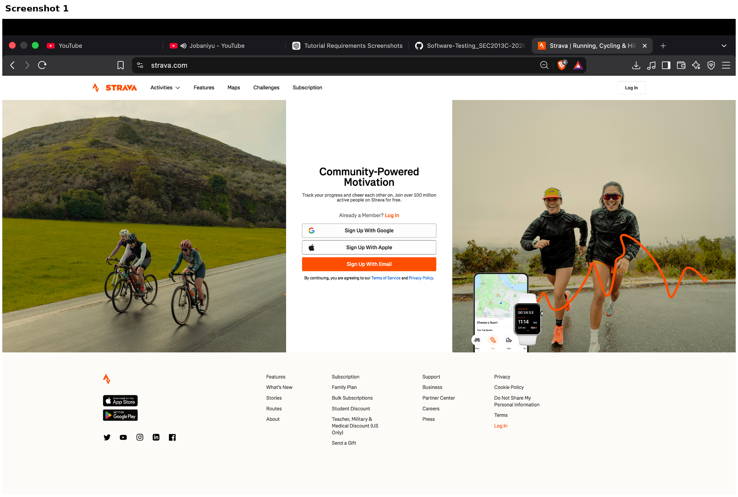

Evidence 02
Authenticated dashboard showing profile, activities, training information, challenges and clubs.

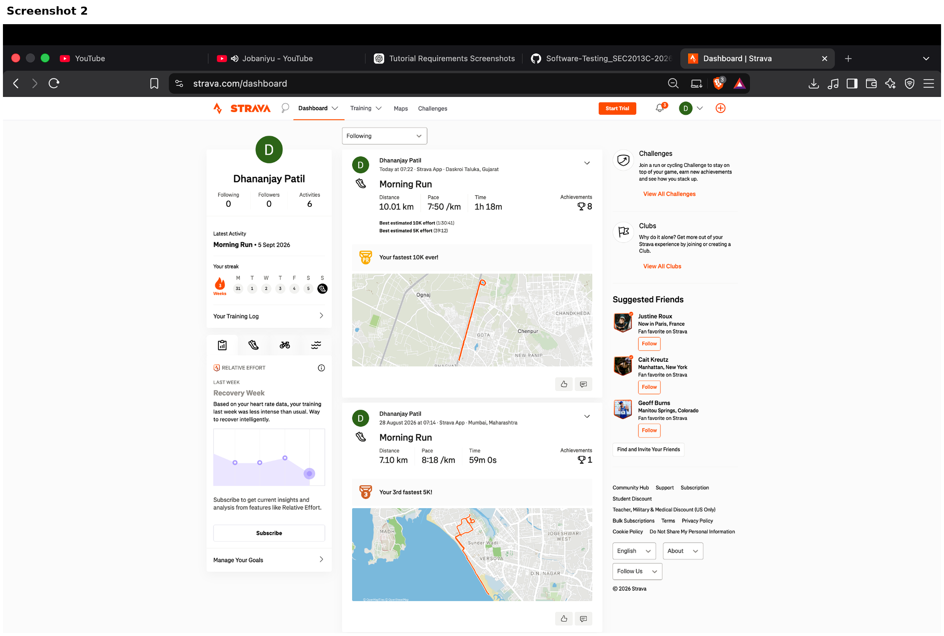

Evidence 03
Dashboard activity-feed evidence showing Morning Run activity cards and training information.

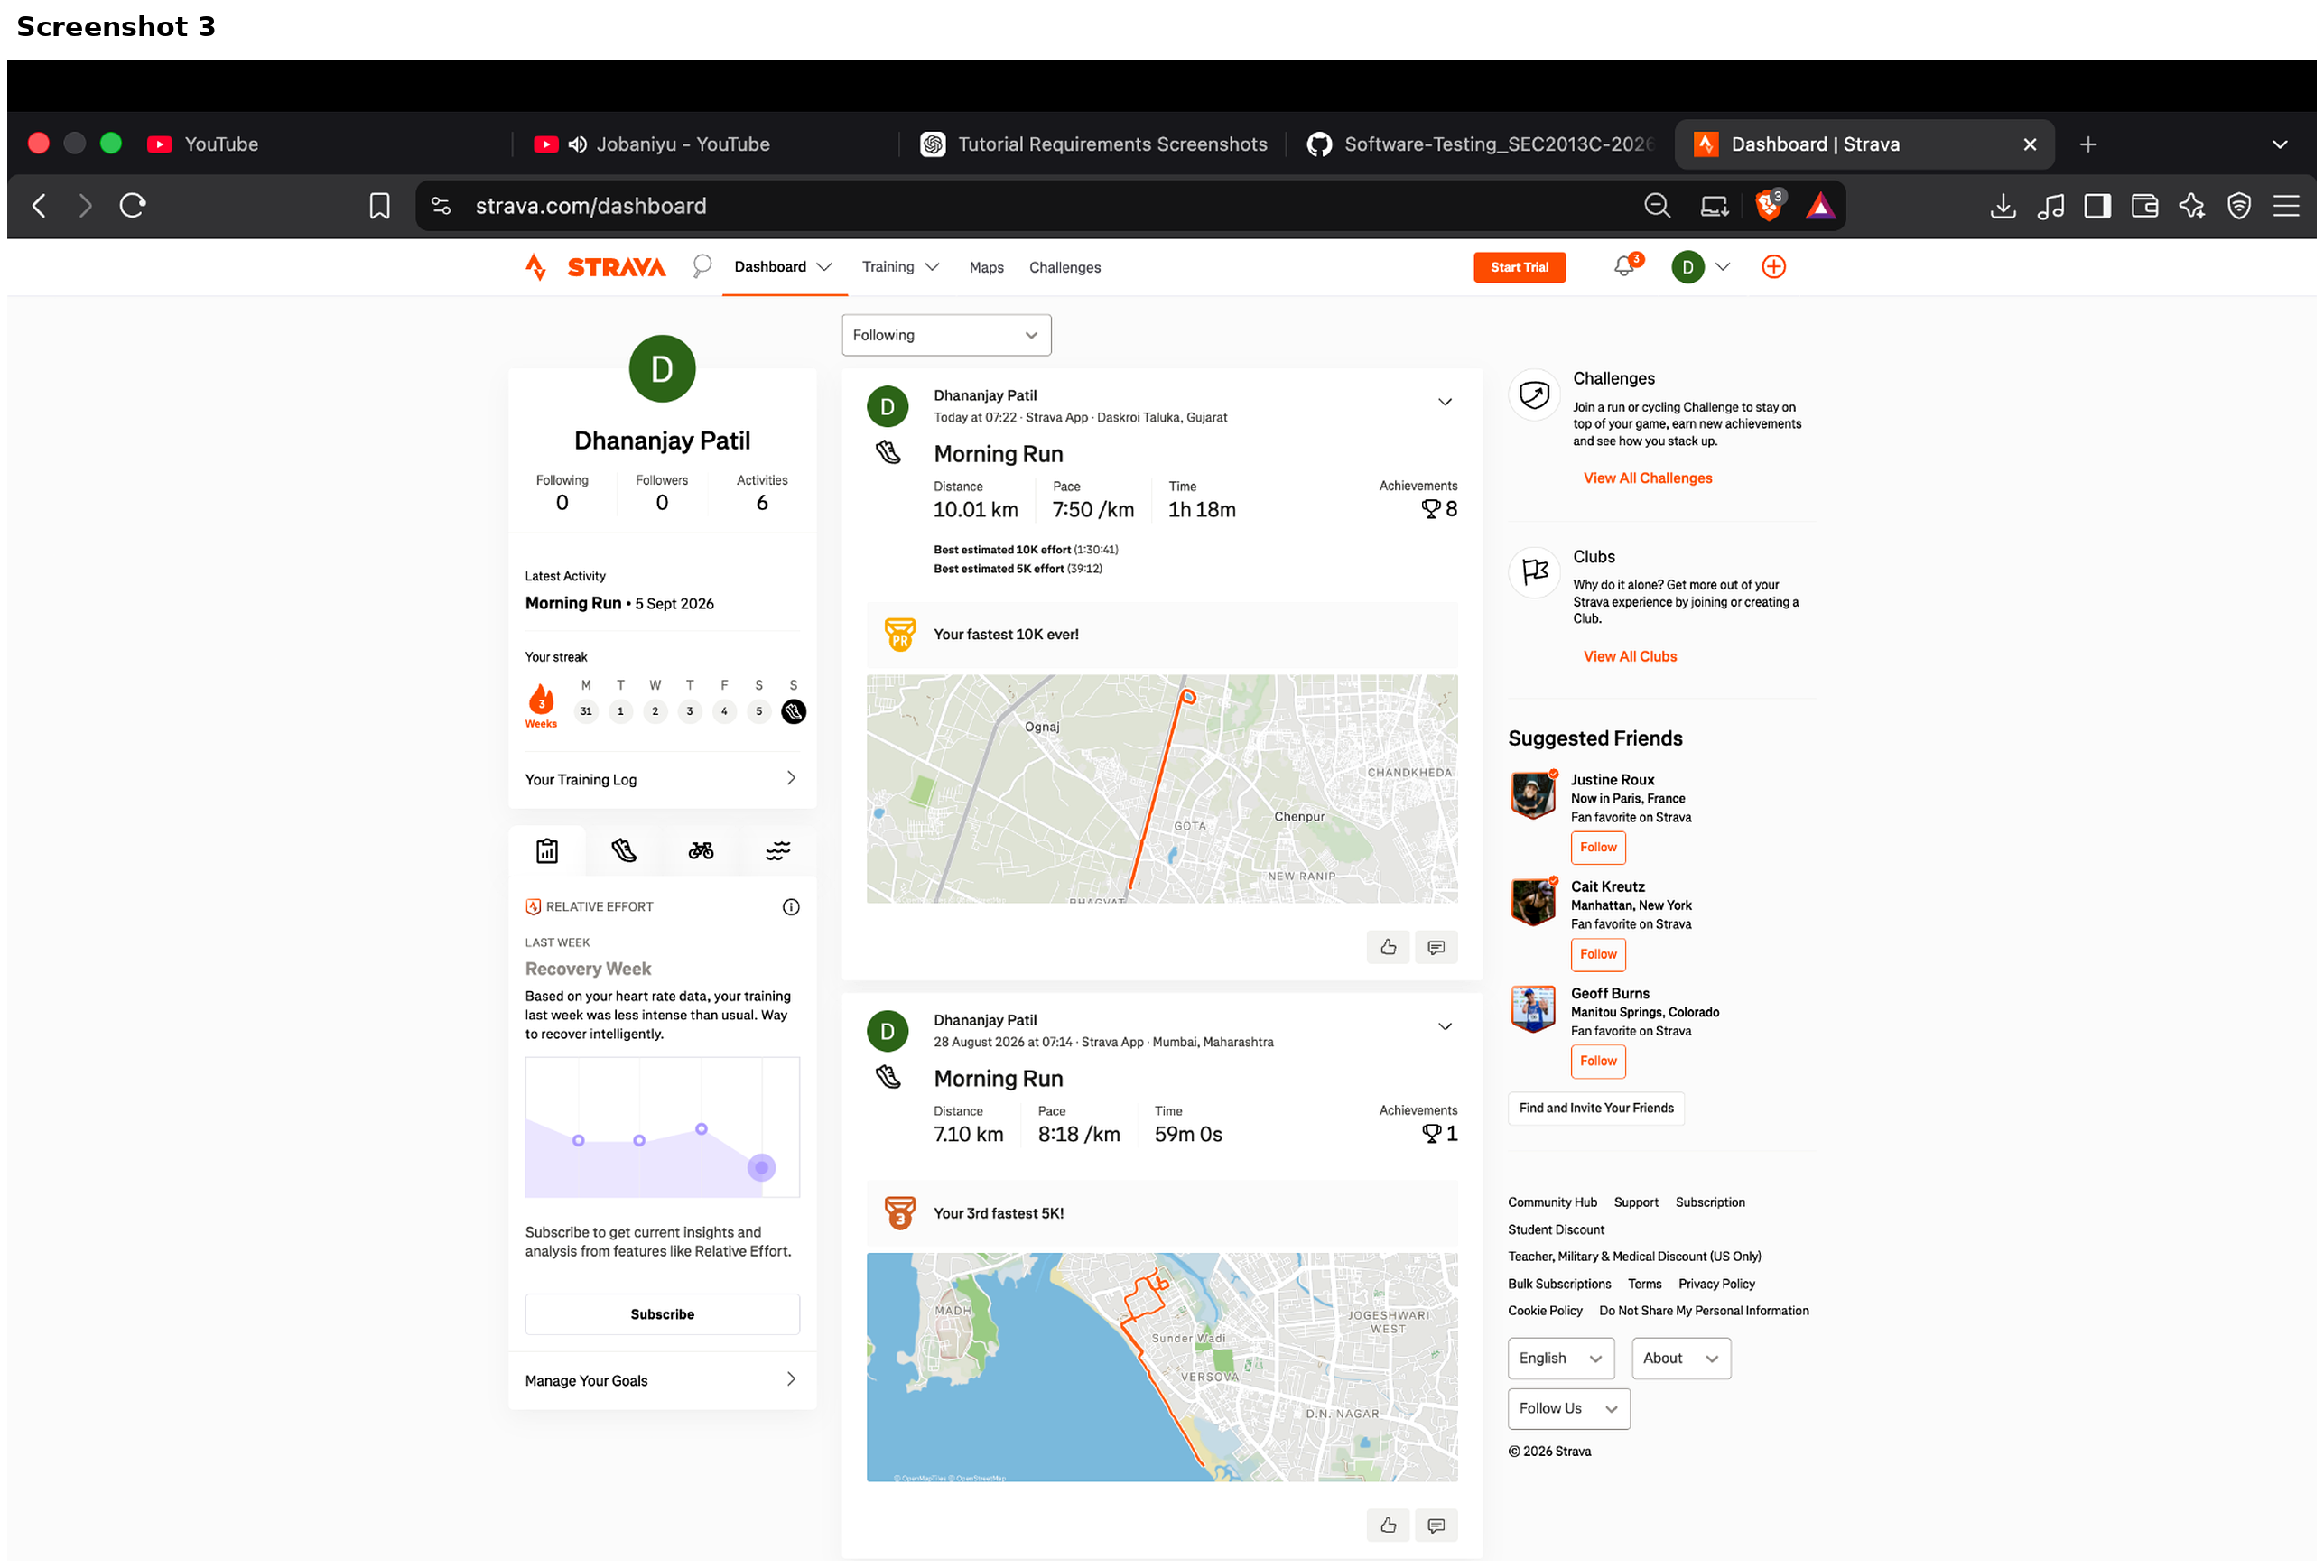

Evidence 04
Morning Run activity detail page showing distance, pace, time, elevation, results and route map.

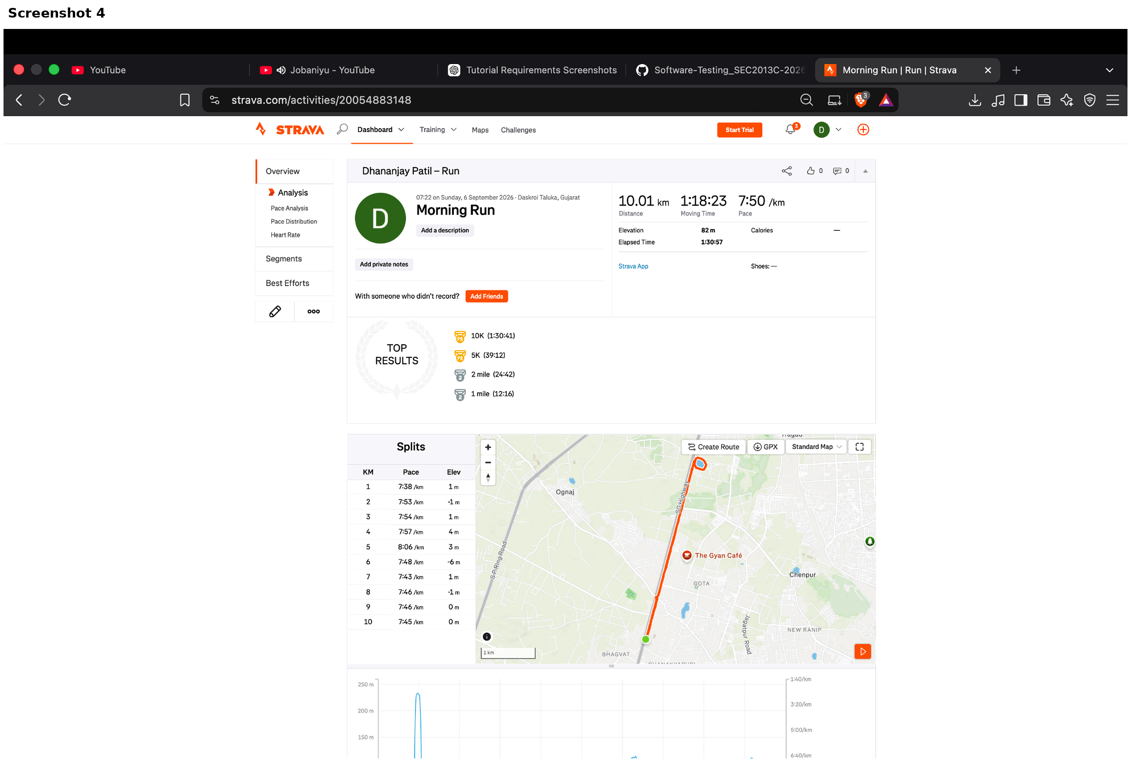

Evidence 05
Activity analysis evidence showing splits, route map and performance graph.

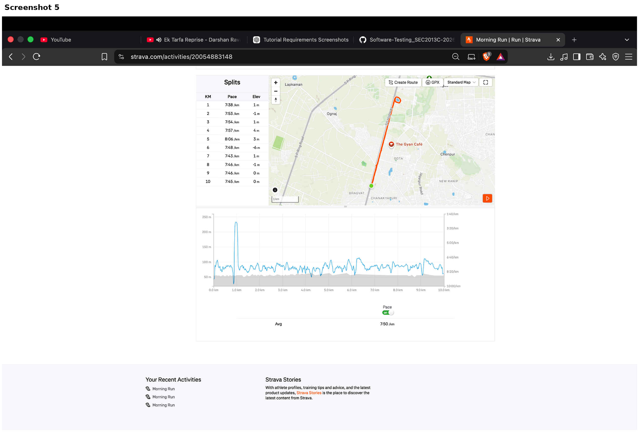

Evidence 06
Strava Maps evidence showing Run, Heatmaps, Segments, search and Create Route controls.

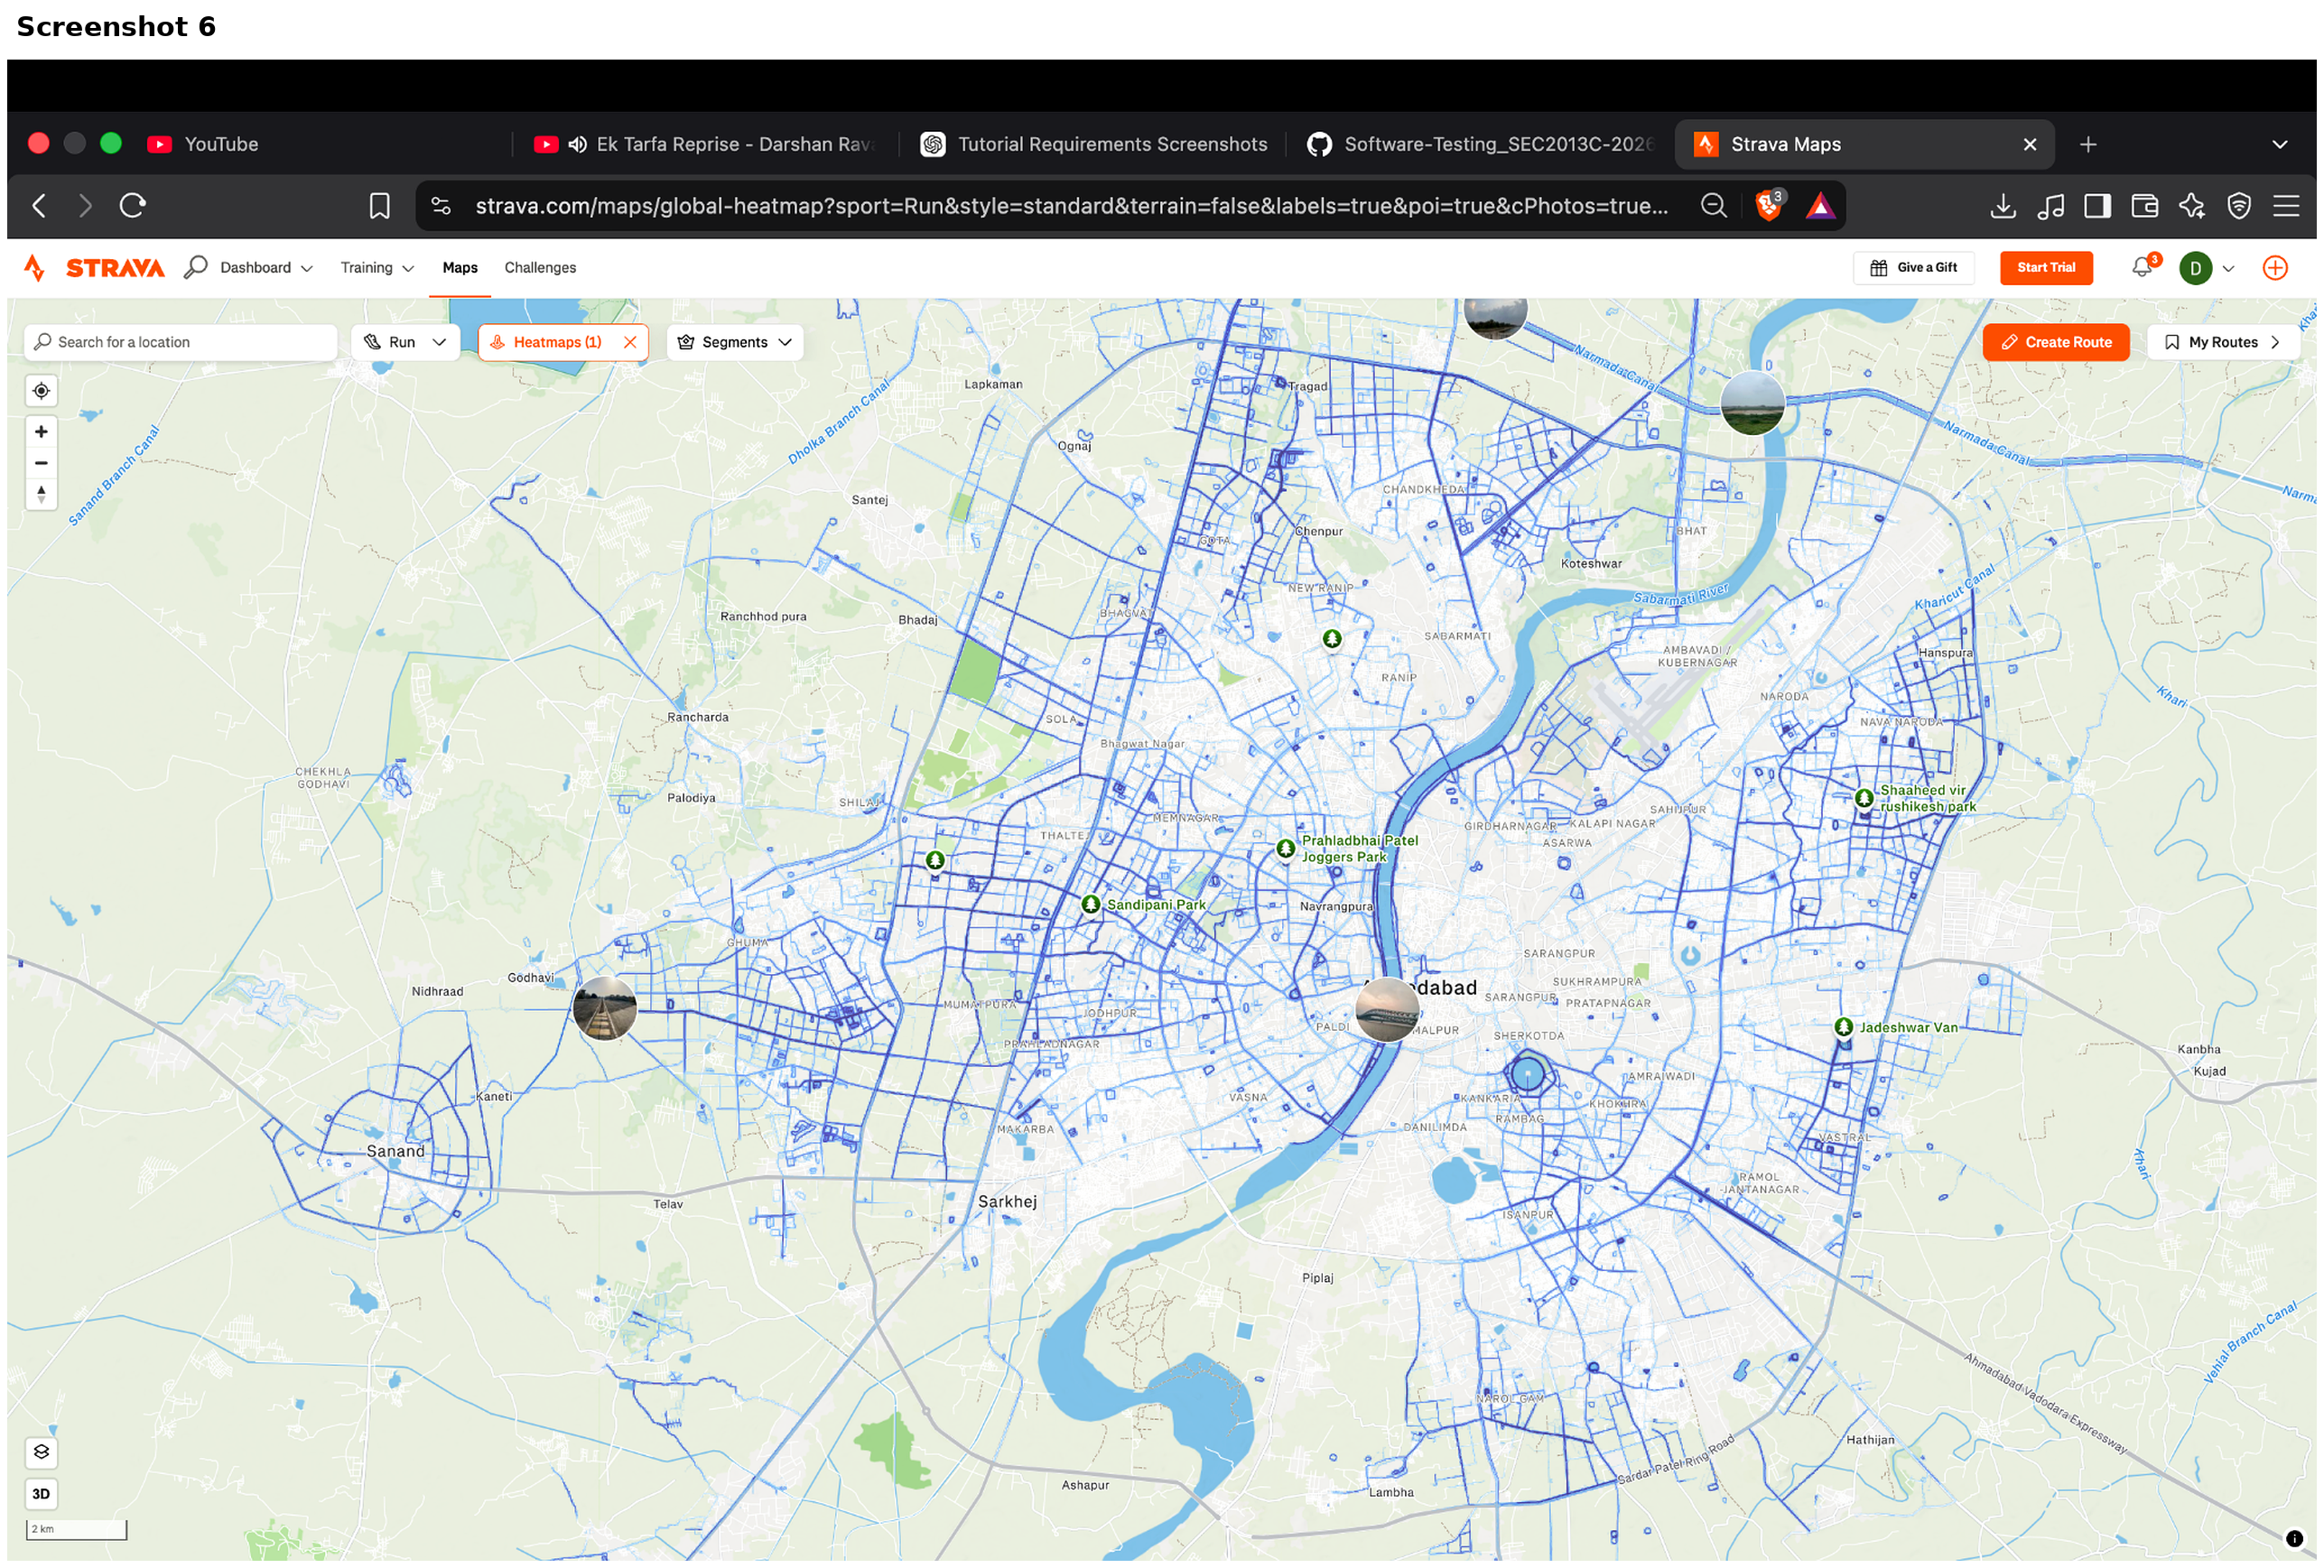

Evidence 07
Clubs search evidence showing Ahmedabad location filtering and Running sport results.

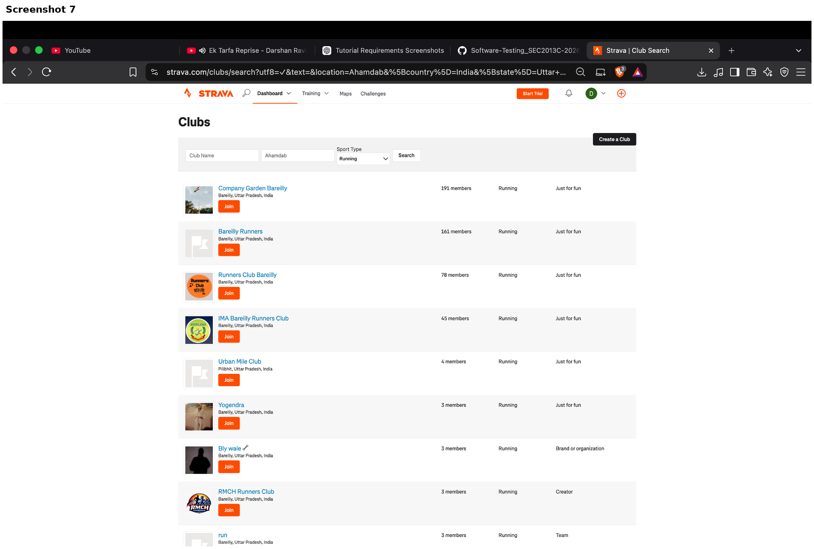

6. Defect & Risk Assessment
No confirmed defect is recorded from the supplied evidence. The screenshots demonstrate successful page rendering and visible feature outputs. A defect should be logged only when a reproducible difference between expected and actual behaviour is observed.
Area | Assessment | Priority
Functional defects | None confirmed from supplied screenshots | N/A
Usability | Minor opportunities for prioritisation/readability improvements | Low
Evidence limitation | Only visible UI states are assessed | Medium

7. Tester Recommendations
- Keep Log In and Sign Up actions prominent on the landing page.
- Prioritise the most important training metrics on the dashboard for faster scanning.
- Keep activity-detail navigation and key metrics visible on smaller displays.
- Maintain readable labels and values in charts and split tables at reduced zoom.
- Show clearer result counts and empty-state guidance in Clubs search.

8. Limitations
This report is an evidence-based screenshot audit. It does not claim that every Strava feature has been tested, and it does not claim that TestLink or Bugzilla execution was completed because those tool screens were not included in the supplied evidence.

9. Final Conclusion
FINAL STATUS: PASS
The seven reviewed Strava areas demonstrate the expected visible behaviour in the supplied evidence. The audit therefore records 7/7 PASS results with no confirmed defect. The accompanying Excel sheet contains the requested detailed execution columns and should be submitted alongside this report.

10. Tester Sign-Off
Tester | ____________________________
Date | ____________________________
Overall Result | PASS – Evidence-Based Review

