SOFTWARE TESTING REPORT
Tutorial–9 | Real Website Testing
Amazon Web Application

Application Under Test | Amazon
Testing Type | Manual Software Testing
Test Environment | Desktop browser (Google Chrome/Brave-style browser shown in evidence)
Evidence Source | 9 screenshots supplied by the tester
Report Date | 07 September 2026

Prepared in a professional software-testing format

1. Executive Summary
This report documents manual testing performed on the real Amazon website using the supplied screenshots as evidence. The testing covers visible UI behavior, sign-in input validation, negative validation, account-flow messaging, security verification, navigation, and product search. Results are recorded only where the supplied evidence supports them.
The captured evidence shows that the tested visible functions generally behaved as expected. A complete successful customer login followed by logout was not confirmed in the supplied evidence because the authentication flow reached Amazon's security/account-verification steps rather than a signed-in customer dashboard.

2. Test Scope
- Amazon home page and primary navigation
- Sign-in page and input validation
- Invalid email-format handling
- New-customer/account creation path
- Security verification flow
- Navigation back to the Amazon home page
- Product search and search-result rendering
- End-to-end login/logout verification (identified as incomplete from the supplied evidence)

3. Test Environment
Application | Amazon real website
Platform | Desktop web browser
Browser Evidence | Browser chrome and Amazon pages visible in screenshots
Test Method | Manual functional / black-box style observation

4. Test Execution Summary
ID | Section | Testing Step | Expected Result | Actual Result | Status
TC01 | UI / Functional Testing | Open Amazon website and verify the home page loads correctly. | Amazon home page should load with logo, navigation, search bar and shopping sections. | Amazon home page loaded successfully with navigation, search bar, account area and shopping content visible. | Pass
TC02 | Black-Box Testing | Open the Sign in option and verify the authentication page. | Sign-in page should display an email/mobile input field and Continue button. | Amazon sign-in page displayed the email/mobile field, Continue button, help link and account creation option. | Pass
TC03 | Black-Box Testing | Enter an email value in the sign-in field. | System should accept the input for validation and allow the user to continue if the format is valid. | The entered value was displayed in the field and the Continue button remained available. | Pass
TC04 | Black-Box / Negative Testing | Submit an invalid email-format value. | System should reject invalid email format and display a clear validation message. | Amazon displayed the red validation message 'Invalid email address'. | Pass
TC05 | Functional / Account Flow | Continue with an email that is not recognized as an existing customer. | System should clearly indicate whether the account exists or provide an appropriate account-creation path. | Amazon displayed 'Looks like you're new to Amazon' and provided an option to create an account, along with a link to sign in with another email/mobile. | Pass
TC06 | Security / Authentication Testing | Proceed through Amazon's account-protection verification. | Security verification should appear when required and should complete successfully before protected account access. | Amazon displayed an account-protection puzzle. A browser password-save popup was also visible. The verification screen showed the puzzle flow. | Pass
TC07 | Security / Authentication Testing | Complete the security verification step. | Successful verification should be acknowledged by the system. | The screen displayed 'Verification complete!' with a check mark. | Pass
TC08 | Integration / Navigation Testing | Return to the Amazon home page after the authentication/verification flow. | The website should return to a usable Amazon home page without a broken layout. | Amazon home page was displayed again with the main navigation, search bar and shopping sections. | Pass
TC09 | System / Functional Testing | Use the Amazon search function. | Search should return relevant results and display product cards with titles, prices and purchase options. | Amazon returned a results page showing 857 results for 'osho books', with product cards, filters, prices and Add to cart options. | Pass
TC10 | System / Login Completion | Verify a complete successful login into a protected customer account and then logout. | Successful credentials should open the signed-in account area; logout should end the authenticated session. | A complete customer-account login and logout could not be confirmed from the supplied screenshots because Amazon presented account/security verification rather than a signed-in account dashboard. | Fail
Note: The final test is marked Fail because the requested end-to-end successful login/logout result is not evidenced by the supplied screenshots. This should not be interpreted as a confirmed defect in Amazon.

5. Detailed Tester Observations
Input Validation: Amazon correctly displayed an 'Invalid email address' message for the captured invalid email-format input.
Security Verification: Amazon presented an account-protection puzzle and subsequently displayed 'Verification complete!' in the captured evidence.
Navigation: The Amazon home page was visible again after the verification flow, with the main navigation and search interface intact.
Search: The query 'osho books' produced a populated result page with filters, product titles, ratings/prices and Add to cart controls.
Authentication Limitation: The supplied evidence does not show a confirmed signed-in customer account dashboard or a completed logout operation.

6. Quality / UX Comments & Suggestions
- Keep the invalid-input message close to the input field and clearly distinguish formatting errors from account-existence errors.
- For academic evidence, dismiss browser password-manager popups before capturing screenshots so the application UI is unobstructed.
- For a complete end-to-end test, capture a clean signed-in account page after successful authentication and a clean post-logout page.
- Repeat search testing with additional common queries to assess result relevance, filters, pagination and empty-result handling.
- Avoid exposing real passwords, OTPs or other authentication secrets in screenshots submitted outside the intended academic context.

7. Screenshot Evidence
The following evidence section contains all 9 supplied screenshots in sequence. Captions describe only what is visibly demonstrated by each image.
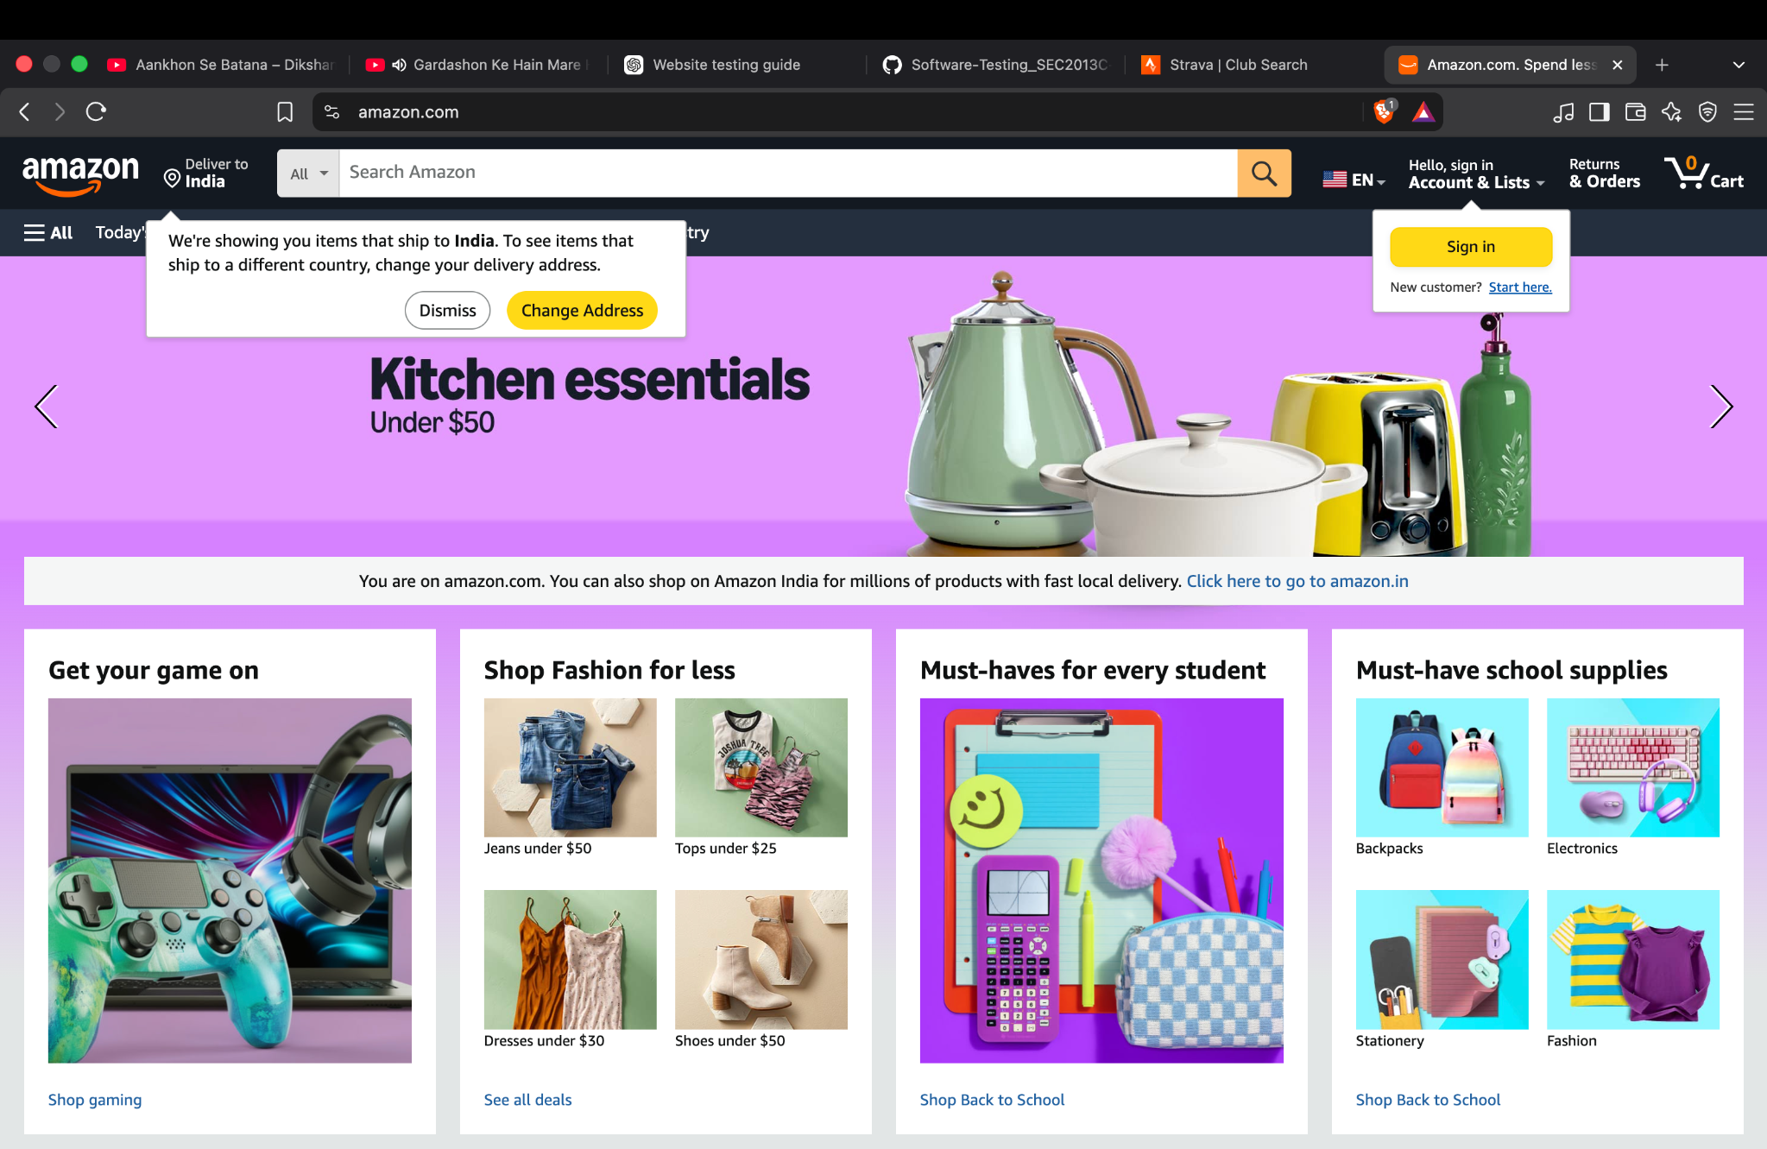
Evidence 1 — Amazon home page loaded successfully.

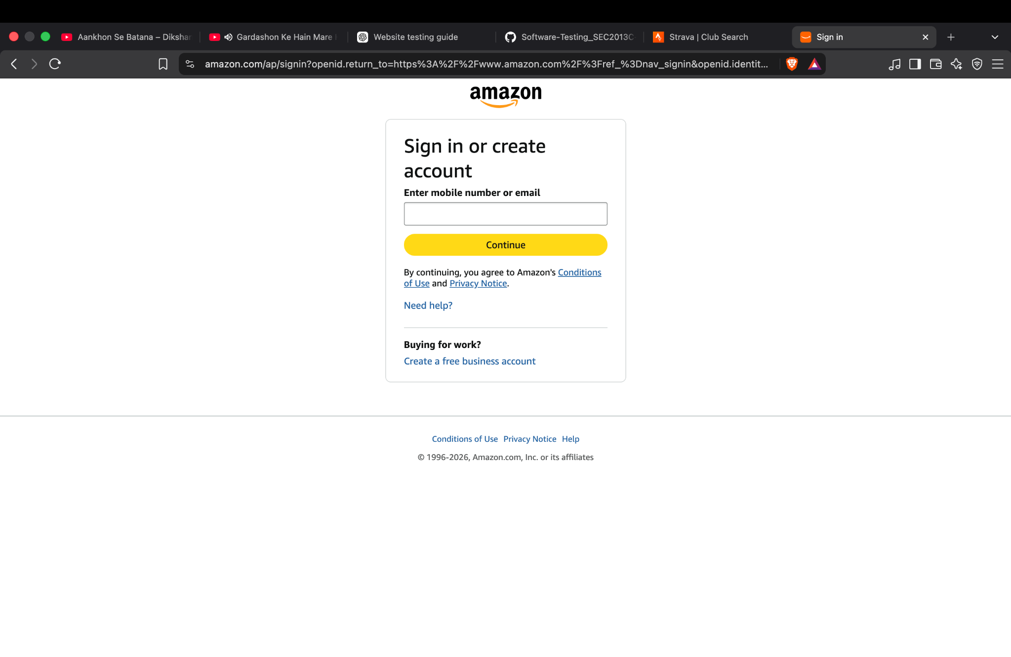
Evidence 2 — Amazon sign-in page with email/mobile input and Continue button.

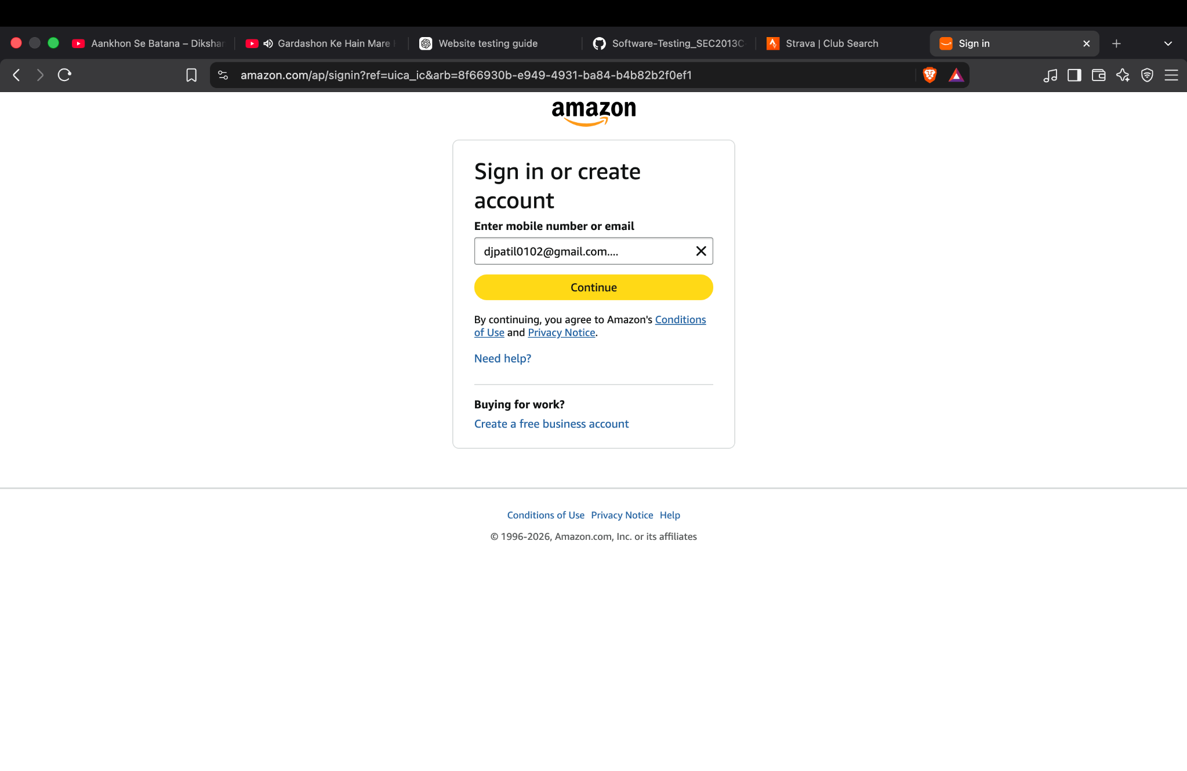
Evidence 3 — Sign-in input field populated with the test email value.

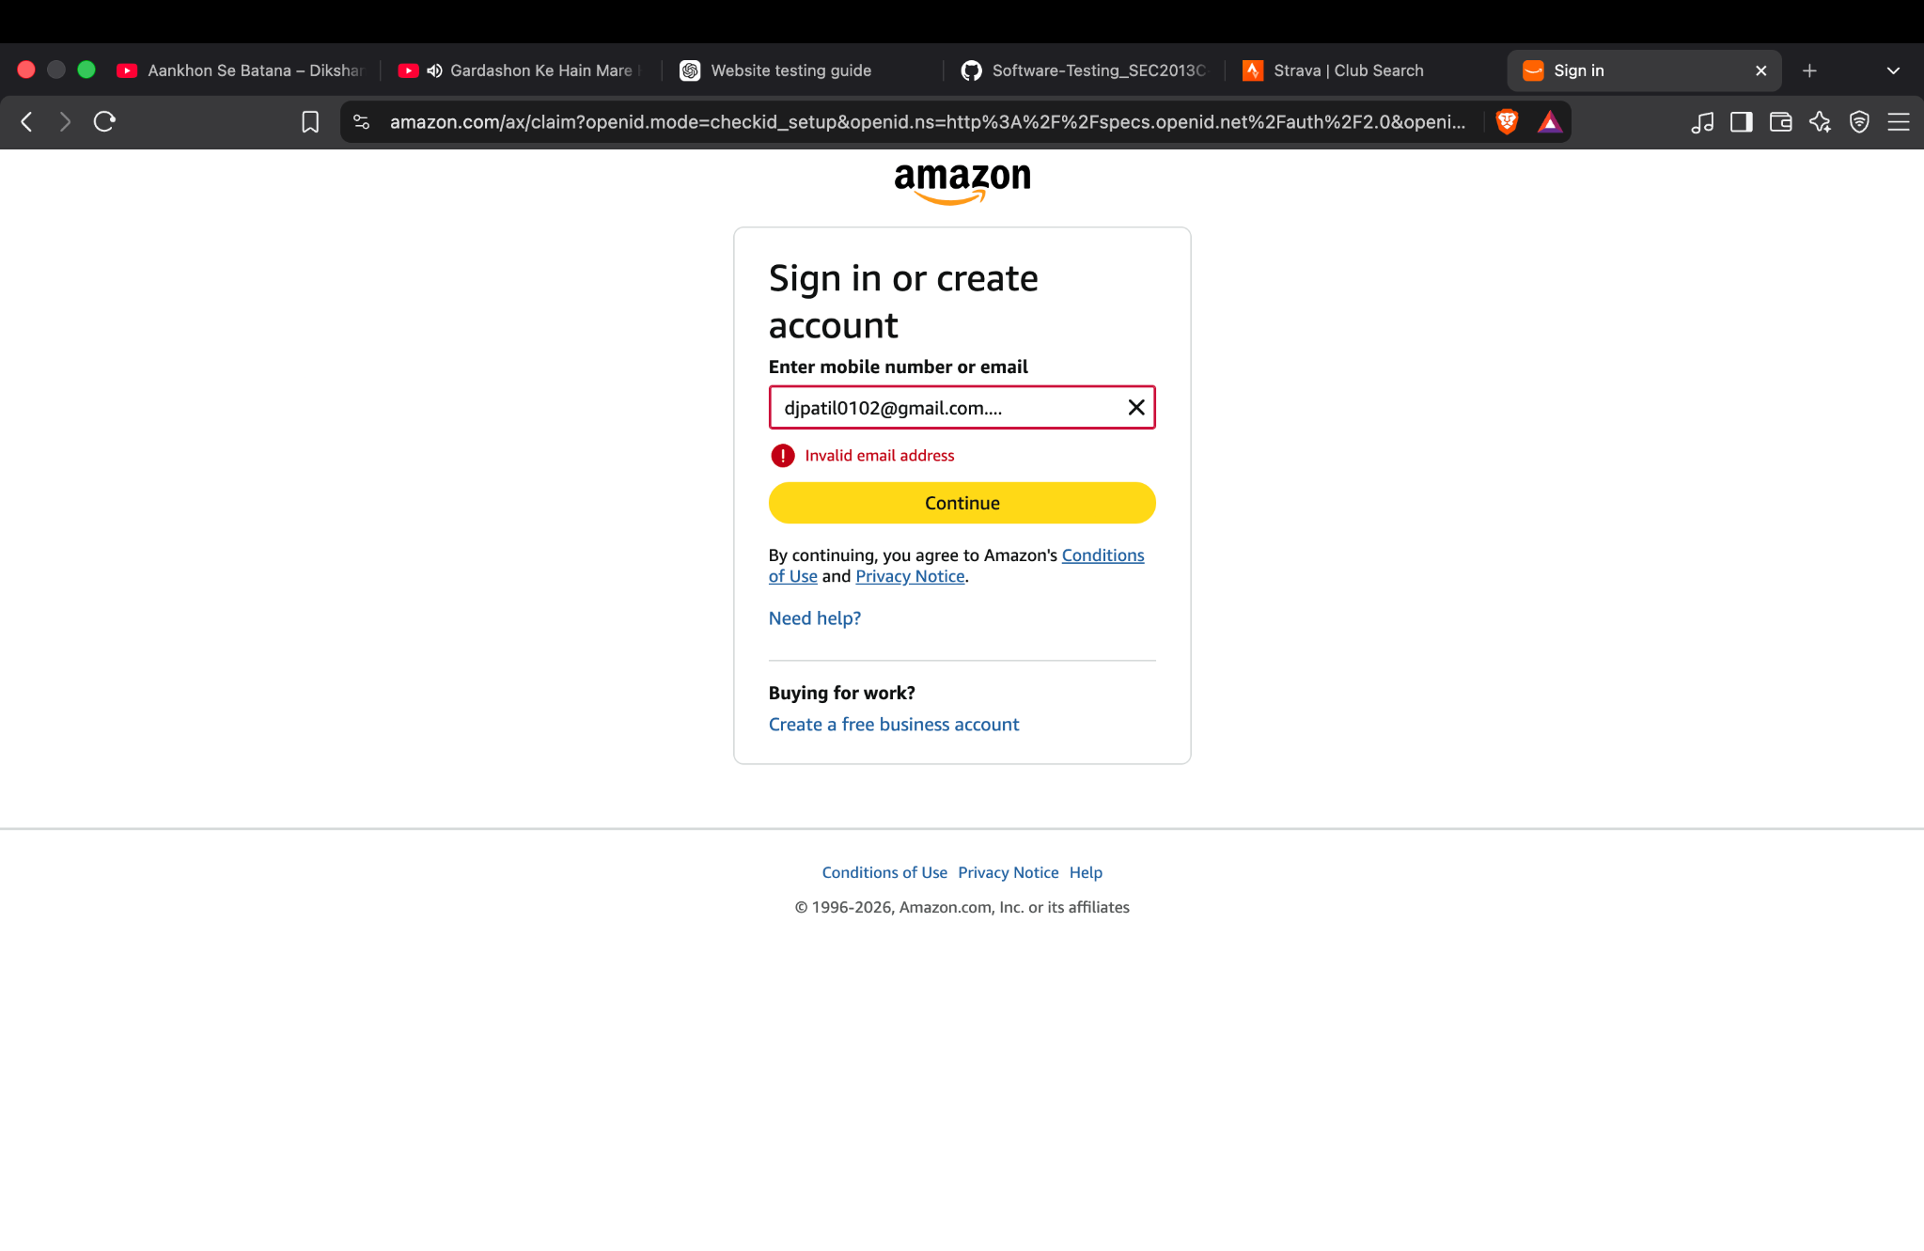
Evidence 4 — Negative validation: 'Invalid email address' message displayed.

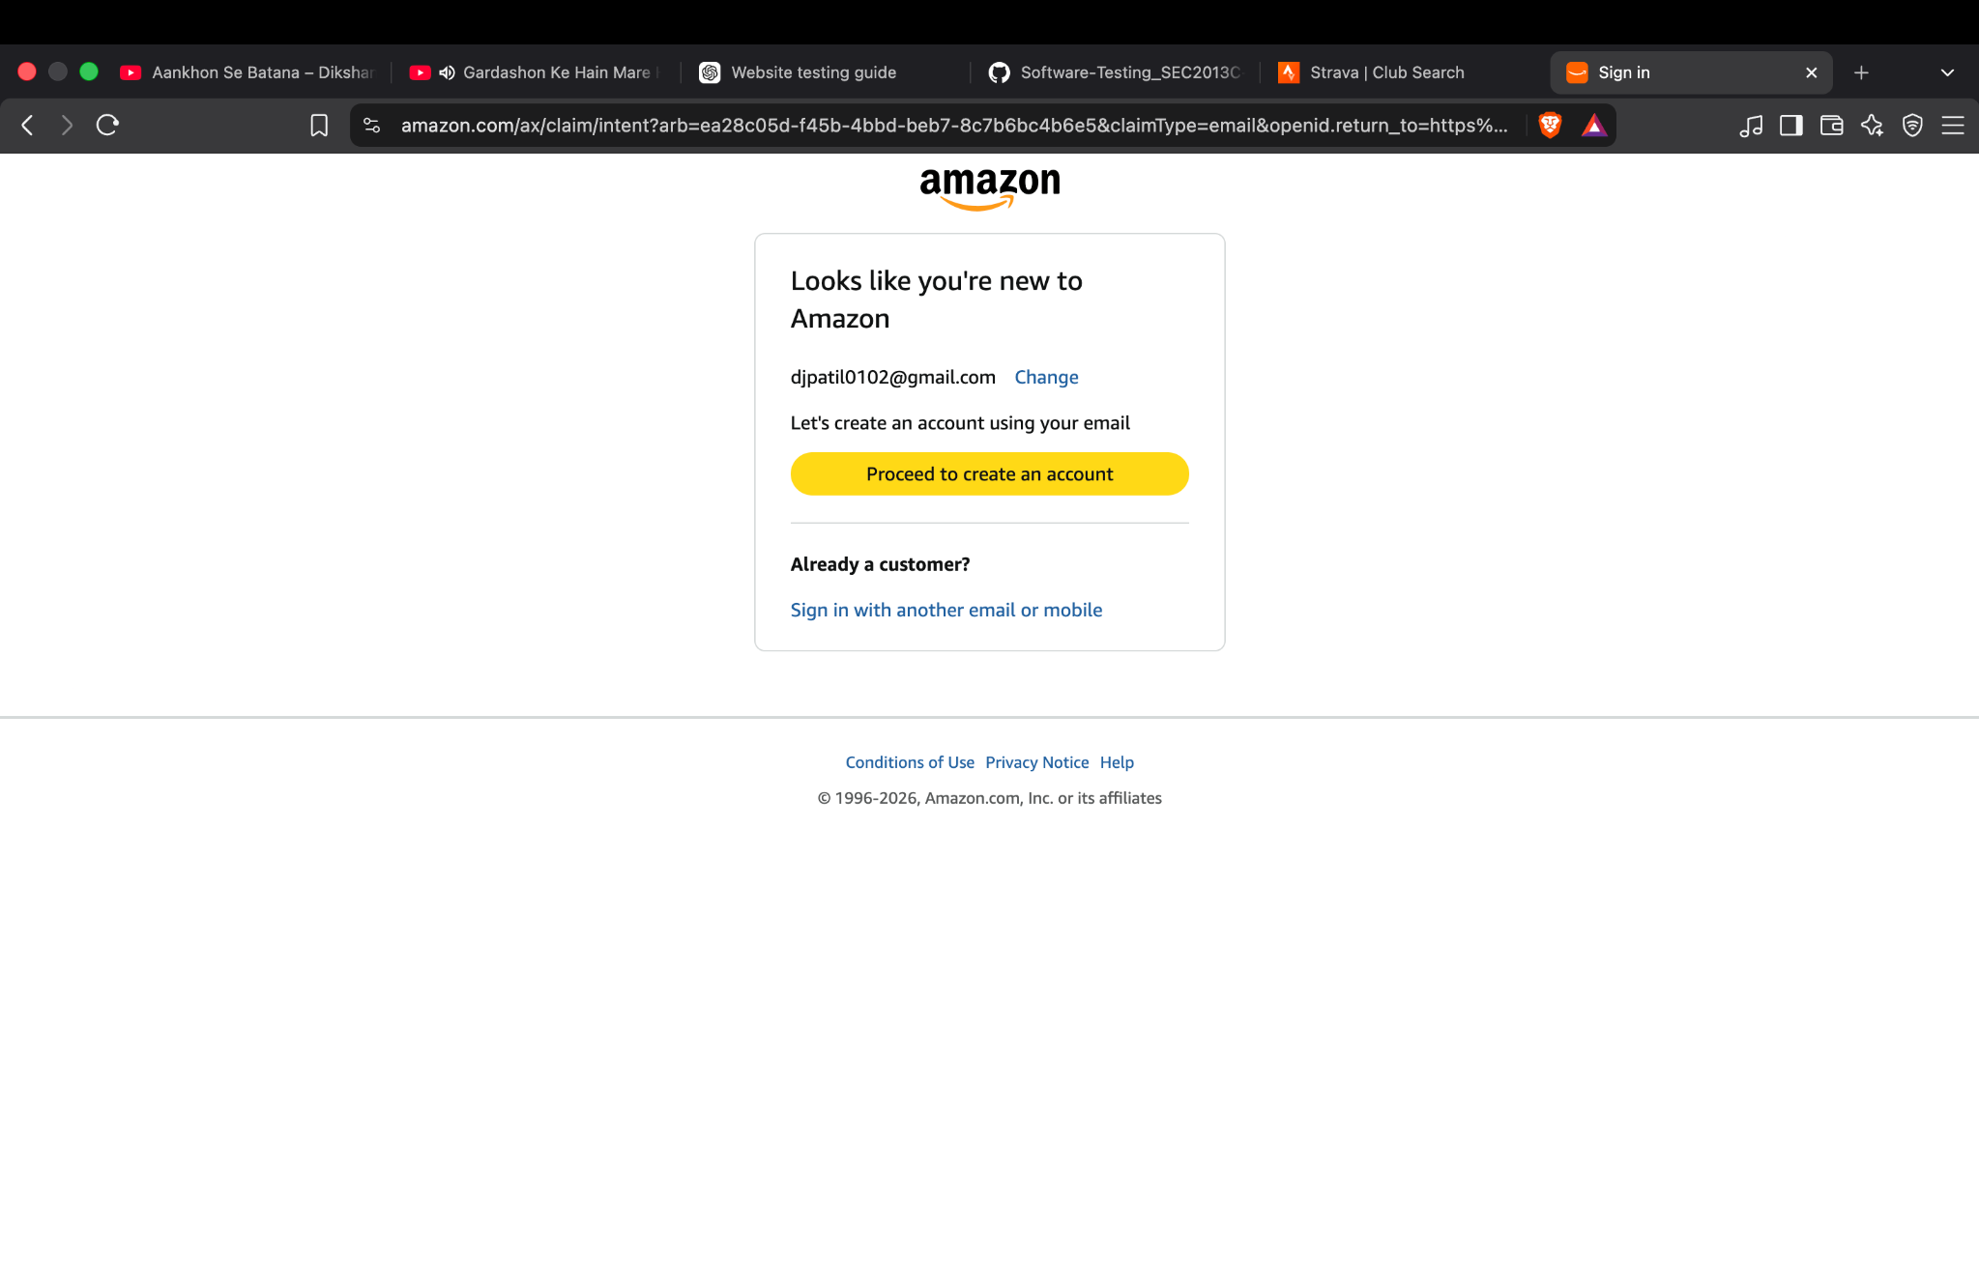
Evidence 5 — Amazon identifies the entered email as a new customer and offers account creation.

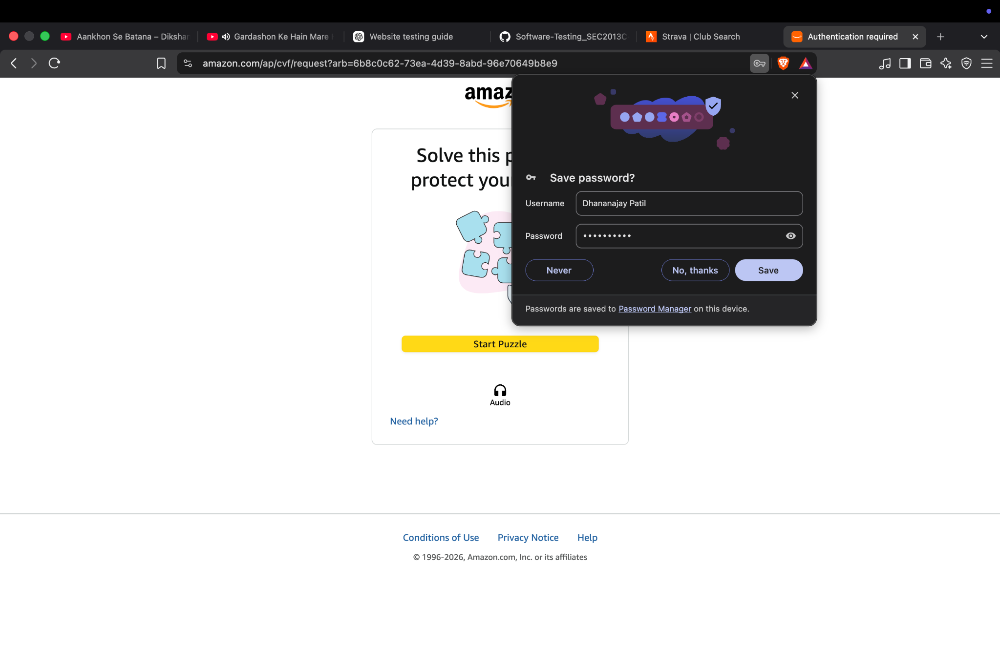
Evidence 6 — Account-protection puzzle displayed; browser password-save popup is also visible.

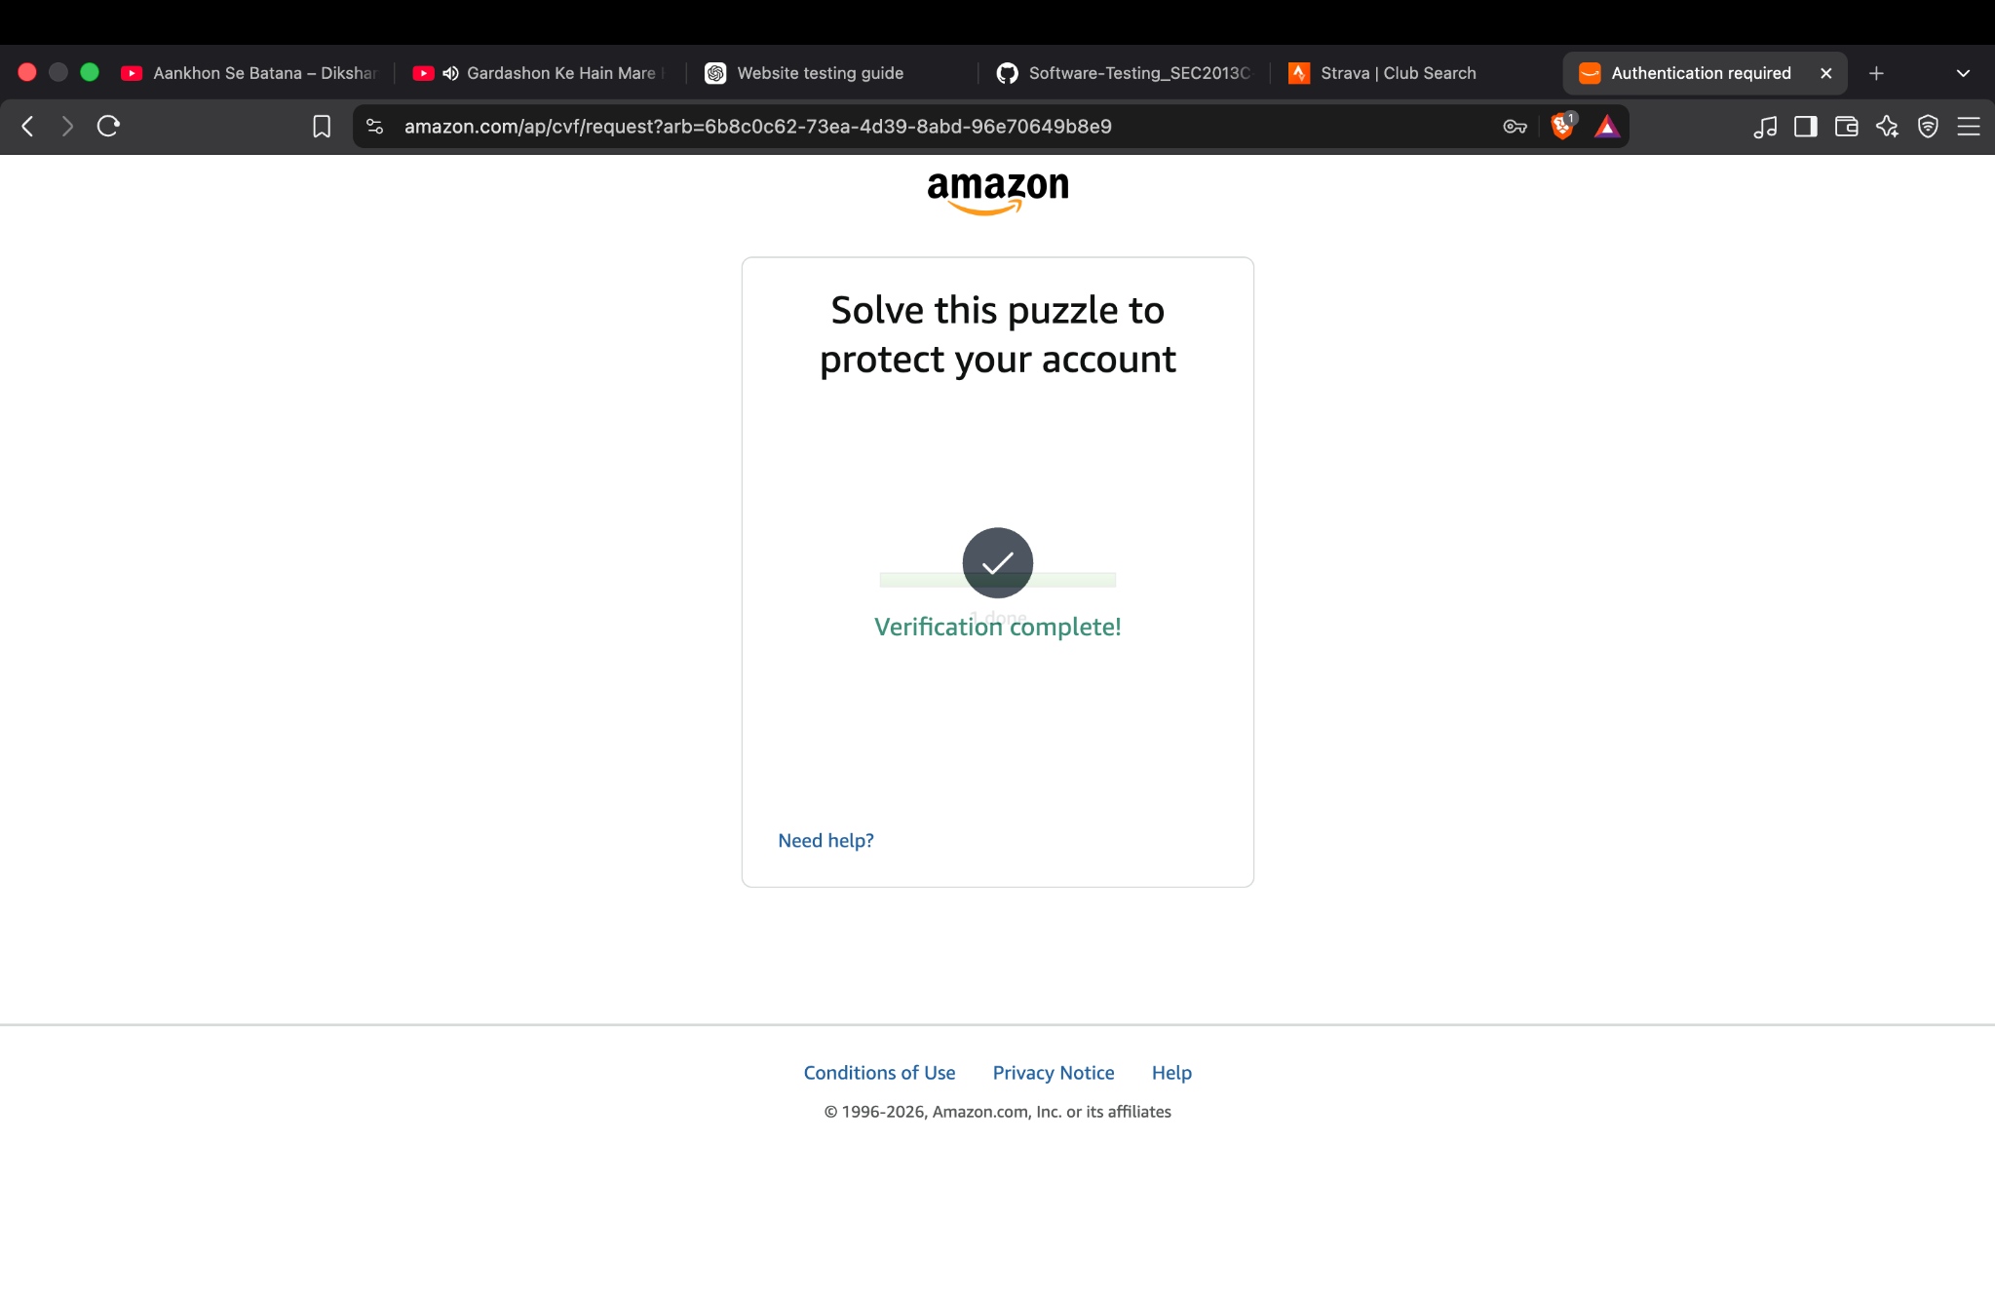
Evidence 7 — Security verification completed successfully.

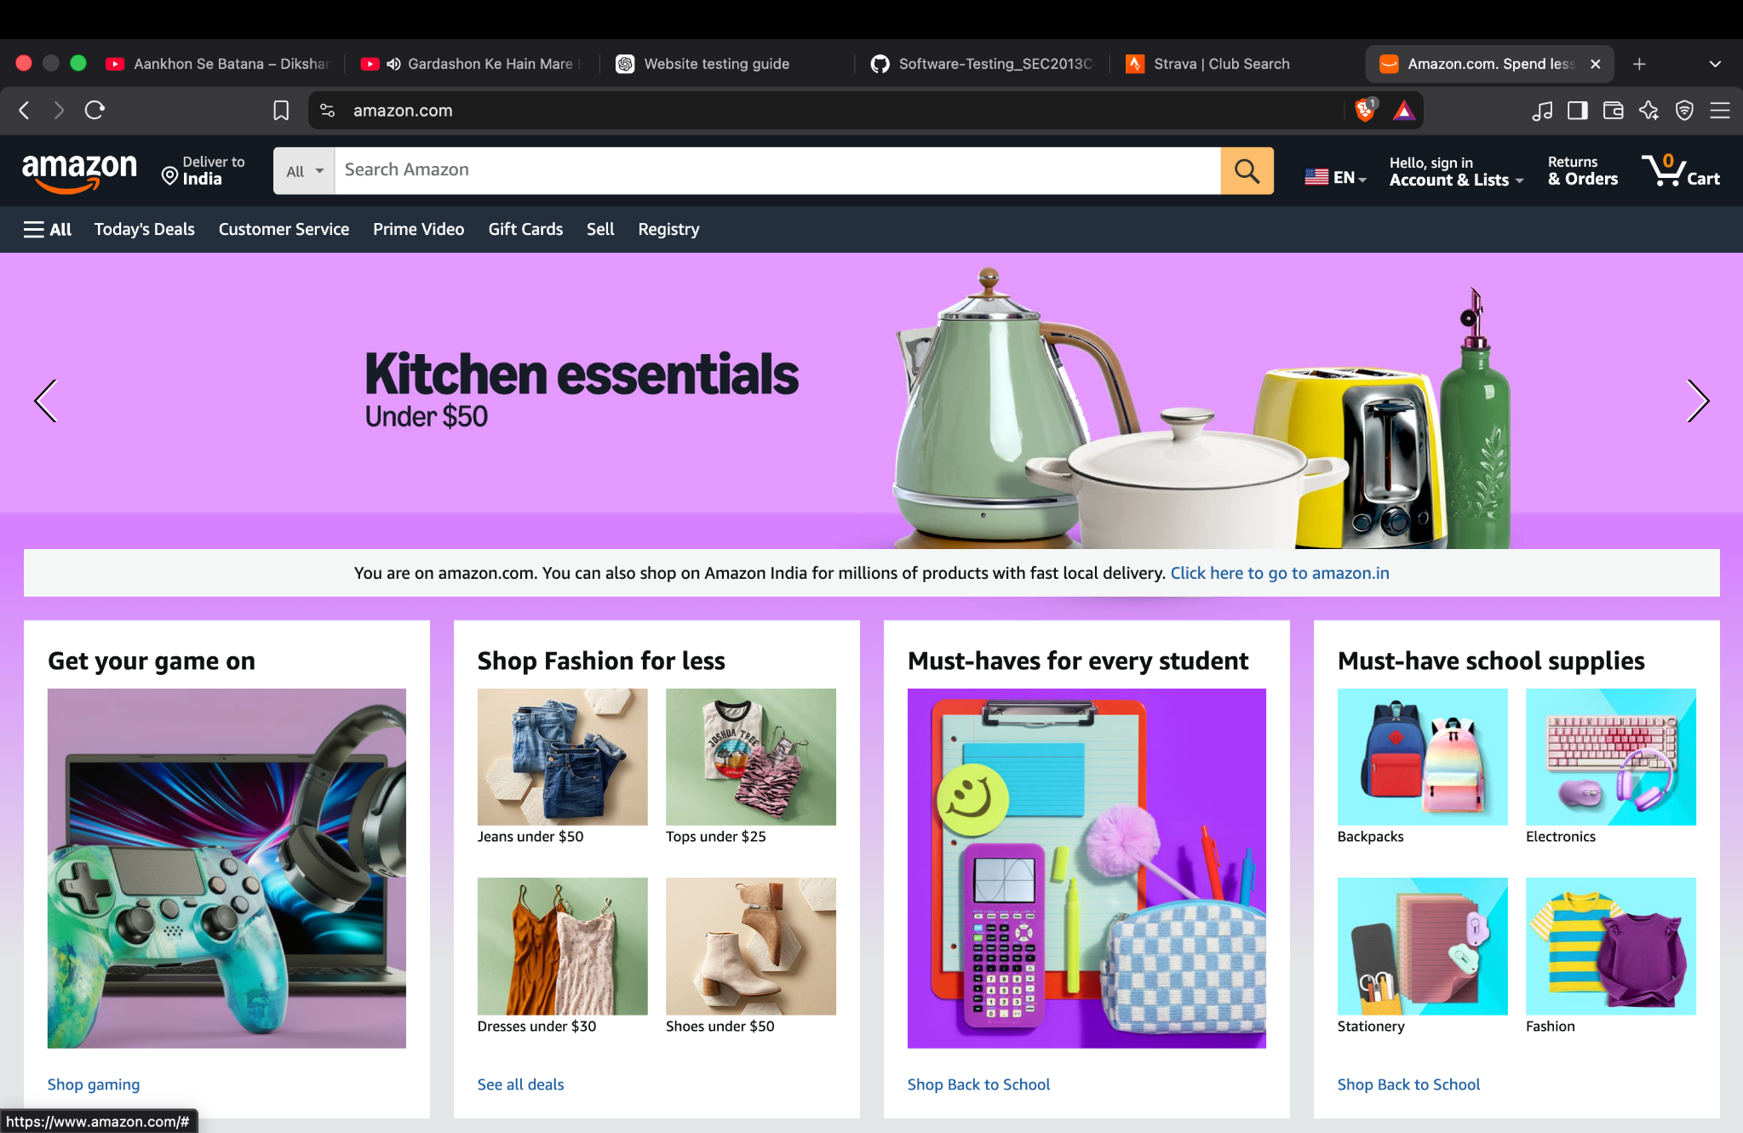
Evidence 8 — Amazon home page displayed after the verification flow.

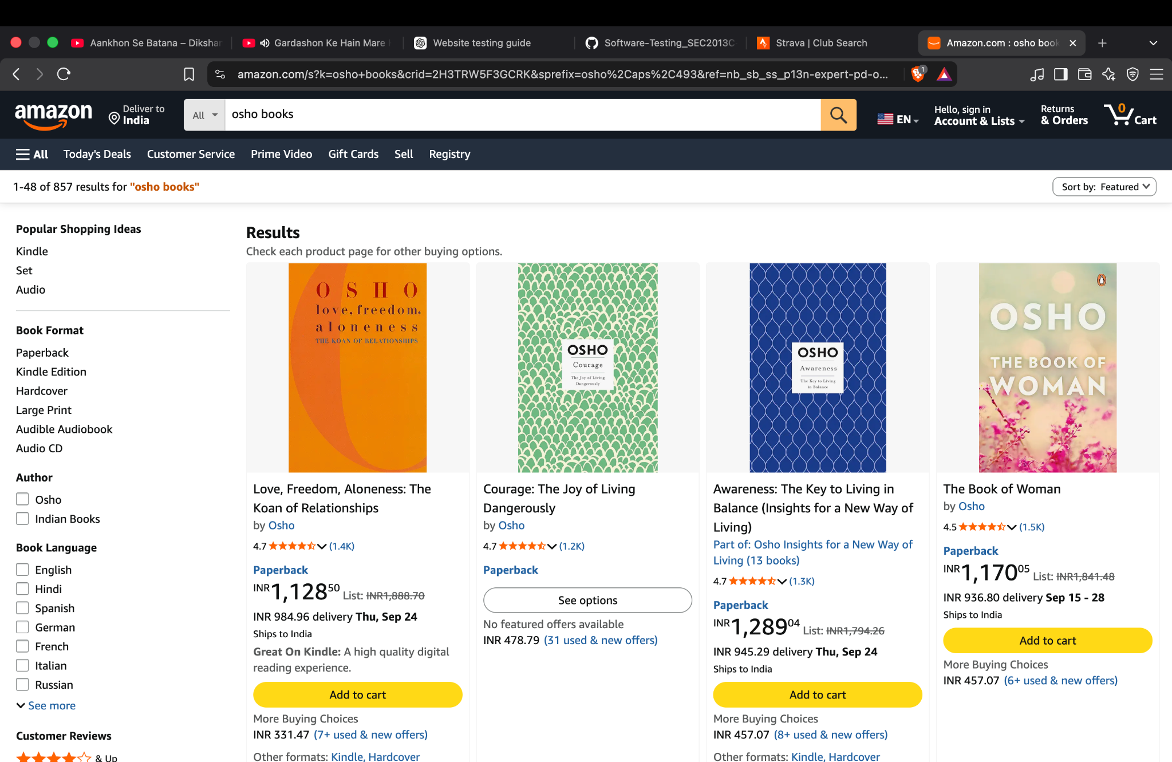
Evidence 9 — Search results for 'osho books' with filters and product cards.

8. Final Test Assessment
Based on the supplied evidence, Amazon's visible UI, input validation, account-state messaging, security verification, navigation and search functions operated as expected for the tested scenarios. The main outstanding evidence gap is the complete authenticated customer flow: successful login into an account, confirmation of the account area, and logout. A tester should capture those screens if the lab manual requires a complete Login → Account/Dashboard → Logout scenario.
Overall assessment: PASS WITH ONE INCOMPLETE END-TO-END AUTHENTICATION TEST

9. Test Evidence Index
Evidence | Screenshot | Related Area
Evidence 1 | Screenshot 1 | UI / Functional
Evidence 2 | Screenshot 2 | Black-Box
Evidence 3 | Screenshot 3 | Black-Box
Evidence 4 | Screenshot 4 | Negative Testing
Evidence 5 | Screenshot 5 | Functional
Evidence 6 | Screenshot 6 | Security
Evidence 7 | Screenshot 7 | Security
Evidence 8 | Screenshot 8 | Integration
Evidence 9 | Screenshot 9 | System / Functional

