## Block Diagram

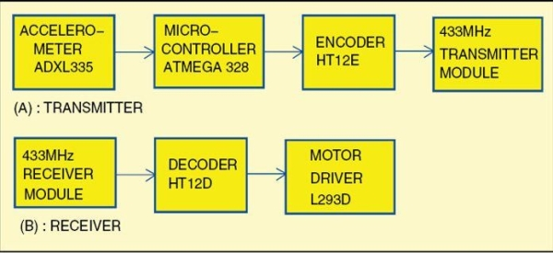

## Transmitter and Receiver Circuit

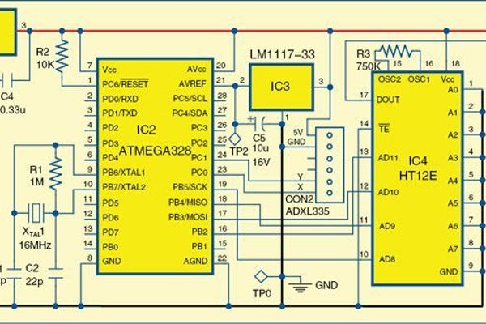

## PCB Layout of Receiver and Transmitter Circuit

## PCB Layout of Receiver and Transmitter Circuit

