**Testing**

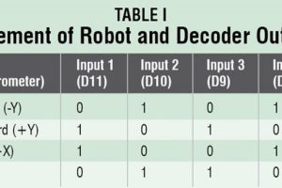

Mount all components on the PCBs shown here to minimise assembly errors. Fix the receiver PCB and 4.5V battery on the chassis of the robot. Fix two motors, along with wheels, at the rear side of the robot and a castor wheel on the front. After uploading the main code into the microcontroller, remove it from the Arduino Uno board and insert it into the populated transmitter PCB.

Now, switch-on the power supplies in the transmitter as well as receiver circuits. Attach the transmitter circuit to your hand(or to a gloves) and move your hand forwards, backwards and sideways. Directions of the robot movement are given in Table I. The robot will stop if you keep your palm horizontal, parallel to the Earth’s surface.