The Synthetic Panopticon
AI-Enabled Identity Fraud, PII Degradation, and Multi-Layered Identity Defense
Dinesh Gowd Patil
Version 1.0
June 2026

Recommended citation | Dataset citation
Dinesh Gowd Patil (2026). The Synthetic Panopticon: AI-Enabled Identity Fraud, PII Degradation, and Multi-Layered Identity Defense. Version 1.0, June 2026. | Dinesh Gowd Patil (2026). SP-SEC-50 Evidence Corpus v1.0: Structured Evidence on AI-Enabled Identity Fraud and PII Degradation. Version 1.0, June 2026.

Contents
- Abstract
- 1. How to read and cite this Version 1.0 release
- 2. Research design
- 3. Evidence map for citation
- 4. The AI-era PII degradation paradigm
- 5. Synthetic Identity Fraud 2.0 and sleeper fraud
- 6. Cross-source quantitative synthesis
- 7. The defensive wall
- 8. Hybrid security roadmap
- 9. SP-SEC-50 Evidence Corpus v1.0
- 10. Research agenda
- 11. Limitations and responsible use
- 12. Conclusion
- References
- Appendix A. Corpus files in this release
- Appendix B. Interpretation rules for citation

Abstract
The financial identity stack was built around a premise that no longer holds: that personally identifiable information (PII) is scarce, stable, and private enough to function as an authentication substrate. Names, dates of birth, addresses, Social Security numbers, phone numbers, device identifiers, email addresses, and historical account attributes now circulate through breached datasets, brokered data markets, phishing kits, malware logs, public records, social networks, and automated open-source intelligence pipelines. Generative AI does not create the exposure by itself. It changes the economics of exploitation by converting partial identity fragments into operational impersonation, synthetic profile construction, document forgery, voice cloning, deepfake-enabled liveness attacks, and personalized social engineering at machine speed.
This whitepaper argues that the modern identity threat is best understood as a synthetic panopticon: a hostile observation and generation environment in which attackers can assemble plausible identity claims faster than institutions can validate them using legacy controls. In that environment, PII can no longer be treated as proof of personhood. It should be treated primarily as lookup data that helps locate a record. The evidentiary burden must shift to layered, continuously evaluated trust: document authenticity, injection-resistant liveness, device and behavioral analytics, authoritative data corroboration, bureau and identity-network coherence, and phishing-resistant authentication.
The empirical basis is visible across public and private telemetry. U.S. consumers reported more than $12.5B in fraud losses in 2024, including $2.95B in imposter scam losses and more than 1.1M IdentityTheft.gov reports [1]. The FBI IC3 reported that cyber-enabled fraud represented 333,981 complaints and $13.7B in losses, accounting for 38% of complaints but 83% of reported 2024 IC3 losses [2]. FinCEN identified about 1.6M identity-related BSA reports for calendar year 2021, representing 42% of filings and $212B in suspicious activity [3]. At the same time, iProov reported 704% growth in face-swap attacks, Entrust reported deepfake attacks every five minutes and 244% growth in digital document forgeries, and NIST now makes clear that out-of-band and OTP authentication are not phishing-resistant [6] [9] [10].
The paper contributes four reusable artifacts: (1) the Synthetic Panopticon framework, (2) a taxonomy of AI-enabled identity attack mechanics, (3) SP-SEC-50 Evidence Corpus v1.0, a structured dataset of extracted metrics and source limitations, and (4) a layered maturity model for enterprise and consumer defense. It is a systematic evidence review and structured quantitative synthesis, not a formal meta-analysis across incompatible reporting regimes.
Keywords: synthetic identity fraud, PII degradation, generative AI, deepfakes, identity proofing, passkeys, credit bureaus, fraud telemetry, SP-SEC-50, identity assurance.

1. How to read and cite this Version 1.0 release
This Version 1.0 release has two citation targets. The title The Synthetic Panopticon names the framework; SP-SEC-50 names the structured evidence corpus. The subtitle explains the scope, and the version number identifies the evidence snapshot used for this release.
The whitepaper should be cited when the reader relies on the conceptual framework, taxonomy, or maturity model. The SP-SEC-50 Evidence Corpus should be cited when the reader reuses the structured source data, grouped synthesis, or data dictionary. Separating the paper citation from the dataset citation gives readers a precise target.
The evidence snapshot is dated June 6, 2026. A dated snapshot makes the analysis auditable: a reader can tell which data were used, which source types were included, which metrics were grouped, and which claims were intentionally not added together.

2. Research design: systematic evidence review and structured quantitative synthesis
This paper uses a systematic evidence review and structured quantitative synthesis. That phrase is deliberate. The evidence base is too heterogeneous for a single pooled meta-analysis. FTC consumer reports, IC3 cyber complaints, FinCEN BSA filings, vendor identity-verification telemetry, bureau exposure estimates, standards guidance, and academic attack experiments measure different populations. Their combined value is architectural rather than additive.
The source collection uses five evidence baskets:
1. Government and regulatory evidence: FTC, FBI IC3, FinCEN, Federal Reserve, SSA.
2. Standards and authentication guidance: NIST SP 800-63-4/SP 800-63B-4 and FIDO passkey guidance.
3. Operational telemetry: iProov, Entrust, TransUnion, Equifax, LexisNexis, and Experian.
4. Academic literature: systematic review, facial liveness/deepfake security, voice deepfake challenge-response, and LLM vishing-classifier attack research.
5. Methodology infrastructure: PRISMA-style reporting, scholarly API collectors, and dataset citation metadata.
Inclusion required at least one of the following: a primary reported statistic, a directly relevant standard or control requirement, a systematic review, an empirical attack/detection result, or a defensible operational telemetry metric. Exclusion criteria were duplicate press restatements, unverifiable blog claims, generic cybersecurity sources without identity-fraud relevance, and sources without an extractable result.
The corpus uses a confidence ladder. Government and standards sources are high-confidence for their own reported populations. Vendor telemetry is high-signal but not a global census. Academic preprints and papers are valuable for mechanism evidence, but their findings should be treated as setting- and dataset-dependent until independently replicated.
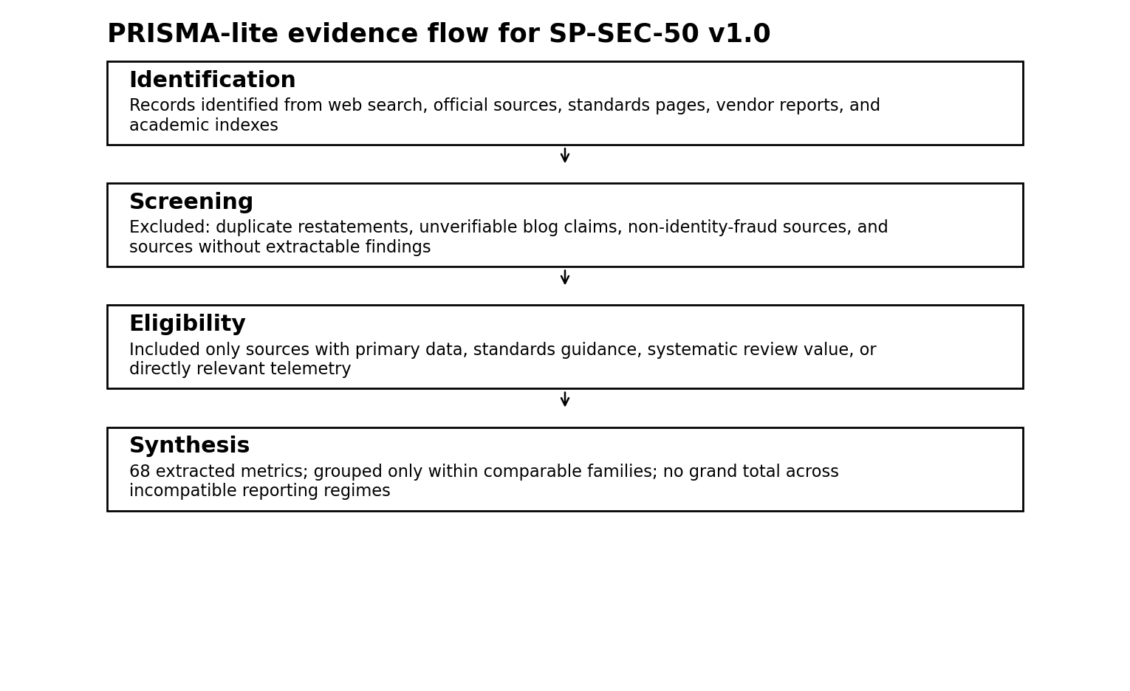
PRISMA-lite evidence flow

3. Evidence map for citation
Risk domain | High-signal finding | Source
Consumer fraud | $12.5B in reported 2024 consumer fraud losses; $2.95B from imposter scams; more than 1.1M IdentityTheft.gov reports. | [1]
Cyber-enabled fraud | 333,981 complaints and $13.7B in IC3 cyber-enabled fraud losses; 38% of complaints but 83% of losses. | [2]
Identity-related BSA activity | About 1.6M identity-related BSA reports in CY2021, 42% of filings, and $212B in suspicious activity. | [3]
Synthetic identity losses | Federal Reserve toolkit cites an estimated $20B in U.S. financial-institution losses in 2020, often miscategorized as credit loss. | [4]
Static authentication weakness | NIST SP 800-63B-4 requires phishing-resistant options at AAL2 and states OTP and out-of-band authentication are not phishing-resistant. | [6]
Authoritative SSN corroboration | SSA eCBSV permits eligible entities, with written consent, to verify SSN/name/date-of-birth combinations and receive yes/no match results. | [7]
Face-swap and injection attacks | iProov reported 704% growth in face swaps, 353% growth in emulator use, and 255% growth in mobile-web injection attacks from H1 to H2 2023. | [9]
Document and deepfake fraud | Entrust reported deepfake attacks every five minutes in 2024, digital document forgeries up 244% YoY, and digital forgeries at 57% of document fraud. | [10]
Digital account-opening risk | TransUnion reported 13.5% of global digital account openings were suspected digital fraud and $3.1B in selected U.S. synthetic exposure at end-2023. | [11]
Synthetic exposure trend | TransUnion reported suspected synthetic exposure reached $3.2B in H1 2024 and 0.20% of new accounts in four U.S. tradelines. | [12]
Unit economics of synthetics | Equifax reported about $13,000 average charged-off loss per known synthetic identity and an AI-based product using identity, credit, and behavioral signals. | [13]
Academic grounding | Recent academic work reviews 43 AI identity-fraud papers, demonstrates deepfake liveness-bypass risk, and studies voice-deepfake and LLM vishing defenses/attacks. | [16] [17] [18] [19]

The evidence map has one important interpretation rule: do not add the dollar amounts into one grand fraud number. FTC, IC3, FinCEN, Federal Reserve, TransUnion, Equifax, LexisNexis, and Experian measure different reporting systems and populations. The right inference is convergence, not arithmetic aggregation.

4. The AI-era PII degradation paradigm
PII degradation is the loss of evidentiary value in personal data. In the legacy identity model, an institution could ask for a name, SSN, date of birth, address, phone number, or knowledge-based answer and treat a correct response as evidence that the claimant was probably the legitimate person. That assumption fails when the data are widely exposed, cheaply enriched, and operationalized through automation.
The core security implication is simple: PII now identifies a record more reliably than it authenticates a person. SSNs, dates of birth, addresses, phone numbers, and historical account attributes can still support matching, routing, eligibility, and risk enrichment. They should not be treated as secrets or sufficient proof of lawful identity control. NIST SP 800-63-4 reinforces the separation of identity proofing, enrollment, authentication, authenticator management, federation, and assertions [5].
AI-enabled identity attacks operate through four recurring mechanics:
- Impersonation: generated text, voice, and video make an attacker appear to be a trusted person or institution.
- Synthesis: real and fabricated attributes are blended into identity claims that may not map cleanly to one real person.
- Injection: manipulated media are fed directly into digital intake systems, bypassing simple camera or document workflows.
- Automation: forms, support interactions, social profiles, low-value transactions, and account-aging rituals are coordinated at scale.
Legacy controls are narrow. A document scan asks whether an image appears valid. A selfie asks whether a face appears live. An OTP asks whether a channel is reachable. A passkey asks whether a private key is available to the authenticating device. None of those questions alone asks whether the identity graph is coherent across time, institutions, devices, behavior, credit history, and authoritative records.
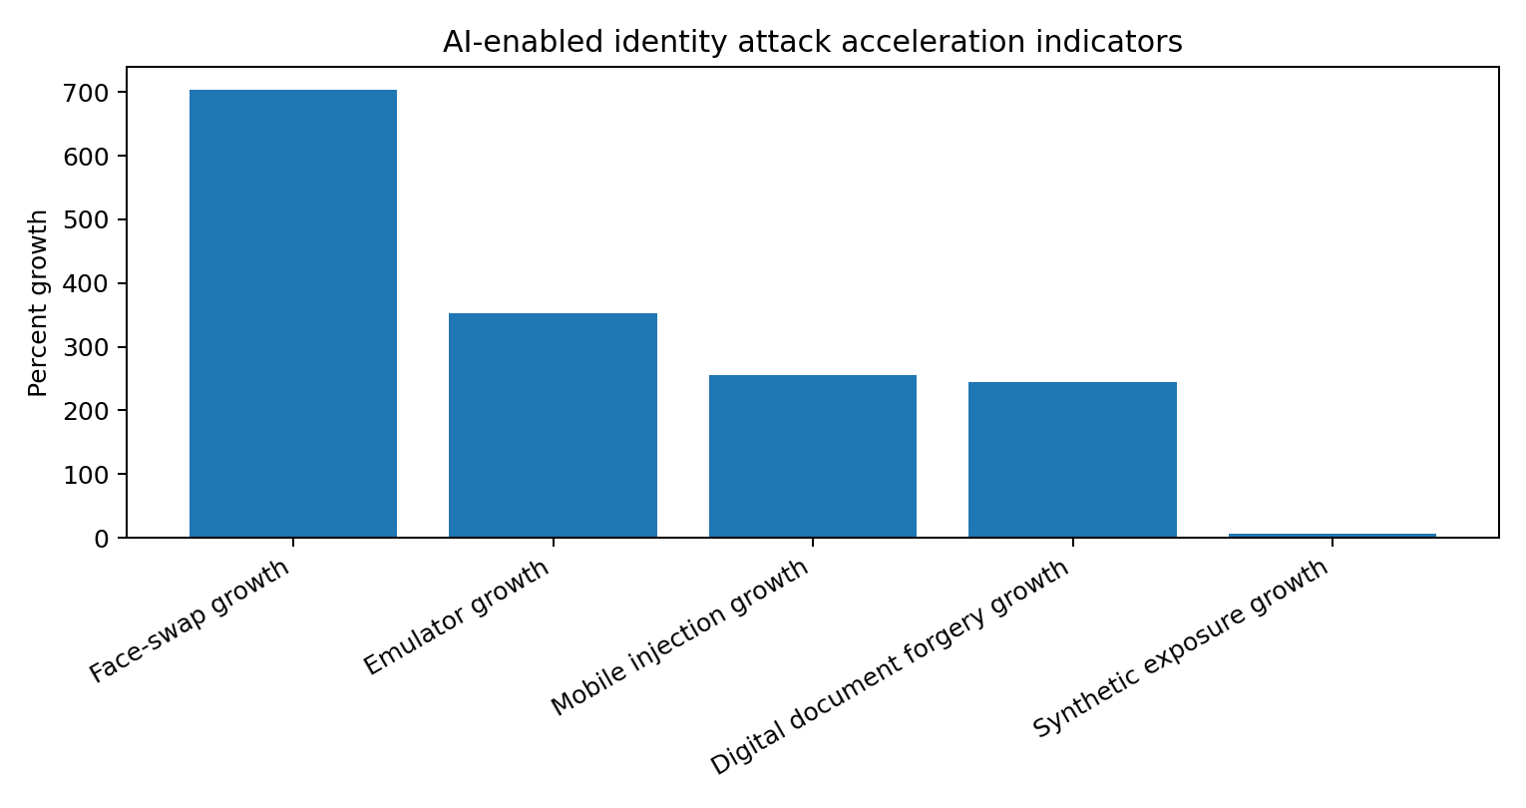
AI attack acceleration indicators

5. Synthetic Identity Fraud 2.0 and sleeper fraud
Synthetic Identity Fraud 2.0 is the use of real and fabricated data to create or operate an identity asset that can survive onboarding, age through low-friction activity, accumulate trust, and monetize through synchronized extraction. The defining feature is not merely fake data. It is the use of time, coherence, and cross-channel narrative to make a non-person look like a low-risk person.
Sleeper fraud is the latent stage of that lifecycle. The fraudster does not immediately extract maximum value. The objective is to pass onboarding, survive early risk checks, build a thin but favorable history, accumulate credit access, and then conduct a bust-out event. A synthetic profile may receive social media accounts, employment claims, small payments, utility-like artifacts, device histories, email aging, and low-risk credit interactions.
The Federal Reserve toolkit explains why synthetics are unusually hard for traditional risk systems: the fraud can be miscategorized as credit loss, and traditional fraud models may not be designed around the possibility that the applicant is not a real person [4]. Equifax similarly defines synthetic identity fraud as coupling real identity elements with manufactured components to create a fictitious identity that can open accounts or obtain loans [13].
The AI accumulation engine has five stages:
1. Attribute acquisition: breached data, public records, phishing, malware logs, and data brokers provide fragments.
2. Identity assembly: real and fabricated components are combined into a plausible applicant profile.
3. Narrative generation: LLMs produce employment histories, business descriptions, support-chat answers, social posts, and document narratives.
4. Digital footprint aging: email, phone, social, device, and low-value transaction histories are created or maintained.
5. Cross-channel expansion: the profile applies across lenders, fintechs, merchants, telecom providers, marketplaces, and government-facing services.
The bust-out vulnerability is financially asymmetric. TransUnion reported suspected synthetic exposure rising to $3.2B in H1 2024 across selected U.S. tradelines, while Equifax reported about $13,000 average charged-off loss per known synthetic identity [12] [13]. A conventional credit model that rewards seasoning, low delinquency, and orderly utilization can therefore become the mechanism through which the attack earns its final payoff.

6. Cross-source quantitative synthesis
The table below summarizes grouped metrics only where a cautious comparison is defensible. The synthesis uses descriptive means, medians, and ranges inside metric families. It does not pool across incompatible reporting regimes.
Metric family | Descriptive result | Interpretation | Publication caution
AI Attack Growth Rates | n=6; median 304; range 153 to 1,600 percent growth | AI-enabled identity attack telemetry shows triple-digit acceleration across 6 indicators; median growth is 304 percent growth. | Use as attack-acceleration telemetry, not as a global prevalence census.
Public Loss Benchmarks | n=3; median 12.5; range 5.7 to 13.7 USD billions | Public loss benchmarks show identity-adjacent fraud has become a board-level risk, but values are not additive. | Directional only; FTC and IC3 measure different reporting systems.
Synthetic Exposure Benchmarks | n=2; median 3.15; range 3.1 to 3.2 USD billions | Synthetic identity risk is visible both as dollar exposure and as a small but costly share of new accounts. | Selected tradelines and proprietary telemetry; not a national total.
Digital Account-Opening Fraud | n=1; median 13.5; range 13.5 to 13.5 percent | Account opening is a disproportionate fraud entry point in digital channels. | Comparable only within TransUnion digital account-opening telemetry.
Synthetic Loss Benchmarks | n=1; median 20; range 20 to 20 USD billions | Descriptive benchmark for this metric family. | Synthetic-ID loss estimates can be misclassified as credit loss.
Fraud Cost Multiplier | n=1; median 4.41; range 4.41 to 4.41 cost per fraud dollar | Descriptive benchmark for this metric family. | Survey-based operating-cost benchmark; not directly comparable to loss reports.
Attack Success Metrics | n=1; median 70; range 70 to 70 percent increase | Academic attack studies show deepfake and LLM-assisted adversaries can materially weaken single-session controls. | Controlled academic attack result; mechanism evidence, not field prevalence.
Deepfake/Voice Detection Performance | n=2; median 78.55; range 72.6 to 84.5 percent accuracy | Academic voice-deepfake controls improve detection in controlled settings but are not substitutes for authentication. | Controlled academic detection result; not a substitute for authentication.

The full grouped-synthesis CSV preserves machine-readable grouping keys for reproducibility and adds human-readable labels for publication use. The table above uses labels only, because raw schema strings should not appear in the body of a typeset whitepaper.
Three findings matter most for decision-makers.
First, the loss surface is already institutional, not merely consumer-facing. FTC fraud losses, IC3 cyber-enabled fraud losses, FinCEN identity-related suspicious activity, Federal Reserve synthetic-ID estimates, and TransUnion synthetic exposure are not additive, but they point to a shared failure mode: identity compromise and impersonation are now embedded in fraud, AML, credit, account opening, and account recovery [1] [2] [3] [4] [12].
Second, the attack surface is accelerating at the presentation layer. iProov's face-swap, emulator, and injection metrics and Entrust's document-forgery metrics show that attackers are not merely stealing passwords or filling out forms. They are attacking the sensors and workflows that institutions use to establish personhood [9] [10].
Third, static and relayable authentication has become structurally brittle. NIST states that out-of-band and OTP authentication are not phishing-resistant, and identifies PSTN out-of-band authentication as restricted [6]. FIDO's passkey guidance points to the corresponding remedy: relying-party-scoped cryptographic challenge-response that is phishing-resistant and replay-resistant [8].
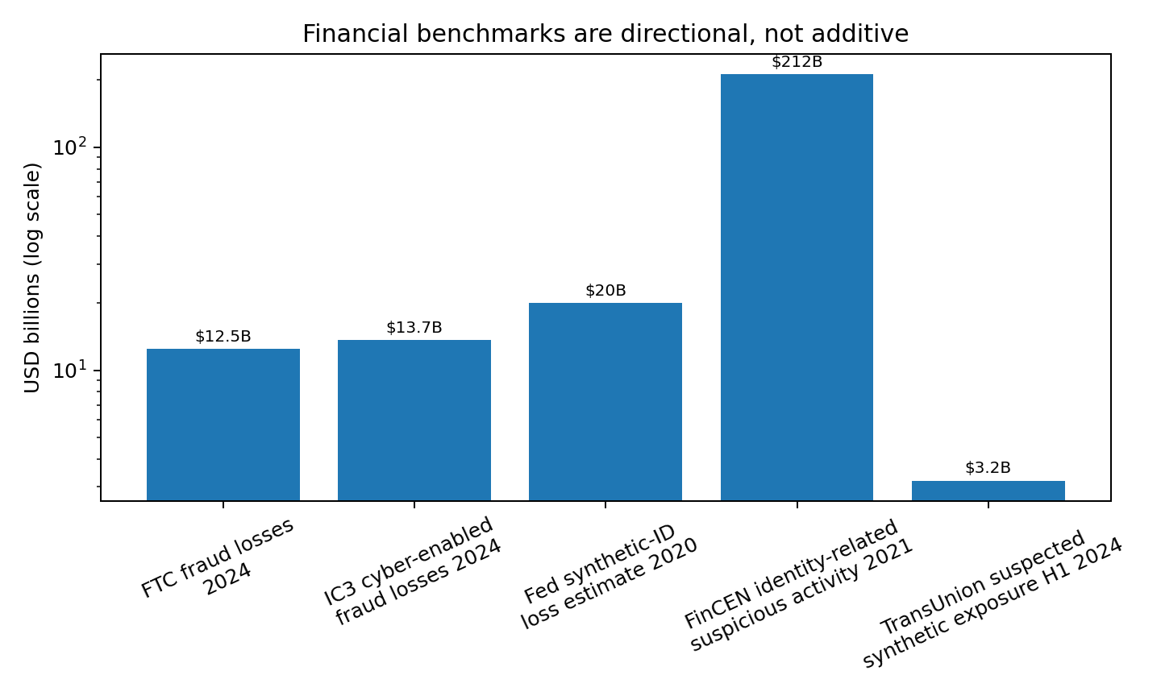
Financial benchmarks

7. The defensive wall: credit bureaus and identity networks as systemic signal layers
Credit bureaus historically served as repositories of credit history: tradelines, inquiries, payment behavior, balances, delinquencies, public records, and identity attributes. That function remains central, but the identity-risk role has expanded. In the synthetic identity era, bureaus and identity networks function as cross-network signal processors.
Their value is not omniscience. It is comparative visibility. A lender sees an application. A bureau-linked identity network can help determine whether the application fits a wider identity and credit graph. A fintech sees device behavior. A bureau or identity network can enrich that behavior with historical identity elements, tradeline formation, inquiry patterns, prior risk signals, and portfolio-level patterns.
Modern synthetic identity detection depends on signal classes that are weak alone but powerful in combination:
- Identity consistency signals: whether name, SSN, date of birth, address, phone, email, and document claims cohere.
- Authoritative corroboration: whether a legally available authoritative source can validate core data, such as SSA eCBSV matching SSN/name/date-of-birth with consent [7].
- Velocity signals: whether identity elements, devices, addresses, phone numbers, or emails appear across institutions too quickly.
- File-formation signals: whether a credit file emerges in a plausible way or appears optimized for scoring.
- Behavioral signals: whether contact-channel changes, payments, transaction behavior, and credit-line requests align with expected behavior.
- Portfolio signals: whether hidden synthetic risk is accumulating inside existing books.

Public product disclosures show this shift. Equifax says its Synthetic Identity Risk product analyzes identity data, credit history, and behavioral signals and can be used at account opening or for account management [13]. TransUnion reports suspected synthetic exposure across auto loans, bankcards, retail cards, and unsecured personal loans, and describes identity verification, IP intelligence, device reputation, and synthetic identity detection as critical components of fraud prevention [12]. Experian emphasizes advanced analytics, alternative data insights, data sharing, and a multi-layered approach to fraud threats [15].

8. Hybrid security roadmap
The minimum defensible posture is not a single control. It is a layered and recursive architecture in which each layer constrains the others.
The figure below illustrates the layered architecture:
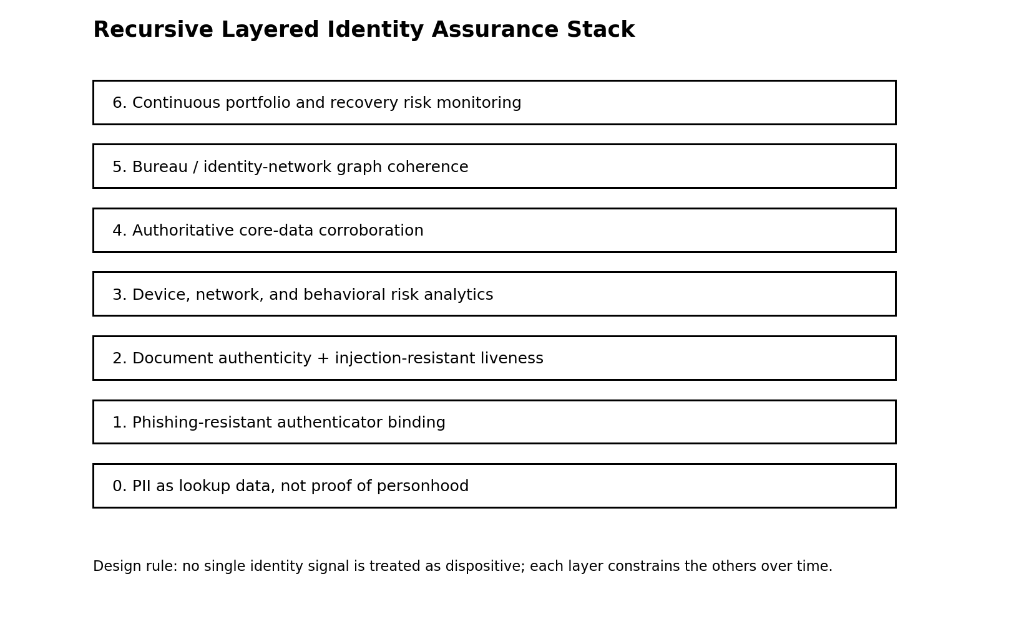
Recursive identity assurance stack

Enterprise maturity model
Layer | Required control | Reason
1. PII minimization and lookup-only treatment | Retire KBA-only and SMS-only high-risk flows; classify PII as regulated lookup data rather than secret authentication material. | Breached and brokered data can locate records but cannot prove lawful control.
2. Strong proofing at account opening | Use document verification, authoritative data matching where legal, device intelligence, phone/email risk, and bureau-network coherence. | Account opening is a high-risk point for synthetic and first-party fraud.
3. Deepfake-resistant intake | Evaluate vendors for replay, face-swap, emulator, and digital injection resilience, not just basic liveness. | AI attacks target the presentation and sensor layer directly.
4. Phishing-resistant authentication | Make passkeys, hardware-backed authenticators, or equivalent phishing-resistant authenticators default for repeat access and sensitive recovery. | OTP and out-of-band flows are relayable and not phishing-resistant.
5. Continuous cross-network monitoring | Monitor device changes, credit-line increases, account recovery, inquiries, identity reuse, velocity, and portfolio synthetic patterns. | Synthetic fraud is a lifecycle problem, not an onboarding-only problem.
6. Recovery hardening | Treat account recovery as a high-risk transaction; require known-channel callbacks, stronger step-up, and anomaly review. | Attackers often choose recovery workflows because they are weaker than login workflows.

Consumer autonomy framework
Consumers cannot solve systemic identity fraud alone, but they can reduce exposure. The most practical consumer model is issuance restriction plus visibility plus phishing resistance. Issuance restriction means using credit freezes when continuous credit availability is not needed. Visibility means monitoring bureau-visible activity, inquiries, address changes, and unfamiliar tradelines. Phishing resistance means moving high-value accounts away from SMS and shared-secret recovery wherever passkeys or hardware security keys are available.
Consumers should also adapt to voice and video deception as normal operating risk. For material requests, the safest pattern is to terminate the interaction and re-establish contact through a trusted channel. In family, executive, and finance contexts, callback discipline and prearranged challenge words create a trust anchor outside the attacker's generated content.

9. SP-SEC-50 Evidence Corpus v1.0
SP-SEC-50 is the reusable evidence layer released with this whitepaper. It contains 68 extracted metric rows from 23 source records, each labeled by source type, evidence basket, domain, metric, denominator, limitation, confidence score, comparable group, and inclusion status for grouped synthesis.
The purpose of the corpus is not to claim a perfect census of fraud. Its purpose is to make the paper's evidence auditable and reusable. Researchers can cite the framework, the dataset, the taxonomy, or the grouped synthesis. Practitioners can use the corpus as a starting point for internal control mapping.
Source ID | Author / organization | Year | Title | Source type
1 | Federal Trade Commission | 2025 | New FTC Data Show a Big Jump in Reported Losses to Fraud to $12.5 Billion in 2024 | government
2 | Federal Bureau of Investigation Internet Crime Complaint Center | 2025 | 2024 Internet Crime Report | government
3 | Financial Crimes Enforcement Network | 2024 | FinCEN Issues Analysis of Identity-Related Suspicious Activity | government
4 | Federal Reserve Banks | 2024 | Synthetic Identity Fraud Mitigation Toolkit | government
5 | National Institute of Standards and Technology | 2025 | SP 800-63-4 Digital Identity Guidelines | standards
6 | National Institute of Standards and Technology | 2025 | SP 800-63B-4 Authentication and Authenticator Management | standards
7 | Social Security Administration | 2026 | Electronic Consent Based Social Security Number Verification Service | government
8 | FIDO Alliance | 2024 | Displace Password + OTP Authentication with Passkeys | standards
9 | iProov | 2024 | New Threat Intelligence Report Exposes the Impact of Generative AI on Remote Identity Verification | vendor telemetry
10 | Entrust | 2024 | Deepfake Attacks Strike Every Five Minutes Amid 244% Surge in Digital Document Forgeries | vendor telemetry
11 | TransUnion | 2024 | H1 2024 Update: State of Omnichannel Fraud | vendor telemetry
12 | TransUnion | 2024 | TransUnion Analysis Finds Fraud Costing Businesses Equivalent of Nearly 7% of Revenues | vendor telemetry
13 | Equifax | 2026 | Equifax Introduces Enhanced Synthetic Identity Fraud Detection | vendor telemetry
14 | LexisNexis Risk Solutions | 2024 | Every Dollar Lost to a Fraudster Costs North America's Financial Institutions $4.41 According to LexisNexis True Cost of Fraud Study | vendor telemetry
15 | Experian | 2024 | Global Identity & Fraud Report 2024 | vendor telemetry
16 | Chuo Jun Zhang, Asif Q. Gill, Bo Liu, and Memoona J. Anwar | 2025 | AI-based Identity Fraud Detection: A Systematic Review | academic
17 | Changjiang Li, Li Wang, Shouling Ji, Xuhong Zhang, Zhaohan Xi, Shanqing Guo, and Ting Wang | 2022 | Seeing is Living? Rethinking the Security of Facial Liveness Verification in the Deepfake Era | academic
18 | Govind Mittal, Arthur Jakobsson, Kelly O. Marshall, Chinmay Hegde, and Nasir Memon | 2024 | PITCH: AI-assisted Tagging of Deepfake Audio Calls using Challenge-Response | academic
19 | Wenhao Li, Selvakumar Manickam, Yung-wey Chong, and Shankar Karuppayah | 2025 | Talking Like a Phisher: LLM-Based Attacks on Voice Phishing Classifiers | academic
20 | PRISMA | 2020 | PRISMA 2020 Statement | methodology

The corpus schema is intentionally simple enough to audit in a spreadsheet and structured enough for later API expansion. The included collector script supports future retrieval from Semantic Scholar, OpenAlex, Crossref, and PubMed/NCBI E-utilities, but this Version 1.0 release uses a manually reviewed, web-verified evidence snapshot.

10. Research agenda
The next six to eighteen months of research should focus on eight gaps:
1. Benchmarking digital-injection resistance across identity-verification vendors.
2. Measuring false-positive and disparate-impact tradeoffs in synthetic identity scoring.
3. Estimating how much synthetic identity loss remains misclassified as credit loss.
4. Testing passkey deployment effects on account takeover, account recovery abuse, and support-center fraud.
5. Building public datasets for voice-clone and vishing detection that preserve privacy and consent.
6. Quantifying the interaction between data breaches, brokered identity data, and synthetic account formation.
7. Modeling cross-institution bust-out timing and early-warning indicators.
8. Creating auditable frameworks for consumer-controlled identity issuance restrictions and bureau-visible risk alerts.

11. Limitations and responsible use
This paper has four limitations. First, many high-signal metrics are vendor telemetry. They are operationally valuable, but they are not global population statistics. Second, consumer and government reporting systems undercount because reporting is voluntary and uneven. Third, source categories are not comparable: a SAR, an IC3 complaint, a consumer fraud report, and a vendor-observed attack attempt are different units. Fourth, stronger identity analytics can create fairness, privacy, and access risks if implemented without governance.
The defense model should therefore be privacy-preserving, explainable at the control level, governed by model-risk discipline, and aligned with consumer rights. The goal is not omnipresent surveillance of consumers. The goal is to stop treating static exposed data as proof of personhood.

12. Conclusion
The AI-era identity problem is not simply that fraudsters can generate fake content. It is that institutions often still treat static data, narrow session checks, and isolated institutional views as if they were enough to prove personhood. The empirical record shows a broader risk: consumer fraud losses, cyber-enabled fraud losses, identity-related suspicious activity, synthetic identity exposure, document forgery, face-swap attacks, vishing, and account-opening fraud are converging into one identity-risk surface.
The Synthetic Panopticon framework names that surface. It describes a hostile environment in which identity fragments are observable, generatable, testable, and monetizable. The response must be equally systemic: verify the document, test liveness and injection resistance, bind the authenticator, validate authoritative data where lawful, examine bureau and identity-network coherence, monitor velocity, harden recovery, and treat every identity event as part of a lifecycle rather than a one-time gate.

References
[1] Federal Trade Commission. (2025). New FTC Data Show a Big Jump in Reported Losses to Fraud to $12.5 Billion in 2024. FTC. https://www.ftc.gov/news-events/news/press-releases/2025/03/new-ftc-data-show-big-jump-reported-losses-fraud-125-billion-2024
[2] Federal Bureau of Investigation Internet Crime Complaint Center. (2025). 2024 Internet Crime Report. FBI IC3. https://www.ic3.gov/AnnualReport/Reports/2024_IC3Report.pdf
[3] Financial Crimes Enforcement Network. (2024). FinCEN Issues Analysis of Identity-Related Suspicious Activity. FinCEN. https://www.fincen.gov/news/news-releases/fincen-issues-analysis-identity-related-suspicious-activity
[4] Federal Reserve Banks. (2024). Synthetic Identity Fraud Mitigation Toolkit. FedPayments Improvement. https://fedpaymentsimprovement.org/resources/synthetic-identity-fraud-mitigation-toolkit/
[5] National Institute of Standards and Technology. (2025). SP 800-63-4 Digital Identity Guidelines. NIST CSRC. https://csrc.nist.gov/pubs/sp/800/63/4/final
[6] National Institute of Standards and Technology. (2025). SP 800-63B-4 Authentication and Authenticator Management. NIST. https://pages.nist.gov/800-63-4/sp800-63b.html
[7] Social Security Administration. (2026). Electronic Consent Based Social Security Number Verification Service. SSA. https://www.ssa.gov/dataexchange/eCBSV/
[8] FIDO Alliance. (2024). Displace Password + OTP Authentication with Passkeys. FIDO Alliance. https://fidoalliance.org/white-paper-displace-password-otp-authentication-with-passkeys/
[9] iProov. (2024). New Threat Intelligence Report Exposes the Impact of Generative AI on Remote Identity Verification. iProov. https://www.iproov.com/press/new-threat-intelligence-report-exposes-impact-generative-ai-remote-identity-verification
[10] Entrust. (2024). Deepfake Attacks Strike Every Five Minutes Amid 244% Surge in Digital Document Forgeries. Entrust. https://www.entrust.com/company/newsroom/deepfake-attacks-strike-every-five-minutes
[11] TransUnion. (2024). H1 2024 Update: State of Omnichannel Fraud. TransUnion. https://www.transunion.com/report/h1-2024-omnichannel-fraud
[12] TransUnion. (2024). TransUnion Analysis Finds Fraud Costing Businesses Equivalent of Nearly 7% of Revenues. TransUnion Newsroom. https://newsroom.transunion.com/transunion-analysis-finds-fraud-costing-businesses-equivalent-of-nearly-7-of-revenues/
[13] Equifax. (2026). Equifax Introduces Enhanced Synthetic Identity Fraud Detection. Equifax Investor Relations. https://investor.equifax.com/news-events/press-releases/detail/1387/equifax-introduces-enhanced-synthetic-identity-fraud
[14] LexisNexis Risk Solutions. (2024). Every Dollar Lost to a Fraudster Costs North America's Financial Institutions $4.41 According to LexisNexis True Cost of Fraud Study. LexisNexis Risk Solutions. https://risk.lexisnexis.com/about-us/press-room/press-release/20240424-tcof-financial-services-lending
[15] Experian. (2024). Global Identity & Fraud Report 2024. Experian. https://www.experian.com/blogs/global-insights/wp-content/uploads/2024/11/Global_Fraud_Trends_Report_2024_FinalV.pdf
[16] Chuo Jun Zhang, Asif Q. Gill, Bo Liu, and Memoona J. Anwar. (2025). AI-based Identity Fraud Detection: A Systematic Review. arXiv. https://arxiv.org/abs/2501.09239
[17] Changjiang Li, Li Wang, Shouling Ji, Xuhong Zhang, Zhaohan Xi, Shanqing Guo, and Ting Wang. (2022). Seeing is Living? Rethinking the Security of Facial Liveness Verification in the Deepfake Era. arXiv. https://arxiv.org/abs/2202.10673
[18] Govind Mittal, Arthur Jakobsson, Kelly O. Marshall, Chinmay Hegde, and Nasir Memon. (2024). PITCH: AI-assisted Tagging of Deepfake Audio Calls using Challenge-Response. arXiv. https://arxiv.org/abs/2402.18085
[19] Wenhao Li, Selvakumar Manickam, Yung-wey Chong, and Shankar Karuppayah. (2025). Talking Like a Phisher: LLM-Based Attacks on Voice Phishing Classifiers. arXiv. https://arxiv.org/abs/2507.16291
[20] PRISMA. (2020). PRISMA 2020 Statement. PRISMA. https://www.prisma-statement.org/prisma-2020
[21] Rodney Kinney et al. (2023). The Semantic Scholar Open Data Platform. arXiv. https://arxiv.org/abs/2301.10140
[22] OpenAlex. (2026). OpenAlex API Documentation: Works. OpenAlex. https://docs.openalex.org/api-entities/works
[23] National Center for Biotechnology Information. (2026). Entrez Programming Utilities Help. NCBI Bookshelf. https://www.ncbi.nlm.nih.gov/books/NBK25501/

Appendix A. Corpus files in this release
- sp_sec_50_evidence_corpus_v1_0.csv: primary structured evidence table.
- sp_sec_50_grouped_synthesis_v1_0.csv: descriptive grouped metric summaries.
- sp_sec_50_data_dictionary_v1_0.csv: schema and allowed-value definitions.
- sp_sec_50_query_log_v1_0.jsonl: query and source-discovery log.
- synthetic_panopticon_v1_references.bib: BibTeX reference file.
- collect_literature_open_sources.py: script for future expansion using scholarly APIs.

Appendix B. Interpretation rules for citation
When citing this work, do not cite the largest dollar value as if it were a national loss total. Cite the paper for the framework, cite the corpus for structured evidence, and cite the original data source for the underlying reported metric. The proper claim is convergence across independent evidence regimes, not arithmetic aggregation.

