

**Veermata Jijabai Technological Institute, Mumbai 400019**

**Experiment No.:** 03

**Aim :** Implementation of parallel quick sort [Hyper quick sort] using CUDA

**Name :** Kiran K Patil

**Enrolment No.:** 211070904

**Branch:** Computer Engineering

**Batch:** IV

**Approach : Optimized Parallel Quick Sort**

In this approach we change a small detail in the number of processes used at each step. Instead of doubling the number of processes at each step, this approach uses n number of processes throughout the whole algorithm to find pivot element and rearrange the list. All these processes run concurrently at each step sorting the lists.

**Steps :**

1. Start n processes which will partition the list and sort it using selected pivot element.
2. n processes will work on all partitions from the start of the algorithm till the list is sorted.
3. Each processes finds a pivot and partitions the list based on selected pivot.
4. Finally the list is merged forming a sorted list.

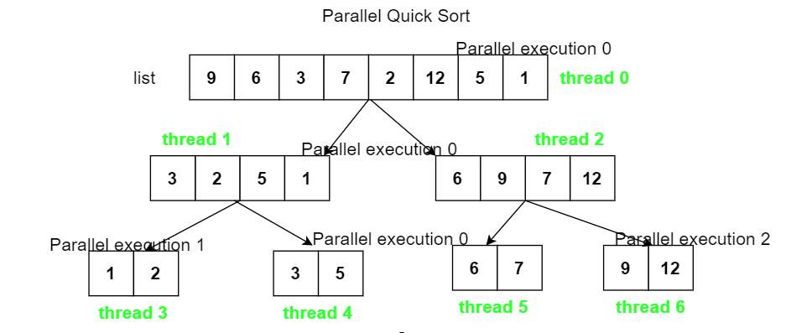

**Program :**

%%cu

#include<iostream>

#include<omp.h>

using std::cout;

using std::endl;

class ParallelQuickSort{

    //keep count of threads

    int k = 0;

    private:

        //partitioning procedure

        int partition(int arr[], int l, int r){

            int i = l + 1;

            int j = r;

            int key = arr[l];

            int temp;

            while(true){

                while(i < r && key >= arr[i])

                    i++;

                while(key < arr[j])

                    j--;

                if(i < j){

                    temp = arr[i];

                    arr[i] = arr[j];

                    arr[j] = temp;

                }else{

                    temp = arr[l];

                    arr[l] = arr[j];

                    arr[j] = temp;

                    return j;

                }

            }

        }

    public:

        void quickSort(int arr[], int l, int r){

            if(l < r){

                int p = partition(arr, l, r);

                cout <<  "pivot " << p << " found by thread no. " << k << endl << endl;

                #pragma omp parallel sections

                {

                    #pragma omp section

                    {

                        k = k + 1;

                        quickSort(arr, l, p-1);

                    }

                    #pragma omp section

                    {

                        k = k + 1;

                        quickSort(arr, p+1, r);

                    }

                }

            }

        }

       //prints array

        void printArr(int arr[], int n){

            for(int i = 0; i < n; i++)

                cout << arr[i] << " ";

            cout << endl;

        }

        //run the whole procedure

        void run(){

            int arr[] = {9, 6, 3, 7, 2, 12, 5, 1};

            int n = sizeof(arr) / sizeof(arr[0]);

            printf("\n************ Implementation of Quick Sort using CUDA ********************* \n\n");

            quickSort(arr, 0, n-1);

            printArr(arr, n);

        }

};

int main(){

    ParallelQuickSort pqs;

    pqs.run();

    return 0;

}

**Output:**

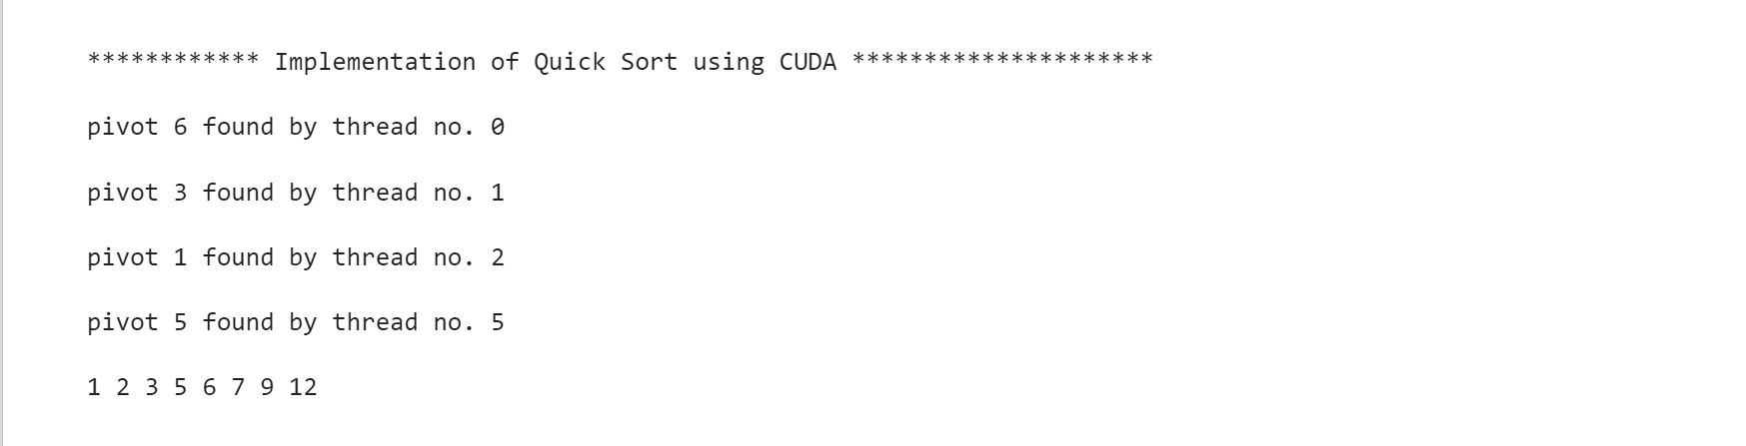

#### Parallel quick sort analysis

* At each step n processes process log(n) lists in constant time O(1).  
  The parallel execution time is O(logn) and there are n processes.
* Total time complxity is O(n log n).
* This complexity did not change from the sequential one but we have a achieved an algorithm that can run on parallel processors, meaning it will execute much faster at a larger scale.
* Space complexity is O(logn).

**Conclusion:**

* Thus we have implemented the parallel search algorithm (BFS) using CUDA.
* This program uses a CUDA kernel to perform BFS in parallel on a GPU.
* **#pragma omp parallel sections**  defines a parallel region containing the code that we will execute using multiple threads in parallel. This code will be divided among all thread.