Steps for Activity1.

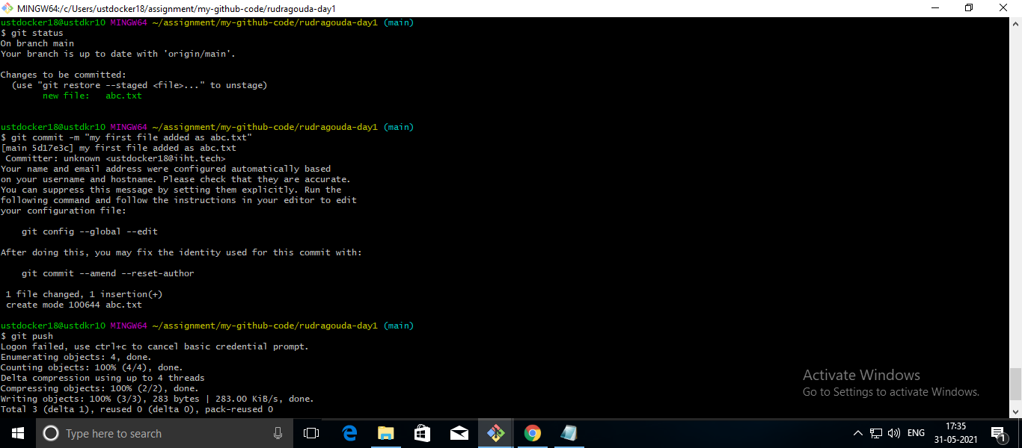

Steps for activity 2.

Made changes to README using GUI

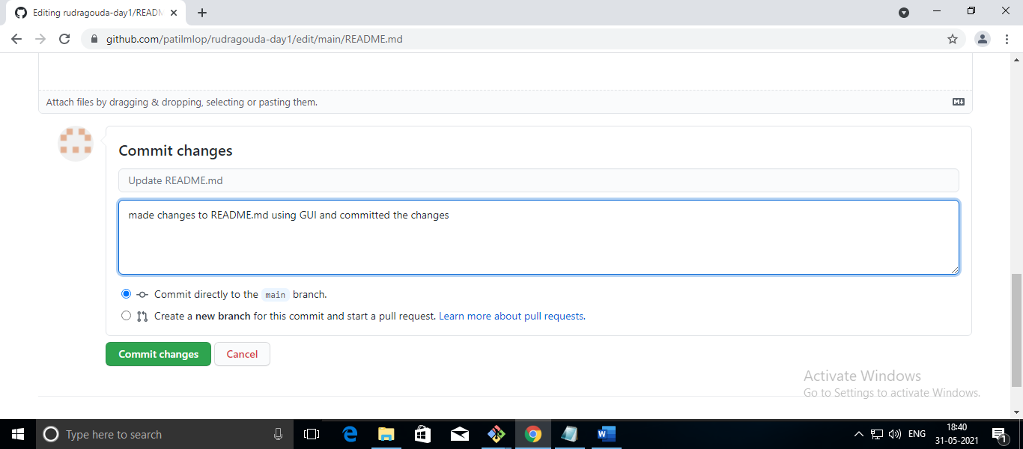

Created new directory and cloned above repo

/c/Users/ustdocker18/assignment/my-github-code-activity2/rudragouda-day1

Pulled the new changes and as shown in the screenshot

