Proposal: Campaign Performance Analysis Implementation Using Mixpanel, Python, and Power BI
Executive Summary
This proposal outlines a comprehensive process to implement a robust campaign performance analysis pipeline using Mixpanel for event tracking, Python for data extraction, and Power BI for visualization. By integrating these tools, we can achieve end-to-end visibility into our advertising campaigns, from ad clicks to sales outcomes, enabling data-driven optimizations to maximize ROI. The process leverages UTM-based tracking, Mixpanel’s event logging, Python-based ETL, and Power BI dashboards to deliver actionable insights.
This initiative will enhance our ability to monitor campaign effectiveness, reduce cost per acquisition (CPA), and improve return on ad spend (ROAS). Below is a clear, step-by-step plan to implement this pipeline, with each step connected to ensure seamless execution.

Objective
To establish a scalable, automated system for tracking and analyzing campaign performance, providing:
- Granular Attribution: Track user journeys from ad clicks to conversions and sales.
- Real-Time Insights: Monitor campaign performance with up-to-date dashboards.
- Actionable Metrics: Optimize campaigns based on CPA, ROAS, and funnel performance.

Step-by-Step Implementation Plan
Each step is designed to build on the previous one, creating a cohesive pipeline from ad tracking to visualization.
Step 1: UTM-Based Tracking Implementation
Objective: Standardize campaign URLs to capture attribution data across platforms.
Connection: UTM parameters ensure all downstream tracking (Mixpanel) is tagged with campaign details, enabling precise analysis.
- Action 1.1: Configure UTM Parameters in Ad Platforms
  - Add UTM parameters (utm_source, utm_medium, utm_campaign, utm_adgroup, utm_content) to all campaign URLs in platforms like Google Ads, Meta Ads, and LinkedIn Ads.
  - Example: https://yourwebsite.com/?utm_source=google&utm_medium=cpc&utm_campaign=spring_launch&utm_adgroup=group1&utm_content=creative1
  - Responsibility: Marketing team to update ad URLs; Estimated time: 1-2 days per platform.
  - Outcome: All ad-driven traffic will carry UTM tags for attribution.
- Action 1.2: Implement Website Tracking with Mixpanel SDK
  - Embed Mixpanel’s JavaScript SDK on our website to capture UTM-tagged events (e.g., page views, conversions).
  - Sample Code:
mixpanel.track("Page Viewed", {
"Campaign Name": getUTM('utm_campaign'),
"Platform": getUTM('utm_source'),
"Ad Group": getUTM('utm_adgroup'),
"Creative": getUTM('utm_content'),
"Landing Page URL": window.location.href,
"Visit ID": generateVisitID()
});
  - Track additional events like form submissions, add-to-cart, and checkout.
  - Responsibility: Web development team to implement SDK; estimated time: 3-5 days.
  - Outcome: All user actions are logged in Mixpanel with UTM context, enabling campaign attribution.
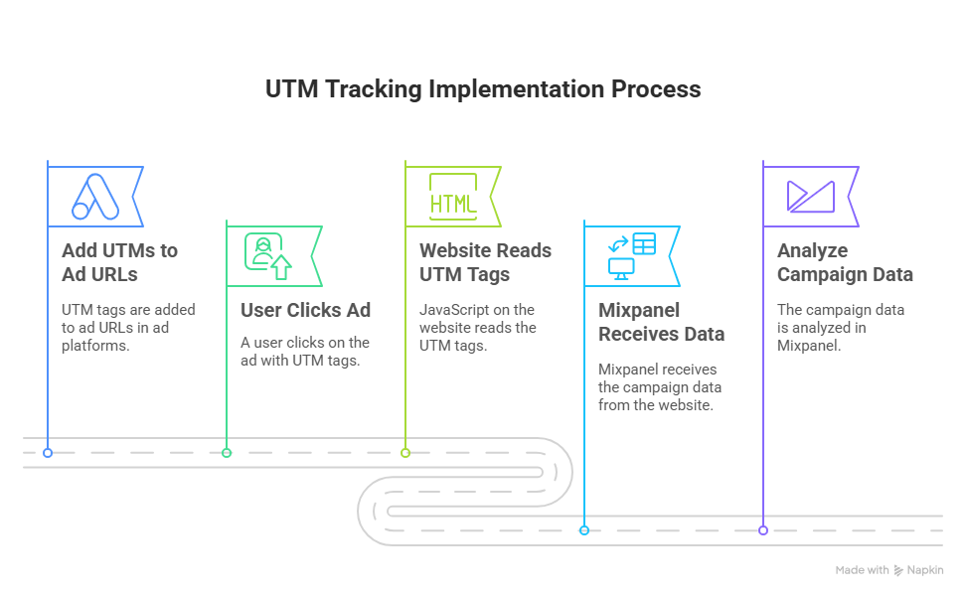

Step 2: Conversion and Sales Event Tracking
Objective: Log conversion and sales events in Mixpanel to connect ad interactions to business outcomes.
Connection: This step builds on UTM tracking by linking ad-driven sessions to revenue-generating events, forming the basis for ROI analysis.
- Action 2.1: Track Conversions and Sales
  - Use Mixpanel to log events like “Deal Closed” with properties such as deal value and conversion ID.
  - Sample Code:
javascript
mixpanel.track("Deal Closed", {
"Deal Value (USD)": 1200,
"Conversion ID": "xyz123",
"Sales Outcome": "Won",
"Lead ID": "lead987"
});
  - Ensure consistent IDs (e.g., Visit ID, Conversion ID) to enable end-to-end attribution.
  - Responsibility: Web development team to add event tracking; estimated time: 2-3 days.
  - Outcome: Conversion and sales data are captured, allowing us to measure campaign effectiveness.

Step 3: Extracting Data via Mixpanel API (Python)
Objective: Pull event-level data from Mixpanel for analysis and visualization.
Connection: This step transforms raw Mixpanel data into a structured dataset, bridging tracking (Steps 1-2) and visualization (Step 4).
- Action 3.1: Develop Python ETL Script
  - Use Mixpanel’s Export API to extract events like “Page Viewed” and “Deal Closed.”
  - Sample Python Script:
import requests
import pandas as pd
from base64 import b64encode
from datetime import datetime, timedelta

api_secret = "YOUR_MIXPANEL_SECRET"
event_name = "Ad Landing Page Viewed"
from_date = (datetime.now() - timedelta(days=7)).strftime('%Y-%m-%d')
to_date = datetime.now().strftime('%Y-%m-%d')

headers = {
"Authorization": "Basic " + b64encode(f"{api_secret}:".encode()).decode()
}

url = "https://mixpanel.com/api/2.0/export/"
params = {
"event": f'["{event_name}"]',
"from_date": from_date,
"to_date": to_date
}

response = requests.get(url, headers=headers, params=params, stream=True)
lines = [eval(line) for line in response.iter_lines()]
df = pd.json_normalize(lines)
  - Enhance script to join UTM data with conversion events and prepare a unified dataset.
  - Responsibility: Data analyst/engineering team to develop and test script; estimated time: 5-7 days.
  - Outcome: A clean dataset containing campaign, user, and conversion data, ready for Power BI.
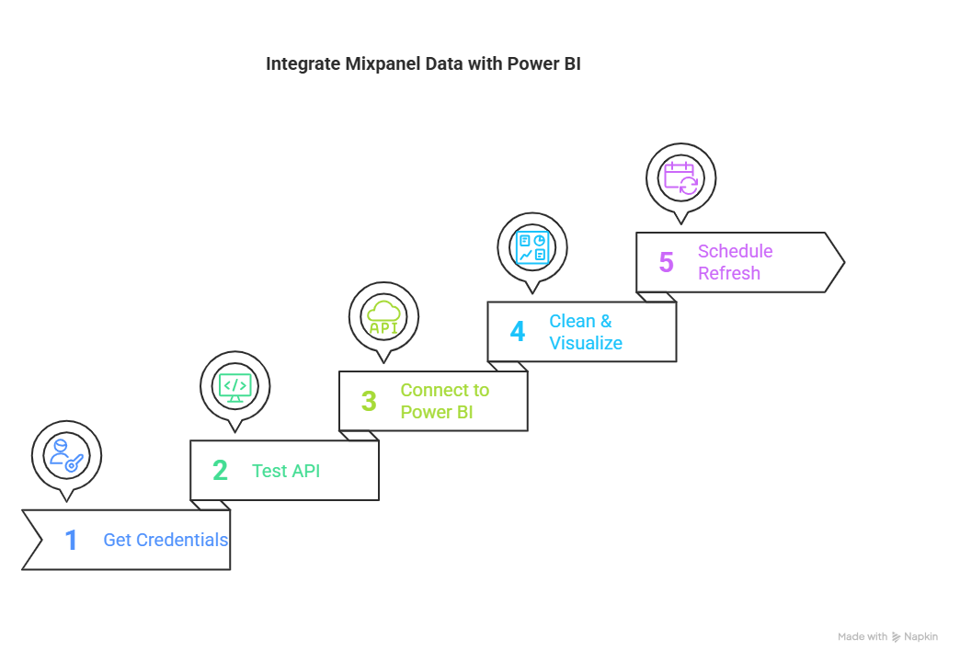

Step 4: Visualizing in Power BI
Objective: Create interactive dashboards to monitor campaign performance.
Connection: This step leverages the extracted data (Step 3) to deliver actionable insights, completing the pipeline.
- Action 4.1: Load Data into Power BI
  - Open Power BI Desktop, select “Get Data → Python Script,” and run the Python ETL script from Step 3.
  - Load the resulting dataset (merged_df) into Power BI.
  - Responsibility: Data analyst to import data; estimated time: 1-2 days.
  - Outcome: Mixpanel data is available in Power BI for visualization.
- Action 4.2: Build Visuals
  - Create dashboards for:
    - Impressions vs. Clicks vs. Conversions
    - CPA (Cost Per Acquisition)
    - ROAS (Return on Ad Spend)
    - Campaign-wise Performance Comparison
    - Conversion Funnel (Ad Click → Visit → Conversion → Deal Closed)
  - Example Visuals: Bar charts for campaign performance, funnel charts for user journeys, and line graphs for trends.
  - Responsibility: Data analyst to design dashboards; estimated time: 5-7 days.
  - Outcome: Interactive dashboards provide real-time insights into campaign performance.

Step 5: Automation for Continuous Insights
Objective: Automate data refresh to ensure dashboards remain current.
Connection: Automation ensures the pipeline (Steps 1-4) delivers ongoing value without manual intervention.
- Action 5.1: Set Up Scheduled Refresh
  - Publish the Power BI report to Power BI Service.
  - Configure a Power BI Gateway to run the Python ETL script on a server.
  - Schedule daily/weekly refreshes in Power BI Service under “Dataset Settings.”
  - Alternative: Store Python output as CSV in OneDrive/SharePoint and enable auto-refresh.
  - Responsibility: Data engineering team to set up automation; estimated time: 3-5 days.
  - Outcome: Dashboards are updated automatically, providing fresh insights.
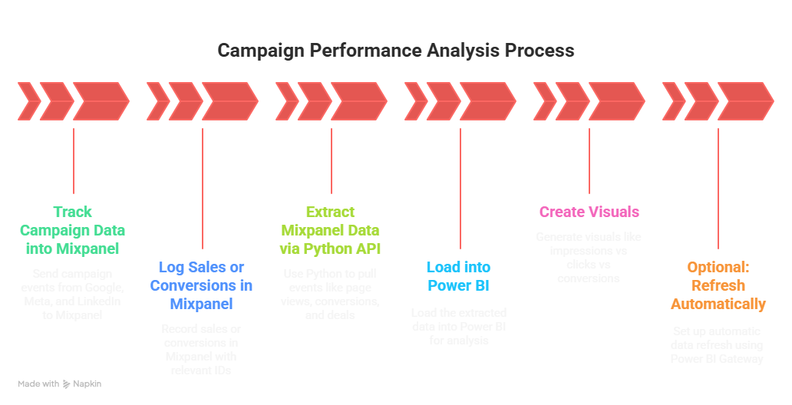

Timeline and Resource Requirements
Step | Estimated Time | Responsible Team
1. UTM Tracking | 4-7 days | Marketing, Web Dev
2. Conversion Tracking | 2-3 days | Web Dev
3. Python ETL | 5-7 days | Data Analyst/Engineer
4. Power BI Visualization | 6-9 days | Data Analyst
5. Automation | 3-5 days | Data Engineer
6. Ongoing maintenance | 5–10 hours/month
Total | 20-31 days

Resources Needed:
- Mixpanel account (existing or new subscription)
- Power BI Pro/Premium license for automation
- Python environment (existing or cloud-based server)
- Developer/data analyst hours (est. 80-120 hours total)

Benefits
- Improved Decision-Making: Granular insights into campaign performance enable targeted optimizations.
- Cost Efficiency: Lower CPA by identifying high-performing campaigns and creatives.
- Revenue Growth: Maximize ROAS by focusing on high-value channels.
- Scalability: The pipeline supports additional platforms and metrics as campaigns grow.
- Automation: Reduces manual reporting, freeing up team resources.

Risks and Mitigation
- Risk: Incorrect UTM implementation leads to missing data.
Mitigation: Conduct a pilot test on one campaign and validate data in Mixpanel.
- Risk: API rate limits or data volume issues.
Mitigation: Use Mixpanel’s Service Account Key and optimize queries for efficiency.
- Risk: Power BI refresh failures.
Mitigation: Set up error alerts and maintain backup CSV exports.

Budget Considerations
- Mixpanel: Subscription costs (if not already in use); check pricing at mixpanel.com.
- Power BI: Pro license (~$10/user/month) or Premium for larger teams.
- Development: Internal team hours or external contractor costs (est. $5,000-$10,000 for setup).
- Maintenance: Minimal ongoing costs for server hosting and analyst time.

Conclusion and Next Steps
This proposed pipeline will transform our campaign performance analysis, providing clear visibility into ad effectiveness and sales outcomes. By implementing UTM tracking, Mixpanel event logging, Python ETL, Power BI visualization, and automation, we can optimize marketing spend and drive revenue growth.
Sincerely,
Mukesh

