ANALYTICS REPORT & INSIGHTS DOCUMENTATION
Stakeholder Retail Performance Analytics Case Study
Prepared by Pranjal Patil
2026

1. Executive Summary
This report presents a stakeholder-oriented analysis of retail performance using a synthetic dataset of 900 orders. The business objective is to improve profitable revenue while protecting customer experience. The analysis examines revenue trends, regional contribution, category profitability, sales-channel performance, customer satisfaction, and return rates. The overall dataset generated revenue of 249,596.14, profit of 85,900.93, and an overall profit margin of 34.4%. Average order value was 277.33, while the overall return rate was 8.8% and average satisfaction was 3.92/5. The report converts these metrics into management-oriented findings and recommendations rather than presenting raw charts alone.

2. Business Objective & Stakeholders
Primary objective: improve profitable growth while maintaining customer satisfaction and controlling returns.
- Executive leadership — overall performance and strategic priorities
- Sales managers — regional and channel performance
- Category managers — revenue, margin, and return behavior
- Customer-experience teams — satisfaction and returns

3. KPI Framework
KPI | Result
Total Revenue | 249,596.14
Total Profit | 85,900.93
Profit Margin | 34.4%
Orders | 900
Average Order Value | 277.33
Return Rate | 8.8%
Average Satisfaction | 3.92/5

4. Data Quality & Methodology
The analysis checks missing values, duplicate rows, and logical constraints before aggregation. Revenue, profit, discount, and satisfaction values are validated against expected ranges. The dataset is synthetic and designed for educational reporting; it does not contain real customer records.

5. Revenue Trend
Monthly aggregation is used to identify changes in revenue, profit, and order volume over time. Management should monitor both revenue and margin because revenue growth without profitable economics can produce misleading performance signals.
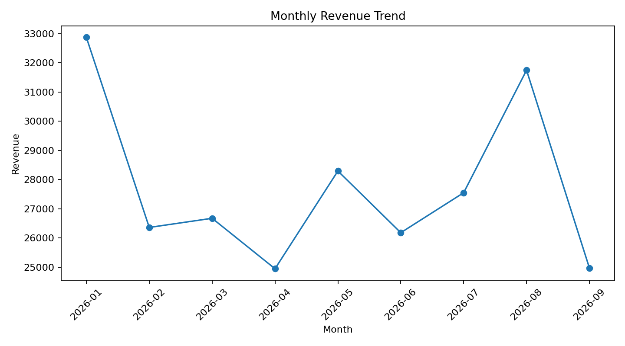
Figure 1. Monthly revenue trend.

6. Regional Performance
The West region is the largest revenue contributor in this dataset. Regional reporting should compare revenue, profit, satisfaction, and returns together so that high sales do not hide customer-experience or margin issues.
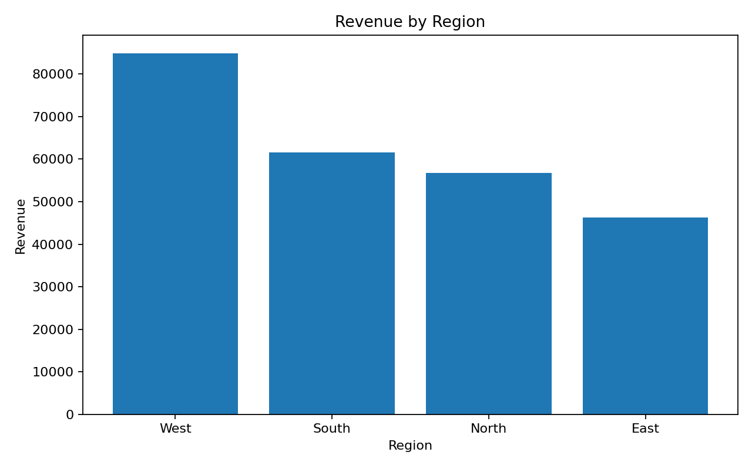
Figure 2. Revenue by region.

7. Category Performance
Electronics is the leading category by revenue, while Electronics is the leading category by total profit. This illustrates why category decisions should consider profit as well as revenue.
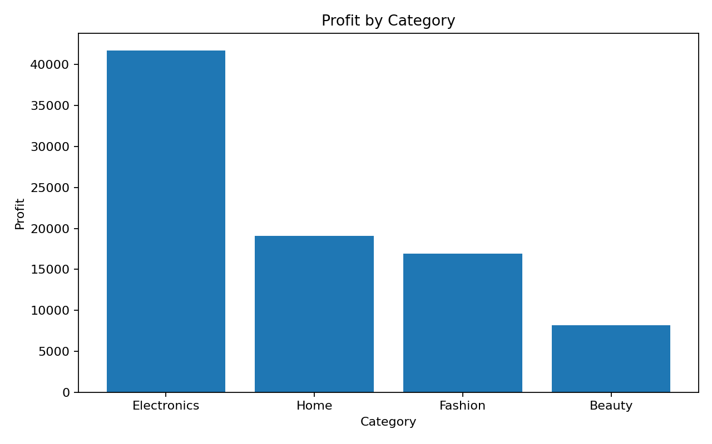
Figure 3. Profit by category.

8. Channel Performance
Online generates the higher total revenue in this dataset. However, channel decisions should also consider returns and satisfaction rather than optimizing revenue alone.
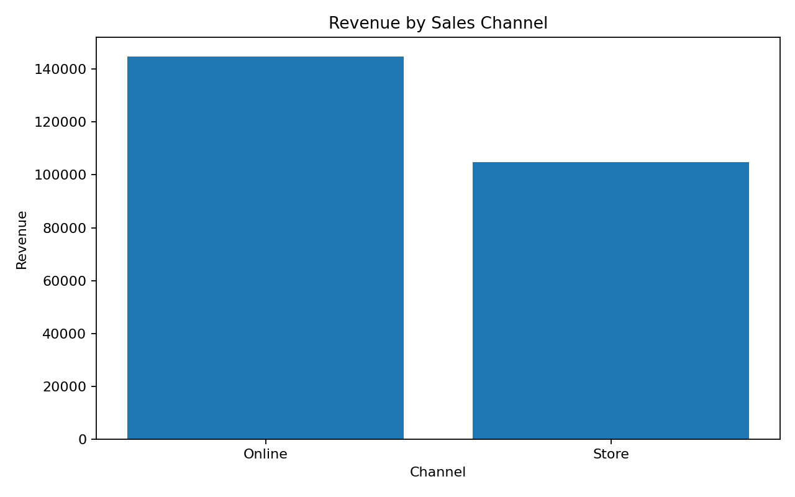
Figure 4. Revenue by sales channel.

9. Key Findings & Business Impact
- Revenue should be tracked as a monthly trend rather than evaluated only as a cumulative total.
- Regional contribution is uneven, creating opportunities for targeted investment and performance management.
- Revenue and profit rankings can differ because category economics and margins differ.
- Channel performance should be evaluated using revenue, profitability, returns, and satisfaction together.
- Return rate provides an operational early-warning signal for product, fulfillment, sizing/fit, or expectation issues.
- Customer satisfaction should remain a core KPI alongside commercial performance.

10. Actionable Recommendations
- Priority 1 — Protect profitable growth
Direct additional sales effort toward high-profit regions/categories, not simply the highest-revenue segments.
- Priority 2 — Investigate returns
Review return reasons, product quality, descriptions, sizing/fit information, fulfillment, and channel-specific issues in high-return segments.
- Priority 3 — Optimize channels
Compare online and store performance using revenue, margin, return rate, and satisfaction together.
- Priority 4 — Establish recurring KPI reporting
Refresh revenue, profit margin, orders, AOV, returns, and satisfaction monthly with region/category/channel drill-downs.
- Priority 5 — Assign ownership
Give each underperforming KPI or segment an owner, deadline, target, and follow-up review.

11. Executive Summary for Stakeholders
Management should focus on profitable growth rather than revenue volume alone. The strongest opportunities come from understanding which regions and categories create sustainable profit, while simultaneously controlling returns and maintaining customer satisfaction. A recurring KPI dashboard should provide a consistent monthly view and enable drill-down from company-level performance to region, category, and channel.

12. Recommended Next Steps
- Validate these findings against actual financial and operational systems.
- Add inventory, marketing-spend, fulfillment-time, and return-reason data.
- Define target ranges for margin, return rate, satisfaction, and AOV.
- Build a recurring dashboard with monthly refresh and stakeholder ownership.
- Review recommendation impact after the next reporting cycle.

13. Limitations
The dataset is synthetic, so numerical results are illustrative rather than representative of an actual company. The analysis is descriptive and does not establish causal relationships. Production decisions should be validated using real financial, inventory, customer-service, and operational data.

14. Conclusion
This project demonstrates a professional analytics workflow: define the business problem, establish KPIs, validate data, identify findings, communicate them visually, interpret business impact, and convert evidence into prioritized actions. The central reporting principle is that every important chart should answer a stakeholder question and lead to a measurable next step.

