DATA SCIENCE TOOL MASTERY PROJECT
Industry-Standard Tools, Practical Exercises & Portfolio Workflow
Prepared by Pranjal Patil
2026

1. Executive Summary
This project demonstrates practical proficiency with key data-science tools by using each technology for a concrete exercise rather than only documenting its syntax. It covers Python and Jupyter, NumPy, Pandas, Matplotlib, Seaborn, SciPy, SQL/SQLite, and scikit-learn. The final workflow combines data cleaning, feature engineering, visualization, statistical testing, SQL querying, machine-learning preprocessing, classification, and evaluation into one reproducible customer-churn analysis. A synthetic dataset is used so that no real customer information is exposed.

2. Objectives
The objectives are to master industry-standard tools relevant to data science, demonstrate proficiency through practical exercises, create portfolio pieces, and document reproducible workflows.

3. Dataset and Context
A synthetic customer dataset was generated for practice. It contains age, monthly spending, tenure, support-ticket counts, satisfaction, plan, region, and a binary churn label. Missing values and duplicate rows were introduced deliberately to provide realistic cleaning exercises. No real customer records or personally identifiable information are included.

4. NumPy
NumPy was used for reproducible random generation, mean, median, standard deviation, percentiles, boolean filtering, and vectorized logarithmic transformation.

5. Pandas
Pandas was used for CSV loading, inspection, descriptive statistics, missing-value analysis, duplicate detection, median imputation, feature engineering, GroupBy aggregation, and pivot tables.

6. Matplotlib and Seaborn
Matplotlib was used for histograms and bar charts. Seaborn was used for box plots, scatter plots, and correlation heatmaps.

7. SciPy Statistical Testing
SciPy was used for Welch’s independent two-sample t-test comparing satisfaction between churned and retained customers at a 0.05 significance level.

8. SQL / SQLite
An in-memory SQLite database was created from the cleaned Pandas table. SQL demonstrates SELECT, COUNT, AVG, ROUND, GROUP BY, and ORDER BY operations.

9. scikit-learn Machine Learning
A baseline Logistic Regression classifier was built using a Pipeline and ColumnTransformer with train/test splitting, imputation, scaling, one-hot encoding, and evaluation using accuracy, precision, recall, F1-score, ROC-AUC, and a confusion matrix.

10. Integrated Portfolio Workflow
The workflow is data loading → cleaning → feature engineering → visualization → statistical test → SQL aggregation → machine-learning pipeline → evaluation → interpretation.

11. Best Practices
The project demonstrates fixed random seeds, meaningful names, documented transformations, pipeline-based preprocessing, avoidance of data leakage, multiple evaluation metrics, explicit statistical hypotheses, clear limitations, synthetic data usage, and dependency documentation.

12. Career Relevance
The skills are relevant to Data Analyst, Data Scientist, Data Engineer, and machine-learning internship roles. Pandas and SQL support data extraction and transformation; visualization and SciPy support analytical communication and statistical reasoning; scikit-learn provides a foundation for machine-learning workflows.

13. Limitations
The dataset is synthetic, so its behavior is not representative of real customers. The classifier is a baseline educational model rather than a production system. Production work would require cross-validation, tuning, explainability, threshold optimization, monitoring, privacy, governance, and drift analysis.

14. Conclusion
This project demonstrates tool mastery through practical integration. Each library is assigned a meaningful analytical task, and the final workflow connects numerical computing, tabular analysis, visualization, statistics, SQL, and machine learning into a reproducible portfolio piece.

15. Representative Outputs
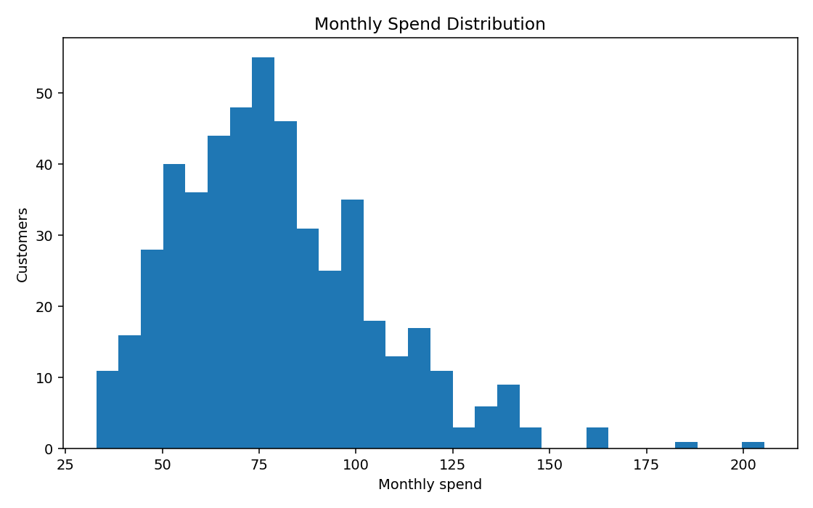
Monthly customer-spend distribution.
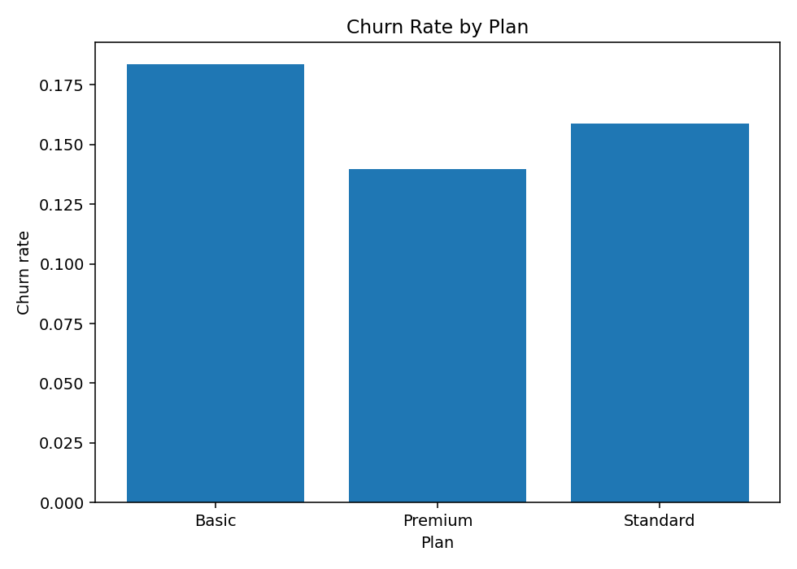
Churn rate by subscription plan.

16. Submission Files
- Data_Science_Tool_Mastery_Project.ipynb
- README.md
- requirements.txt
- data/customer_churn_practice.csv
- reports/REPORT_DESCRIPTION.md
- outputs/

