REAL-WORLD DATASET ANALYSIS PROJECT
Diabetes Progression Dataset — Exploratory Data Analysis
Prepared by Pranjal Patil
Data Science / AI & Data Science Project
2026

1. Executive Summary
This project performs a complete exploratory analysis of the real-world Diabetes dataset distributed through scikit-learn. The dataset contains 442 observations and 11 analytical columns, consisting of ten baseline numerical predictors and a continuous target representing disease progression one year after baseline. The project follows a structured data-science workflow: understanding the dataset and analytical context, inspecting data quality, cleaning and preprocessing, screening for potential outliers, performing exploratory data analysis, creating visualizations, studying correlations, and communicating findings and limitations. The analysis identifies the variables with the strongest linear associations with the target and uses BMI quartiles to demonstrate a practical group-level comparison. The project is educational and demonstrates responsible analytical interpretation rather than clinical prediction or diagnosis.

2. Project Objectives
- Select and understand a reliable real-world dataset and its analytical context.
- Explore structure, data types, distributions, missing values, duplicate records, and relationships.
- Clean and preprocess the dataset using documented, appropriate techniques.
- Perform exploratory data analysis using Pandas, NumPy, and statistical methods.
- Create meaningful visualizations including histograms, box plots, scatter plots, and bar charts.
- Present findings, interpretations, limitations, and practical recommendations in a reproducible report.

3. Dataset Selection and Context
The selected dataset is the Diabetes dataset available through scikit-learn's load_diabetes() function. It is a well-known real-world dataset used for regression and machine-learning experimentation. The data contains ten baseline variables: age, sex, body mass index (BMI), average blood pressure, and six blood-serum measurements. The target is a quantitative measure of disease progression one year after baseline.
Analytical objective: understand the structure and quality of the data, identify patterns and relationships among variables, determine which predictors have stronger linear associations with the target, and communicate descriptive findings that can support a later modeling stage.
Responsible-use note: the target is not interpreted as a clinical diagnosis. The analysis is an educational demonstration of data-science methods and does not provide medical advice.

4. Dataset Overview
Metric | Result
Rows | 442
Columns | 11
Predictor variables | 10
Target variable | target
Missing values | 0
Duplicate rows | 0
Data type | Numerical / continuous measurements
Primary tools | Python, Pandas, NumPy, Matplotlib, scikit-learn

5. Data Exploration and Quality Assessment
The first stage inspected dimensions, column names, data types, descriptive statistics, and sample records. This established that the analytical columns are numerical and suitable for statistical exploration. Missing-value counts and duplicate records were then checked explicitly.
The packaged dataset contains 0 missing values and 0 duplicate rows. Because the source dataset is already curated for machine-learning experimentation, no major structural data-quality problem was identified.

6. Cleaning and Preprocessing
- Missing values were checked before analysis. A documented median-imputation fallback was included in the notebook for numerical missing values, although the source data does not require it.
- Duplicate records were assessed and only accidental duplicates would be removed.
- Numerical data types were verified before statistical analysis.
- Potential outliers were screened using the 1.5 × IQR rule.
- IQR flags were treated as investigation indicators rather than automatic deletion criteria.
This approach is important because real-world outliers can represent genuine observations rather than data errors. Removing them without investigation can bias results.

7. Exploratory Data Analysis

7.1 Distribution Analysis
Histograms were used to examine the spread and concentration of each variable. The standardized predictors are centered and scaled, while the target is on a different numerical scale. Distribution plots help identify skewness, concentration, and unusual observations before modeling.

7.2 Box Plot Analysis
Box plots summarize median, interquartile range, and potential extreme observations. They complement the IQR calculations and provide a compact visual quality check.

7.3 Feature–Target Relationships
Correlation analysis showed that BMI had the strongest absolute Pearson correlation with the target among the predictors (approximately 0.586). Other variables also showed meaningful associations, indicating that the target is not explained equally by every feature.
BMI showed a positive Pearson correlation with the target of approximately 0.586, while average blood pressure showed a correlation of approximately 0.441. The S5 serum measurement also showed a relatively strong association of approximately 0.566. These are associations and should not be interpreted as proof of causation.

8. Visualizations
The project includes the following visualizations:
- Histograms for the numerical variables
- Box plots for distribution and outlier screening
- Scatter plots for BMI, blood pressure, S5, and age versus the target
- Correlation matrix
- Bar chart comparing average target values across BMI quartiles
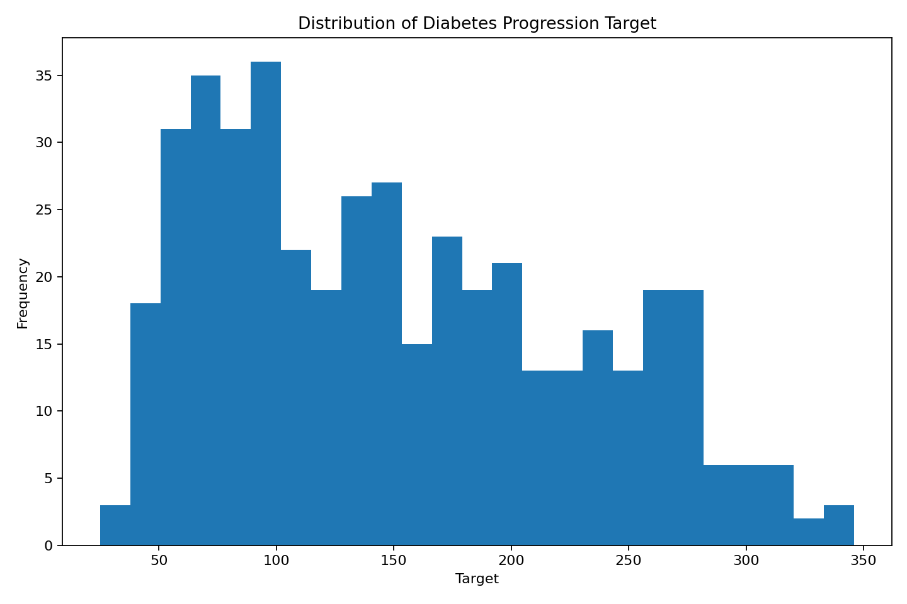
Figure 1. Distribution of the target variable.
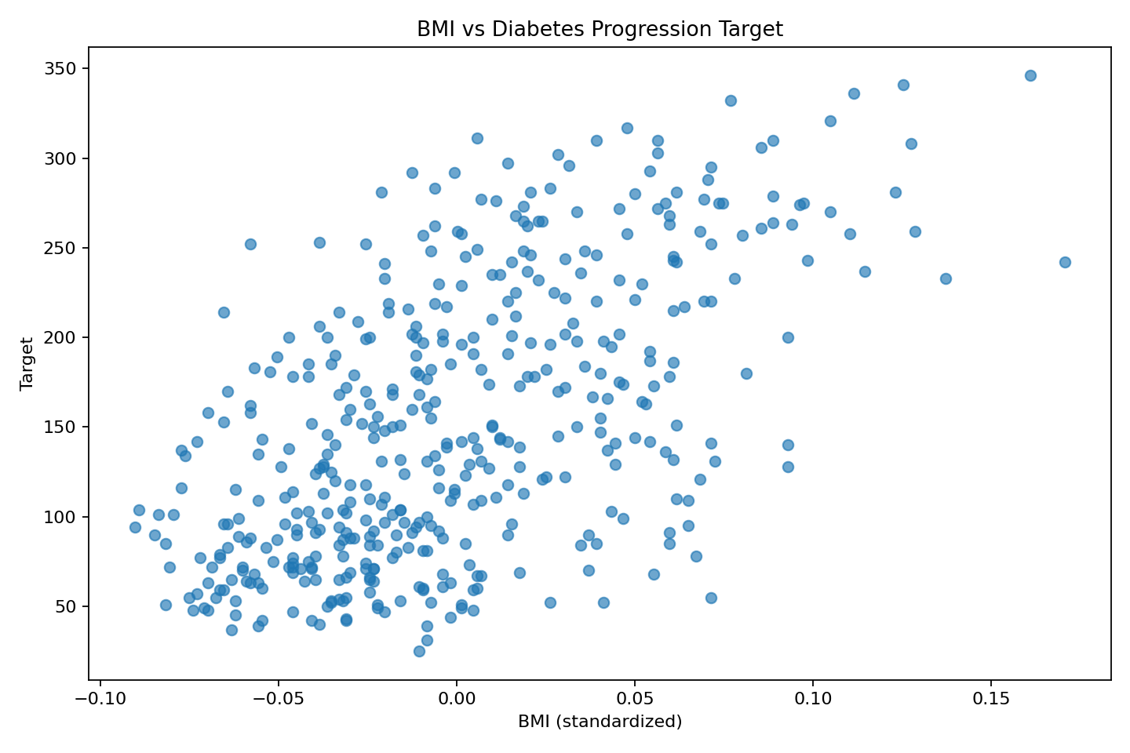
Figure 2. Relationship between standardized BMI and the target.
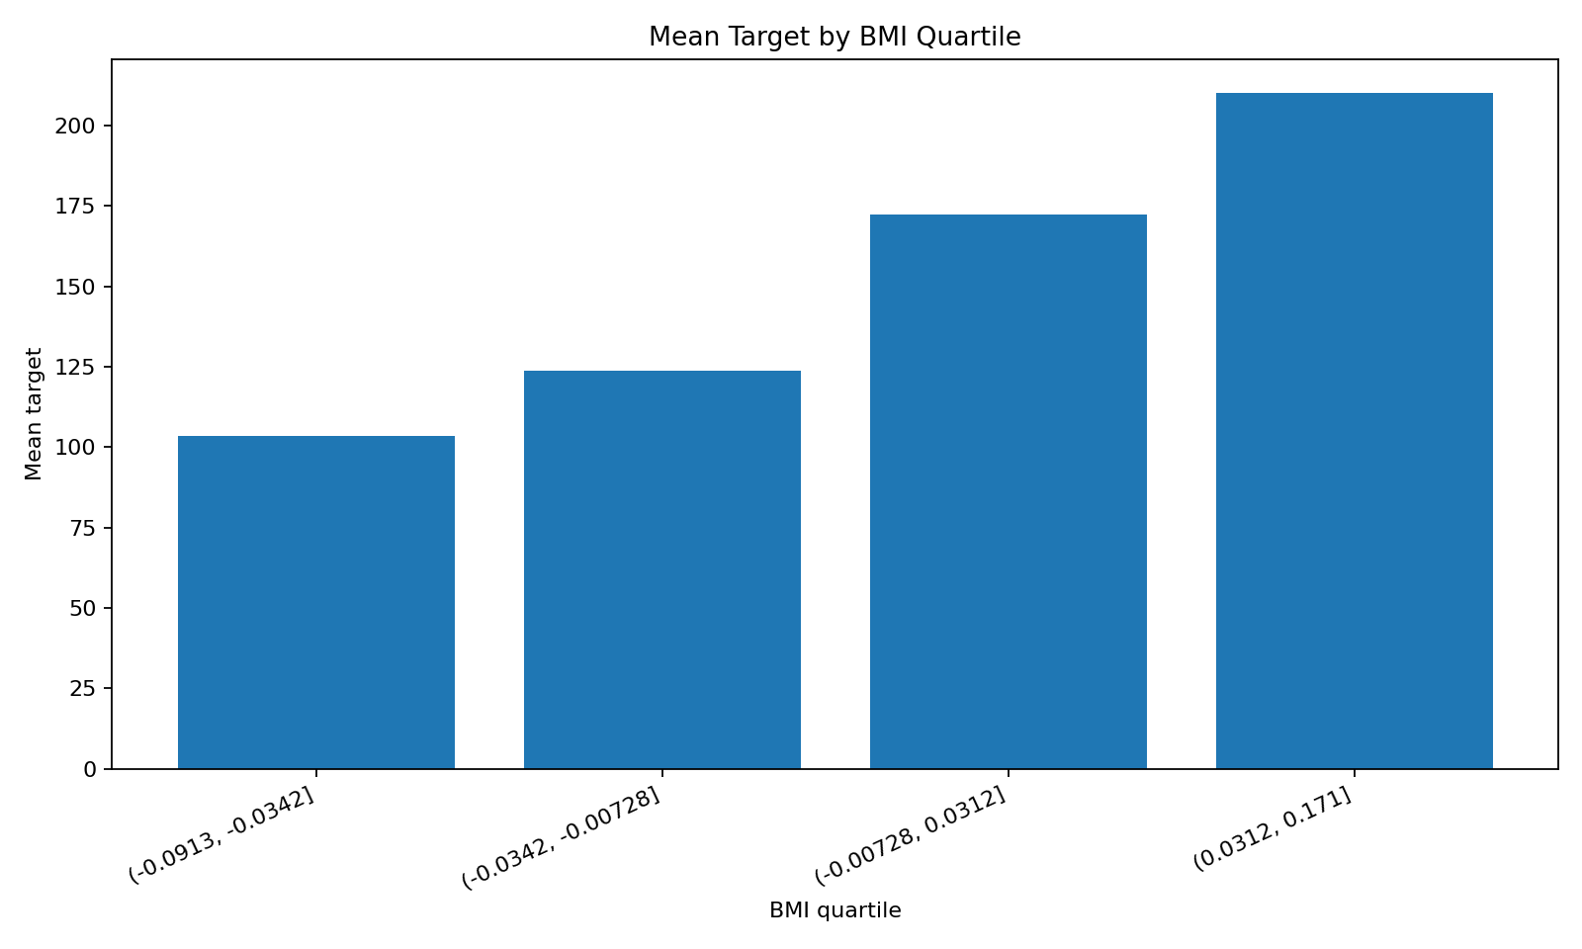
Figure 3. Mean target by BMI quartile.

9. Key Findings
- The dataset contains 442 observations and 11 analytical columns, with ten predictors and one continuous target.
- The source dataset is clean from a basic missing-value and duplicate-record perspective.
- All analytical variables are numerical and already standardized in the packaged source representation.
- BMI has the strongest absolute linear correlation with the target among the predictors (about 0.586).
- BMI has a positive association with the target (about 0.586), and BMI quartile analysis provides an intuitive descriptive comparison.
- Potential outliers are present in some variables under the IQR screening rule, but they should be investigated rather than automatically removed.
- Correlation analysis identifies association and does not establish causation.

10. Recommendations
- Use the strongest candidate predictors to build a baseline regression model.
- Compare ordinary linear regression with regularized approaches such as Ridge and Lasso.
- Use train/test splits or cross-validation for model evaluation.
- Investigate flagged observations using domain context before transforming or excluding them.
- Document preprocessing, feature definitions, and assumptions so the workflow can be reproduced.
- Avoid using this educational analysis as a clinical decision-making or diagnostic system.

11. Limitations
- The analysis is descriptive and exploratory; it does not establish causal relationships.
- The dataset is relatively small compared with many production datasets.
- The predictors are standardized, so their numerical values do not directly represent original physical units.
- The analysis does not include external clinical or demographic context beyond the provided variables.
- No predictive model was trained as part of this assessment; the focus is dataset analysis and communication.

12. Tools and Technologies
Python, Jupyter Notebook, Pandas, NumPy, Matplotlib, and scikit-learn.

13. Reproducibility and Best Practices
- Dependencies are documented in requirements.txt.
- The notebook follows a clear sequence from loading and inspection to preprocessing, EDA, visualization, and interpretation.
- Meaningful variable names and explanatory markdown are used throughout.
- The source dataset is documented and a local CSV copy is included in the repository.
- Data-quality decisions are explicitly described rather than hidden inside transformations.
- Interpretations distinguish correlation from causation and state project limitations.

14. Submission Files
- Real_World_Dataset_Analysis_Project.ipynb — complete Jupyter Notebook
- README.md — GitHub project documentation
- requirements.txt — Python dependencies
- data/diabetes_dataset.csv — local dataset copy
- reports/REPORT_DESCRIPTION.md — 200+ word submission description
- outputs/ — generated analysis figures

15. Conclusion
This project demonstrates a complete real-world data-analysis workflow from dataset selection through interpretation. The analysis shows why reliable data science requires more than generating charts: the analyst must understand the dataset, verify data quality, document preprocessing decisions, select appropriate statistical methods, communicate relationships carefully, and state limitations. The result is a reproducible foundation that can be extended into predictive modeling, feature engineering, and more advanced statistical analysis.

