`

Performance Test Run Report

Local Cache Testing
by
disable search rule

Version | Date | Author(s) | Recipients
1.0 | 12-11-2021 | Pravin Patil | Performance Team

Name | Author | Reference | Version | Date
One Test Report Metrics | Pravin Patil | One Test tool | 10.1 | 12-11-2021
Grafana dashboard Metrics | Pravin Patil | Grafana | 8.1 | 12-11-2021

ASSOCIATED DOCUMENTS

Contents

1.Test Run Objective 4

2.Test Configuration 4

3. Executive Summary 5

4. Conclusion 12

1.Test Run Objective
- Disable the Search rule and execute the baseline test
- Apply the cachespec.xml (for local only) in query app
- Execute the test and compare the redis as well as overall performance

2.Test Configuration

Tests# | Users | Duration | Scenario Executed | Test Window (EST)
Test1  (Baseline) | 100 | 1 hour | Registered shopper and search term | 2021-11-09 18:04:00  To  2021-11-09 19:10:59
Test2  (Cachespec Local only) | 100 | 1 hour | Registered shopper and search term | 2021-11-10 17:27:00  To  2021-11-10 18:35:59

During the both test 3 query app pods have been used.

3. Executive Summary

- Looking at the avg response time from one test report , test with cachespec has improved response time.

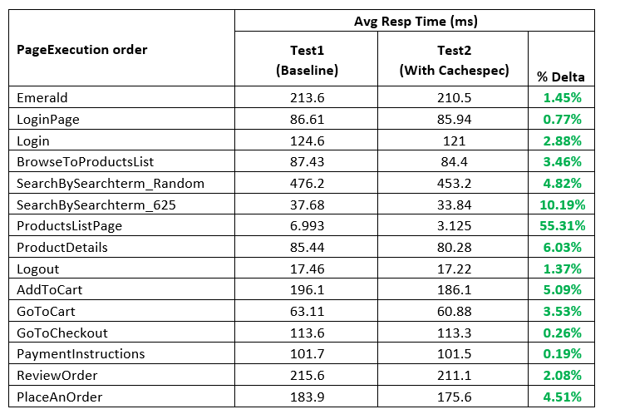

- Looking at the rest call resp time from grafana it has been observed that test with cachespec has been improved.

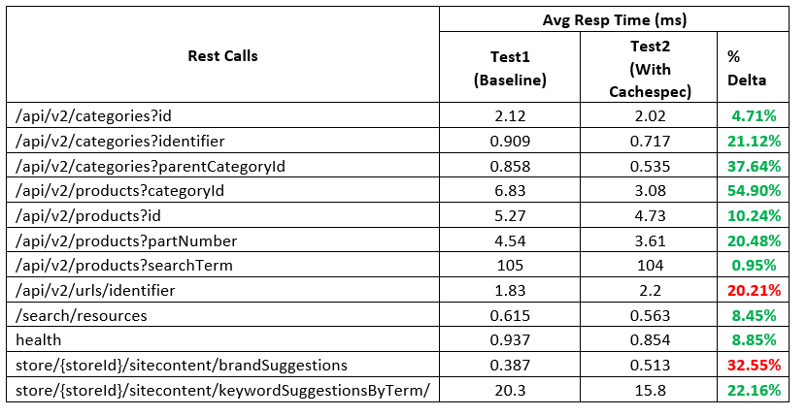

- Overall Total avg Response time comparison

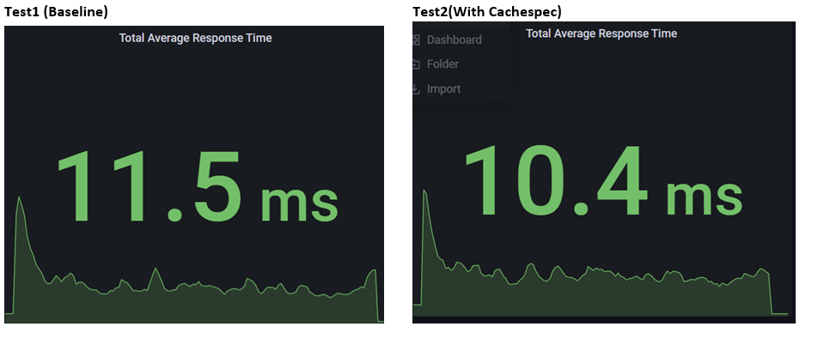

- Redis memory for the both the tests
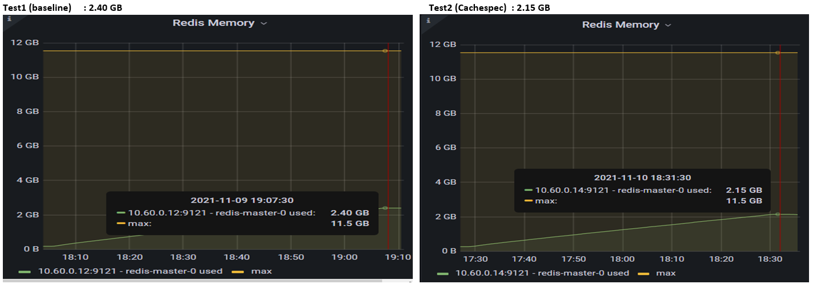
- Redis Operations per second dropped in test2 in comparison with test1
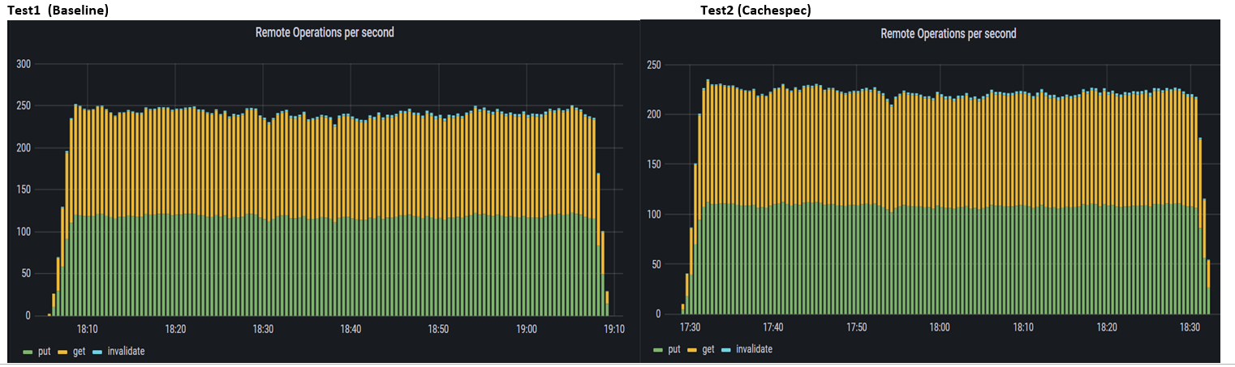
- Redis remote cache gets per second
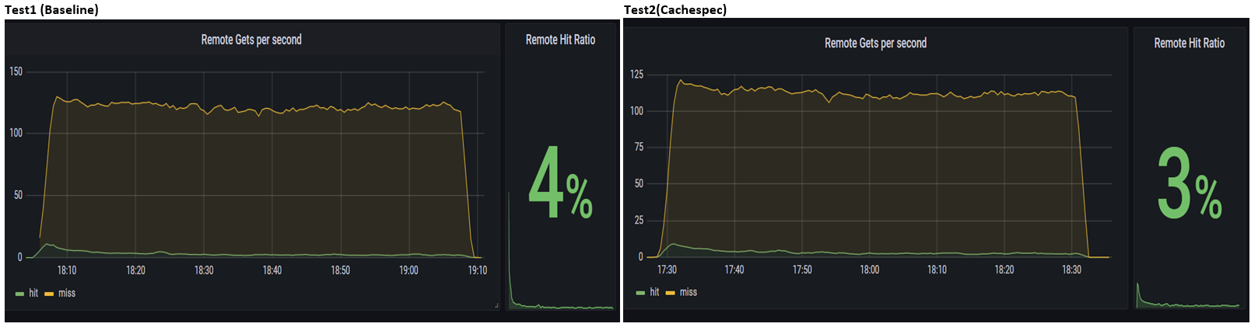

- Redis Commands Executed / sec
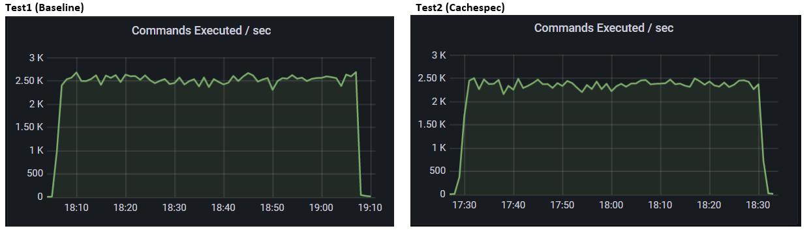
- There is not much difference between redis cahe hit / misses
Tes1(Baseline) Test2(with cachespec)
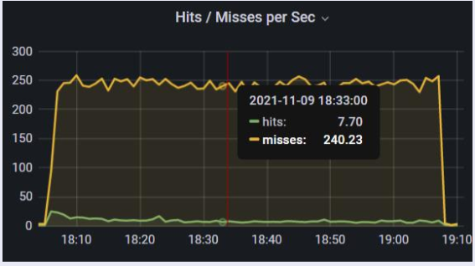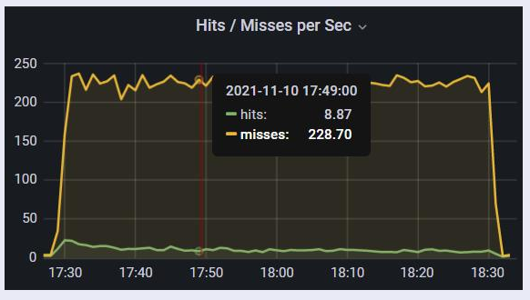
- However, significant difference has been observed in remote base cache
Test1(Baseline) Test2(With Cachespec)
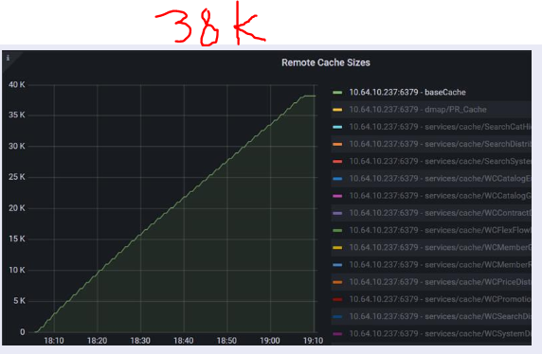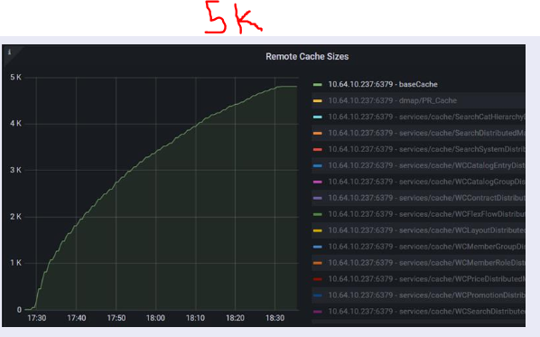
- Remote base cache operation per second
Test1(Baseline)
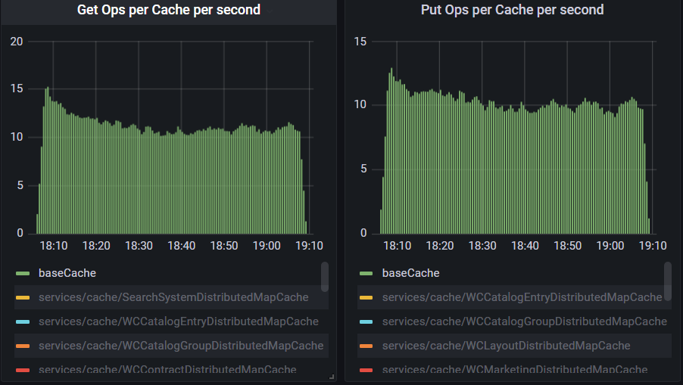

Test2(With Cachespec)

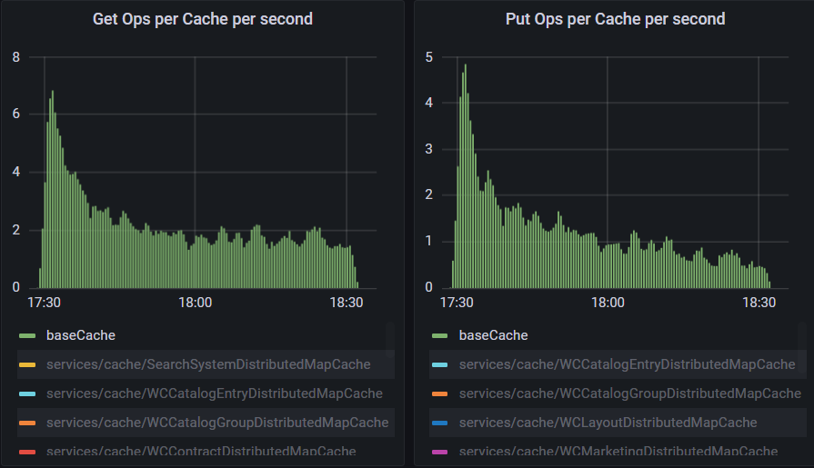

- Local cache hit/ miss for base cache looks identical
Test1 (Baseline)
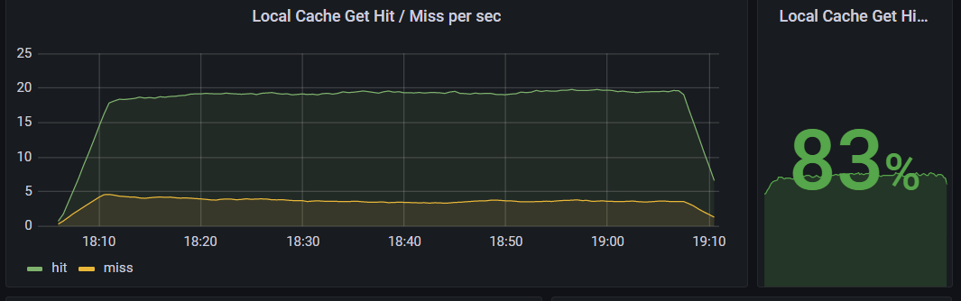

Test2(With Cachespec)

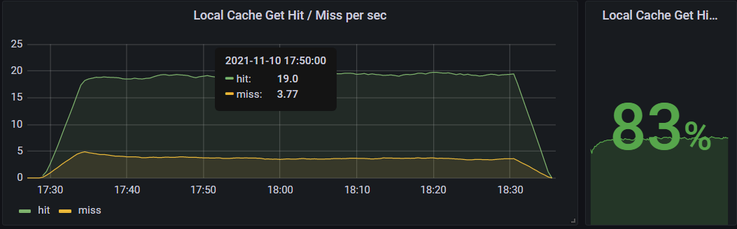

- Please see the grafana dasboard for more details

Dashboard Name | URL
HCL-Local-Cache | http://localhost:12001/d/Zv01rGZnz/hcl-cache-local-cache-details?orgId=1&var-namespace=commerce&var-job=demoqalivequery-app&var-pod=demoqalivequery-app-76bb8888cd-clfp6&var-cache=baseCache&from=1636461240000&to=1636465259000&refresh=10s
HCL-Local-Cache | http://localhost:12001/d/Zv01rGZnz/hcl-cache-local-cache-details?orgId=1&var-namespace=commerce&var-job=demoqalivequery-app&var-pod=demoqalivequery-app-65757bbc9d-nxz92&var-cache=baseCache&from=1636545420000&to=1636549559000
HCL-Cache-Remote | http://localhost:12001/d/EcI-rGZ7z/hcl-cache-remote?orgId=1&from=1636461240000&to=1636465259000&var-namespace=commerce&var-environment=demoqalive&var-job=All&var-pod=All&var-cache=All&var-redis=All
HCL-Cache-Remote | http://localhost:12001/d/EcI-rGZ7z/hcl-cache-remote?orgId=1&from=1636545420000&to=1636549559000&var-namespace=commerce&var-environment=demoqalive&var-job=All&var-pod=All&var-cache=All&var-redis=All
Redis Dashboard | http://localhost:12001/d/MUiTnkFnz/redis-dashboard-for-prometheus-redis-exporter-helm-stable-redis-ha?orgId=1&from=1636461240000&to=1636465259000
Redis Dashboard | http://localhost:12001/d/MUiTnkFnz/redis-dashboard-for-prometheus-redis-exporter-helm-stable-redis-ha?orgId=1&from=1636545420000&to=1636549439000

4. Conclusion

- Looking at the average response time from one test report and grafana rest calls, it concludes that test with cachespec performance has been improved for all the business transactions

- In terms of redis performance, slight drop has been observed in redis memory and remote operations / second during test2 (with cachespec).

- If we compare the remote as well as local cache hit /misses there in not much significant difference between both the tests, having said that , there is huge drop for baseCache put and get opertion per seconds.

- Looking at the overall performance test results we can infer that test with cachespec has improved the performance.

