1. Creating a VPC:
2. Create a new VPC.

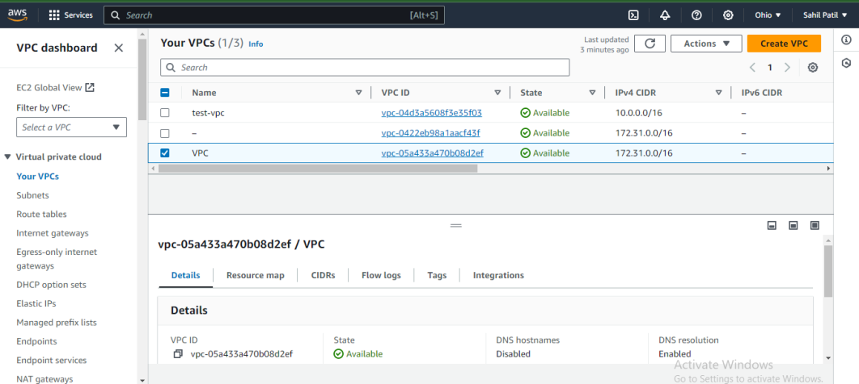

1. Create two private subnet for above VPC

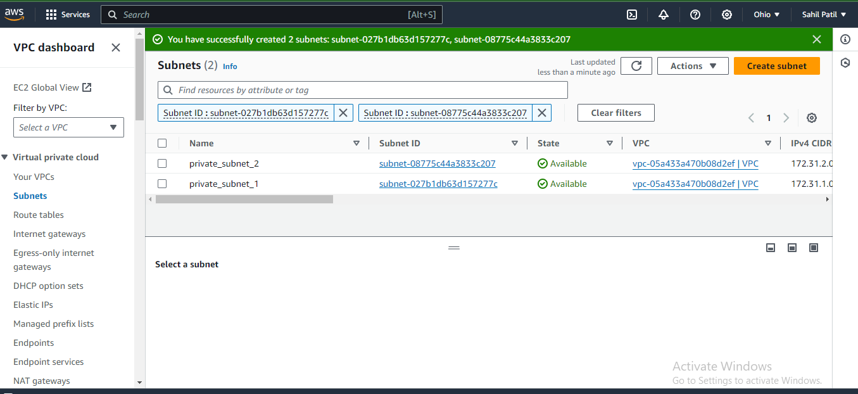

1. Once the subnets are created, create an internet gateway and attach newly created VPC to same.

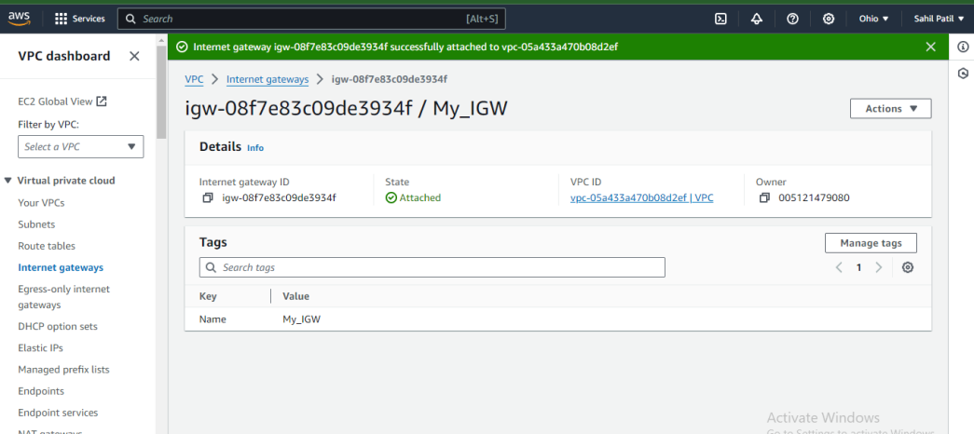

1. Now, we need to configure the Network ACL settings to control inbound and outbound traffic.

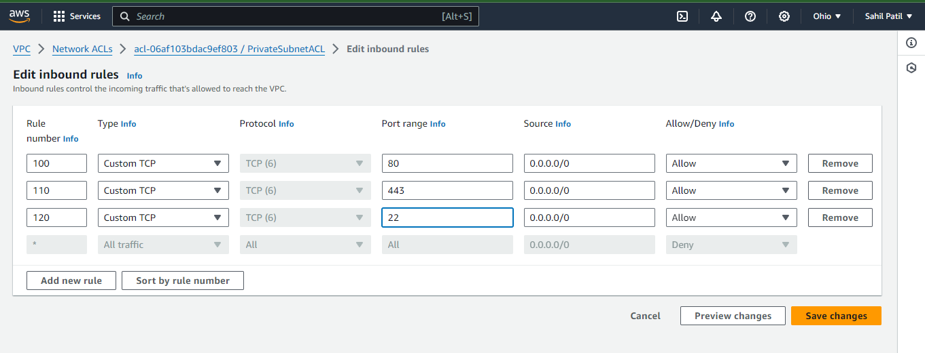

f. Configure security group settings.

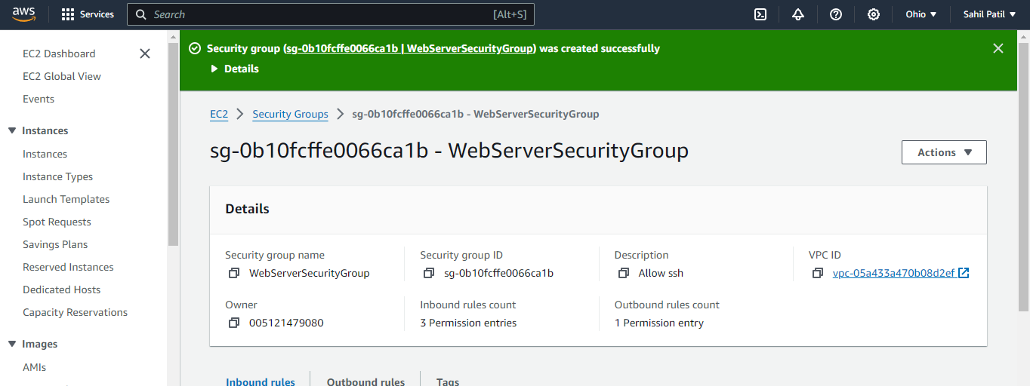

g. Now as we have to create total 3 instances for web application,database and jump server respectively. Jump server is required as web server and db server will be created under private subnet.

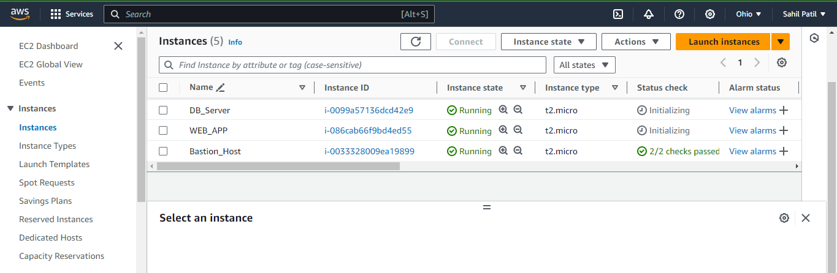

G . Now connect the web application using Jump server. Once connected, clone the github repo and install docker.  
 Once docker is installed, build an docker image and run an docker container containing flaskapp

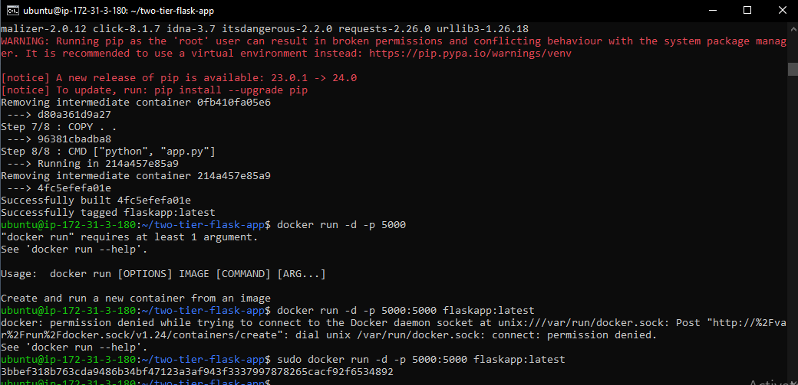

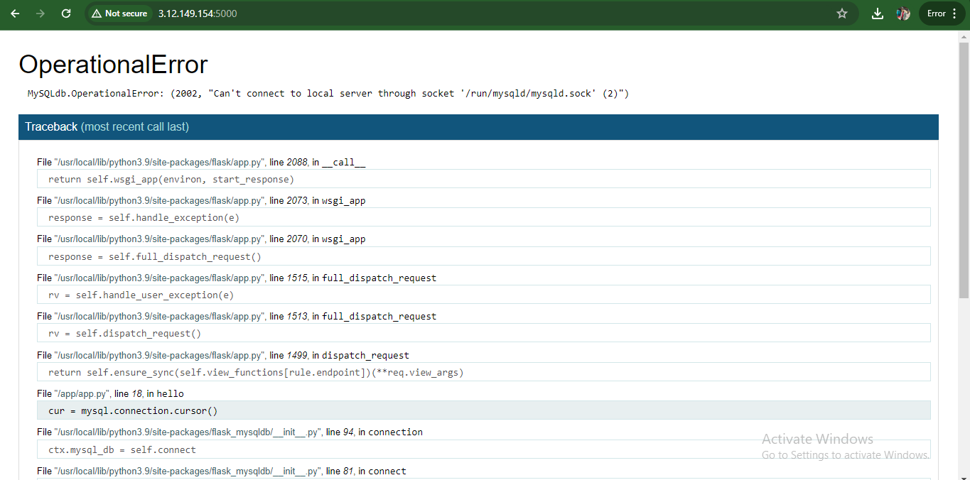

**Now our application is running but it is not able to connect database as we haven’t configured it yet.  
  
To connect to database server, we need to do the SSH tunneling through Jump server.**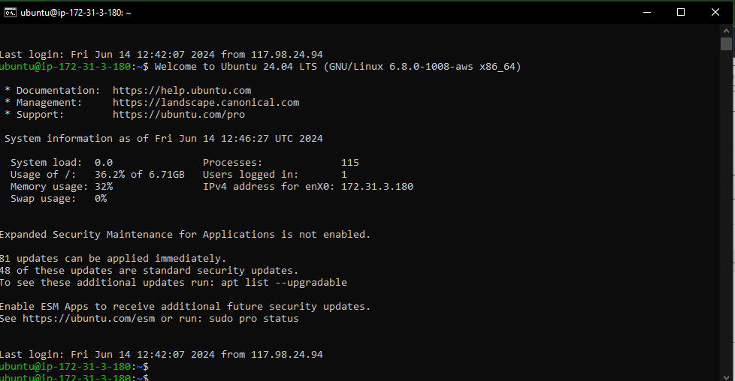

**Now we are able to connect both Web application instance and database server to boiston host and our web app is running.   
  
Now we need to set up database configuration. Steps are as follows:**1. We will use docker compose to connect database with web application. For that we need to first download docker compose.

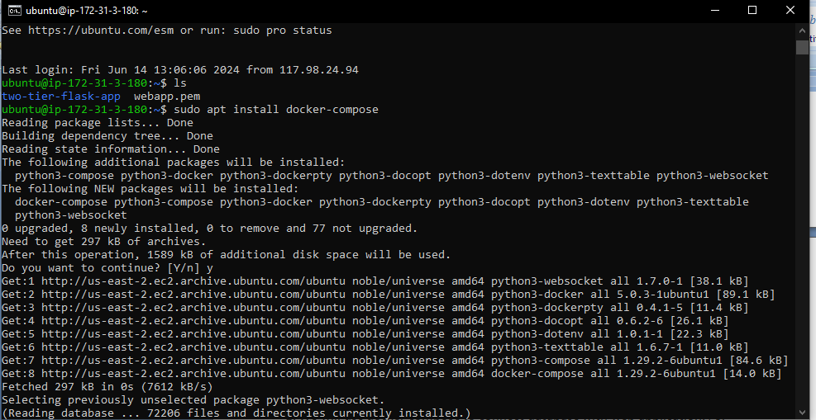

1. Once the docker compose is installed, add the docker-compose.yml file into repo and write the script to run flask application and my sql. In this, we will also use the concept of PVC and PV to assign the volumes.

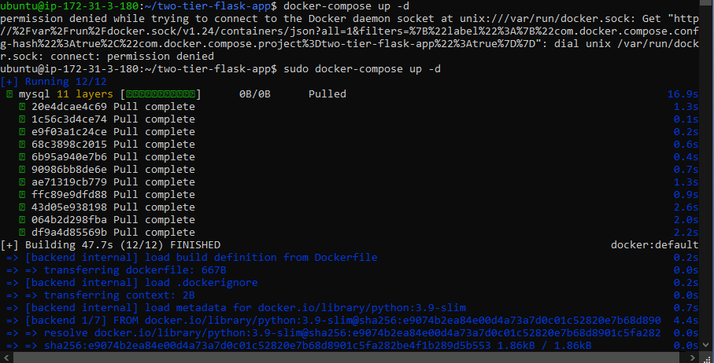

1. Once the docker compose is run successfully, our app will be running perfectly. Below snip for the reference.

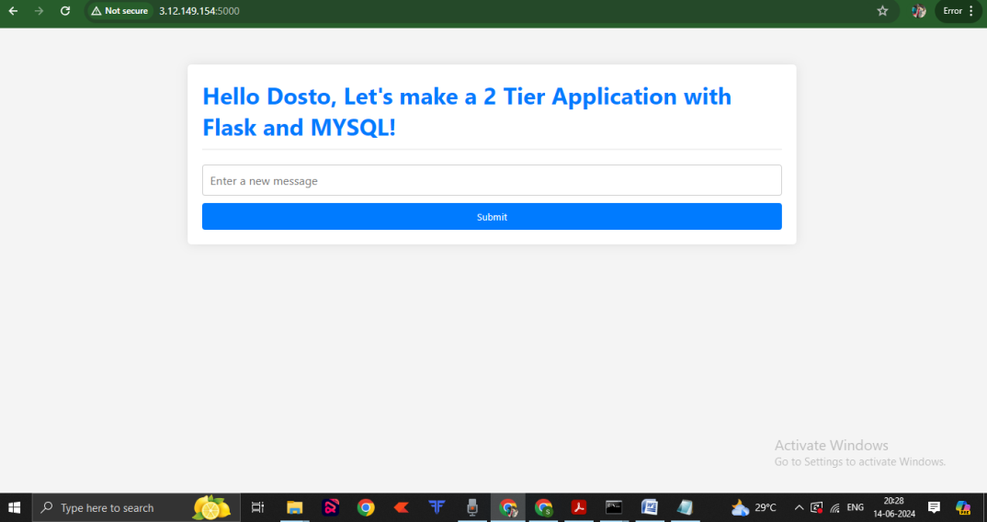

**Terraform to automate the setup of the VPC, subnets, security groups, and EC2 instances.**

**Steps:  
  
1. We need to download and install terraform on our EC2 instance.  
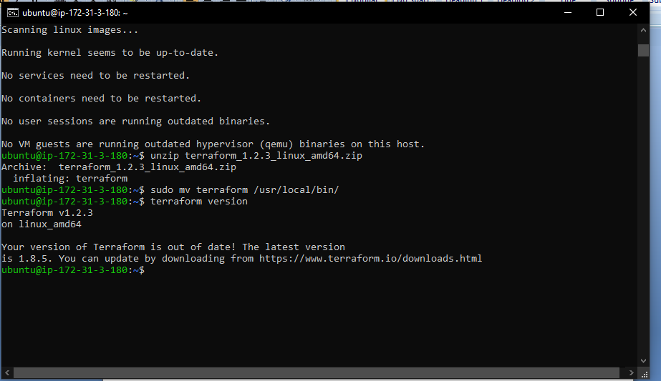**

**2. Install and configure AWS CLI:**

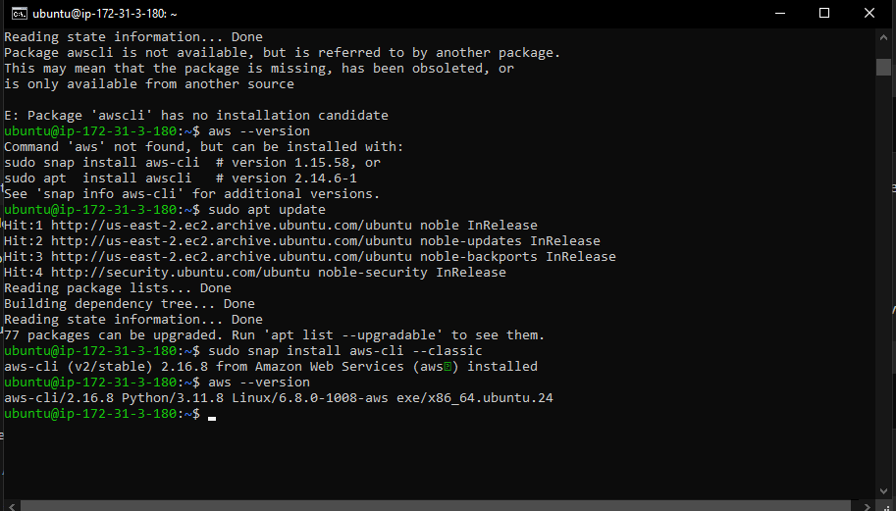

**3 Write terraform main.tf file where we will define our whole infrastructure.   
  
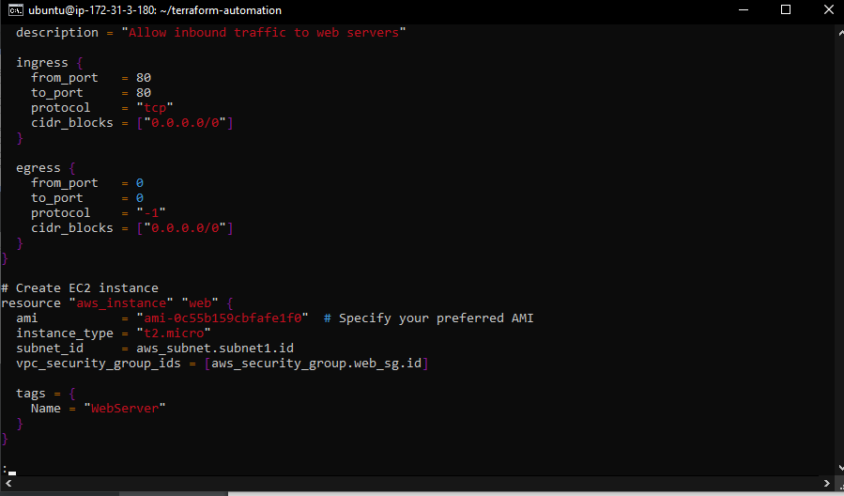**

1. **Now we can initialize the terraform using “terraform init:  
     
   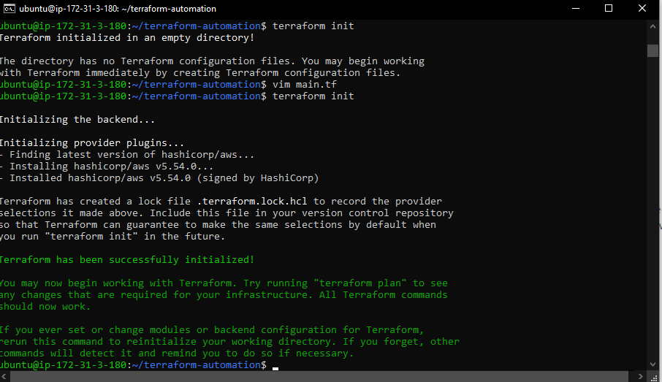**
2. Then use “terraform apply” to create the infrastructure.  
   