AI Job Tracker – Technical Documentation

1. Architecture Diagram
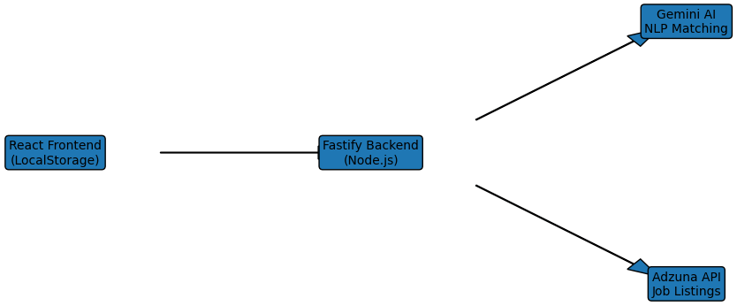
The application follows a decoupled, high-performance architecture designed for scalability and low latency.
Frontend: React.js Single Page Application (SPA) handling UI and LocalStorage-based persistence.
Backend: Fastify (Node.js) server optimized for high throughput.
AI Integration: Stateless communication with Google Gemini-1.5-Flash for semantic matching.
External Data: Live job listings fetched via the Adzuna Job Search API.

2. AI Matching Logic
Semantic Analysis: Uses Gemini AI to evaluate skill context, seniority, and relevance.
Fallback Reliability: Regex-based manual keyword matcher ensures uninterrupted scoring during AI downtime.
Parallel Processing: Promise.all() enables concurrent job-resume matching for faster response times.

3. Critical Thinking: Popup Flow
Event-Driven Detection: window.focus event triggers confirmation when users return after applying externally.
Edge Case Handling: Popup appears only if an Apply link was clicked beforehand.
Design Choice: Automated confirmation improves accuracy over manual logging.

4. Scalability & Tradeoffs
Scalability: Redis caching proposed for storing frequent job-resume match scores.
Tradeoff – Persistence: LocalStorage chosen for demo simplicity; PostgreSQL recommended for production.
Tradeoff – Complexity: MERN-lite stack (Fastify) reduces boilerplate while maintaining performance.

